
Assignment Cover Sheet

Student Name: | Rachael Boon
Student Number: | 1501
Course: | Diploma in Fashion Design
Assignment NO: | 6

Marking Criteria:
We expect the learners to write minimum one well expressed point in three lines against each allocated mark. This means one needs to write 15 lines with 5 well expressed points to get high grades for a 5 marks question.
For high grades use examples and illustrations where appropriate.
- How is the formal balance achieved in dress designing?
Formal balance, or symmetrical balance, is achieved by designing a garment in which both sides are mirror images of each other from the centre point. This also applies to the upper and lower part of a design, e.g. if the top part of the garment is lighter in shade and the lower part is darker or heavier it may appear the product is shortened.
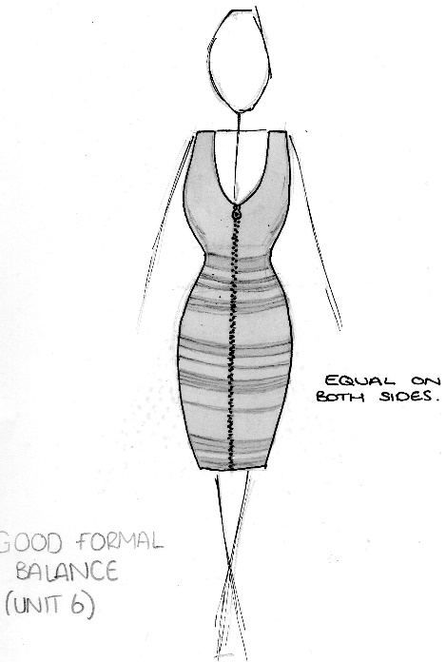
(Illustration of formal balance)

- How can harmony be created in a design?
Harmony is created when all parts of the design are related in a similar way. When doing so the composition becomes attractive and ‘works’, when all components of the design are used accordingly to the best of their ability.
- What is the relationship between the principles and elements in a design?
The principles of design including, balance, emphasis, harmony, proportion, rhythm, are guidelines that the elements of design follow when designing or evaluating a garment. To arrange the elements of design well, the application of principles are essential.

IV
Repetition
Rhythm is created through repetition by regular repeats of a key component of the design, e.g. shape, buttons, pleats, lace, colour etc. Repetition can differ the mood of the dress. For example a soft, graceful trim would create a calming effect, whereas harsh or jagged lines would give off a more exciting and daring design.
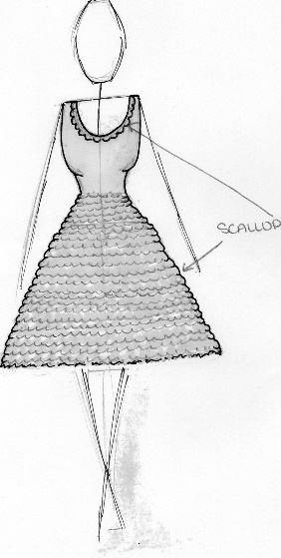

Progression
Progression of a colour can create rhythm in a dress. For example if a design goes from dark blue to light blue. Progression or gradation cause also be used in design by increasing the size of motifs/buttons and also textures e.g. coarse to fine.
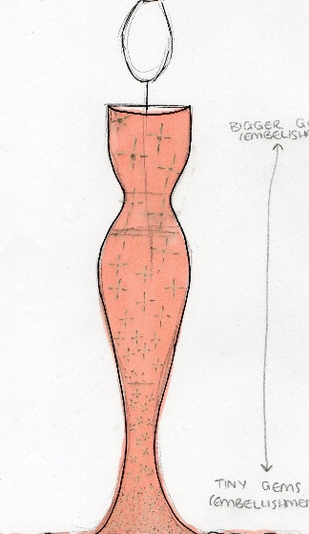

Transition
Another way rhythm is developed in a design is through transition. This is very smooth way of created rhythm as it follows a curved line, leading the eye from one area to another.
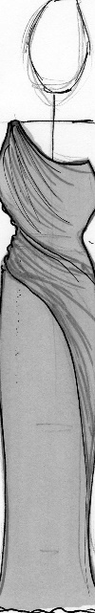

Radiation
Rhythm by radiation allows the eye to be directed in many different ways, usually from one central point using pleats, lines, gathers, folds etc. Radiation can be in a number of different directions including, similar, opposing, one or several directions.
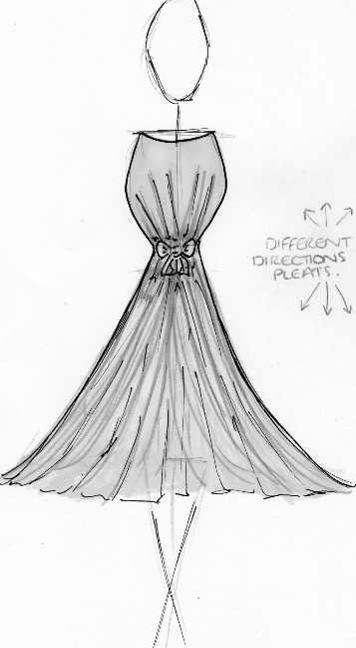
(Illustrations of repetition, progression, transition and radiation)

Q: 2.
The principles of design are balance, emphasis, harmony, proportion and rhythm.
Balance is needed to be analysed by the designer in order to ensure the dress is flattering and creates to desired effect, this is achieved in the garment when the design elements are equal on both sides; e.g. structural or decorative features. Emphasis of a design is important when analysing the effectiveness of a garment. It is essential that emphasis is not created on parts of the body the wearer does not wish to draw attention to, for example stomach. Harmony is created when all parts of the design are related, holding the attention of any observers. The wearer would feel comfortable in the garment as all components are put together in an orderly manner. Proportion is another essential part of the design making process that needs to be correctly analysed. Like the harmony of a design, proportion needs to be correctly weighed up in order for the garment(s) to be appealing. Uneven proportions are usually more interesting that equal ones and also create a longer, slimmer silhouette. As well as the whole design, detail needs to be precisely analysed such as pockets, buttons and texture in order for the outfit to be visually pleasing. Finally, the rhythm of the design is analysed. Rhythm is formed through gradual change, giving the garment continuity and can become stronger through repetition. Rhythm is usually created through; line, shape, space and also colour.

Activity
The first dress I found was very flattering on most body shapes as it was completely symmetrical and very detailed. The lines on the dress went in all directions so places that wanted to be hidden, e.g. arms and stomach, could appear smaller and the eye would be drawn along the lines to emphasise other areas. A lot of repetition is used within both the fabric and the shapes on the dress keeping the dress in proportion.
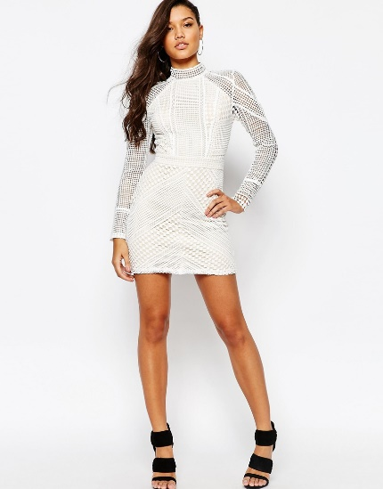

The second dress I found was very different to the first in terms of style and colour, however equally as symmetrical with its design. The lines of the dress where very flattering as they elongated the body, and the sleeves cut off at a complimentary length hiding the top of the arm, which a lot of people like to cover up. The length the sleeves cut off at are also equal to the bust, creating a ‘cape’ effect, making the dress look very expensive by adding an extra element to the design. The colours of the dress contrast very well, as the light coral colour of the main dress made the royal blue embellishment stand out and become the main focal point of the dress. I think all elements of this dress work harmoniously and are very balanced.
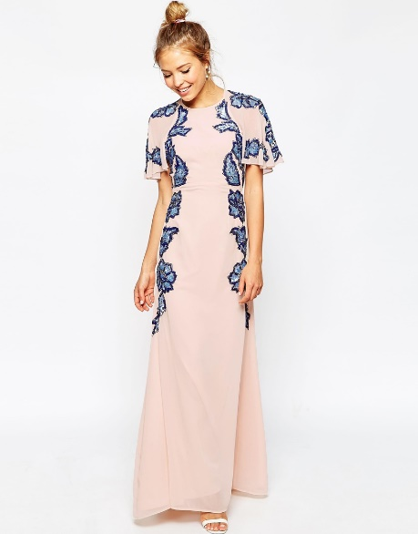

I also found some dresses were the design didn’t create a well-balanced silhouette. The first dress I found was balanced in terms of line and silhouette, however where the lines fell didn’t flatter the models silhouette and unless the wearer had a very straight figure, I feel it would attract the eye to areas that may not wish to be emphasized. The monochrome colours of the dress are usually complimentary on all skin types/ body-shapes, however the silhouette of this dress is very straight and doesn’t accentuate any particular body part. I feel if the silhouette was fitted or the lines where vertical down the leg to lengthen it, the design would be more appealing.
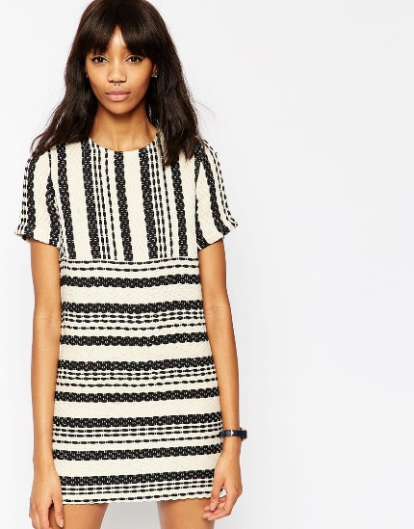
The second dress I found which I thought could be improved was a black and white monochrome dress. It was advertised as a plus sized dress, however the lines of the dress were not symmetrical on both sides. In particular one of the sides directed the eye outwards at the stomach which was surprising as most dresses are designed to minimise areas that some wearers want to hide, including the stomach. The silhouette of the dress was ok, but could have been improved by lengthening the sleeves to draw the eye down rather than outwards.
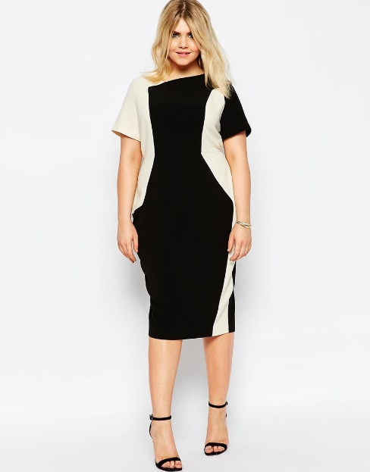

Student Statement:

By submitting this assignment, I confirm that this is my own work.

Student Signature | RACHAEL BOON | Date | 21/02/2015

For Tutor / Assessor Use Only
Total Marks
Marks Obtained
Percentage / Grade

