
Assignment Cover Sheet

Student Name: | Annur Zara Liyana Othman
Student Number: | 1227
Course: | Diploma of Fashion Design
Assignment NO: | 6

Student Statement:

By submitting this assignment, I confirm that this is my own work.

Student Signature | 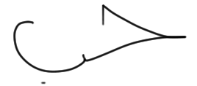 | Date | 14th June 2014

For Tutor / Assessor Use Only
Total Marks
Marks Obtained
Percentage / Grade

Principles of Design
Assessment 6
Q: 1: Give short answers for the following questions:

I. How is the formal balance achieved in dress designing?
Balance is the concept of visual equilibrium, and relates to our physical sense of balance. It is reconciliation of opposing forces in a composition the result in visual stability. Most successful compositions achieved balance in one of two ways; symmetrically (formal balance) or asymmetrically (informal balance). Balance in a three dimensional object is easy to understand; if balance isn’t achieved, the object tips over. To understand balance in a two-dimensional composition, designers must use their imaginations to carry this three dimensional analogy forward to the flat surface.
Formal balance, also known as symmetrical balance. Its easier to create than informal balance. This balance can be described as having equal “weight” on equal sides of a centrally placed fulcrum. When the elements are arranged equally on either side of the central axis, the result is two-side symmetry. It is also possible to build formal balance by arranging elements equally around the central point, resulting in radical symmetry. The formal balance can be creating by this major factor; the upper and lower portions of design should be like a mirror. It should be in same or similar length. The elements of design such as colour or pattern also can be arrange and adapt in order to create a formal balance in dress designing.

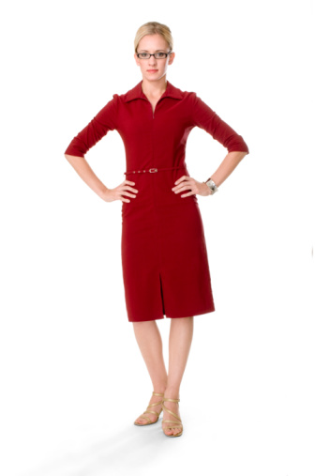

Example of formal balance dress

II. How can harmony be created in a design?
Harmony also known as unit that can be refers as the underlying principle that summarizes all the principle and element of design. The sense that all of the parts are working together to achieved a common result; a harmony of all the parts. In other word, harmony is the pleasing visual unity. This is created when all parts of the design are related, in a regular or orderly manner.
Harmony can be achieved through the effective and consistence use of any elements, but pattern (underlying structure) is the most fundamental element for a strong sense of unity. Consistency of form and colour are also powerful tools that can pull a composition together.
Harmony also can be achieved by the implies of the fabric in garment that create comfortable, moves easily and breathes with body, perform any specialized duties effectively and fits well. For physical look. The harmony can be achieved by the usage of right accessories, jewellery, hairstyle and facial ornamentation. Shape and spaces that created by the details like pockets, collars, cuffs, sleeves, ect will harmonized if they are designed well and match the garments. The other factors that can create harmony in the design are the texture. It should be match in the whole garment. The other that quite important factors that designers should pay a close attention are occasion, climates, sizes, ganders, ages, personal, colouring, life styles and personality of the wearer because it can be effect the whole garment.
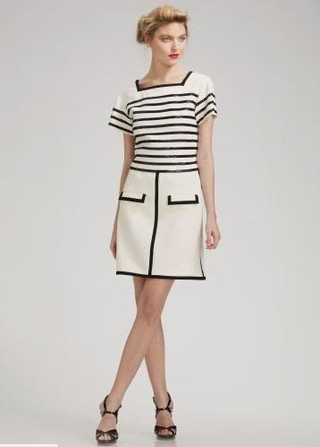

Example of the a good harmony in a dress.

III. What is the relationship between the principles and elements in a design?
When designing, there are several ideas or aspects of design that need to be kept in mind. These aspects of design can be categorized into two areas: Principles and Elements of Design. One way to describe this is: The principles are the directions for a cake recipe and the elements are the ingredients. The directions (principles) are flexible and should be interpreted within a current fashion or problem the designer is trying to solve. For example, the directions (principles) would apply differently for a design of a costume than for a design of a current fashion garment. The ingredients (elements) are raw materials that must be combined. These elements change the taste of the garment, just as the ingredients can change the taste of a cake. A dress is more eye-catching in a bright color than a dull, neutral color, even though the design is the same.

ELEMENTS
Shape and form are among the most important in fashion and accessory design. The shape, or silhouette, is the most obvious visual element of a garment; it is probably the first thing that is seen. The silhouette can be described as the outline of the entire garment, and it is often called "form." The goal of a silhouette is to compliment the shape of the body. However, exaggeration is often used in order to create a certain type of effect or emphasize a certain part of the body; whichever is the current fashion trend.
Line is the simplest element of design. There are two types: outline and style lines. Outline is the outer edge of the design whereas style lines are the lines that divide up the space inside of the outline. For example, if you were to trace around an outfit in a magazine or catalogue, you would be following along the outline. Style lines can be created by several things: belts, ruffles, seams, a color line, or a pocket.
Next to the silhouette, one of the first things noticed about a design is the color. Color has an enormous effect on how you feel. Everyone loves wearing their favorite color, and in fact, it makes them feel good.
Texture is another important element that actually can determine a lot. The way the fabric feels is a big thing to consider. When designing, it's important to know how a fabric will drape and feel. For example, overalls are great in denim, but would people wear silk satin overalls? Probably not. The design should be paired appropriately with the right fabric.

PRINCIPLES
The first principle is proportion. This creates the feeling of unity that is created when all of the parts (sizes, numbers, or amounts) relate well with each other. Also, when drawing or sketching the human form, proportion refers to the size of the head when in comparison to the rest of the body. Scale therefore refers to the overall size of any object or its parts when compared to the size of other parts or objects in the design.
A simple concept to understand is balance. There are two kinds of balance, and in fact they relate to more than just fashion design; these two types relate to almost any type of design and art. Symmetrical and asymmetrical balance are the only two types that designers and artists use when it comes to balance of their piece. The outfit is symmetrical if you were to divide it right down the middle and both sides are exactly the same. Therefore, if you divide an outfit right down the middle and both sides aren't the same, the balance is asymmetrical. Asymmetrical balance is quite popular in dressy evening wear because it is dramatic and eye-catching.
Unity is the feeling of harmony between all parts or objects of the design. The overall design creates a sense of completeness.
Rhythm refers to the repeated use of lines, colors, trims, shapes, or details that create a pattern that the eye can follow throughout the design. Examples could be stripes, polka dots, ruffles, etc.
What your eye is drawn to on any outfit is considered to be emphasis. It could be anything that you focus on, from a horizontal stripe, a belt, jewel, or contrasting color.
Overall, based of the info above, the element and principle of design is related so close to each other. Without this two thing, a good design can’t be create.

IV. Describe at least three ways for creating rhythm in dress designing.
Rhythm can de defines as the pleasing arrangement of the design elements so the eye cam moves easily over the apparel. Rhythmic affect becomes stronger when a pattern is repeated, but repetition is not very essential always. Rhythm is use most effectively with line, shape and space and also by changing the hue, value and intensity colour.

Rhythm through Repetition
It can be created by repetition or regular repeats of motifs of design, shape, button, edge, colour, ect. This can be done with all the parts having the same shaped, edges. Repetition in colours also can create a good finish.
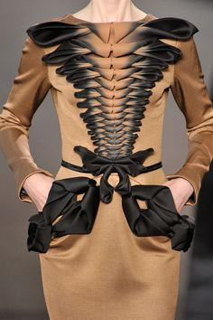

Rhythm through Progression
Also known as gradation. Gradation implies a gradually increase or decrease of similar design elements. The colours can go form light to dark or texture from fine to coarse. Shape may range from thin to thick. The successful design will gradually changes provide continually while giving a feeling of movement.
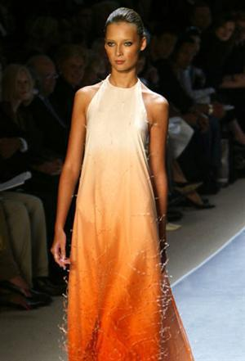

Rhythm through Transition
Transition can be refers as a fluid rhythm created when curved line lead the eye over an angle. Transitional lines and shapes sweep and glide over the figure in an undulating rhythm leading the eye gracefully and easily from one area or direction to another. Transition can also be achieved by using scarves, shawls, ruffles, and gather in outfits.
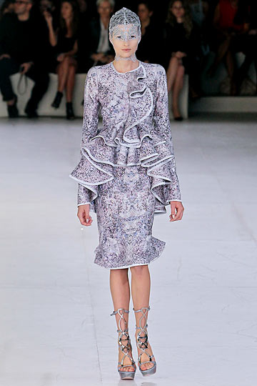

Rhythm in Radiation
Radiation can creates a feeling of movement in different directions. Its usually starts from a central point of gathers, folds, tucks, darts, pleats, and lines. The direction can be in a similar or one direction, opposing direction or both the directions, several directions and all directions.
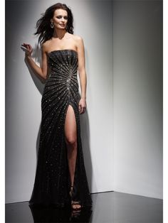

Rhythm by continuously line movement
This type of rhythm is based by flowing lines of trims, band pd colour, fabric design, ect, which make the eye moves in a continuous line. The harmony also can be obtained this movement. Fabric design with widely placed motifs may lack rhythm when the garment design didn’t follow the rhythm. It may create a weird look on the wearer. So designer should pay a close attention especially using such fabric design in a dress designing.

Q: 2. What are the principles of design? How do they help a designer analyse the effectiveness of a design?
The principles of design are essential to the development and production of clothing used by individuals and families around the world. Each principle has a specific role in creating an aesthetically pleasing garment or ensemble. The principles of design consist of: balance, proportion (also referred to as scale), emphasis, and rhythm. When a garment or ensemble uses the elements and principles of design to create a visual unity, harmony is achieved. Garments often integrate more than one principle, while drawing from the elements of design to create a cohesive look. The following discussion will present background information on each of the principles of design and applications to clothing design and construction.

Balance
Balance is a very important thing in the making of a design. Without the right balance, the garment will not look good on the wearer body as well as change the whole visual mood and feeling. Balance in fashion design can be achieved with the use of features, such as seams, hemlines, and necklines. Symmetrical applications of balance (for example, a straight hemline) are the norm, but asymmetrical balance can be effective too. In the past several years, asymmetrical necklines have achieved popularity. Asymmetrical balance is more complex and trickier to achieve than symmetrical balance. For example, a one-shoulder gown might look interesting with its asymmetrical neckline, but a jacket with one lapel larger than the other would just look bad.
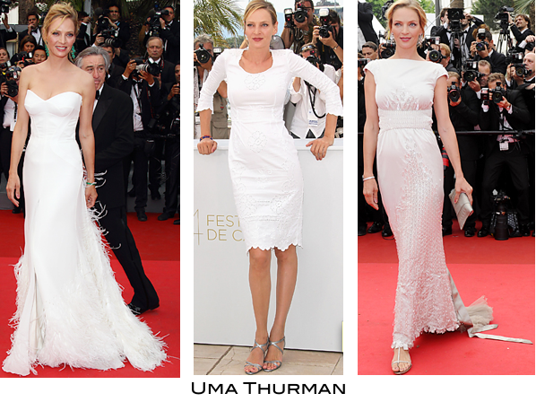

Examples of formal and informal balance.

Emphasis
There are a number of techniques that a fashion designer may use to place emphasis on a feature of a garment or a fashion accessory. Such techniques may include the addition of embellishment, cut-outs, ruffles, peplums, and so on. Use of color and its placement is another way to create emphasis, making some areas stand out more than others. Exaggerated or unusual designs, such as the leg-o-mutton sleeves that were popular on 1980s wedding gowns, also create emphasis, highlighting a particular area. Knowing about emphasis, which can be part of the design itself or emphasis on the body because of the way a garment is designed, can help any woman when she is selecting a garment or fashion accessory. For example, if a woman wants to showcase her shoulders, she may select a strapless top or dress. If she wants to highlight her cleavage, she may select a gown with a deep V-neckline.
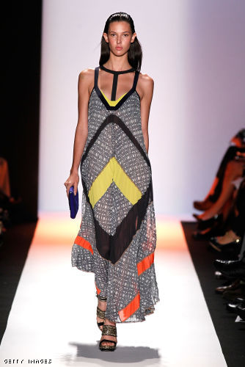

Harmony/Unity
When the principle of unity in fashion design is applied well, a garment or fashion accessory should look good overall. It should look as though it goes together, and it should look as though all the design elements are contributing to make a harmonious whole. In an effective application of the principle of unity, each element enhances the others, rather than distracting from the design. So, based on the guideline in making a harmony look, designers can create a garment that will be great the wearer body.
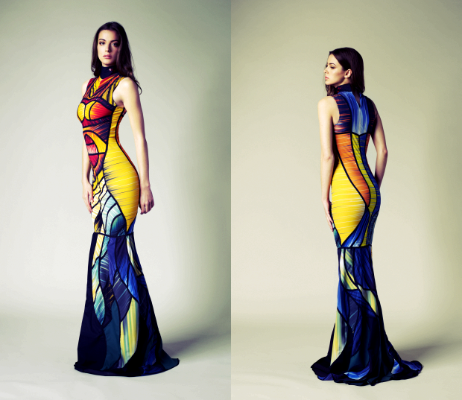

Proportion
Proportion in fashion design is the principle that holds that the size of various components of a garment or fashion accessory must look good together. Proportion is one of the most important principles of fashion design for the petite woman because when she selects garments, their proportion (or size/scale of the garment or various components of a garment or fashion accessory) should be relative to her small stature. For example, a tea-length, full skirt would have so much volume that it would be overwhelming on a petite woman.
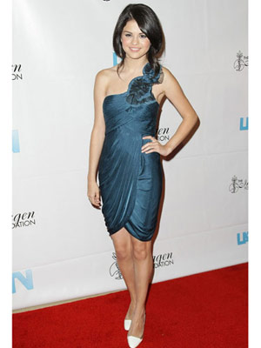

Example of a good proportion dress in a petite figure.

Rhythm
This principle of design is as important as others. A good rhythm in of garment will catch a consumer attention. Designers can use the guideline rhythm rule in order to make a good design. Based on its definition, Rhythm creates a sense of movement in a design. The eye moves from one feature on the body to another with the use of this principle. Further, a pattern or texture is created with the application of rhythm to the surface design of fabrics used in the construction of clothing items or products. Specific applications of rhythm are classified in the following categories: Gradation, Opposition, Radical Arrangement, Repetition, and Transition.
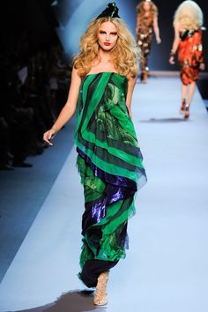

In conclusion, the principle of design is very important to designers to see or to get know how effective a design when it turns into garment. When designers designing a garment, they wouldn’t know how the garment would look on the wearer body. By using this principle of design, it’s clearly show and help designers to analysis and gives them a first imagination about how suitable and practical the design when it be a garment soon.

Activity
Find pictures of some dresses from fashion magazines. Describe the beauty of each in terms of line, silhouette, shapes and spaces, colour, and texture (fabric, pattern, and trims) as well as balance, proportion, rhythm, and emphasis. Do all elements and principles work together harmoniously? What elements dominate? Find two garments that you feel are unsuccessful. Analyse them in the same way to discover what element or principle has not been properly used.
Dolce & Gabbana Fall 2014 Ready-To-Wear
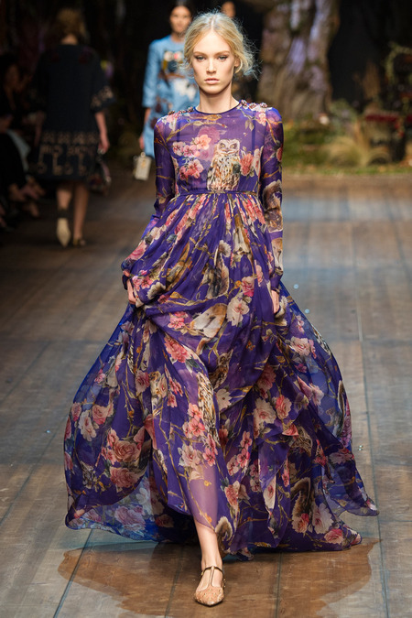

Line: This dress has a straight horizontal line to divide the upper and lower part of this body.
Silhouette: Its keep a simple silhouette by used the triangle shape.
Shape & space: Since this dress used a pattern fabric, there is no other decorative thing added. A long sleeves been attached to the triangle shape dress.
Colour: The based colour use is a cool colour; purple. With some flower print in peach-pink colour. A little bit paleness in the intensity in order to make this dress look more dramatic.
Texture
Fabric: the fabric use is a little transparent chiffon-silk look like.
Pattern: Purple based with few owls and flowers in peach-pink colour.
Trim: It’s a fit trim in the upper part, and loose trim in lower part
Balance: This dress have an informal balance which is the upper part is was shorter than the lower part
Proportion: It’s a well proportion in the whole garment. Especially the upper part includes the long sleeves. Its stick well to the wearer body.
Rhythm: The rhythm of repetition and transition is dominated the rhythm on this dress
Emphasis: A straight horizontal line that place under the bust probably the main emphasis.
Overall, this dress such a successful design and perfect for autumn season. The colour and the print design match very well. The shape of this dress is a triangle shape with long sleeves gave a romantic and cosy feeling Pair with a flat shoes/sandal. The upper part seems to be proportion well by it stick up to the body and the lower part such a great design. It’s flowing down after the middle line under the bust. It definitely looks beautiful and gorgeous.
So, even the colour and printing design kind of bold up in this dress, still the majestic shape or silhouette dominated the whole dress.

Chanel Spring 2014 Ready-To-Wear
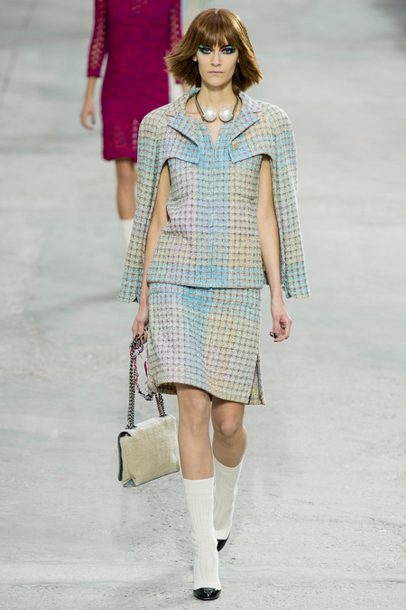

Line: This dress got many line in a whole look. The straight and curve were the most. The sleeve spit and open up in the inner part and that’s give the vertical straight line. In the collar part, designer used a little horizontal line combine with a curve line. At the middle of this garment, an illusion line created by the different colour usage.
Silhouette: The unique silhouette at the sleeve part and a normal look at the lower part. It’s made by two-piece (jacket and skirt)
Shape & space: The space quite busy-looking at the shoulder, collar and upper bust part. Meanwhile looking simple at the skirt shape.
Colour: The colour is very harmony mix by pastel blue, yellow, beige, and light pink.
Texture
Fabric: The fabric is quite strong give a stiff look yet interesting.
Pattern: The pattern is look like a graph check pattern.
Trim: The trim is interesting in the upper part and that’s can cover a little cliché look at the lower part.
Balance: This clothes is made by two-piece and it’s almost like a formal balance garment.
Proportion: Its stick well to the body for the whole garment. A little bit loose in the body makes it look super comfy
Rhythm: repetition and transition.
Emphasis: The collar and sleeves design and the accessory.
Overall, this garment is the perfect combination between a formal look and casual look. Its look interesting by the collar attach the sleeve cover which give a casual look and the skirt has a little bit cut up in the sides to make the whole skirt look match the upper wear design. The colour also a little bit likes a colour gradation. The accessory match well the garment with the big white pearl and the beige colour shoulder handbag.
So, the emphasis by the collar that attach to the sleeves is dominated the whole garment

Moschino by Jeremy Scoot fall 2014 Ready-To-Wear
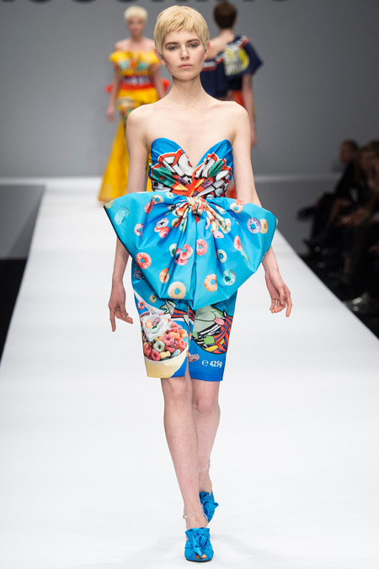

Line: Restrained curve as well as many other various line. The big bow really catch the eye.
Silhouette: The silhouette is based on the basic mini dress with the big bow in the front.
Shape & space: This dress looking so fresh with the cute shape and very interesting space. The whole shape look so feminine.
Colour: The colour is so great by using the sky blue with interesting printing design.
Texture
Fabric: The fabric looking strong so the bow can be shape well.
Pattern: The pattern is very unique. Its inspired by a snack food package.
Trim: The trim looks so fresh and new. The neck shape and the bow seem be trimmed well.
Balance: This dress used the formal balance.
Proportion: Its well proportion on the wearer body. Stick up so well.
Rhythm: Is has the transition rhythm as well as the repetition.
Emphasis: The fabric pattern is very eye catching in addition of the big bow as a decoration in the whole garment.
Overall, this dress is a little outstanding by the unique printing on the fabric and the big bow that place in the middle of the body. The fabric type is easy and comfortable to wear. It goes very well with the same colour shoes. It’s a perfect harmony by the design that gives a casual feeling in a formal balance dress.
So, the colour and printing is dominated the whole garment as well as the big bow as a decoration.

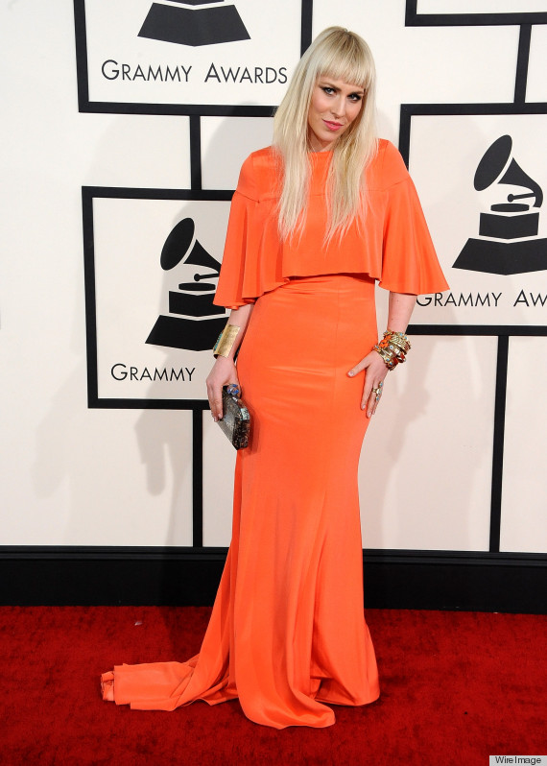

Line: The horizontal straight or a little bit curve line for the upper part.
Silhouette: This dress is based from a basic long dress with the attached open up sleeve that wrap the whole upper part.
Shape & space: The shape are shaggy with the upper part style and the space is relaxing without any decorative addition.
Colour: The colour is a warm colour; orange.
Texture
Fabric: The fabric is look like stretchable fabric.
Pattern: A plain fabric.
Trim: The trim in upper part as the sleeves that wrap the whole upper body
Balance: Informal balance
Proportion: For the lower part it proportion well and for the upper part it’s a little bit loose.
Rhythm: The rhythm is the transition of line.
Emphasis: The major emphasis probably the colour and the upper part of the garment.
Overall, this dress looking a little not good by the design of the upper part of the body. Its look too much for the whole garment. The length of this dress also too long so its look like too heavy in visual. The colour was nice.

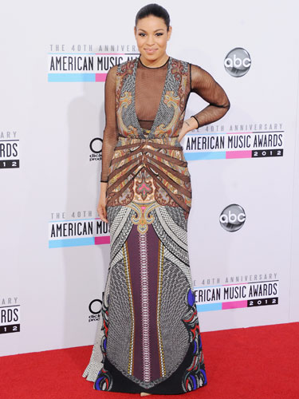

Line: This dress got too many line. The main line in the v shape neckline and few decoration lines.
Silhouette: This dress is a basic long dress with the v neckline.
Shape & space: The shape is fit to the body and the space is ready busy looking.
Colour: The colour seems like the earth colour mixing with few colours such as purple, yellow and blue.
Texture
Fabric: The fabric seem not to thick and not to thin.
Pattern: The pattern originally is quite good. The geometrical and a little nature style.
Trim: The v neckline is too long and the Semi horizontal line look to matching up with the fabric pattern.
Balance: Informal balance
Proportion: Its fit well to the body and the lower part kind of beautiful.
Rhythm: The rhythm is the transition, radiation and repetition.
Emphasis: The major emphasis probably the v neckline
Overall, this dress originally a quite good dress by the fabric pattern that look good by the colour and style. But, the decoration line at placed it the middle of the garment looking not right and its look so full since the fabric is patterned one. Its not harmonized together.
So, the major element that dominates this dress is the V-neckline.

Reference
Information: BOLC’s unit 6 note, Fashion Websites, Fashion Blogs, Fashion magazines, Fashion books
Picture: Online Fashion Magazines, Certain Brand Websites

