
Assignment Cover Sheet

Student Name: | Salma Mohamed Safaa
Student Number: | 1170
Course: | Interior Designing
Assignment NO: | 8

Student Statement:

By submitting this assignment, I confirm that this is my own work.

Student Signature | Salma Mohamed Safaa | Date | 22/10/2015

For Tutor / Assessor Use Only
Total Marks
Marks Obtained
Percentage / Grade

Student Name: | Salma Mohamed Safaa
Student Number: | 1170
Course: | Interior Designing
Assignment NO: | 8
Page NO: | 1

Interior Designing Course
Unit 8: Pattern & Texture
Q.1. Short Questions:
I. The best and simplest way of mixing patterns:
A designer's starting point is to choose a decorative pattern that includes several colours. Then a designer should coordinate with the colour palette of the chosen pattern simpler solid, geometric or tone-on-tone patterns. But in order to create a successful pattern mixture, scale and density of these patterns' elements should be considered while bringing them together.
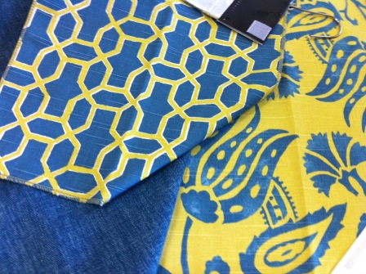
Examples;
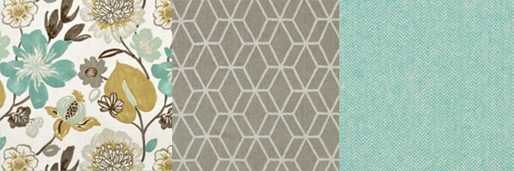
Mixing these patterns was simple and easy as it is only a three colored palette. A floral pattern of large scale and medium in density with a geometric pattern less in scale but also a medium density adding to both a third solid fabric.
Mixing these is much challenging. Three very different scales; large floral, medium geometric, and small herringbone.
The floral fabric is quite high in density compared to the simplicity of the other two. The geometric and the plain patterns are different colors, but since they are pulled from the colours of the floral fabric they work together.
II. The density of a pattern is how tightly its elements are grouped together and how much from its background is shown.
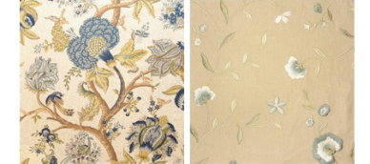
For example; The difference of density of two floral pattern; one with small bud flowers on an open solid background beside a large floral pattern of high dense crowded that it shows a little of its background.

Student Name: | Salma Mohamed Safaa
Student Number: | 1170
Course: | Interior Designing
Assignment NO: | 8
Page NO: | 2

III. Stripped pattern is a type of geometric pattern that tricks the eye, it's known as "a space manipulation tool'.
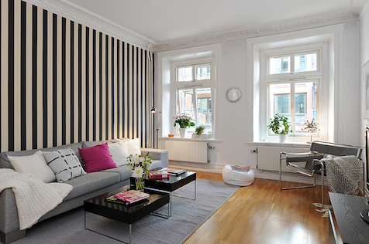
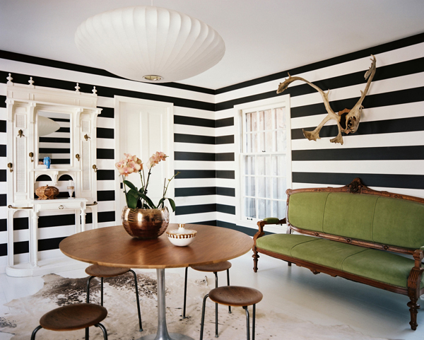
Vertical stripes on walls gives the sense of tallness it would make the ceilings appear higher, whereas horizontal stripes create a sense of width and makes the ceiling appear lower.

IV. Texture is an element which can sometimes be overlooked when planning a scheme. It has the ability to add a powerful, and subtle dimension to any room. Texture refers to how the surface of an object feels.
Textural depth is can be created in a design scheme by mixing items of different textures. Considering how you can mix textures in your room schemes, is the most important in the design scheme. All surfaces have texture be they matt or shiny, coarse or fine, rough or smooth.
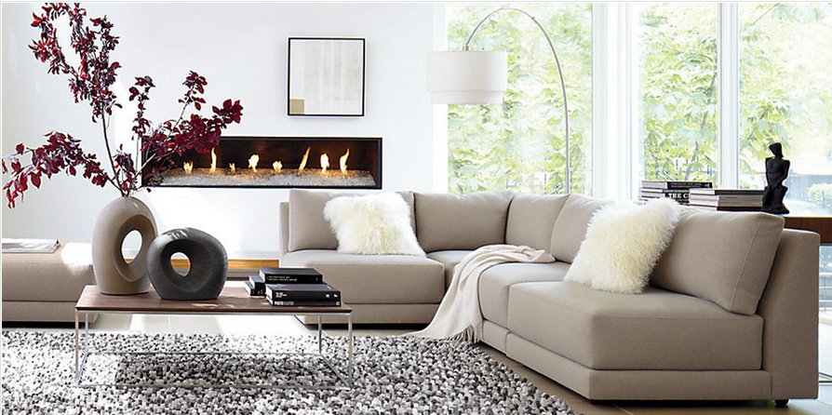
For example; This living space is perfectly composed. Different textures mixed; a soft linen light sofa, a rough carpet giving the smooth flooring a heavier contrast.
By adding two stone warm and heavy accessories on the light and cold metal and smooth wooden coffee table creates a sense of harmony. The white cool painted wall needs a warm feeling, so a horizontal built-in wooden and stoned fireplace was designed to evoke a sense of warmth. A single colour palette and a sophisticated mix of texture create a design scheme with depth of interest.
Student Name: | Salma Mohamed Safaa
Student Number: | 1170
Course: | Interior Designing
Assignment NO: | 8
Page NO: | 3

V. "Texture in fabrics emphasis mood in a room"
Every fabric has its textural significance and a personality of its own.
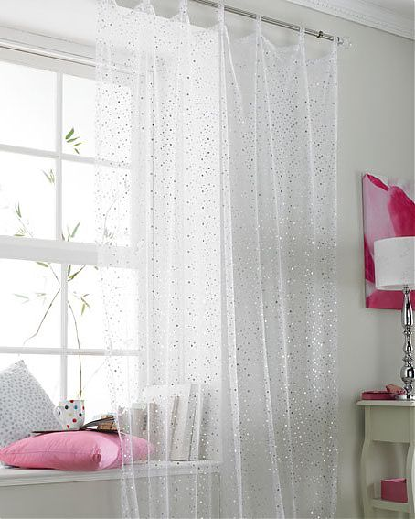
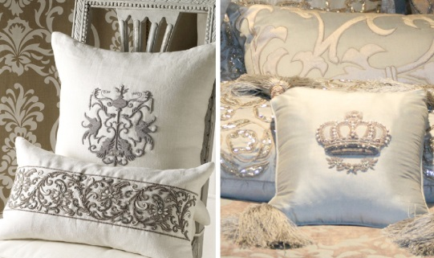
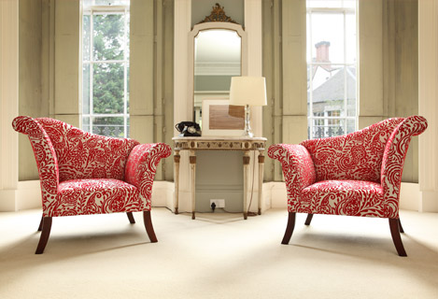
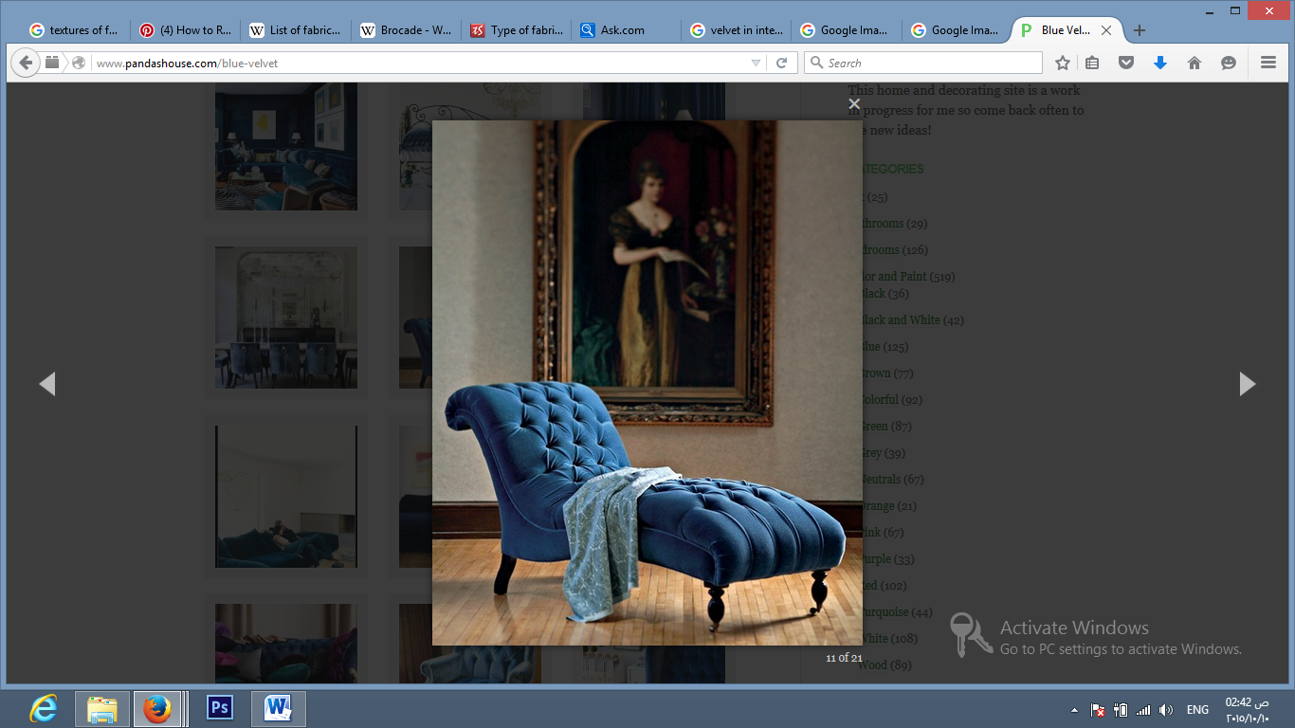
Some fabrics' textures are heavy that gives the room a synonymous, classic and rich mood such as velvet, brocade, paisley, taffeta and etc.
Modern Voile Curtains creating a romantic window seat
Rich brocade stitching
Paisley printed armchairs.
Plain heavy velvet.

Other fabrics that their textures are more lighter give a romantic mood to the such like voile, light cotton, silk, chiffon, organza and more..

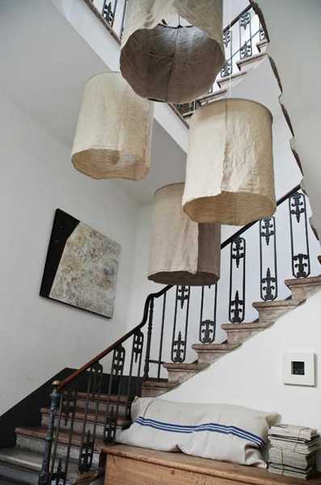
Handmade casual linen fabric lamp shades
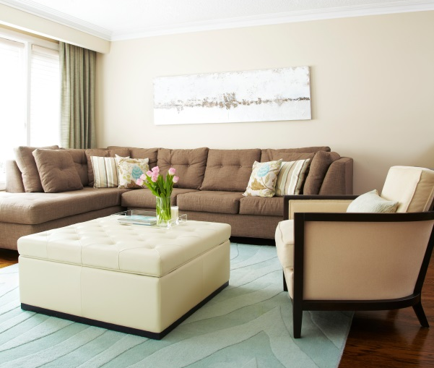
There more different fabrics of texture that can give a casual mood and can be used to create the smart town house look. For example smooth linen, suede, leather and more.
L-shabped pale brown sofa with a wooden framed ivory arm-chai, both of linen. Added to the setting a rectagular white leather ottoman giving a casual mood to the living space

Student Name: | Salma Mohamed Safaa
Student Number: | 1170
Course: | Interior Designing
Assignment NO: | 8
Page NO: | 4

VI. Sometimes the same colour appears different in different types of light.
The reason behind it is that the surface of a texture affects the way it appears under different lighting conditions. Many textures absorb light others reflect it while others diffuses and passes light through.
Smooth and Shiny textures; like shiny silk, glossy painting & glazed tiles reflect light making its colour appear brighter and stronger.
Rough and matt textures; like stones, wood & woven fabrics absorb light making its colour appear darker and duller.
Light diffusing textures; like sheer, voile, linen allow light to pass through making its colour appear softer and paler.

VII. "Texture can work like colour to bring surfaces forward or can give the impression that they are further away."
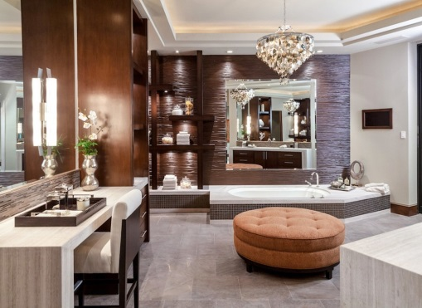
Shiny and smooth textures which reflect light seem to come at you; as they give a cool impression and make an object feel lighter. In opposite to that the soft, rough and raised textured that absorb light and therefore gives a sense of warmth and makes the object feel heavy, so they seem to move apart.
Combining fabrics or finishes of very different textures' temperatures can be visually very engaging; using textures of similar temperatures brings a sense of quiet harmony to a room.

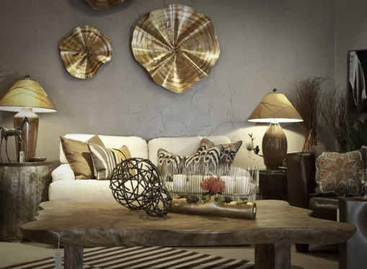
Also considering the placement of textures is very important. Putting a smooth texture directly next to a rough one while make the rough object stand out more and seem weightier than if you space them apart.
Student Name: | Salma Mohamed Safaa
Student Number: | 1170
Course: | Interior Designing
Assignment NO: | 8
Page NO: | 5
Activity 1:
Samples of different materials:
Stones:
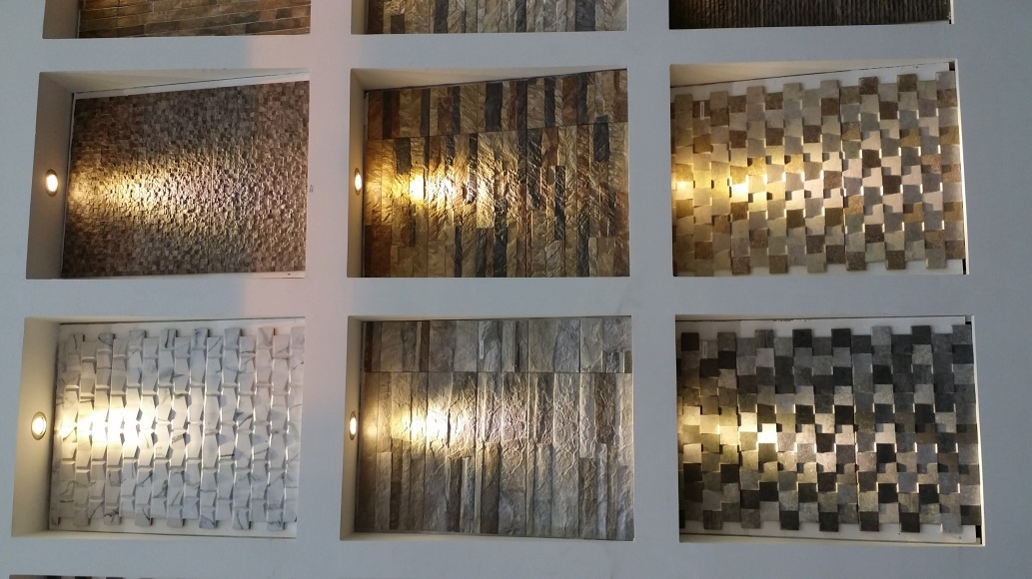
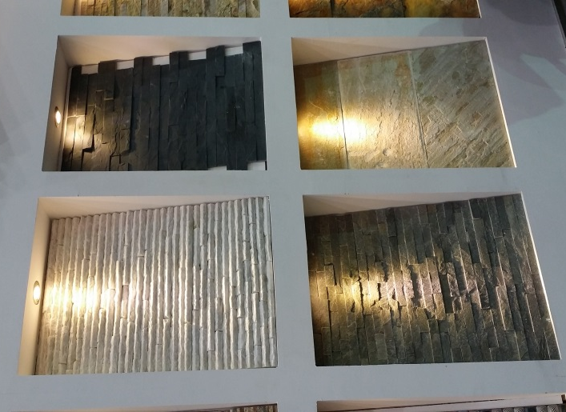
Figure 1 & 2: Natural stones for wall cladding
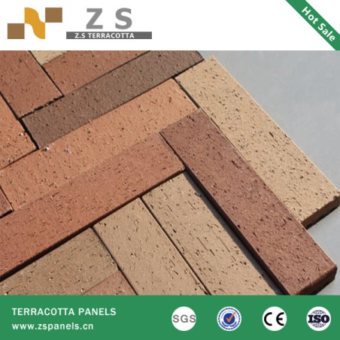
Figure 3 Terracotta brick tiles

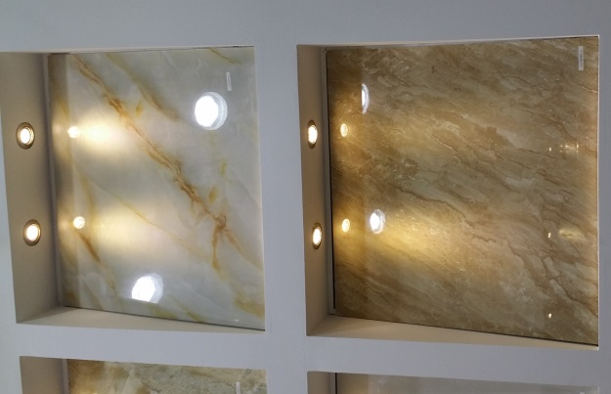
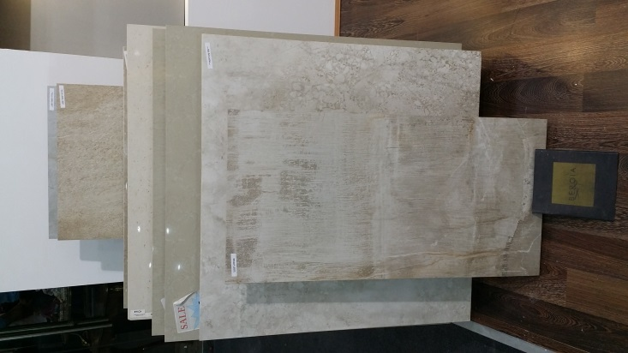
Porcelain Tiles:
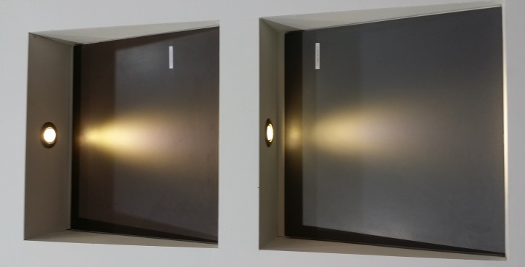

Student Name: | Salma Mohamed Safaa
Student Number: | 1170
Course: | Interior Designing
Assignment NO: | 8
Page NO: | 6
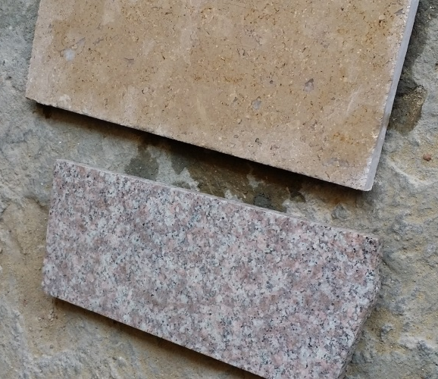
Marble Tiles:
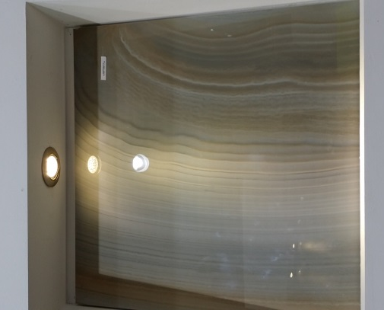

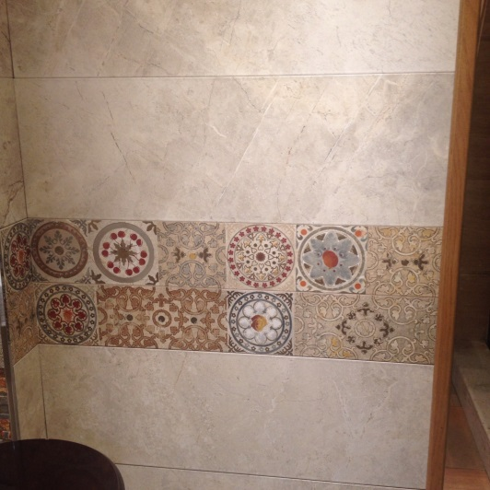
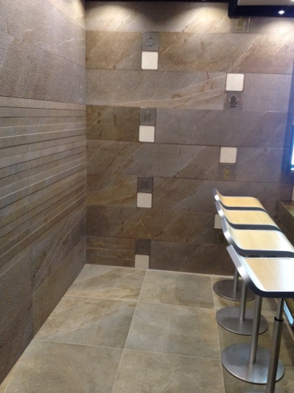
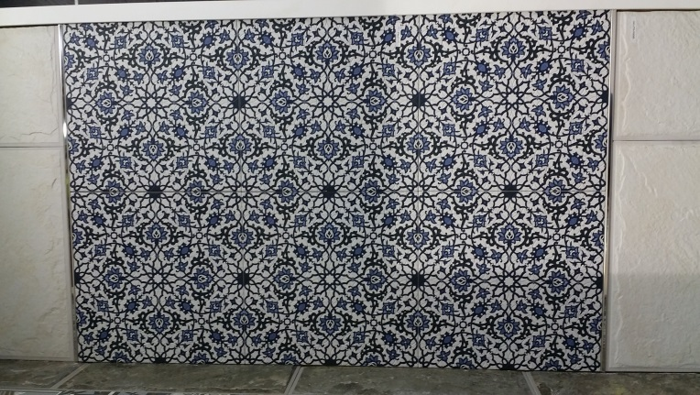
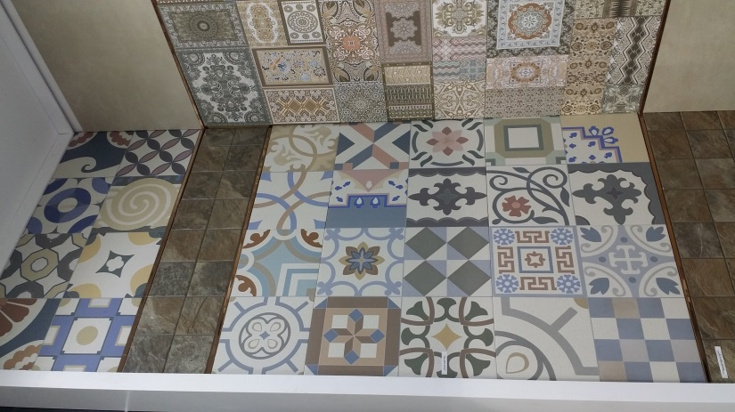
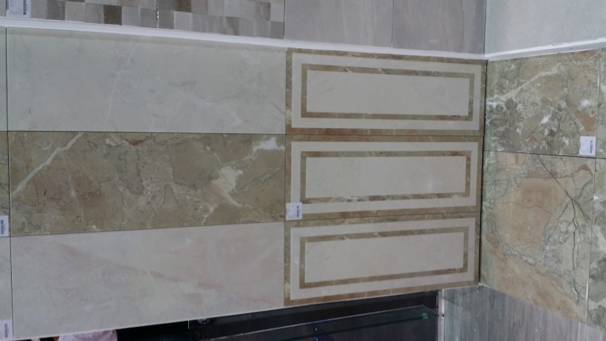
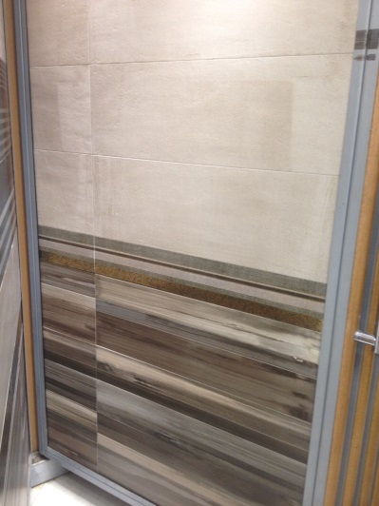
Ceramic Tiles:
Student Name: | Salma Mohamed Safaa
Student Number: | 1170
Course: | Interior Designing
Assignment NO: | 8
Page NO: | 7
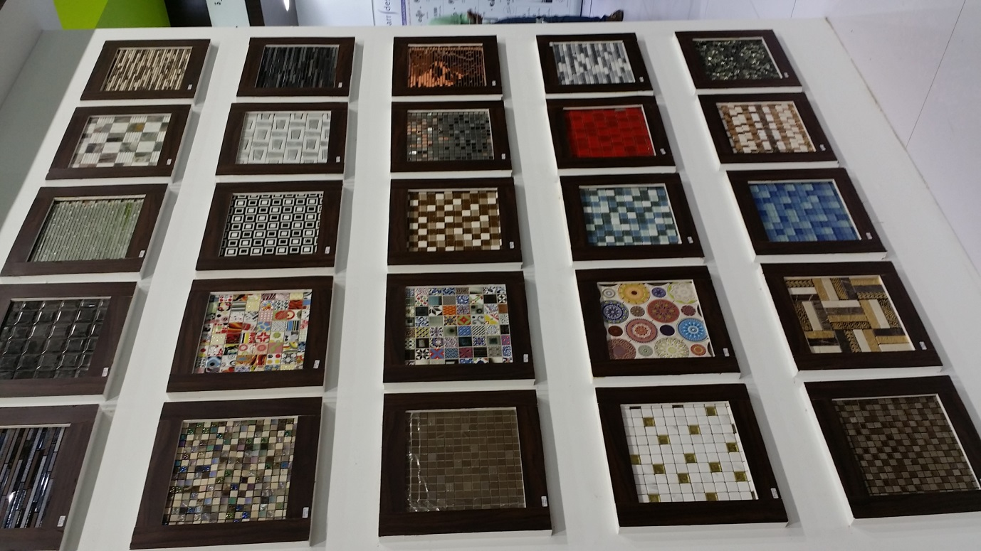
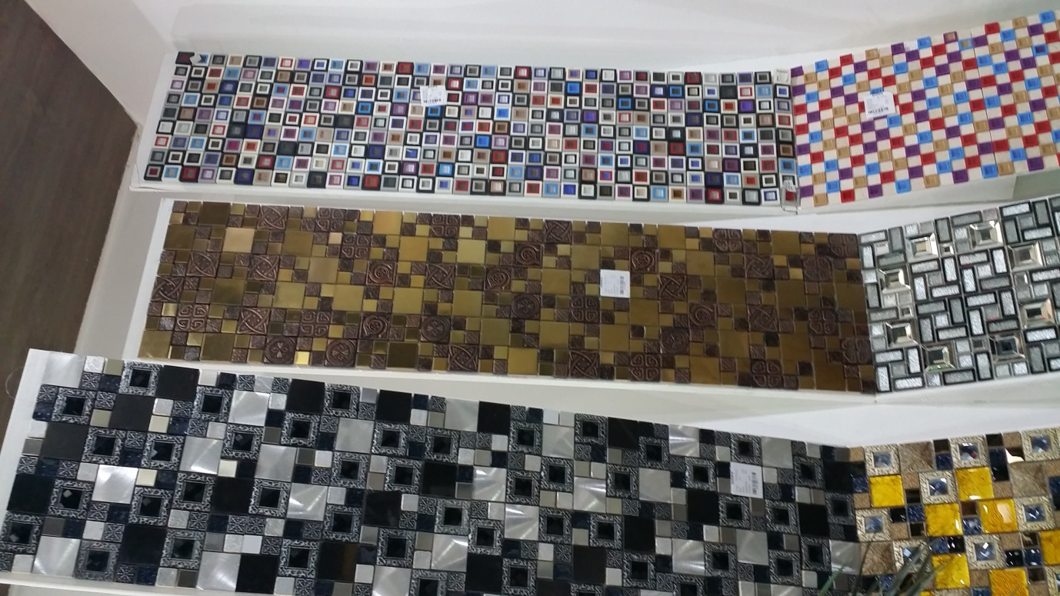
Mosaics:

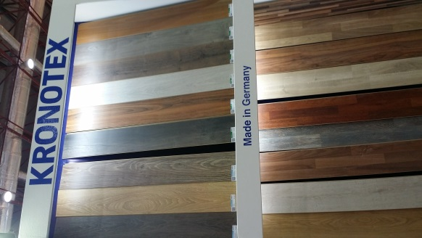
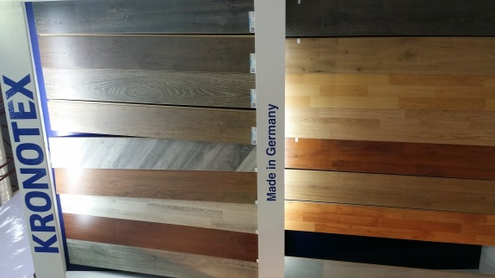
HDF Wood Floorings:

Student Name: | Salma Mohamed Safaa
Student Number: | 1170
Course: | Interior Designing
Assignment NO: | 8
Page NO: | 8
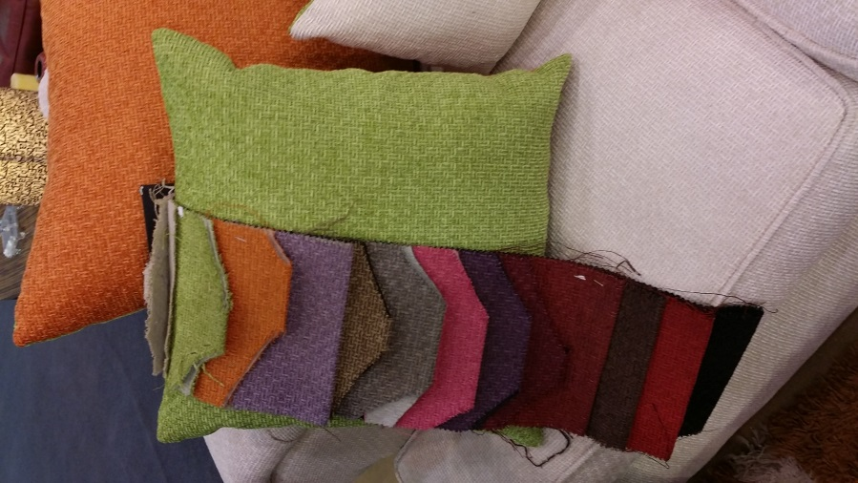
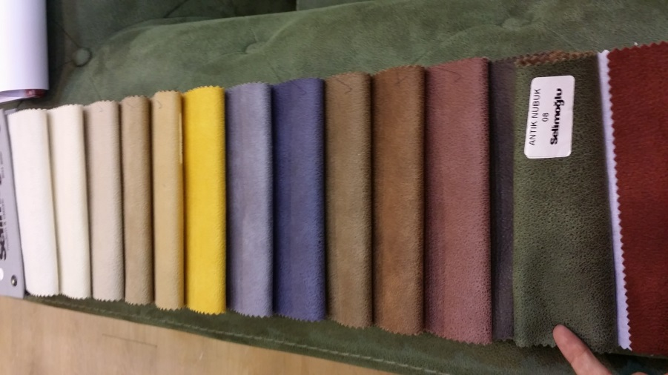
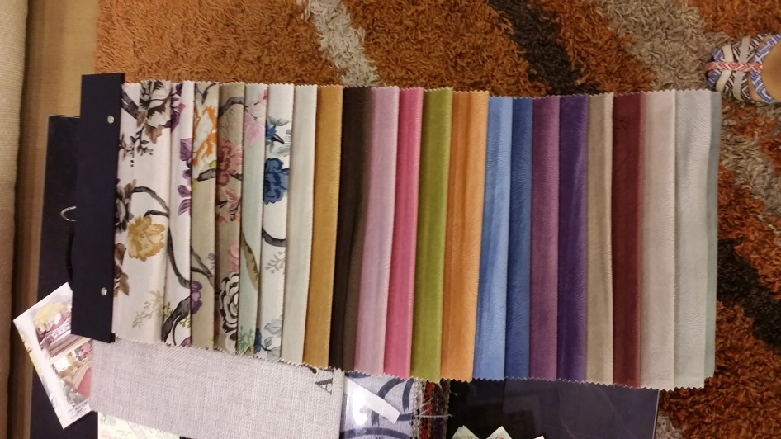
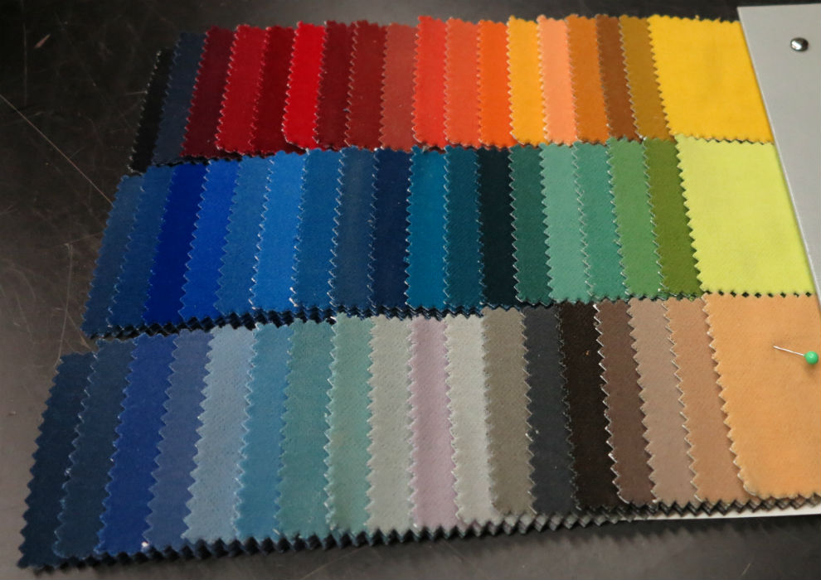
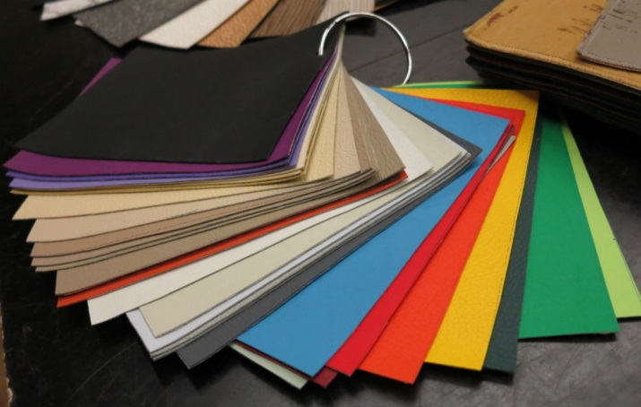
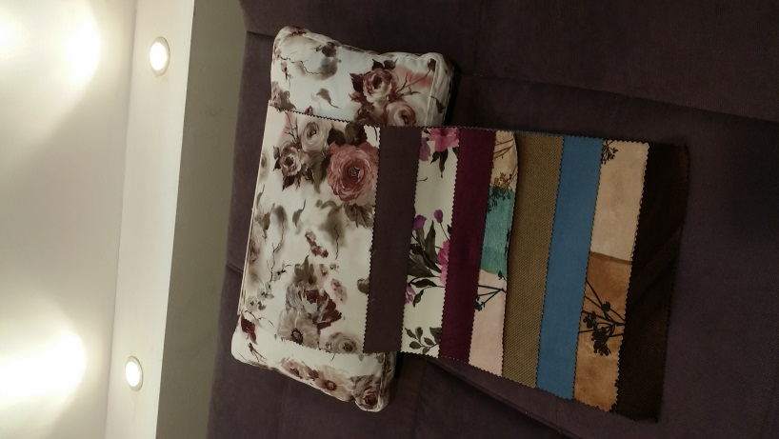
Fabrics:

Student Name: | Salma Mohamed Safaa
Student Number: | 1170
Course: | Interior Designing
Assignment NO: | 8
Page NO: | 9
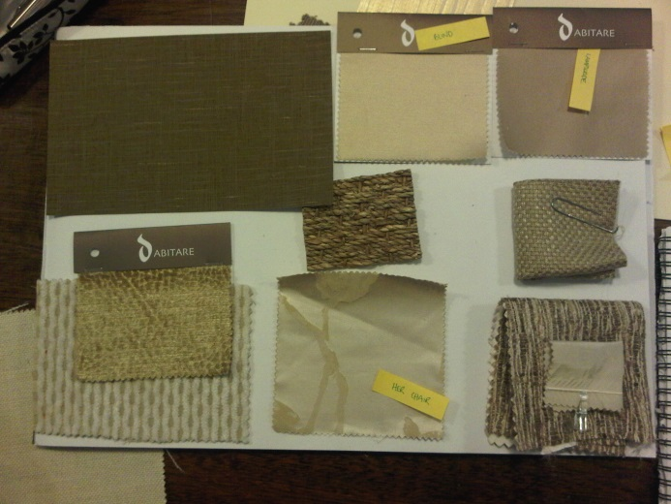
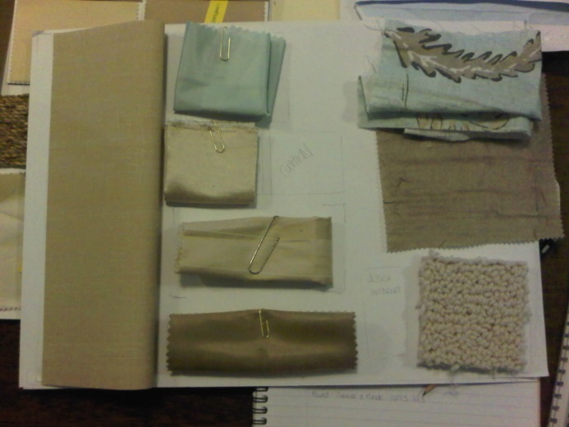
Trying out various contrasts:
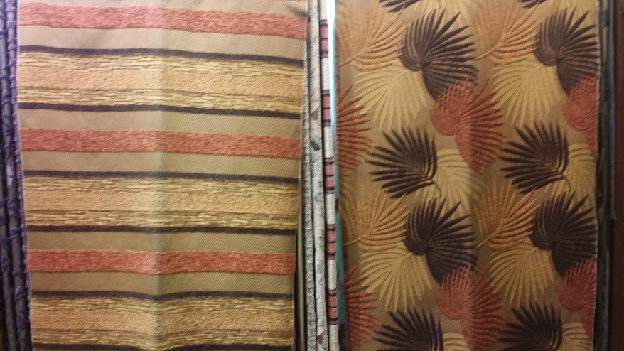
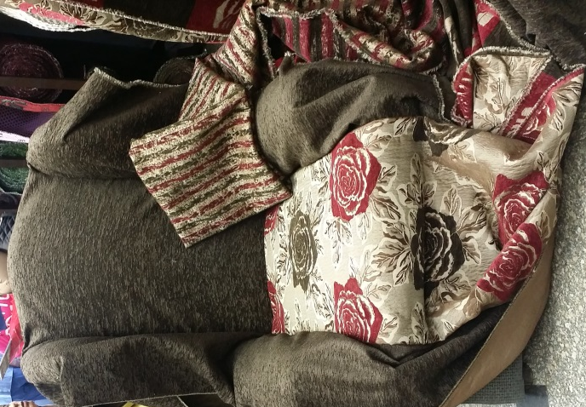
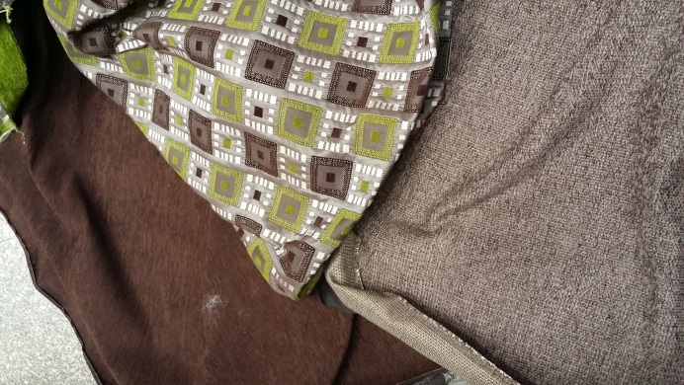
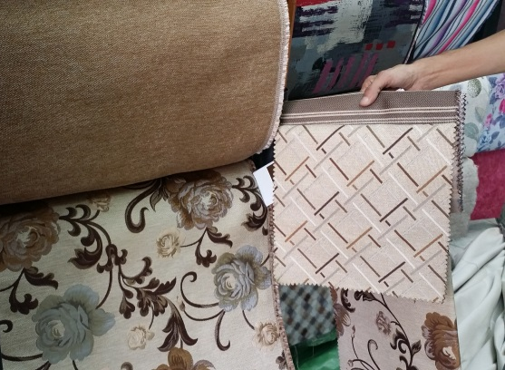

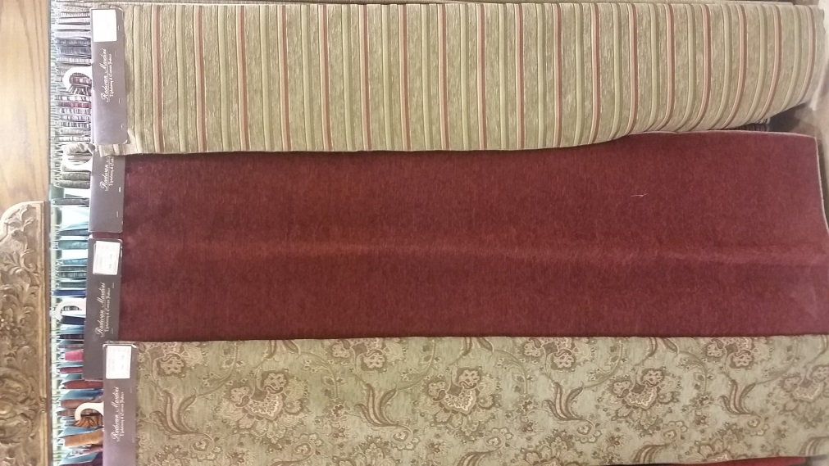
Student Name: | Salma Mohamed Safaa
Student Number: | 1170
Course: | Interior Designing
Assignment NO: | 8
Page NO: | 10
Activity 2:
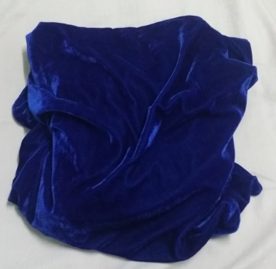
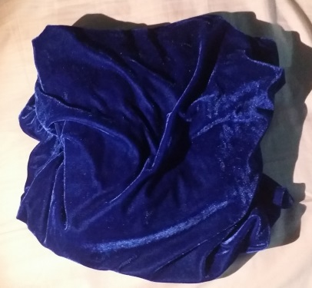
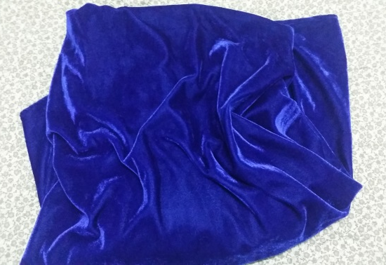
Velvet fabric

Artificial florescent lighting Artificial Yellow lighting Natural Daylight
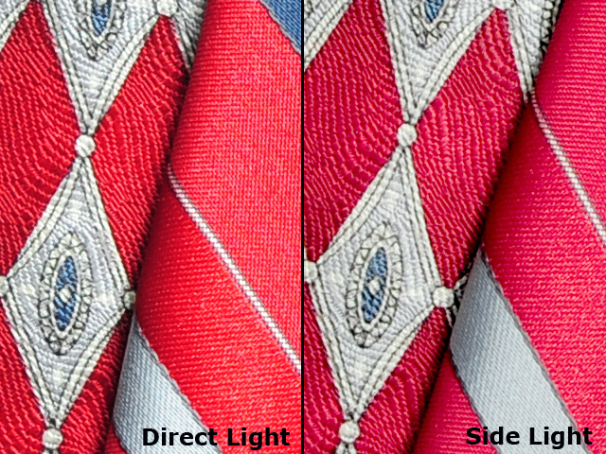
Chenille weaved fabric

Natural Daylight Artificial Lighting
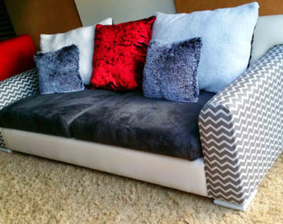
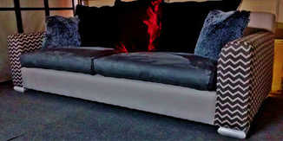
Sofa upsholtered by different fabrics ; Velvet, Chevron &Linen:

Artificial Yellow lighting Natural Daylight

