
Assignment Cover Sheet

Student Name: | Omnia Rafiq
Student Number: | 1343
Course: | Diploma in interior Design
Assignment NO: | 12

Student Statement:

By submitting this assignment, I confirm that this is my own work.

Student Signature | Omnia Rafiq | Date | 19-4-2015

For Tutor / Assessor Use Only
Total Marks
Marks Obtained
Percentage / Grade

Q.1.i. How does an Austrian blind works? What is the main difference between Austrian and Festoon blinds?
Austrian Blinds are in reality a curtain, and are made up as such with a fullness of twice the track or batten width. The only differences being that the blind is pulled up from the bottom to the top by means of cords attached at the back, and is made longer than the required finished drop. The extra fabric in the length forms scallops, even when the blind is in the lowered position.
Austrian Blinds are generally made up in lightweight curtain fabrics, they will hang better and exclude more light if they are lined. They can be hung inside or outside the window recess. If they are hung outside the recess they can be frilled at the side and bottom edges. However, if they are hung inside the recess, they look better if a frill is added to the bottom edge only.
Press & drape heading tape is attached to the top edge so that the blind can be hung from a blind track or a wooden batten. Grip tape will be needed if a wooden batten is used.
An Austrian blind has a series of rings, usually as part of Austrian blind tape, attached to the back of the blind in vertical lines. Each line of the rings is threaded with a code and is attached to the lower ring. The top is attached to the Austrian blind track or a wooden batten. Austrian blinds
Are usually made with light, airy fabrics.
While Festoon Blinds are the ultimate in fancy window dressing, and if they are made properly using the right sort of fabric, they can simply transform a plain and boring room into a luxurious feeling home. Of the three cousins, Romans, Austrians and Festoons, the Festoon Blind is by far the most fussy of the three. Made the same way as an Austrian Blind, the difference being that Festoons are gathered over the drop as well as over the width, making the blind look as full as possible.They are often confused with Austrian blinds, however, an Austrian blind falls flat like a curtain, while a festoon blind needs twice the length of fabric for the finished drop.
Austrian Blinds Festoon Blinds
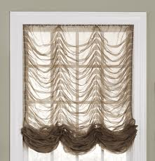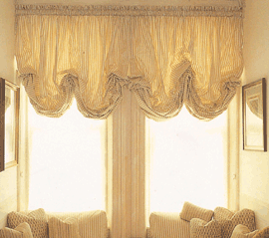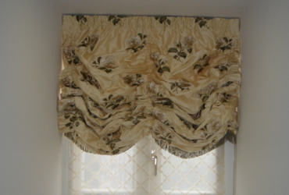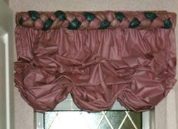

Q.1.ii. How can a window seat be created? And what effect it creates in a room?
Building a window seat is another way of creating a long graceful window. This can be done by fixing a wood frame around the top and sides of the window and down to the floor. Creating a cosy and colourful window seat can be done by putting scattered foam cushions and pillows on the seat, to hide the wall between the window sill and seat. Select cushions and pillows in colours that complement the walls, floors and decor already present in your room to create visual interest and harmony. Cushions in patterns and prints bring colour and interest to window seats. To create contrast or to add small bursts of colour to your scheme, add bright or bold solid accent pillows that enhance window seat cushions. You can add as many pillows as preferred, depending on how comfy you want to make the environment. For a clean and simple look, opt for two or three smaller pillows on each window seat, or just use cushions for the seat instead.If there are two or three such windows in the room, you can make this arrangement look an integral part of the room.
Also by using Scone lights, Since they not only add ambiance to your space, but also help to transform your window seat into a quaint reading nook at the same time. You can either install a sconce light to both walls surrounding the window seats, or just to one of the walls, but remain consistent if you have more than one window seat. For example, if you add two sconce lights to one window seat, add two to the other window seat for balance. Sconce lights come in all sizes and colours, from fixtures with mini lampshades, to one with an adjustable swing arm. Coordinate sconce lights to mesh with your home’s current design style and theme.

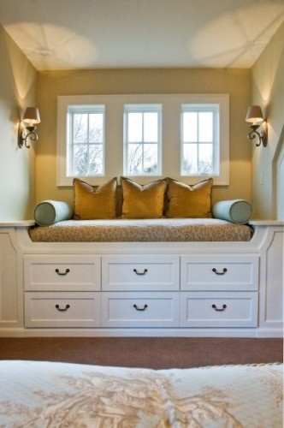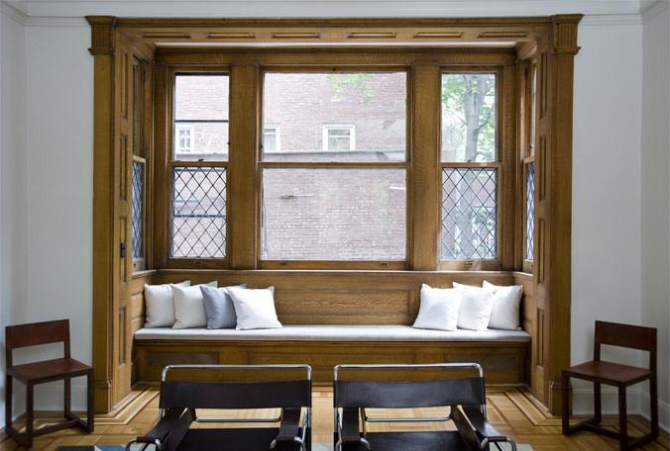
Another way of creating a more practical window seat can be done by using home storage cabinets. First, you need a niche that features a window. Then, the seat has to be custom-built by a cabinetmaker or trim carpenter to fit the exact width and sill height of the window. Not surprisingly, this approach is expensive and time-consuming.
Here's how to build a beautiful, custom window seat in just a couple of days using ready-made kitchen cabinets. This simple, You can do-it-yourself. This seat was built under a 6-foot-wide kitchen window, but its design can easily be adapted for any size window in almost any room. The seat is made up of six kitchen wall cabinets and two 48-inch-tall bookcase units, which are trimmed with decorative crown melding. The window seat itself is composed of two 15-inch-tall, over-the-refrigerator cabinets set side-by-side.
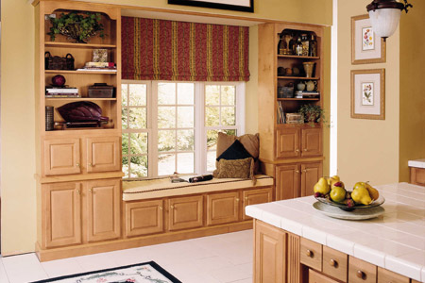

Q.1.iii. Discuss different options for upholstering the dining chairs?
A set of matching chairs always looks smart but in order to give more vitality to the dining room contrasting colors or patterns can be used.
There are two simple options: either the same fabric can be used in to different colors or same color in two different patterns can be used. You can choose a blue stripe or check for the back or you can alternate the chairs around the table from stripes to checks. Matching buttons or ribbon- ties down the back of each chair add a further decorative detail remember that dining chair is one item of furniture that is often viewed from the back. Drop in seats provide an easy mean for introducing seasonal changes. Rich velvets are ideal for winter, while simple ginghams are perfect for summer.
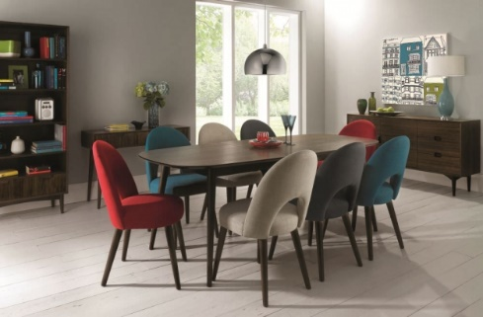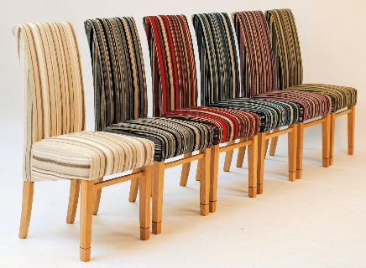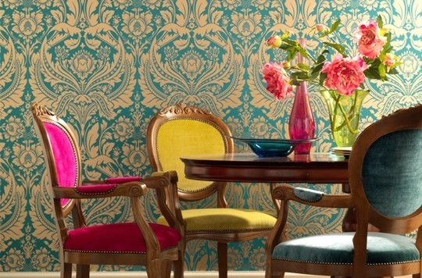

Q.1.iv. Which type of cushions should be used for children’s rooms?
Diced floor cushions are usually used for children’s rooms, Since children mostly love to sit on the floor. Bright colours are recommended for these cushions.
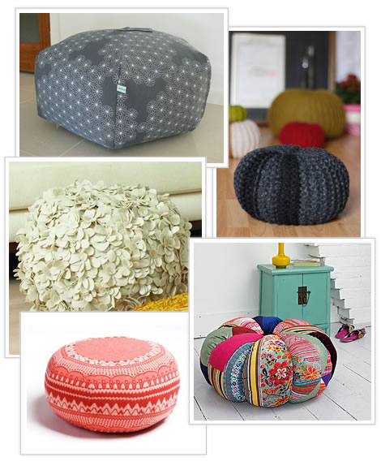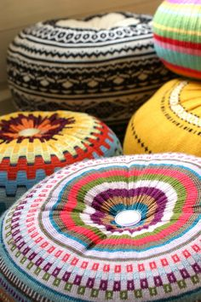

Q.1.v. Describe different ways for decorating the cushions.
1- Paint :
One of the easiest ways to personalize cushions is to use fabric paints to create your own designs. The sky is the limit when using this method. Purchase stencils and use pre-designed shapes or simply freehand a scene or object onto the outer shell of any cushion or pillow. Try abstract ideas for a contemporary look. For any type of decoration, it is usually best to remove the inner stuffing of a cushion before you begin, making it easier to work with on a flat surface. Always use paints rated for fabrics, as these can withstand handling and are typically waterproof.
2- Embroidery and Yarn:
The art of embroidery is an ancient one, passed down through generations. In recent years, it has experienced a comeback in trendy home decor, making it ideal for decorating cushions. Another old-fashioned technique is to sew pieces of yarn onto the cover of cushions, using bright colours that complement one another.Cushions can also be customized by adding, trimmings, piping, buttons or beads to complement the furniture or the room’s decorative style. Pillows can also be made to suit the bedroom’s style. Piped or pleated edged cushions are the popular choice for a classic room: made from patterned Or plain fabric to match or accent the curtains or slip covers, they complete the scheme, giving it a seamless continuity. A sophisticated country house look can be achieved by making cushions from scraps of antique textiles, damask, brocade and tapestry, edged and trimmed with cord, braid, fringing and tassels. If a more relaxed rustic look is required, use printed, striped or checked cotton, linen or even wool weaves for a country air. Choose a style and trimming to complement other furnishings in the room: floral print cushions look appropriate in a pretty country style rooms, decorated with dry flowers. Cushions can also be a valuable accessory in contemporary rooms too. Plain colored glazed chintz or robust weave edged contrasting piping looks stylish on modern Upholstered furniture. In quieter surroundings, large, flat bordered cushions made from textured natural fabrics in neutral shades, or uncomplicated colors like sage green, terracotta and navy, all look wonderful against uncluttered lines of American country furniture. In a bedroom where chintz is used for curtains and bed cover, make matching cushions from the same fabric but give them a softer look by out-line quilting the design.
3- Accessories:
Be experimental and use ordinary household items to create unique designs on your cushions. You typically want to use this technique on cushions that you lean against rather than sit on. Buttons, sequins, antique jewellery or even old handkerchiefs and neckties are options. Anything that catches your eye and brings a smile to your face can be re-purposed as a design element on cushions.
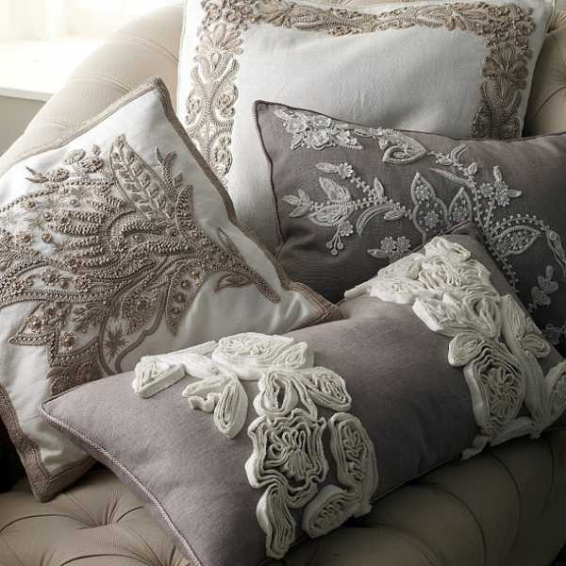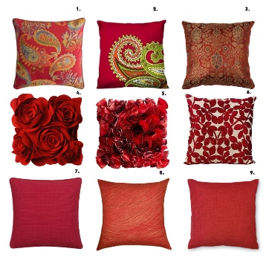

Q.1.vi.When choosing bedding for a bed what are the most important factors to consider?
As bed is the most dominant part of a bedroom scheme it can be the perfect way to make sure that you get exactly the colors and fabrics you want. Bedding should be chosen to suit the look of the bedroom, you like it romantic or smart, country or simple. Pattern, scale and color are
Important here, so choose bedding with care. Colors can either harmonize or contrast with the scheme and patterns can be mixed, for example by using checked pillowcases with plain ones or florals with stripes. The tactile qualities of bedding are all important. Whether you opt for linen or cotton sheets, blankets or duvets, eiderdowns or throws, rectangular pillows or square ones, what matter is, you have to make the bedroom as comfortable as possible.
Pure linen is the most luxurious choice – it feels lovely and cool in summer as well as being strong and durable, but it is expensive, it is time consuming to iron and not widely available.
Pure cotton is the next choice for luxury and comfort, although unless it is easy care, it too needs pressing. Egyptian cotton is superior to ordinary cotton, having longer and finer fibers than average. Cotton flannelette has a warm, fluffy surface which makes it suitable for winter sheets.
Cotton polyester is non- shrink, hard wearing and takes less looking after than natural fibres. It is also less expensive. For the dressing of the bed, The look of the bed can be changed with seasons, by having the loose covers for headboard. In winter you might use cozy wool or felt, then in summer switch to a pretty voile or stripped cotton. Loose covers are also easier to keep clean than tight upholstery. Use different colored ribbon ties to complement other colors in the room. A valance around a bed looks smart if it is coordinated with the headboard. If the headboard and
Valance are permanent features- rather than being changed seasonally, keep them plain. Ticking stripes and checks are good choice if you want to use a pattern. Decorative cushions, such as patch work or appliqué, can give a bed a finished look. These too can be used to complement the
Colors and patterns found elsewhere in the room. Fringing, piping or braiding could be used to enhance the look further.
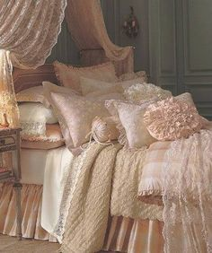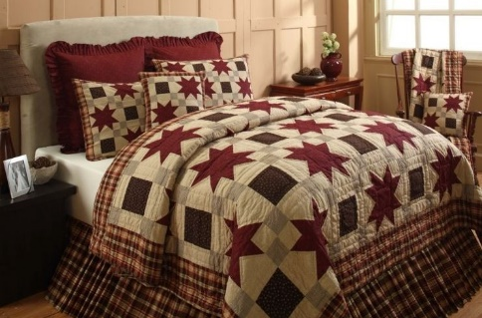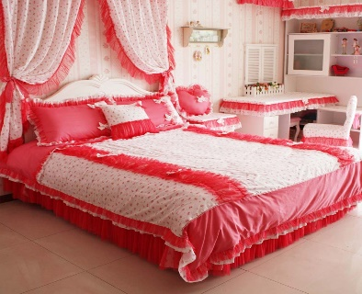
Q.1.vii. What is a half tester?
In ancient times bed curtains were used for privacy. The Victorians briefly reintroduced four poster but decided that it was not healthy choice to enclose the bed with curtains, so they chose the half tester instead. This was a canopy over the head end of the bed only.
The easiest way to add style and interest to a bed is to display a rug, patchwork quilt or fabric hanging behind the bed.Bed head can be decorated with many devices from simple wall hanging to elaborate coronets ad half testers.
Alternatively, you can fit a coronet on the wall above the bed head.

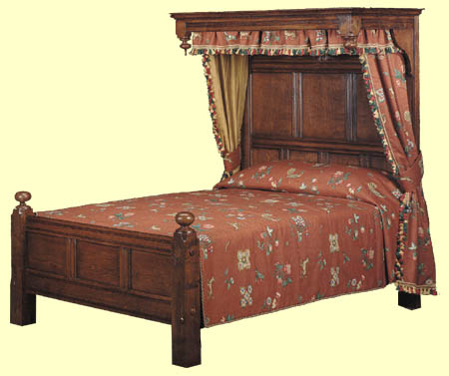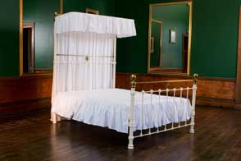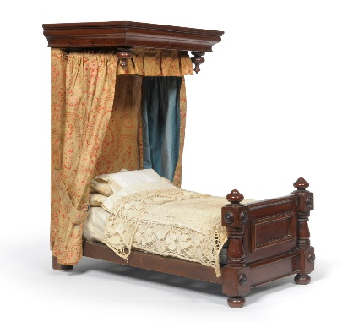

Q.1.viii.What is the main difference between a half tester and a coronet?
This is a small semi- circular pelmet from which you hang drapes. A coronet can be fitted on the wall above the bed head. These need to be lined preferably With contrasting fabric, and are supported on either side of the bed head with hold backs. Half testers are similar to coronet but pelmet is often in rectangular shape and is decorated.
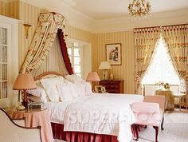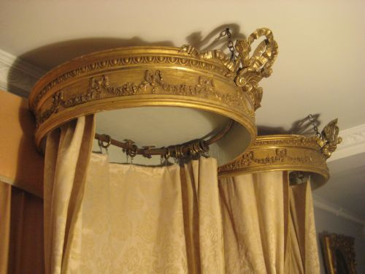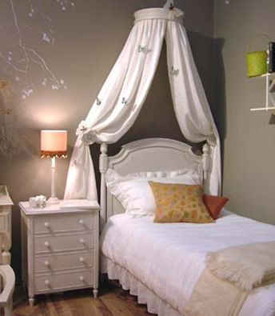

a. Design fabric for your room. (Work folder)
Fabrics play an important role in defining the style and mood of a room. Every fabric has four main elements - color, texture, scale and pattern. Each of these contributes to a room’s character. Color is the most powerful element; texture has an enormous influence on atmosphere: rich velvets and silks bring a feeling of opulence and grandeur to a room.
- For Curtains and blinds :
Since the window of my room looks out onto a busy street, I can make it look attractive from outside by using colored or patterned lining for the curtains. Choose a linking fabric that unifies all the rooms
Facing the street. Light weight curtains should be three times the width of the window, with deep hems,
To help the fabric hang better. Stretching colored or patterned voile between two poles to form a panel is a lovely way of allowing light to filter in. and is considered to be a light, transparent solution in summer.
Also adding a patterned trim to a simple pair of curtains gives them a more stylish look.
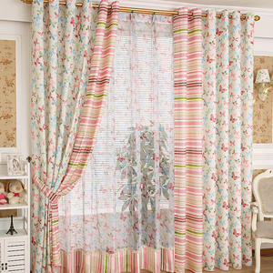

- For upholstery style :
I would like to choose durable fabric which can be cleaned easily. Loose covers and
Seat cushions should be machine washable. Use neutral colours like “white” for the small sofa to give a contemporary style to the room. Make matching cushions from the same fabric of the curtains but give them a softer look by out-line quilting the design, Small square cushions with lace covers will make the white sofa look prettier!

Small chairs, such as bed side chairs offer lots of scope for experimenting with fabrics because they do not dominate a scheme. I would choose a pale pink coloured check in two scales, and use one for the seat and one for the back.

I would Choose upholstery trim to suit the style of the room and the furniture. The easiest way to feature of a sofa or a chair is to use a contrasting color or pattern for the edging rather than a matching one. Using the same trim as that one used at the curtain edge would be my best solution! This gives a same level of finish as binding a curtain edge.

- For the Bed Linen :
Although polyester is a highly durable fabric and usually can survive years of washing and wear, Pure cotton will be my 1st choice.Cotton is more delicate and it is more susceptible to general wear and tear from daily use and tends to shrink slightly when it is washed. Although polyester generally retains its shape and look over the years, polyester fabric tends to pill, and it doesn't get much softer with use. Most cottons, particularly long-fibre cotton sheets, stay soft and free of pills. Cotton is considered to be the 2nd top choice for luxury and comfort after the linen. Egyptian cotton is superior to ordinary cotton, having longer and finer fibers than average. But, polyester Cotton is non- shrink, hard wearing and takes less looking after than natural fibres. It is also less expensive.

- Dressing the Bed :
The look of the bed can be changed with seasons, by having the loose
Covers for headboard. In winter you might use cozy wool or felt, then in
Summer switch to a pretty voile or stripped cotton. Also loose covers with Ticking stripes and checks will be my choice since I would like to use a pattern. Decorative cushions, such as patch work or appliqué, can give a bed a finished look. These too can be used to complement the colors and patterns found elsewhere in the room. Fringing, piping or
Braiding could be used to enhance the look further.
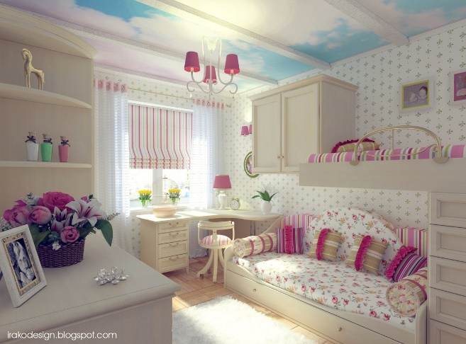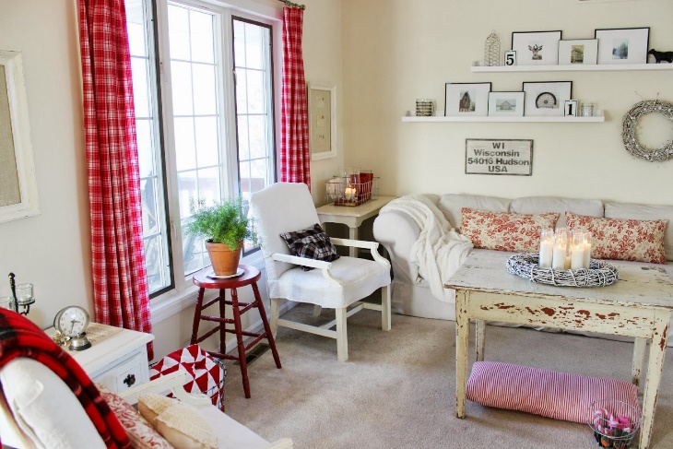

b. Design a cushion show in miniature and write down how it will coordinate with the room scheme. Based on this design plan a room scheme and write down the details of your scheme in your work folder along with the sample of your designed cushion.

Steps to plan a Living-room scheme for example :

Base the design scheme on a neutral colour and give it a little bit of lift is to put in an accent colour. Generally, start with a floor. For this particular scheme, choose a lovely white-washed white-oiled oak floor, an engineered floor so you could put in underfloor heating.
An engineered floor has a solid piece of wood on the top and several layers of thinner pieces underneath and it's all held together with another piece of wood at the bottom so it will not move with any kind of heat underneath it. If you use a solid wood floor and put underfloor heating underneath it, because the grain goes right through the wood, the wood would start to fold up when the heat is under the floor. The curtain fabric here is made of warm gravy tones and this is very easy to work with in an interior.
Gary won't make the interior look drab or anything, it's a very easy colour to live with. Nice warm reds and a little bit of sandy gold colour go in there which give us some colours to work with for accents. Have that underneath the curtain for elegance.
An off-white colour sheer could go with this line and the fabric and it just lightens up the curtain colour and filters the light nicely through the window. Pick a solid colour on the sofa quite often. A chenille fabric would be very tough and it's comfortable as well, so that would be your sofa.
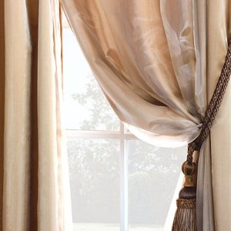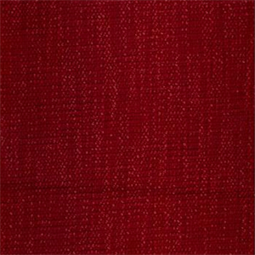
- For the design of cushions:
To lighten up the sofa, put some lovely cushions on it, bringing out the tones that are in the curtain. We've got the sandy gold, the grays, a bit of warm red, a bit of silvery white, and that's a different pattern from the stripe which adds interest into the room on an unexpected quality and just gives it a bit more of a contemporary look. Have some nice cushions in lovely satin or silk with trimmings, which would sit very nicely.
- I prefer using Cushions with additional borders or embellishments, since they fit easily together and blend well on a garden bench, piled into a squashy sofa, or displayed on a bed. Frilled edges, cords and piping, fringes and tassels are pretty decoration and encourage a romantic and period atmosphere. The contemporary style is padded and double borders.
- Cushions placed on chairs and window seats should be deep and wide enough to provide comfort.
- We can use different sizes of cushions to add more interest to the design scheme.
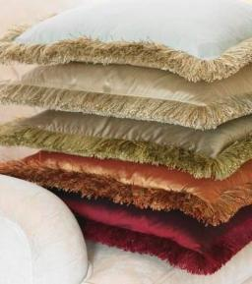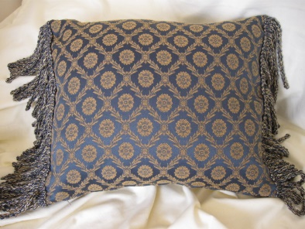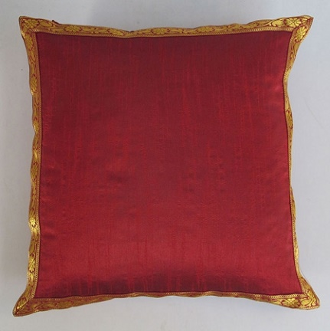

To add another bit of liveliness, have a floral motif. But again, bring out the colour tones we're working with. For some chairs, have an accent chair that then brings the pattern design into it so that provides a link in the room and that livens up again your neutral sofa.
What your eye needs to do in a room, what it wants to do is to find links. If you've got this red as your accent, the eye will go around the room looking for links to that red colour and that helps pull the room together. Find a beautiful tieback that has all the lovely colours.
And finally, if you've got your wood floor, why not put a really plush rug on it that warms everything up. A lovely silk tufted rug and this would be your accent on top of your wooden floor to make this really luxurious living room scheme. So, that's how you could approach working on a living room scheme. .
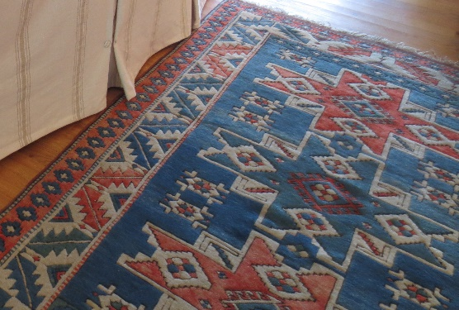

The planned scheme!