
Assignment Cover Sheet

Student Name: | Omnia Rafiq
Student Number: | 1343
Course: | Diploma in interior Design
Assignment NO: | 18

Student Statement:

By submitting this assignment, I confirm that this is my own work.

Student Signature | Omnia Rafiq | Date | 6-6-2015

For Tutor / Assessor Use Only
Total Marks
Marks Obtained
Percentage / Grade

Q.1 Short Questions:

I. “Being the boss is fun. It is also risky and a lot of hard work”. Explain.
Owning a business is actually taking
On a lot of responsibility. It has its advantages and disadvantages which must be considered
Before stepping into it.

Advantages of Owning a Design Business
- Do not have to report to a boss.
- Making a potentially higher income.
- Potential long term job security.
- The chance to develop a creative style, which is not possible when working for
- Others.
- Potential satisfaction in achieving success.
- Increased contacts with clients, suppliers, and other industry members, by dealing
Directly with clients and suppliers.
- Making your own decisions.

Disadvantages of Owning a Design Business
- Greater legal responsibility. Owners are not only responsible for their own acts but
Also for their employees.
- Great financial risk. It involves the risk of losing personal assets, also.
- Long hours. Owners have to give more time to their business than anyone else in the
- Business setting.
- Greater stress. The owner is responsible for paying all the bills, salaries, preventing
- Any kind of bad publicity or poor customer service. He or she has to see that all the
- Employees are doing their jobs properly and legally.
- Minimum income in the starting years.
- Though the business owner is the boss, he is controlled by the wishes of the clients. He has to satisfy his clients.
- A great deal of management responsibility.
- Once a business has been started it is difficult to quit it. A financial loss can result from closing down.

ii. Briefly describe three main advantages of owning a design business.

- You could make much more money that working for someone else.
- Be your own boss, and make all the decisions crucial to your own success.
- Influence: Hire other people to help – chip in to the local economy.
- Security: No one can fire you.
- Discovery: Put your own ideas into practice, and see what works and what doesn’t.
- Oversight: Control every aspect of the business.
- Experience: Learn about every aspect of a business and gain knowledge in a variety of disciplines.
- Contact: Work directly with your customers, and see what they need first-hand.
- Self-Belief: Take personal satisfaction of creating and running a successful business on your own.
- Interest: Work in a field or area that you really enjoy, or that compels you to continue working.
- Long-term: Build real retirement value – for example, by selling the business when you retire.
- Establishment: Put down roots in a community; provide a sense of belonging and stability.

iii. What is the first thing you should look at in yourself before starting your own
Design practice?
But first thing before starting a design practice is, as a designer and a business owner, One should look at his motivation. Maybe his motivation comes from a desire to work only with clients who really want to buy the designer’s creative ideas, rather than the need to meet the demands of an employer. The Designer may be motivated by the idea of making more money or working for yourself rather than for others. Whatever his motivations are, at the back of a designer’s decision for starting up his own practice, the important point is to know and consider what they are. Although the motivations mentioned above seem positive they may turn up in negative issues. For example, working from home does save commuting time but it also requires a good deal of discipline.

iv. “An interior designer has to be versatile and should be able to change with time.”
Why?
An interior designer has to be versatile and be able to change with the times. With new
Trends me as a designer will have to change my current way of thinking. This is crucial for a success in this field because most people hire interior designers so that they can keep up with current trends and stay abreast of fashion. If the designer keeps sticking to the basics and originals, he cannot be a success in this business.

v. Why is it essential for a designer to possess skills for negotiation?
Negotiation is the basic skill that an interior designer must be good at. As an interior designer I will be negotiating with clients, either to acquire them, or on budget requirements. I will be negotiating with the contractors, furniture dealers, plumbers, electricians and everyone else who is involved in the project undertaken. Of course, my main concern is to complete my project to the client’s satisfaction.

Q.2. What is a portfolio? How important it is for an interior designer?
A portfolio is just like a scrapbook. It has all the listings and photographs of a designer’s work to
Date. My portfolio will help my future clients see what work I have done and what I
Am capable of doing for them. A portfolio is the best marketing tool for any designer. It
Should look as professional as possible. A designer can also request letters of recommendations
From the clients and list those on his portfolio as satisfied customers.
The importance of an interior design portfolio should not be underestimated. Making a portfolio for interior design involves selecting a variety of different projects that I’m most proud of and that demonstrate a range of different projects I have worked on; including visual and graphic documentation in the form of photos, CAD designs, and plans; and providing a brief biography and resume that tells the client, school, or employer something about myself and my work.

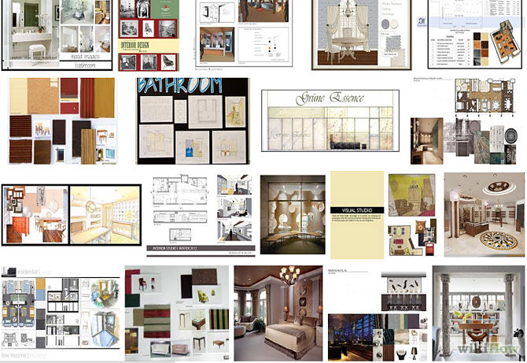

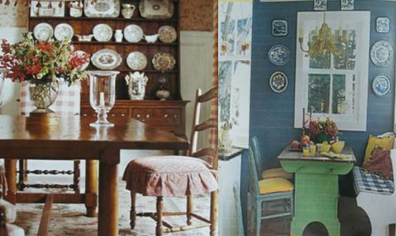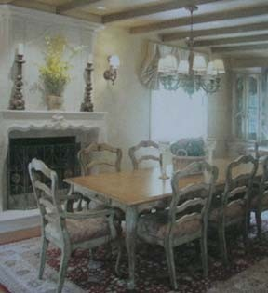FRENCH COUNTRY:

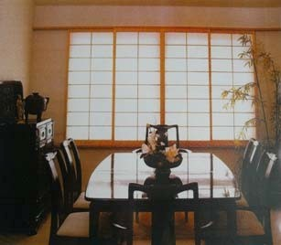ASIAN:

EARLY AMERICAN:

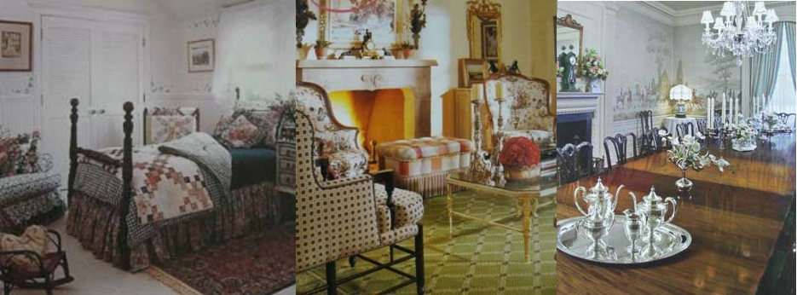
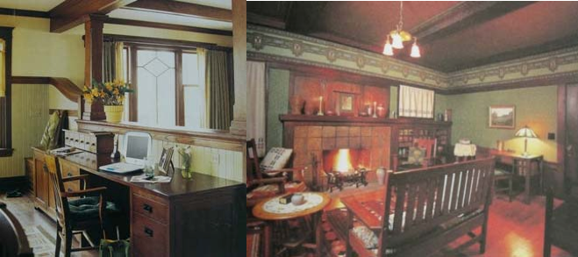MISSION:

SOUTHWESTERN:

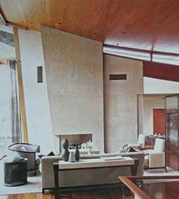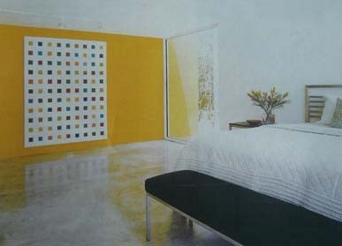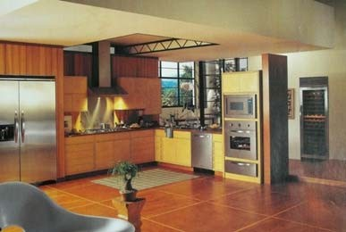INDUSTRIAL:

