ELIZABETH ABIDEMI AKINLABI

1380

ASSIGNMENT 4

DIPLOMA IN FASHION DESIGN

ELIZABETH ABIDEMI AKINLABI
1380
ASSESSMENT 4
PAGE 1

Q1. Give short answers for the following questions?

- What is meant by market segmentation? Market segmentation is the division of the market by the categorization of people, into income groups, social class, their professions, where they place in the cycle of the family, and what prompts them to purchase apparel.

- “ Design is a visual thinking, perhaps of a higher order than verbal thinking”. Explain? The designer is stimulated by what he can feel, see and touch, he or she is constantly learning to take these ideas that he/she sees in their minds eye and translate the idea to clothing. Fashion is visual communication and I believe it is of a higher order than verbal thinking as the process of creating is brought together by an awareness, and this awareness allows the designer over time to create pieces that bear their signature style.

- Explain briefly the developing of a sample garment? The development of a sample garment begins with a sketch, this sketch is experimented on, until the designer can come up with a working sketch, this sketch includes exact details so the designer can communicate easily to the pattern maker, this working sketch also includes measurements and construction details.
The pattern maker then creates the first pattern; this pattern is used to create the first

ELIZABETH ABIDEMI AKINLABI
1380
ASSESSMENT 4
PAGE 2

sample garment, which is made in a sample size, these sample sizes may differ according to the product being produced. During this time the designer and the pattern maker work closely, the design is then altered on a dress form, this aids the designer in achieving his/her designs in a working 3D form, every detail is properly marked during this process, seams, button holes etc.
The 3D design is removed from the dress form and trued up, all corrections are made with pattern drafting tools, and then transferred to a more permanent flat form of heavy paper, and this becomes the sloper.
The assistant designer or sample cutter then uses the sloper to trace and cut out the fabric to create the first sample also known as a prototype.
The sample maker who is adept in the factory sewing methods, and who has the ability singlehandedly put a garment together on their own, makes the prototype, during this stage the design staff supports the sample maker in solving construction problems and ensuring the garment meets all factory standards, which includes testing for fit and all round effect.
To get proper feedback on the garment, a model wears the garment and he/she moves around in it, to determine how comfortable it is. At this stage whatever minor changes need to be made by the

ELIZABETH ABIDEMI AKINLABI
1380
ASSESSMENT 4
PAGE 3

designer will be made, after which a comfortable, fashionable, proper fitting sample garment is made.

PROJECT/ MARKET RESEARCH

- Compare two dresses of similar price by two different designers; try them on. Which one has the best fit? Compare fabric choices in terms of quality and suitability to the design. Compare styling, which is more innovative? Which dress is the best buy? Sketch both garments.

ELIZABETH ABIDEMI AKINLABI
1380
ASSESSMENT 4
PAGE 4

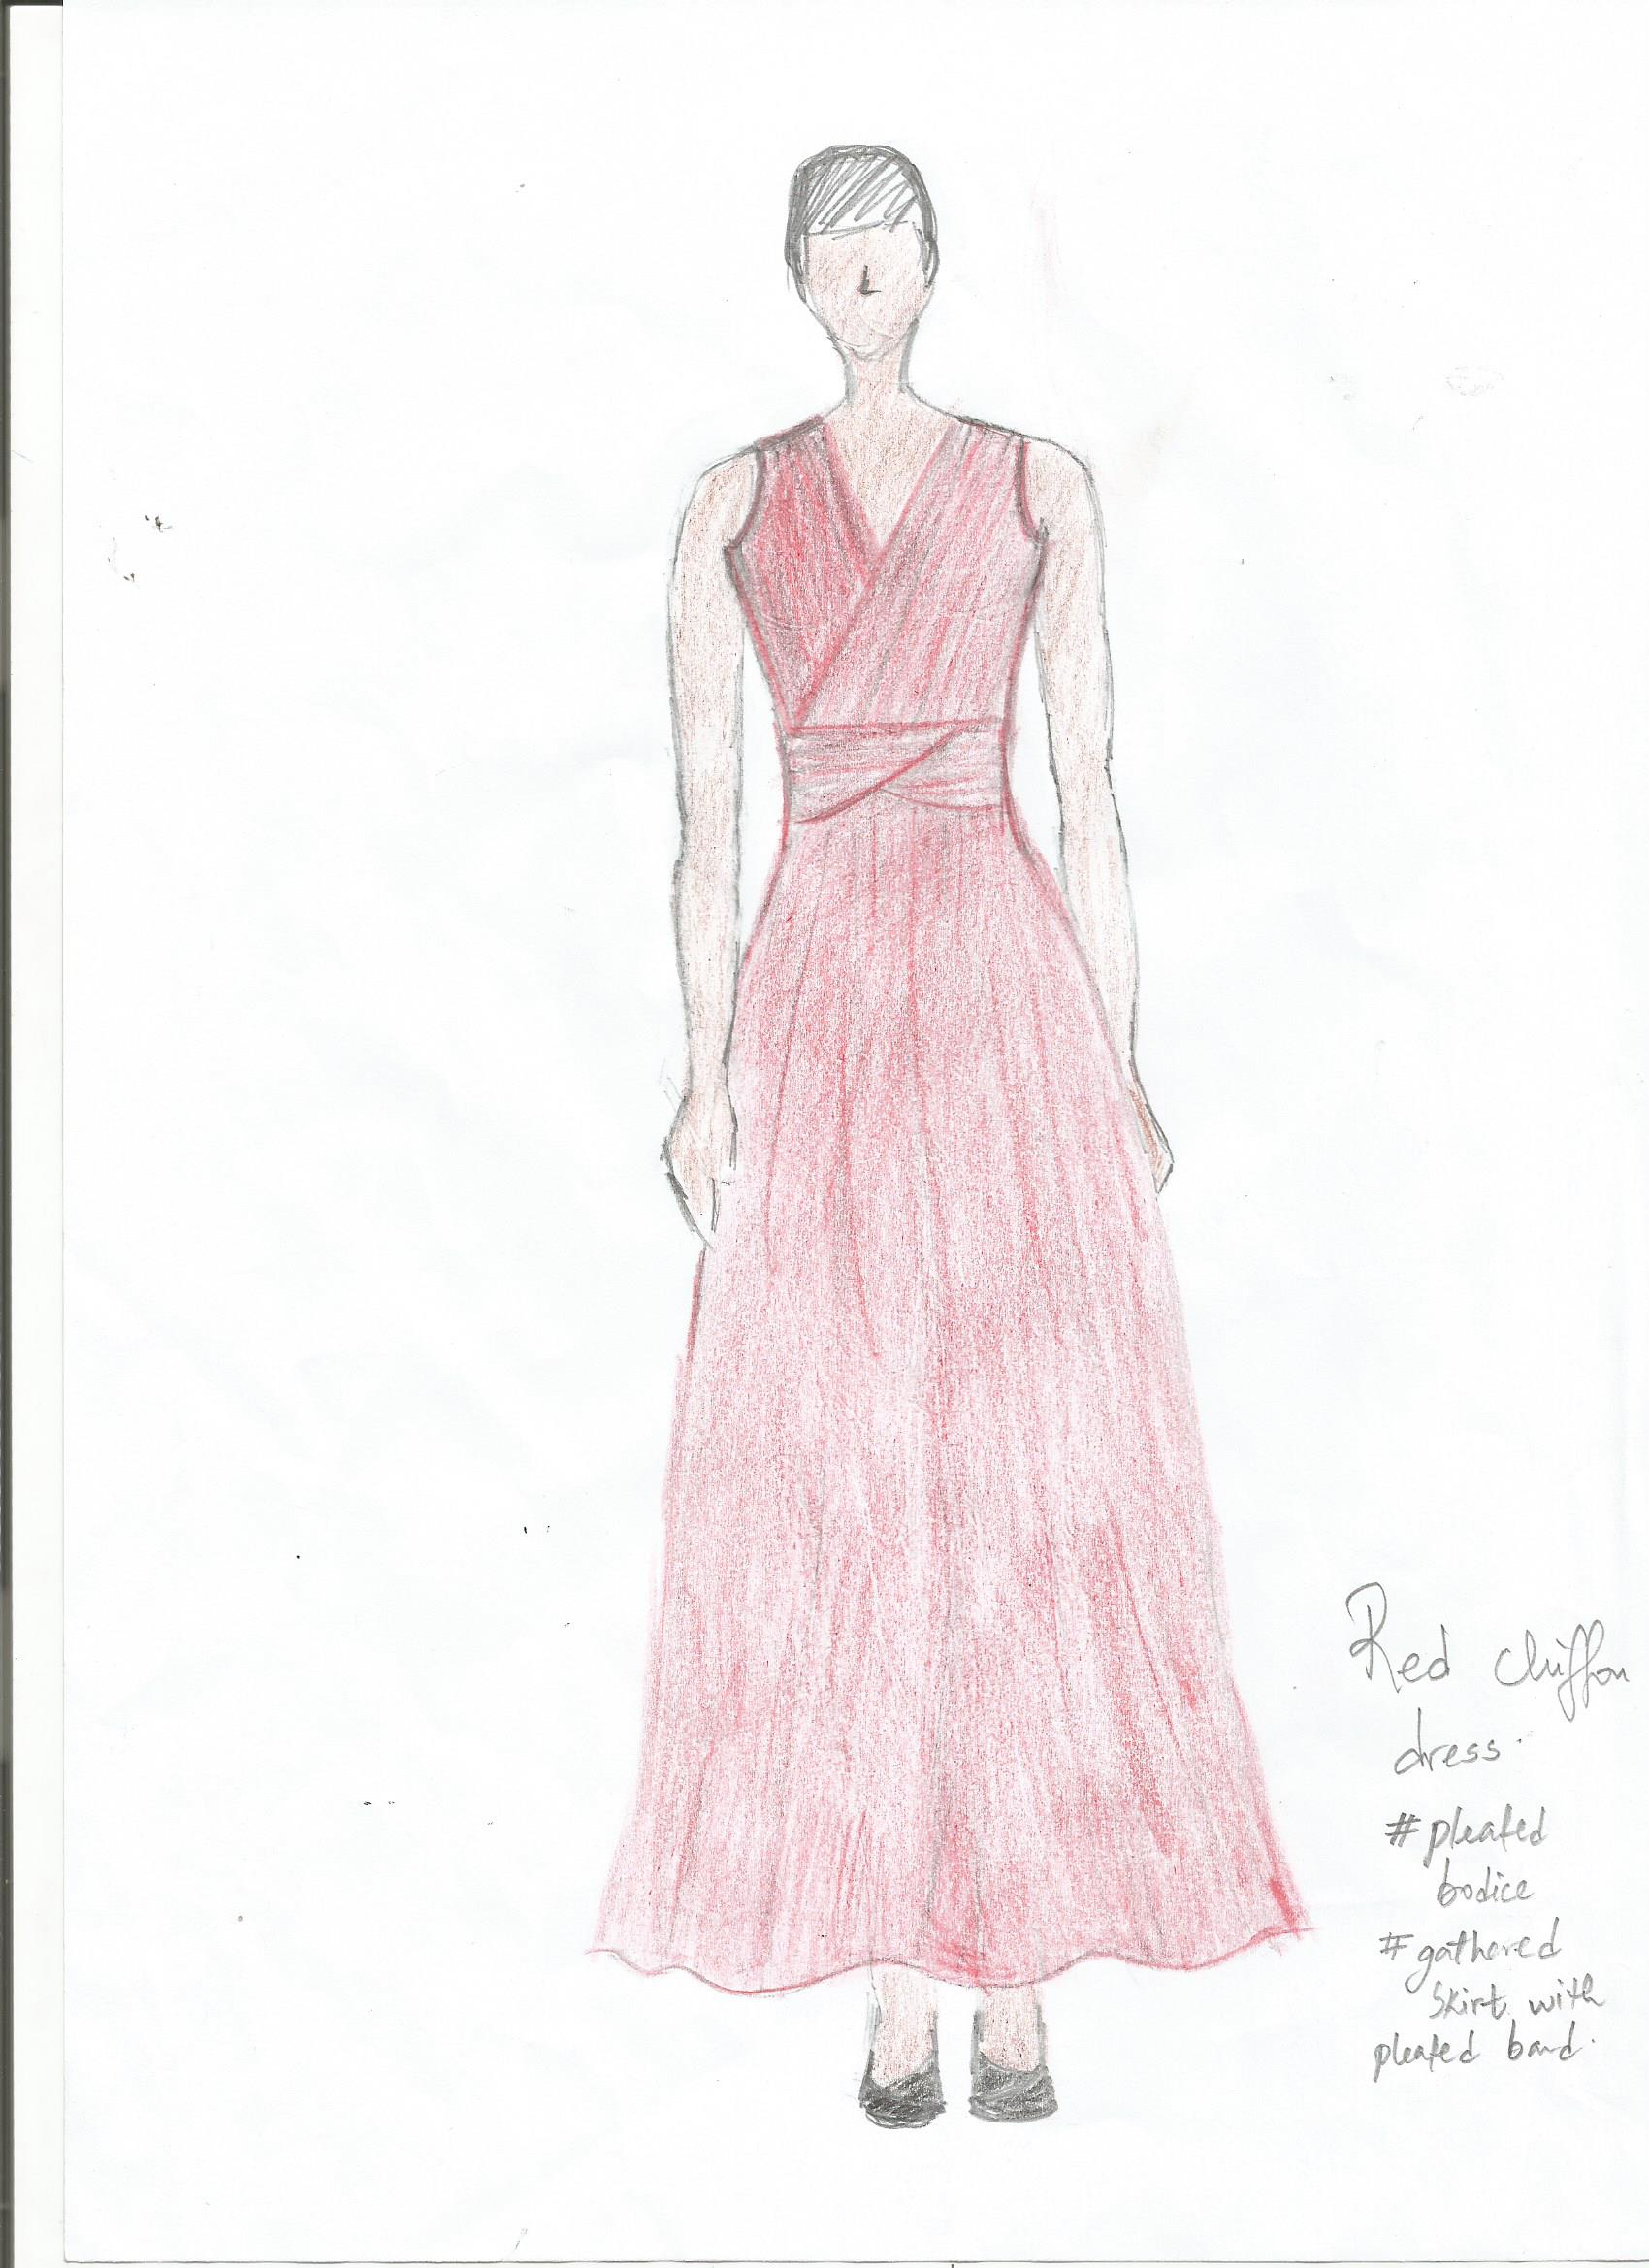

ELIZABETH ABIDEMI AKINLABI
1380
ASSESSMENT 4
PAGE 5

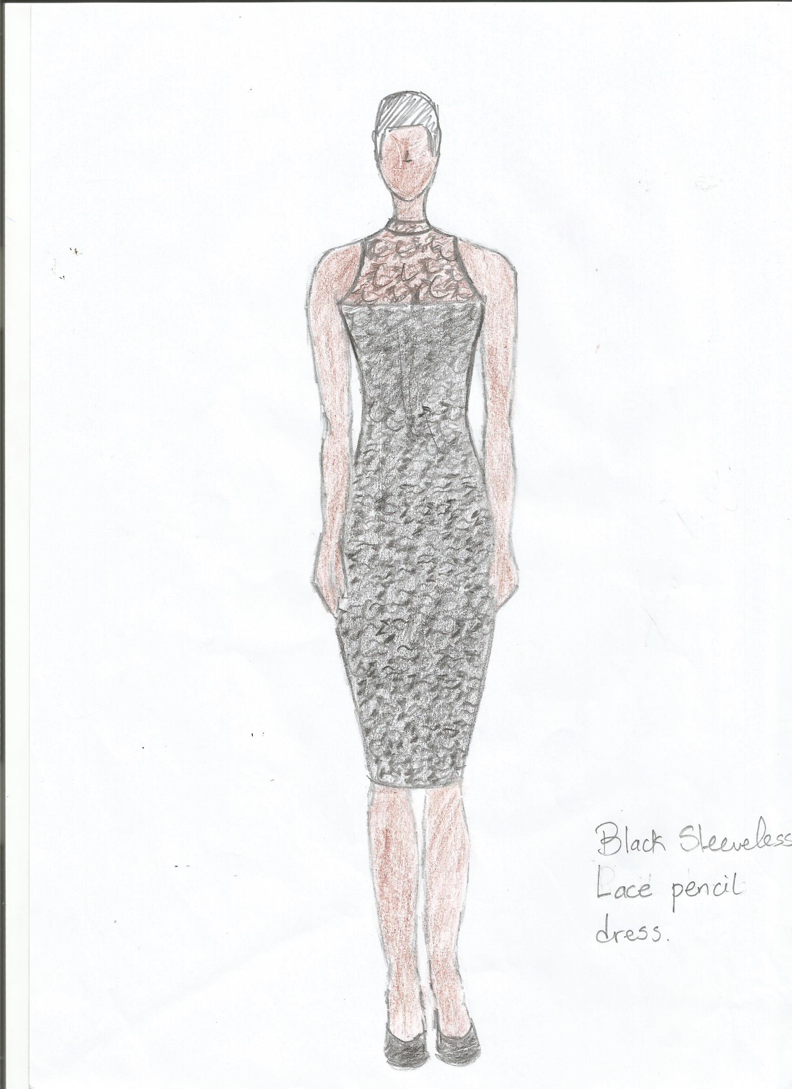

ELIZABETH ABIDEMI AKINLABI
1380
ASSESSMENT 4
PAGE 6

Black sleeveless lace pencil dress  *  * The black lace had a bit of elasticity, which worked well with this dress, especially with the peekaboo design around the décolleté, the dress was a bit tight around the thigh area, I wish the lining had a bit more elasticity, it was too snug.  * I liked the pencil cut of the dress and the high neckline, the way the sleeves were cut out showed of my shoulders nicely. It was not the best buy for me. | Red chiffon dress  This dress had a better fit.  I really liked the chiffon, it felt soft and flowed quite well, the bodice was pleated and the back as well, the only problem was the zip kept snagging on the pleats.  I loved the fact that the delicate chiffon was pleated, I thought it was quite innovative the way it was tacked to shape the bodice, I especially like the way it flowed as I walked around, and the length was perfect! I knew I wouldn’t have problems getting stuck in the hemline. This was definitely the best buy for me.

ELIZABETH ABIDEMI AKINLABI
1380
ASSESSMENT 4
PAGE 7

- In a local department store, compare contemporary and junior departments. List the major manufacturers in each department, and explain the styling differences.

I used Macy’s department store for this project:

Brand names in each department.  Brand names available in both departments.  Styling differences | Impulse contemporary clothing  7 for all mankind, citizens of humanity,  Denim and Supply,  Ralph Lauren,  French Connection,  Lucky brand jeans,  True religion,  Sanctuary.  Bar III, Guess?  Free people,  Jessica Simpson,  Levi’s.  * Clothes designed for fuller figured mature women.  * Clothes were not so revealing, a lot of the styles had sleeves.  * Clothes had looser fits.  * The crop tops were more conservative, didn’t reveal too much of the midriff.  *Prints were not so bold and adventurous; colors of the prints were safe.  *White denim was trending in this department.  * Detailed denim and high waist denim was also trending in this department. | Junior Department  American rag, BCX, Celebrity pink jeans,  Material girl,  Marilyn Monroe,  Roxy, XOXO.  Bar III, Guess?  Free people,  Jessica Simpson,  Levi’s.  * Clothes designed for ladies still developing, not full figured.  * The clothes were more revealing, a lot more sleeveless clothes.  * There were a lot more hoodies and tank tops in this department.  * A lot of the tee shirts had graffiti and pop culture quotes.  * The cropped tops showed more of the midriff.  * The prints in this department were more playful and the use of colors was uninhibited.  * The denim available in this department was of a wider, daring variety; it ranged from destroyed denim, distressed denim, and true blues to high waisted denim. White denim wasn’t too popular in this department.
Prices | Prices in this department was higher;  * The average top cost; $39,50  * The average dress cost; $79,50  * The average pair of jeans cost; $89,50. | Prices in this department was lower;  * The average top cost; $24,00  * The average dress cost; $39,00  * The average pair of jeans cost;  $59,00

Over all, the impulse contemporary department caters to a higher income group, this group of consumers are mature and more physically developed than the junior department, the consumers in this department are trend conscious but also conservative, they also appreciate quality, the clothes are fashionable but not juvenile.
The junior department caters to young females who are not girls but not yet women. The clothes are fresh, funky, colorful and uninhibited; they come from a lower income-earning group than impulse contemporary brand.

Reference; Macys.

