
Assignment Cover Sheet

Student Name: | Omnia Rafiq
Student Number: | 1343
Course: | Diploma in interior design
Assignment NO: | 2

Student Statement:

By submitting this assignment, I confirm that this is my own work.

Student Signature | Omnia Rafiq | Date | 22-11-2014

For Tutor / Assessor Use Only
Total Marks
Marks Obtained
Percentage / Grade

Q.1.i) What were the main elements of Tudor interiors?

The main elements of Tudor interior design were: wood panelling and plaster ceiling panels, The furniture was heavy very solid in construction and carved.

We can say that Tudor style appeared mainly in the following elements:
- Symmetrical architecture, around an ‘E’ or ‘H’ shaped plan
- Multi-paned, lattice work and casement windows
- Stained glass with heraldic and ecclesiastical motifs
- Rich oak panelling, plasterwork and stone hearth surrounds
- Walls adorned with tapestries and embroideries
- Colors of dark brown, gold, red and green
- Walls adorned with tapestries and embroideries
- Decorative symbols of Tudor rose, thistle and fleur de lees
- Trestle tables, benches, heavy chests and carved four-poster beds
- Wooden floors, encaustic tiles and plaited rush matting
- Fireplaces would have been the focal point for a Tudor room – with a constantly lit, genuine, open, log fire.

Plaster ceiling examples:

ceiling rose with a floral or leaf design
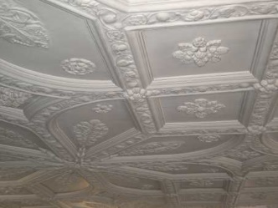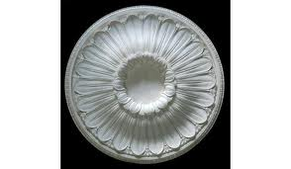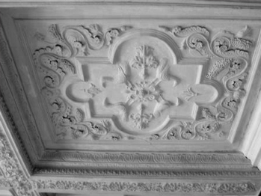

Wood Panelling Tudor styled room
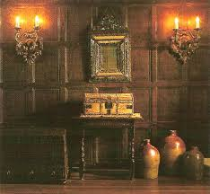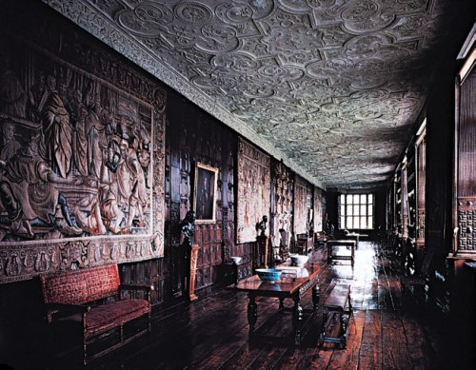

Stained glass with heraldic and ecclesiastical motifs Lattice work windows

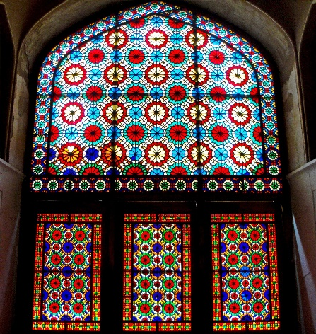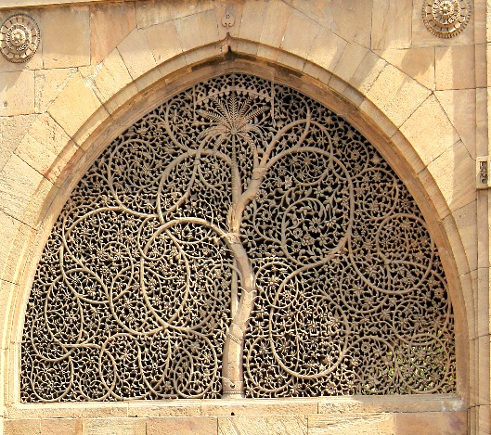

Tudor furniture style: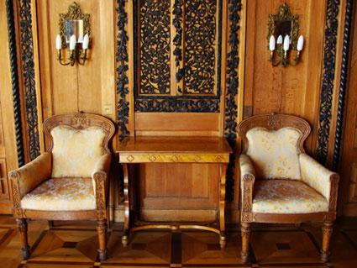 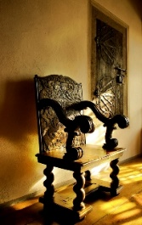

Tudor house architecture
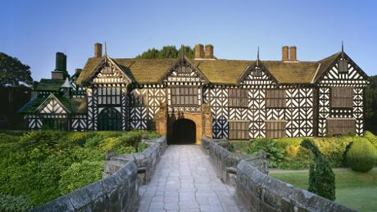

Q.1.ii) Which surface decorations were used in Tudor Interiors?

Carpets, Upholstery and wall hangings were commonly used as surface decoration in Tudor interiors. Velvet, damask and brocade fabrics were used for bed hangings and drapes.

Essential Tudor-style furniture pieces are four-poster beds (don’t forget the heavy-weight drapes!)

Wall hangings velvet bed hanging
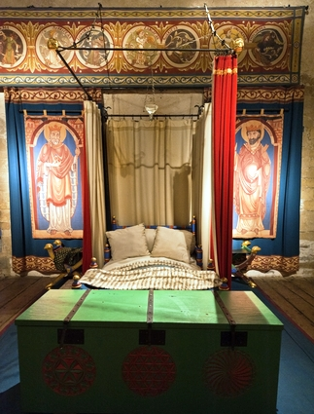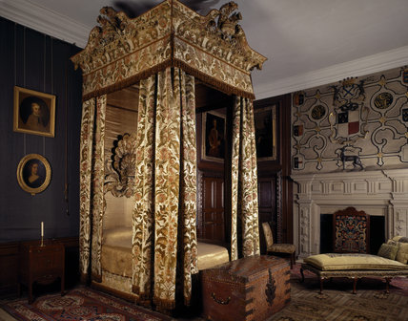

For the wealthy of the Tudor period, elaborate embroidery was found around the home to brighten expanses of dark wood furniture and panelling.
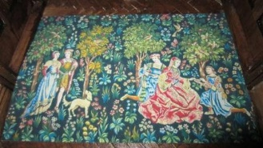

Damask window drapes Tudor wall hanging
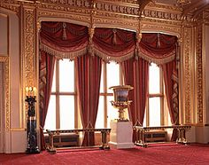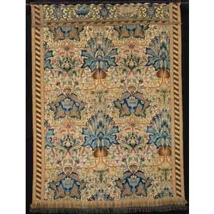

Tudor embroidery Tudor table runner
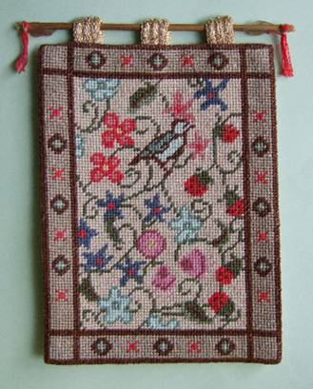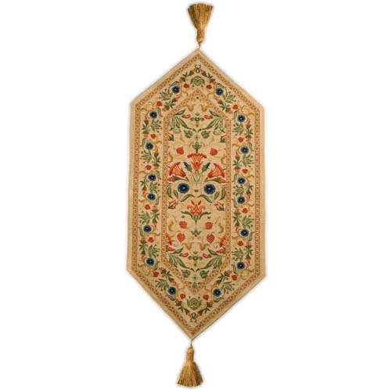

Q.1.iii) What has made the modern Interiors different from the period interiors?

Our life styles have changed, and the interiors designs have adapted to match our modern life style. Nowadays mostly what is wanted is a large space where various activities can take place. Technological developments have made an office space a dire need in almost every house., the room planning and everything in the room is planned in accordance with the technologies like; television, computer and etc.
Lighting, both artificial and modern became an important way of adding atmosphere to the rooms.
New materials were discovered like plastic which has made a big difference in the world of interiors, as it is now used everywhere from telephone and flooring to window frames. Synthetic fibers are used for carpets, curtains, beds and table linens.

Q.1.iv) How is modern kitchen different from the kitchens of the past?

The kitchen is now located in the central area of the house and is more of a food processing room than a traditional kitchen. The technologies have made a big difference in the interiors of kitchens and the arrangement of it. In the past, they used fireplaces to heat food. But, now electricity has made things become easier.
The fireplaces or hearth are now replaced by different stove designs (Gas, electric, with or without oven).
Different electrical appliances and food processors are necessary in the kitchen.
Kitchen ware used in the past were a lot bigger in size and heavier than that we use nowadays.
Since different materials for manufacturing of cooking pans, plates, and cups were discovered, thus changed their shapes and the way people use them.
The ancients have planned larger spaces for kitchens and cooking only, nowadays most of the kitchens are opened to the dining rooms.

Old kitchen with fireplace. Kitchen ware of the past
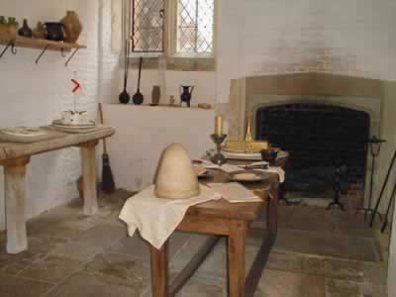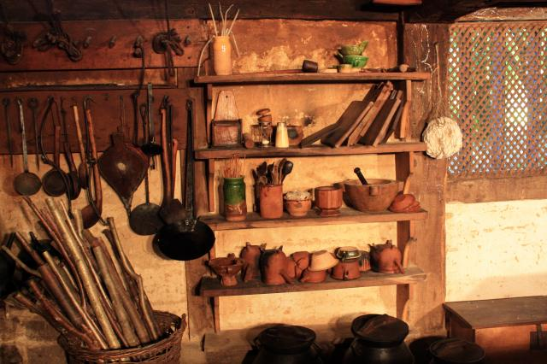

Modern Kitchen Modern kitchen ware
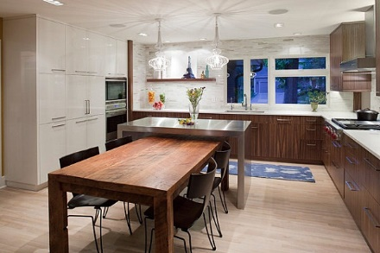

Q.1.v) How important it is for an interior designer to have knowledge of the period interiors and why?

With all of today’s modern interiors development, to a certain extent the work of interior designers today is distillation of ideas that are taken from past periods.
In case a client requested a specific period design for their homes or a certain room, an interior designer should have the right knowledge of the past interiors.
In addition to this, Interiors reflect the time and history of a place. A good knowledge of the past interiors is Important for a skilled interior designer. As it gives him more ideas and increases his creativity, getting closer to professionalism. Sometimes an individual idea is selected and extended at other times’ period treatments’, such as creating a room with Victorian style, are followed closely, with only the necessary adjustments being made to suit the 20th century way of life.

Q.2) Briefly describe the three important features of the Oriental style.

The oriental style is simple; the colours used are those of nature. Furniture is hand crafted. Accessories are predominantly of utensil. Fabrics are dyed in natural way and reflect the colours of earth and vegetation.

Hand painted Chinoserie wall paper
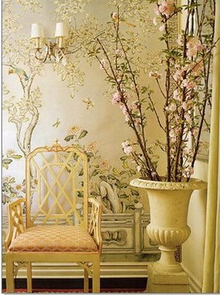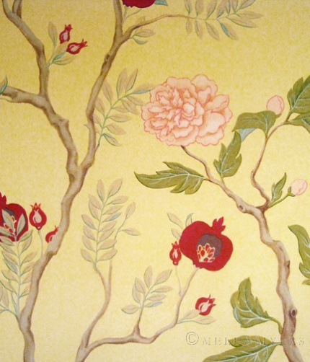

Chinoserie fabrics

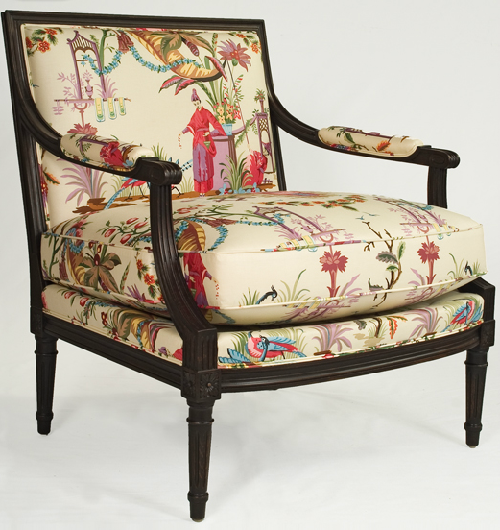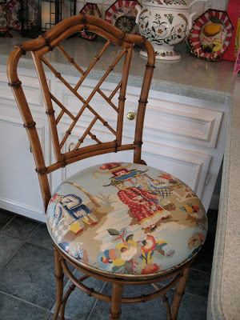

Some examples of hand crafted furniture with hand painted nature inspired designs
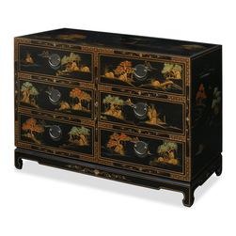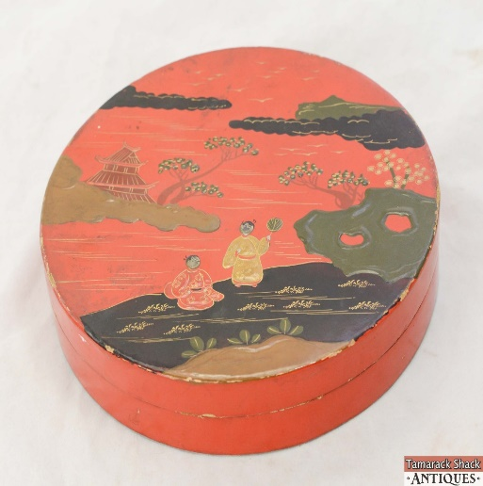

Case Study:

1. Anna in an interior designer her new project is a period property. It was built in 1800’s. The owner is interested to decorate it in seventeenth century style.

How can Anna re-create the required style?

First by learning about past trends and traditions in interior design, and knowing what materials did the ancients of the 17th century know, which colors did they use the most, the style of furniture they used, how they arranged it, knowing the differences between the interiors of the 18th and 17th centuries, and begin to work on making that property have same sense of style like that of the 17th century, by changing the design of the whole space or even adjusting the main elements to recreate the same effect, including:walls,floors,ceilings,windows,furniture,candles and mirrors.

2. A) Which materials she can choose for the walls, floors, windows and ceilings?

For wall treatment:

Oak panelling can be used with wool tapestries or damask wall hangings. Oriental wall papers, panels or screens can also be used.

Wood paneled walls
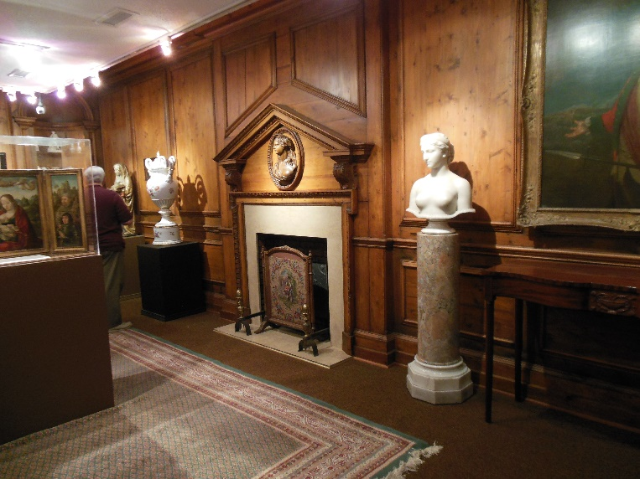

Wool Tapestries

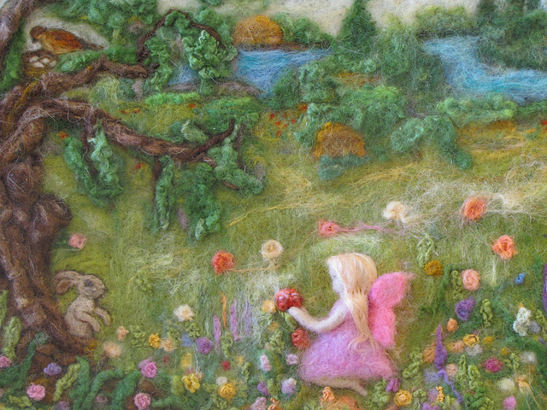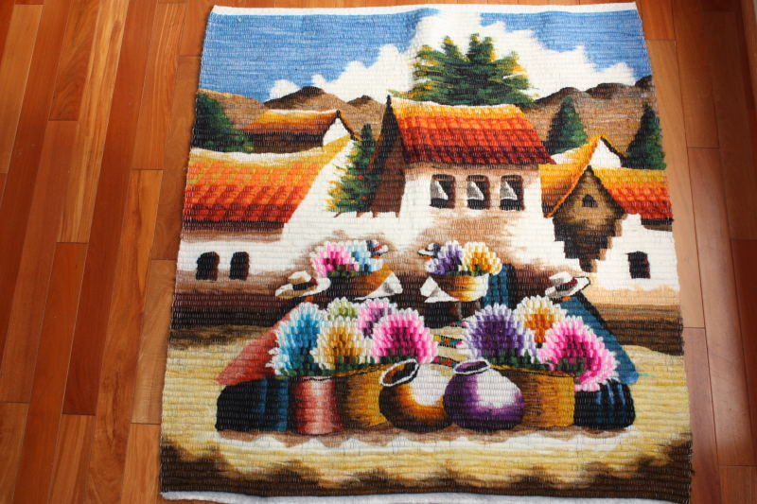

Oriental Screen Damask wall hanging
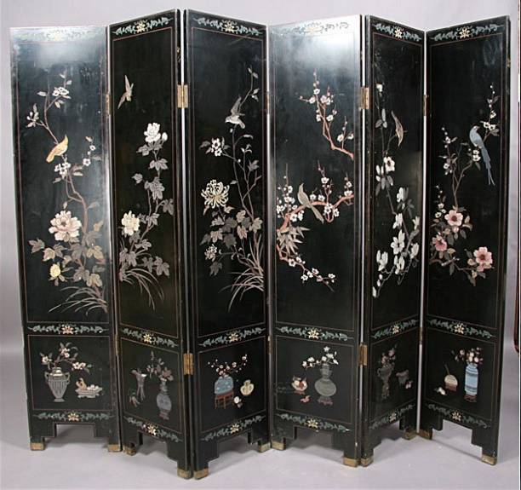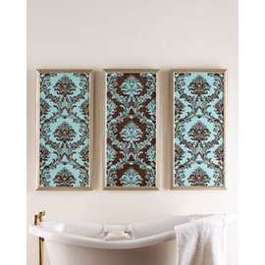

2.b)For the floors:

Parquet and other types of wooden floorings can be used, either in plain or covered with Indian or Persian rugs. Alternately, sand and seal existing wooden floor boards covered with natural flooring can be used. Black and white vinyl flooring can also be used.

wooden floor covered with Persian rug
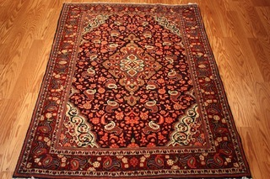

2.c)For the windows:
Suitable fabrics for curtains include; printed Jacobean designs on heavy cottons and linens, ‘flame stick’ and barbell patterns in weave and prints, and faded colors for velvet and silks.

printed Jacobean designs on heavy cottons Velvet curtains
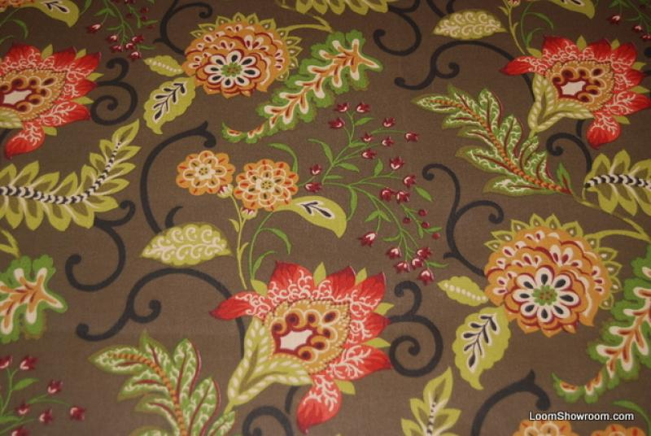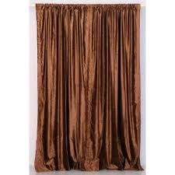

2. D) For the ceiling: she should use the plaster ceilings.

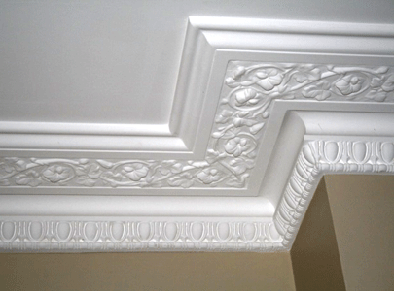

3. Which type of furniture she can use to re-create the effect of 17th century?

She can use Simple chairs with turned legs and rush seats or tall chairs with caned backs and upholstered seats would be suitable for everyday use. Tables with planked top, chunky legs or extending draw leaf tables can be used. Use fully upholstered arm chair in the bedroom with four poster bed.

extending draw leaf tables
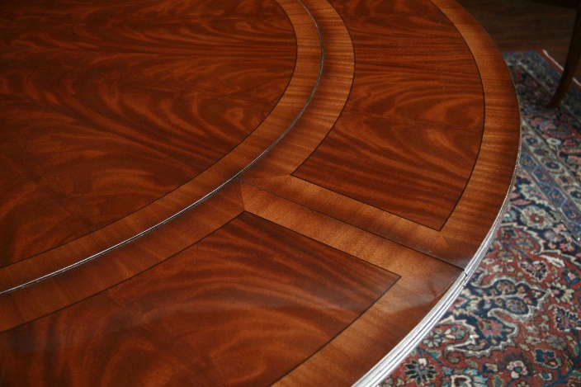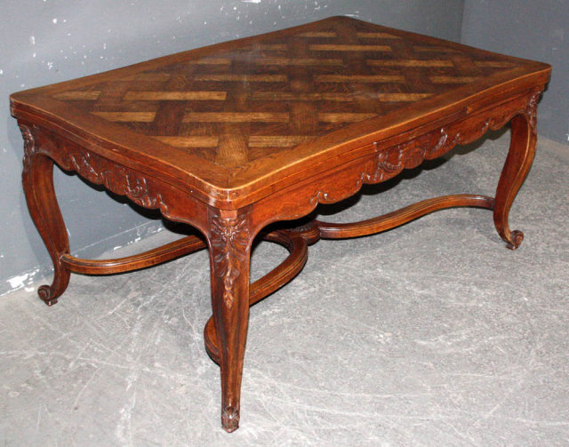

Chunky legs shapes
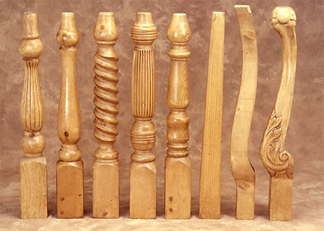

Four poster bed
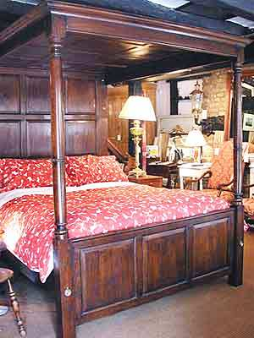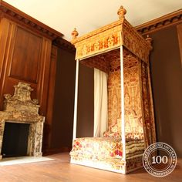

Upholstered seating Canned seating and back
