
Assignment Cover Sheet

Student Name: | Sumbal Jamil
Student Number: | 1149
Course: | Fashion Design
Assignment NO: | 9

Student Statement:

By submitting this assignment, I confirm that this is my own work.

Student Signature | Sumbal Jamil | Date | 3-3-2014

For Tutor / Assessor Use Only
Total Marks
Marks Obtained
Percentage / Grade

Q: 1: Write short notes on the following topics: (9)
a) Engraved roller printing

Answer: Engraved Roller Printing:
Roller Printing also called engrave roller printing. It is a modern continuous printing technique. In this method, a heavy copper cylinder (roller) is engraved with the print design by carving the design into the copper. Copper is soft, so once the design is engraved, the roller is electroplated with chrome for durability. This printing technique developed in the late 19th and early 20th centuries. Until the development of rotary screen printing; it was the only continuous technique. Designs with up to 16 colors present no problem in Roller Printing.
Main Parts of Roller Printing:
- Colour doctor
- Lint doctor
- Blankets
- Back grey
- Furnishers
- Colour box / tray
- Colour unit
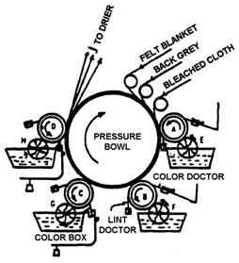
Roller Printing Machine

b) Flat- bed screen printing

Answer: In flat bed screen printing, this process is an automated version of the older hand operated silk screen printing. For each color in the print design, a separate screen must be constructed or engraved.
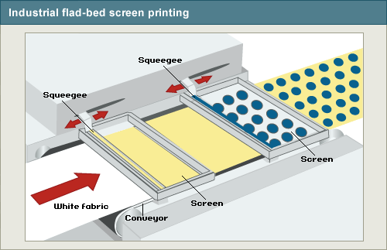
From BBC, Bitesize, Design & Technology, Printing
If the design has four colors, then four separate screens must be engraved. The modern flat-bed screen-printing machine consists of an in-feed device, a glue trough, a rotating continuous flat rubber blanket, flat-bed print table harnesses to lift and lower the flat screens, and a double-blade squeegee trough. The in-feed device allows for precise straight feeding of the textile fabric onto the rubber blanket. As the cloth is fed to the machine, it is lightly glued to the blanket to prevent any shifting of fabric or distortion during the printing process. The blanket carries the fabric under the screens, which are in the raised position. Once under the screens, the fabric stops, the screens are lowered, and an automatic squeegee trough moves across each screen, pushing print paste through the design or open areas of the screens. Remember, there is one screen for each color in the pattern. The screens are raised, the blanket precisely moves the fabric to the next color, and the process is repeated. Once each color has been applied, the fabric is removed from the blanket and then processed through the required fixation process. The rubber blanket is continuously washed, dried, and rotated back to the fabric in-feed area. The flat-bed screen process is a semi-continuous, start-stop operation. Flat screen machines are used today mostly in printing terry towels.

c) Rotary screen printing
Answer: Rotary screen printing is so named because it uses a cylindrical screen that rotates in a fixed position rather than a flat screen that is raised and lowered over the same print location. Rotary presses place the squeegee within the screen. These machines are designed for roll-to-roll printing on fabric ranging from narrow to wide-format textiles.
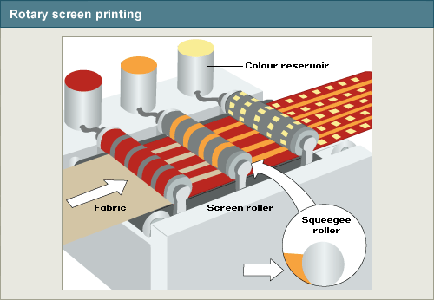
From BBC Bitesize, Design & Technology, Printing
In rotary printing, the fabric travels at a consistent speed between the screen and a steel or rubber impression roller immediately below the screen. (The impression roller serves the same function as the press bed on a flatbed press.) As the fabric passes through the rotary unit, the screen spins at a rate that identically matches the speed of substrate movement.

Q: 2: What is the difference between weft knitting and warp knitting? (6)
Answer: Weft and Warp knitting are technical terms that describe two different types of knitting used by either machine or hand. They refer to the widths and lengths of the thread and how many needles are used. Knitting is typically done by hand, although some machines are used today. These terms are technical terms mostly used when discussing machine knitting, although weft knitting can be done by hand, too. There are many differences between weft knitting and warp knitting, and since many knitters don’t commonly know these terms, we’ll discuss them here. There is a lot to learn about weft and warp knitting, so continue reading to expand your knowledge of the ancient art of knitting.
Weft Knitting Versus Warp Knitting
Weft and warp knitting are completely different knitting technique that results in two different types of fabrics. The most obvious difference in these two techniques is that weft is a yarn that runs back and forth, while warp is a yarn that runs up and down. Due to these different techniques, the finished product is entirely different, too. For example, weft knitting can produce shaped garments and highly drape able fabrics while warp knitting produces only coarse yardage.
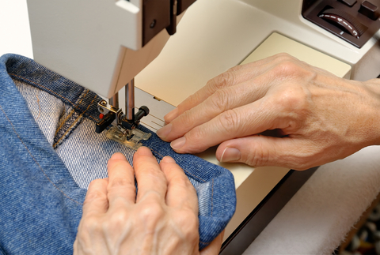
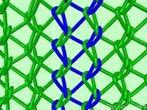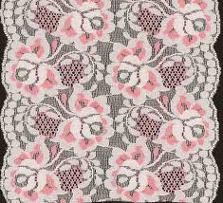

Activity

1. Examine the fibre content labels in the clothes in your wardrobe. How many garments are made from natural fibres? How does the fibre content affect the care of the garments?
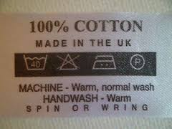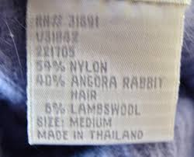
- (B)
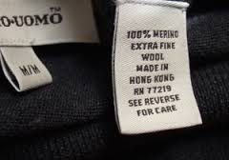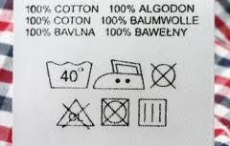
(C) (D)

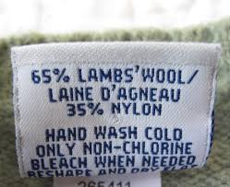
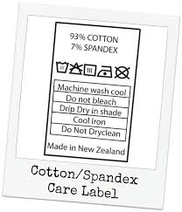
(E) (F)

(a)Cotton is Natural Fibre.
(b)Organic fibre..
(C)Wool is natural fibre.
(D)wool, natural fibre.
(e) Wool, natural fibre.
(f) Cotton, natural fibere.
FIBER FACTS
Fiber and Trade names |  | Special Properties
Natural Fibers | Advantages | Limitations
Cotton | absorbent, cool, strong | wrinkles and shrinks (unless treated), can mildew, lacks elasticity
Linen | absorbent, cool, strong | wrinkles, shrinks, weakened by mildew
Silk | absorbent, warm, drapes beautifully | weakened by sunlight and perspiration
Wool | absorbent, warm, flame and wrinkle resistant | shrinks, absorbs odors, attracts moths
Synthetic Fibers | Advantages | Limitations
Acetate  Avisco, Celanese, Chromspun, Estron | silk-like luster, drapes well, resistant to mildew and moths | weak when wet, dissolves in acetone, has static cling, low abrasion resistance
Acrylic  Acrilan, Creslan, Orlon, Zefran, Zehkrome | warm; good resistant to mildew, moths, wrinkles, shrinkage, and abrasion | pilling, has static cling
Nylon  Antron, Cantrece, Caprolan, Cumuloft | strong; lightweight; high resistance to moths, mildew, wrinkles, and abrasion | has static cling, absorbs and holds body oils, heat sensitive
Polyester  Dacron, Fortel, Kodel, Trevira | strong; warm; resistant to wrinkles, mildew, mold, and sunlight | has static cling, pills, oily stains hard to remove, hold body heat
Rayon  Bemberg, Cupioni, Fortisan, Viscose | absorbent, resistant to pilling, drapes well | weak when wet, low elasticity and resiliency, wrinkles (unless treated)
High Modulus Rayon  Avril, Avron, Zantrel | increased strength, abrasion and pilling resistance | low resiliency, susceptible to mildew
Spandex  Blue C, Lycra, Vyrene | resists abrasion, body oils, and perspiration; excellent stretch and recovery | heat sensitive, some discoloration from chlorine bleach

Washing Symbols
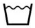 | The number in the wash tub shows most effective wash temperature in degrees C

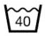 | A wash tub without a bar indicates that normal (maximum) washing conditions may be used at the appropriate temperature

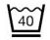 | A single bar beneath the wash tub indicates reduced (medium) washing conditions

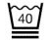 | A washtub with double bars (two bars) indicates a very mild washing process and spin. The number in the tub is the maximum temperature, for example 40°c.

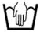 | Do not machine wash. Hand wash only

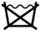 | Do not wash

Drying Symbols
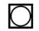 | Can be tumble dried

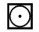 | Tumble dry on LOW heat

 | Tumble dry on HIGH heat

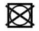 | DO NOT tumble dry

Dry Cleaning Symbols
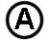 | Dry clean in all solvents

 | Dry clean in white spirit or Solvent 113

 | Dry clean in perchloroethylene,  white spirit or Solvent 113 or Solvent 114

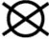 | DO NOT dry clean

Bleaching Symbols
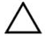 | May be treated with chlorine bleach

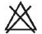 | DO NOT use chlorine bleach

Ironing Symbols
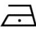 | Iron at maximum temperature of 110°C

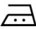 | Iron at maximum temperature of 150°C

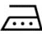 | Iron at maximum temperature of 200°C

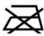 | Do not iron

2. Visit a local fabric store and find examples of a plain weave, a twill weave, a satin weave, and a non woven fabric. Collect swatches of each type.

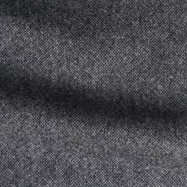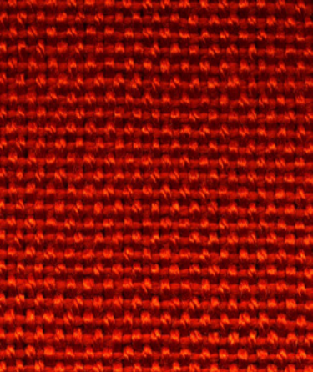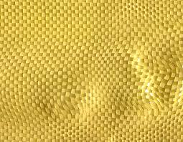
Plain weave

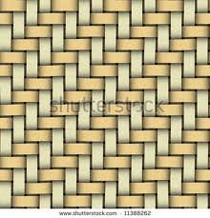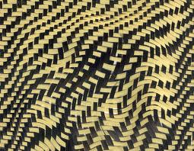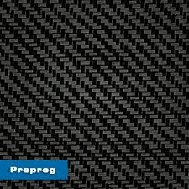
Twill weave
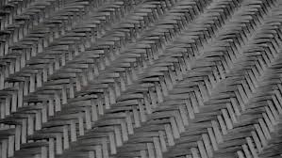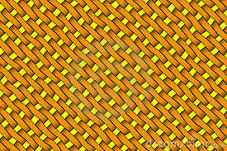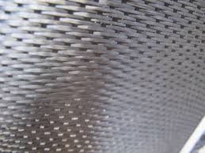
Satin weave
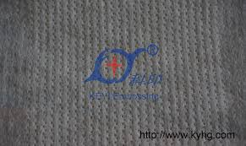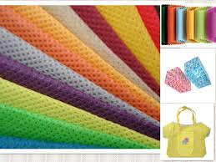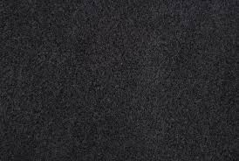
Non woven fabric

