
Youssef
Assignment Cover Sheet

Student Name: | Gehan Aly Youssef
Student Number: | 1092
Course: | Interior Design Diploma
Assignment NO: | Module 12

Student Statement:

By submitting this assignment, I confirm that this is my own work.

Student Signature | Gehan Youssef | Date | 11/2/2014

For Tutor / Assessor Use Only
Total Marks
Marks Obtained
Percentage / Grade

Name: Gehan Aly Youssef
Student no.: 1092
Assessment no.: Module12
Course Name: Interior Design Diploma
Address: Beverly Hills Compound, Build. No. 89,Square 1,El Sheik Zayed, 6 October, Giza,Cairo,Egypt
Page no.: 1

Q.1. Short Questions:

i. How does an Austrian blind works? What is the main difference between Austrian and festoon blinds?

Austrian Blinds are classic style of window covering combining the fullness and drape of a curtain with the practicality of a blind. They are a pull up Blinds that pulled from bottom to the top by using cords that are attached to the back of the blind in vertical lines and made longer than required drop to raise the blind giving a billowing effect. Also the top of this kind of blinds is attached to a track or wooden batten but with twice the track or batten width.
Austrian Blinds are made usually from light weight airy fabrics as to pass more light and not to be much heavy.
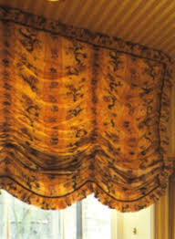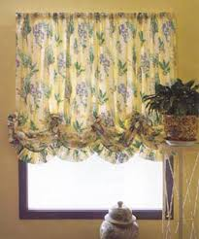

Name: Gehan Aly Youssef
Student no.: 1092
Assessment no.: Module 12
Page no.:2

The festoon Blind is made in the same way as Austrian blind but the difference being that Festoons are gathered over the drop as well as over the width making the blind look as full as possible , also Austrian blind falls flat like a curtain while festoon blind needs twice the length of fabric as if we have 1 meter by 1 meter so we need 2.5 meters by 2.5 meters of fabric.
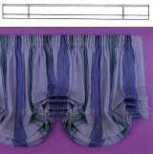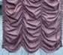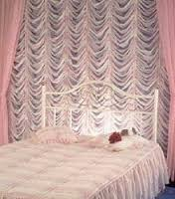
ii. How can a window seat be created? And what effect it creates in a room?

A window seat is a very challenging for designers although it looks very nice and can be a focal point in a room when it’s made very well. It can be created mainly under bay bow windows, curved or arched windows it’s used as a treatment for the space under the window instead of being lost space also it increase the feeling of space and nature in the room make it cozy, attractive we can use mattresses and cushions under window also it may have same or matching cloth of curtains as to be comfort, also it’s used for side by side windows as a corner in the room. We can make a special or different paint for wall in this area that matches with cloth of mattress and curtain.

Name: Gehan Aly Youssef
Student no.: 1092
Assessment no.: Module 12
Page no.: 3

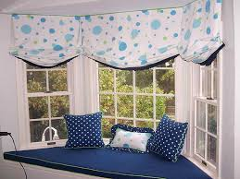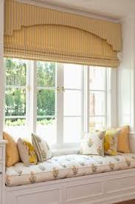

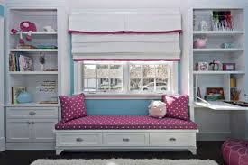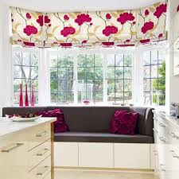

iii. Discuss different options for upholstering the dining chairs?

Dining chairs doesn’t need to feel good when seat on them only but also they need to look good so they must have comfortable upholstering and also nice one with different colors and patterns that make contrast with the painting colors and the shape of the dining table must take in consideration, also we
must be careful of choosing the fabrics and colors for every chair model weather it is classic or modern, fully upholstered or half, made from wood or

Name: Gehan Aly Youssef
Student no.: 1092
Assessment no.: Module 12
Page no.: 4

metal. They can be from one or two colors, plain, checks or stripes. The back of the chair can be in different color or pattern from the rest of upholstering as the main thing that appear from the dining chair is its back, Also buttons and ribbons can be used in upholstering the chairs back.
We can use covers over the dining chairs for seasonal changes also we can use chair cushions for wooden or metal chairs and they can be easily changed.

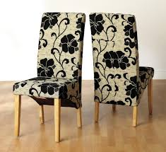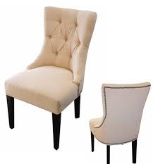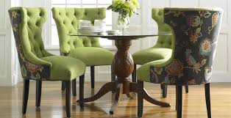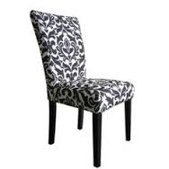

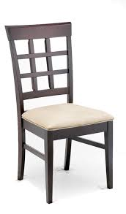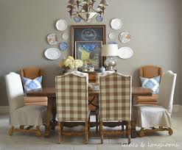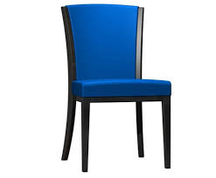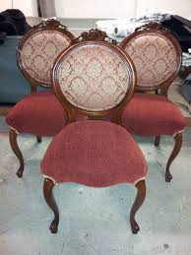
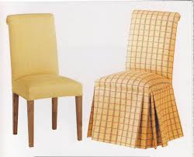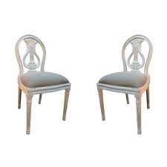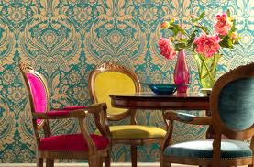

Name: Gehan Aly Youssef
Student no.: 1092
Assessment no.: Module 12
Page no.: 5

iv. Which type of cushions should be used for children’s rooms?

Children cushions must be made of durable, washable, soft fabrics
like cotton linen. Also it must be colorful or we can put Disney characters on them or lovely cartoon characters or personalized letters or memories they could be in form of favorite animals of children or shapes like dolls or cars or sun, clouds and stars. It could be diced or rectangular as children prefer to sit on floor so they can sit on them or very small and soft to be used on bed or children’s sofas.
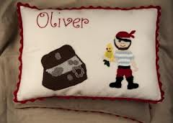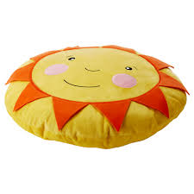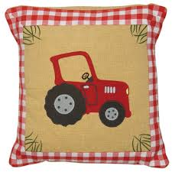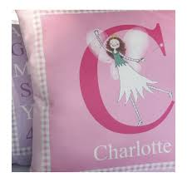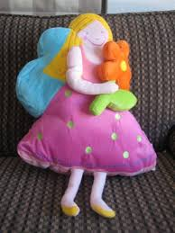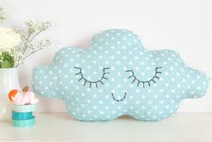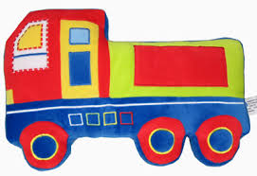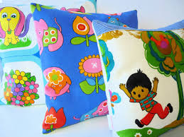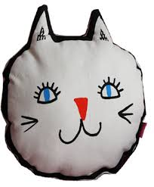

v. Describe different ways for decorating the cushions?

Cushions have different types and shapes as circular, rectangular, square, boxed or cylindrical or even triangular shaped. Also we have beads, piped, buttons or trimmings cushions which give decorative style to the room
We have different ways for decorating the cushions as:

- Tied corner cushions: this type has borders which is tied in the corner it can be a back in a chair or sofa also cotton is the best fabric or this type.

Name: Gehan Aly Youssef
Student no.: 1092
Assessment no.: Module12
Page no.: 6

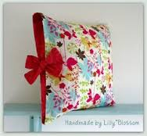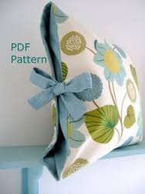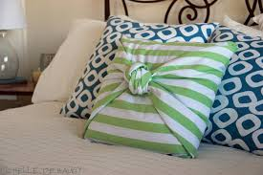

- Boxed cushions: they are cylindrical they looks nice when used loose in chair seats they are suitable for chairs and sofas backs also windows seats.
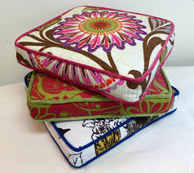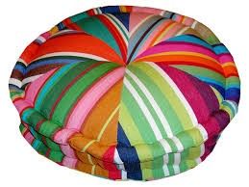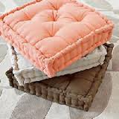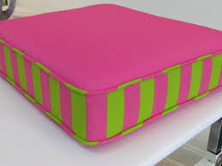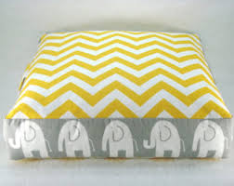

- Piped and frilled cushions: it looks very nice when the edges of the cushion are piped the best use for them is in the bedrooms also frilled cushions give a very soft touch in living rooms or classic rooms.

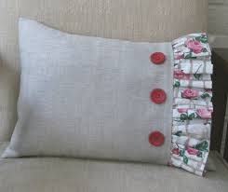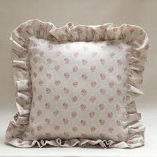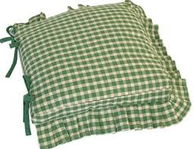

- Bordered cushions: it’s very appropriate for contemporary design cushions with borders are very nice in a bench or squashy sofa. Frilled edges, cords, fringes, tassels and piping

Name: Gehan Aly Youssef
Student no.: 1092
Assessment no.: Module 12
Page no.:7
give a romantic look for the place it’s very suitable in receptions and classic sofas and chairs.
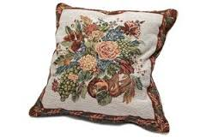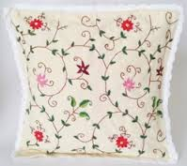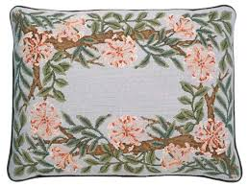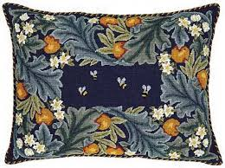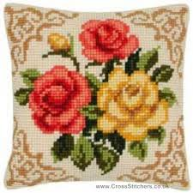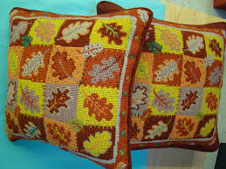

- Buttoned lined cushions: here we use decorative buttons and beadings to give a fashion look it’s very suitable in living rooms and bedrooms.
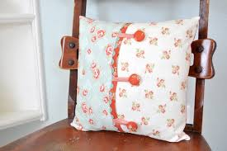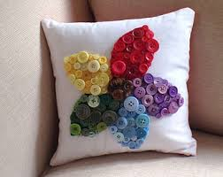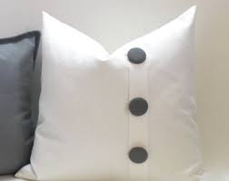

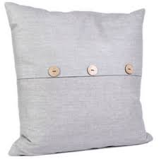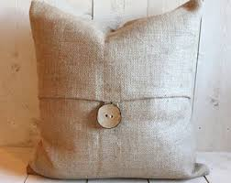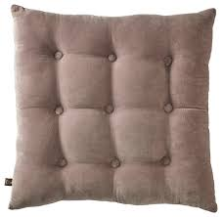

- Bolsters cushions: they are used most in bedrooms on beds specially for reading also they are used in living rooms as to give comfortable look for the room.

Name: Gehan Aly Youssef
Student no.: 1092
Assessment no.: Module 12
Page no.:8

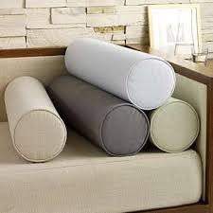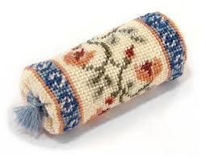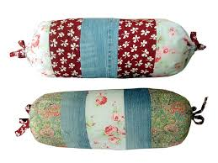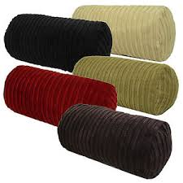

- Children’s cushions: bright colored floor cushions are mostly used in children rooms as to sit on them to be comfortable.

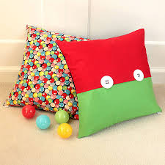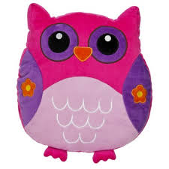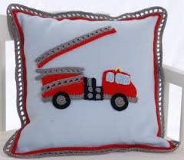

vi. When choosing bedding for a bed what are the most important factors to consider?

The most important factors to consider when choosing bedding for a bed are colors, fabrics, scale and pattern as the bed is the largest thing in the bedroom and the focal point so bedding must be chosen very carefully as it affects the atmosphere of the room it can be simple, classic, romantic, modern, cozy or country . so colors can be contrast and harmonize with each other , patterns can be mixed as checked or stripes with plain or floral pillows also shape of pillows can differ rectangular or square pillows can be used with different cushions . Any type of blankets is used cotton, linen the most

Name: Gehan Aly Youssef
Student no.: 1092
Assessment no.: Module 12
Page no.:9
important thing is to make the bedroom most comfortable as you can.

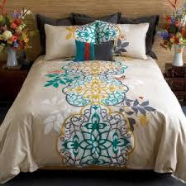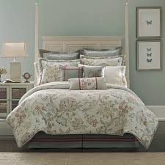

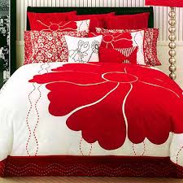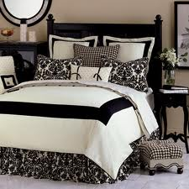

vii. What is a half tester?

A half tester is a rectangular shape canopy is set on the bed over the head side in the bed instead of a whole curtains set in the 4 corners of the bed so it’s just 2 sides curtains in the side of pillows over the head of the bed it’s a Victorian idea they are the first to use it in bed styles.

Name: Gehan Aly Youssef
Student no.: 1092
Assessment no.: Module 12
Page no.:10

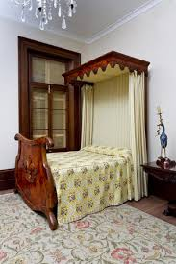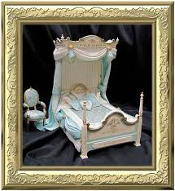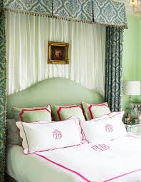

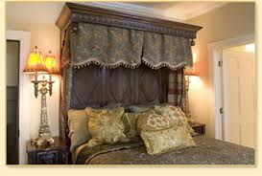

viii. What is the main difference between a half tester and a coronet?

As I had explained the half tester is rectangular shape where the curtains and drapes are hanged and it’s put over the head side on the bed and it’s decorated more than cornet.

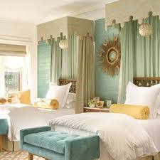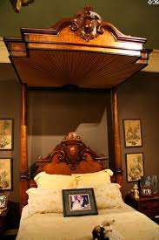

Name: Gehan Aly Youssef
Student no.: 1092
Assessment no.: Module 12
Page no.:11

While the cornet is a semi circular shape ring where the curtains and drapes are hanged it’s also set over the head side of the bed above pillows.

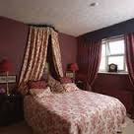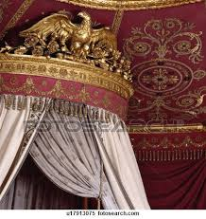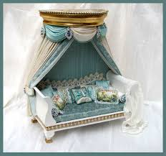

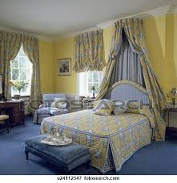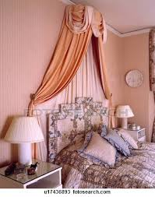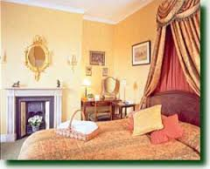

Name: Gehan Aly Youssef
Student no.: 1092
Assessment no.: Module 12
Page no.:12

Activity

- Design fabric for your room. (Work folder)

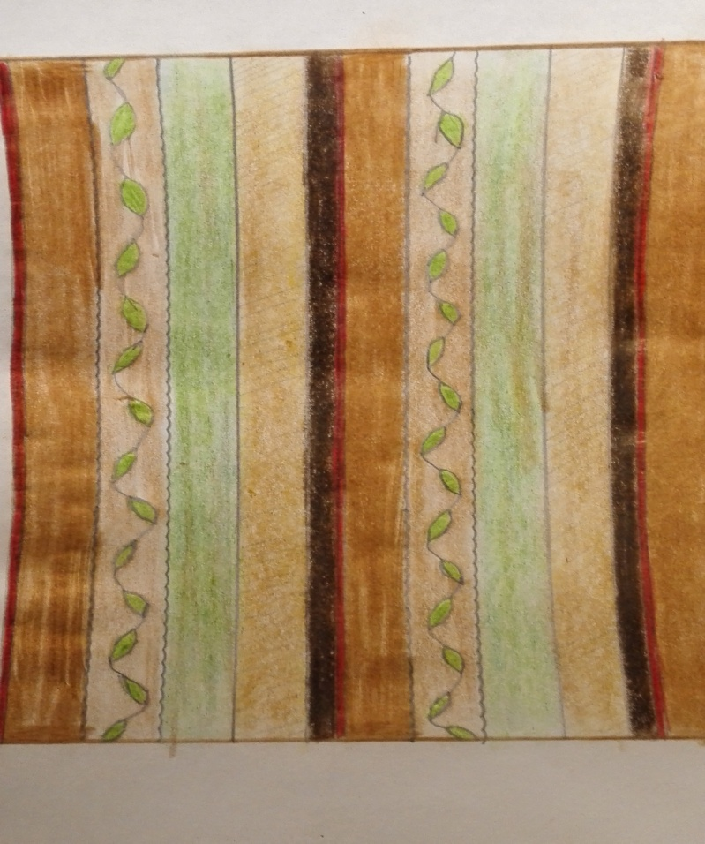

This fabric if for sofa is from velvet , if bedding so cotton is the best.

Name: Gehan Aly Youssef
Student no.: 1092
Assessment no.: Module 12
Page no.:13
- Design a cushion show in miniature and write down how it will coordinate with the room scheme. Based on this design plan a room scheme and write down the details of your scheme in your work folder along with the sample of your designed cushion.

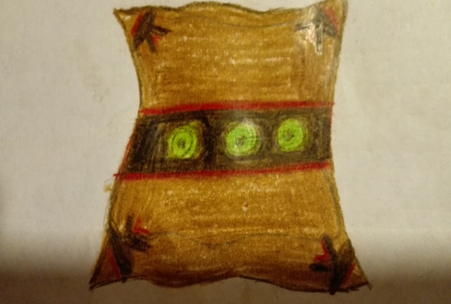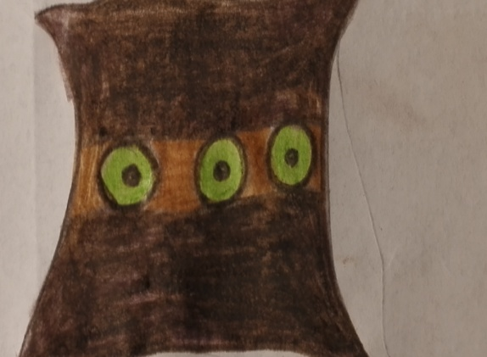

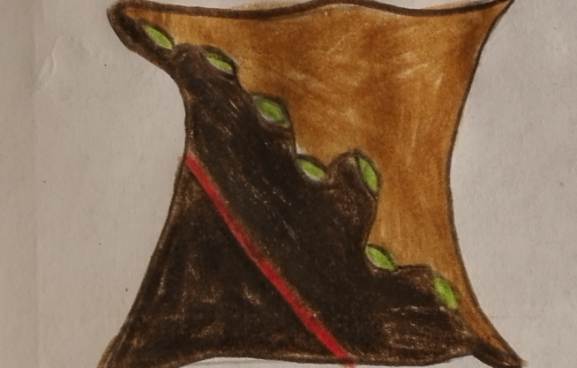

First design is a cushion used from same fabric as above it can be from either velvet or cotton fabric and the edges can be tided .
Second design also from same fabric but here I used buttons in the middle.
Third design from same fabric and here I used same green design as the fabric with same red line.
I prefer the first one as it matches most with the fabric but in a room I can use three of them in my design.

Name: Gehan Aly Youssef
Student no.: 1092
Assessment no.: Module 12
Page no.:14

Here I have tried a design for a cushion that matches with the fabric above as I can make this fabric for the main sofa in a living room with plain light and dark brown cushions with 2 plain arm chairs from the light brown color
putting on them theses cushions, the tables will be from dark brown color,
curtains should be a mix from plain light brown and stripes fabric of sofa.
Or the sofa is plain and two arm chairs from stripes fabric above design.

If we tried this fabric on bedding so the stripes will be the main cover of the bed and cushions should be from main cover and either first two cushions or the last one design with plain cushions from light and dark brown and small
Cushions from light green color, curtains should look like cushions or be plain light and dark brown with light green color.

