
Assignment Cover Sheet

Student Name: | Salma Mohamed Safaa
Student Number: | 1170
Course: | Interior Designing
Assignment NO: | 6

Student Statement:

By submitting this assignment, I confirm that this is my own work.

Student Signature | Salma Mohamed Safaa | Date | 13/08/2015

For Tutor / Assessor Use Only
Total Marks
Marks Obtained
Percentage / Grade

Student Name: | Salma Mohamed Safaa
Student Number: | 1170
Course: | Interior Designing
Assignment NO: | 6
Page NO: | 1

Interior Designing Course
Unit 6: Lighting.
Q.1. Short Questions:
I. Light and colour are linked together as they both are main factors in creating the mood and atmosphere of the space.
Also light has a major impact on the appearance of colour. Different light intensity and different light types and sources affect how the colors of the interior walls and setting look and feel.
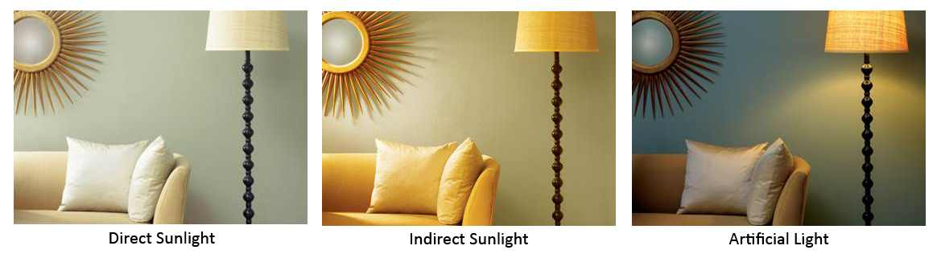
That's why both should be carefully planned with a well-designed scheme that coordinate both light and colour together.
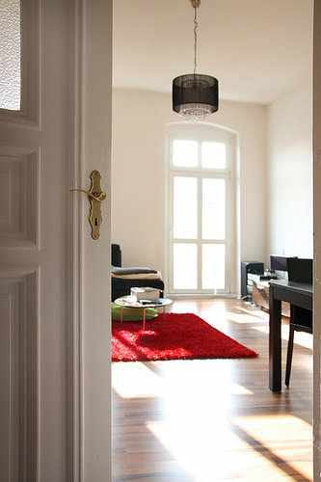
II. If the amount of natural light is not enough for a room, I have options to solve this problem;
The picture above shows the same paint on the wall in three different lights—one being direct sunlight, indirect sunlight, and artificial light.
- Adding another window or perhaps maximizing the existing one.
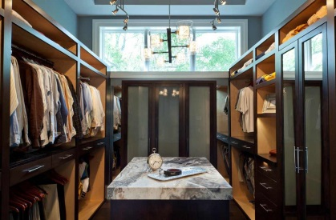
The designer maxizimed the window's height to be nearer to the ceiling and lowered it to reach the floor, enabling a large quantity of natural light to enlighten the whole room.
Student Name: | Salma Mohamed Safaa
Student Number: | 1170
Course: | Interior Designing
Assignment NO: | 6
Page NO: | 2
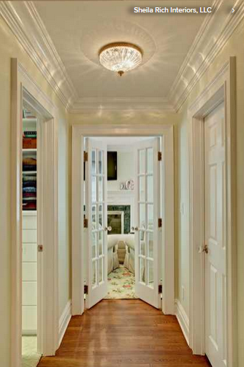

- Replace interior solid doors with glass doors, providing a way for room to share light.

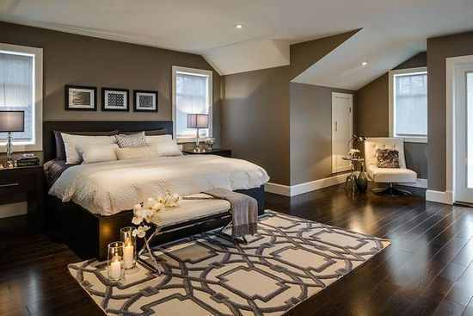
- Adding artificial lighting with the existing daylight.

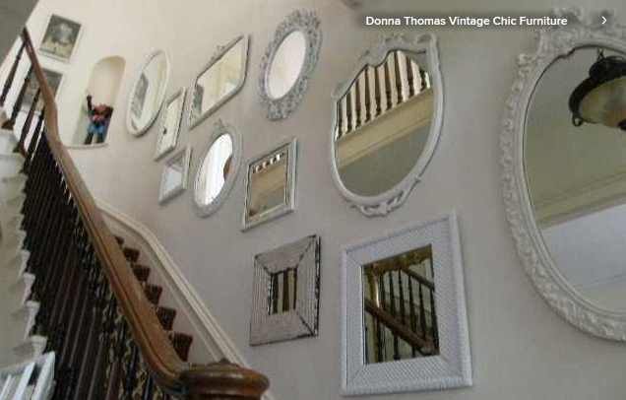
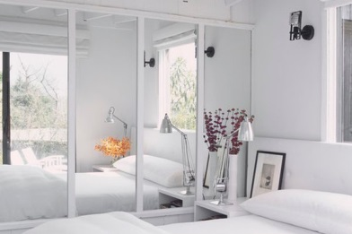
III. "Light enhancers" are light reflecting textures such as; mirrors, glass or crystals. By placing them right they help enhance and increase the amount of light in the interior space.
- Mirrors
Here using antique mirrors climb the stairs. It's a beautiful display that reflects light from the second story.
When placed opposite, the mirror will reflect light and views from the window.

Student Name: | Salma Mohamed Safaa
Student Number: | 1170
Course: | Interior Designing
Assignment NO: | 6
Page NO: | 3

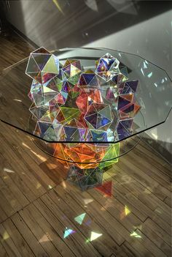
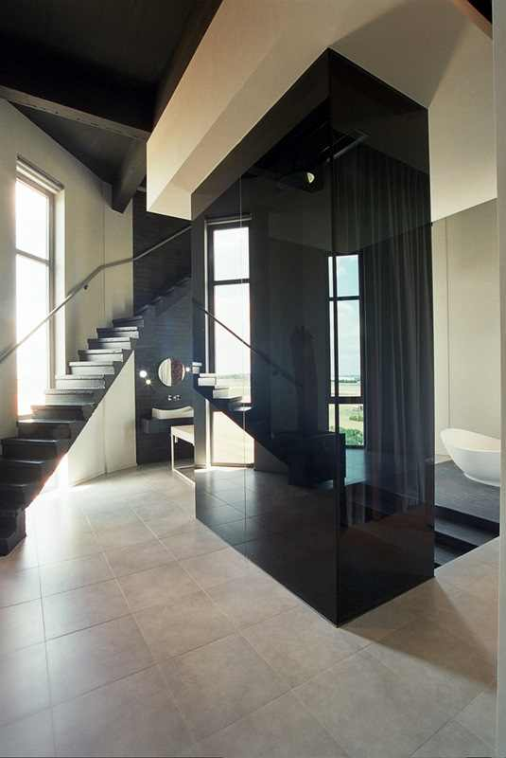
- Reflective surfaces bounce light around and give the impression of more light when windows are limited

A crystal and glass coffee table reflecting light embeding beautiful rainbow colours
Applying Black glass partitions to reflect the light from the window.

IV. It is very important for a designer to know the function of the room before designing its lighting scheme. A designer should first be aware of all the activities, the movement and the circulation that will occur in the room.
Understanding the function carefully helps designing the space and arranging the furniture right, which enables the designer to correctly choose the right type, fitting and adequate strength of light intended for the uses.
V. Certain features of a room, or special objects should be highlighted in the interior to enhance and inspire your mood. Features such as an attractive picture or photo frame, a unique fire place, an attractive architectural detail of the ceiling or of the window or even a particular object - it can either be an artwork, sculpture, bookcases, or plants.

Student Name: | Salma Mohamed Safaa
Student Number: | 1170
Course: | Interior Designing
Assignment NO: | 6
Page NO: | 4

Accent lighting is directional and is used to highlight those features, as it provides a way to focus attention on those decorative aspects.
Accent lighting adds drama to a room by creating visual interest as part of an interior design scheme. For effectively accent you need to ensure three times of level of general lighting. Too much of accent lighting might destroy effect and wash out from the room. Accent lighting is usually provided by recessed and track lighting or wall-mounted picture lights.
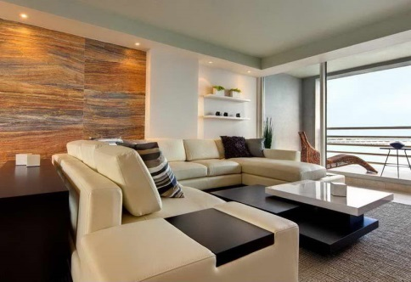
Examples:
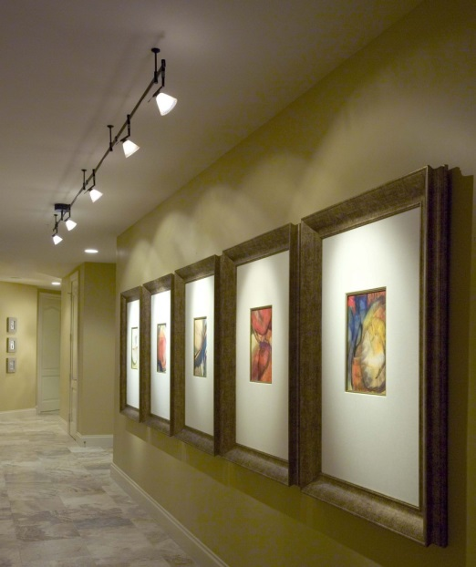
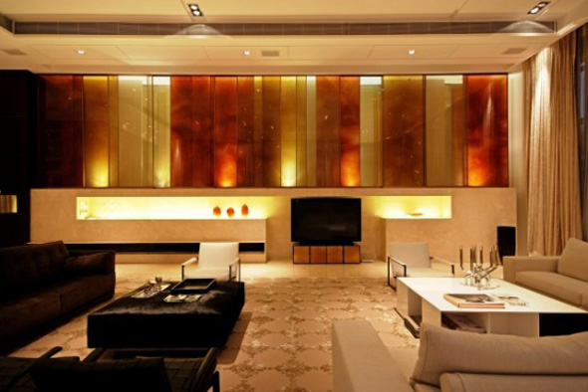
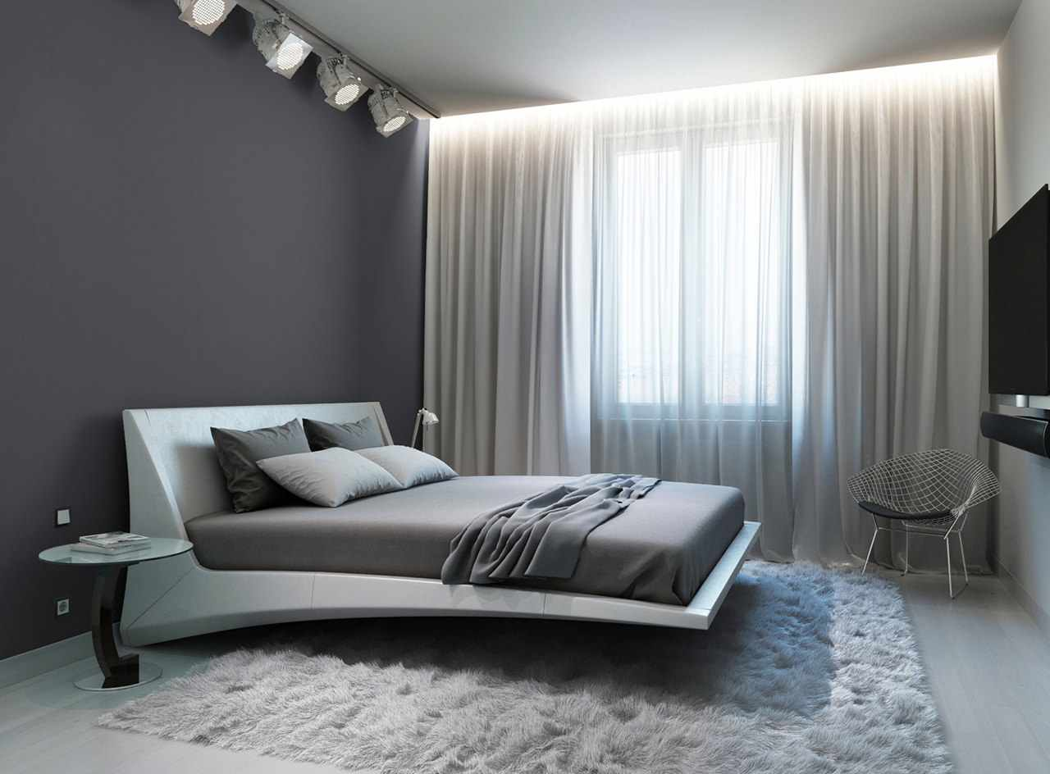
Setting a dramatic mood in this living room by adding uplighters to illimante the warm colored glass partitions against the walls and in the recesed horizontal niche.
Showing off the lovely new curtains by fitting concealed lighting behind a pelmet.
Using spotlights to highlight the natural wood wall that provides a warm accent to the white palate of the design scheme.
Using track lighting that are three times brighter than the general lighting of the museum to focus on the artworks.
Student Name: | Salma Mohamed Safaa
Student Number: | 1170
Course: | Interior Designing
Assignment NO: | 6
Page NO: | 5

VI. The main advantage of free standing light fixtures: is they are the greatest flexible and portable type of lightings that helps you to adjust them as you intend to perform specific tasks, such as reading, grooming, preparing and cooking food, doing homework, working on hobbies, playing games and balancing your checkbook.
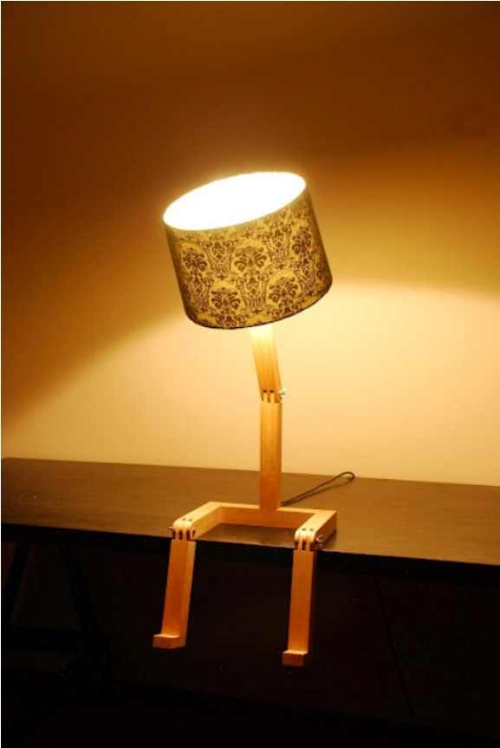
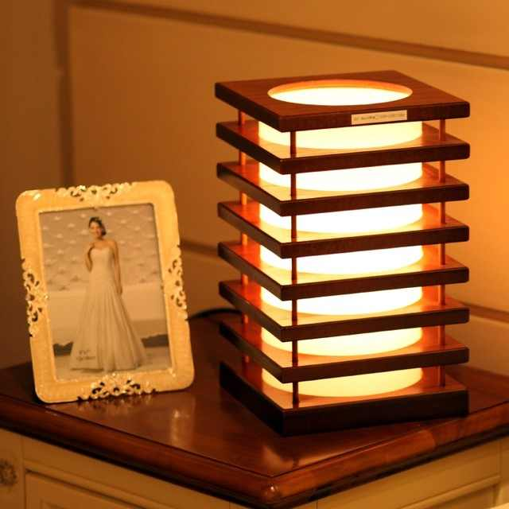
Table lamps are the best example of free standing light fixtures. They take the functionality of lighting to a higher level, in addition to providing decorative value. They are designed to be adjusted in height, reach or angle, frequently moved as well as add beauty to your home.
Modern Style Square Tower Wood Decorative Table Lamp
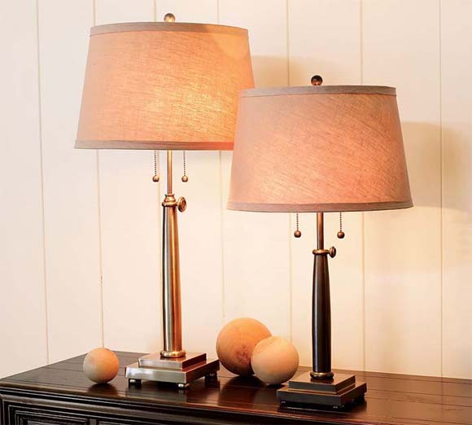
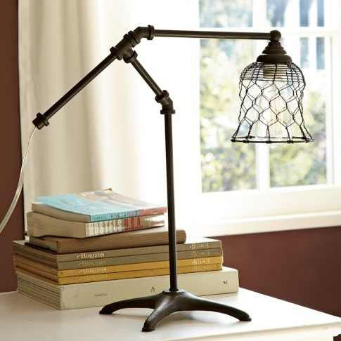
Vintage task desk lamp and also decorative
Adjustable Column Table & Bedside Lamp Base
Decorative Table Lamp Looking Like Person sitting down
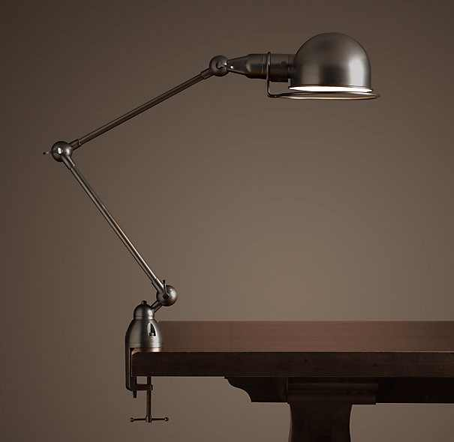
Task Table Clamp Lamp

Student Name: | Salma Mohamed Safaa
Student Number: | 1170
Course: | Interior Designing
Assignment NO: | 6
Page NO: | 6
Q.2. "A well-oriented house is designed to make the most of what nature gives us."
One of the most important considerations in putting a design scheme is each room's orientation to the sun, the climate, and the placement of the windows in your space. As it can play a critical role in how much energy will be consumed and how much you’ll enjoy living in the space.
When an architect designs a space he should use the sunlight and the climate to the space's advantage. He should think about how the windows relate to the sun’s movement. Which rooms have a southern exposure? Where the windows should be placed? How will the natural light fall in different areas of the space?
South-facing windows supply steady, even daytime light and warmth, and they let in the most winter sunlight. “A south-facing window is always a net energy gainer,” Minneapolis building scientist Mark LaLiberte says. “Whatever heat is lost through the glass during the evening is balanced by gains during the day.”
North-facing windows admit soft, indirect light with little glare or summer heat gain, but they’re most affected by cold. East- and west-facing windows funnel in light in the morning and afternoon, respectively, but can cause glare. The western sun’s angle makes light hard to control, and its heat is weak in winter.

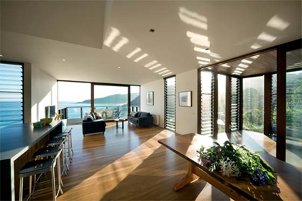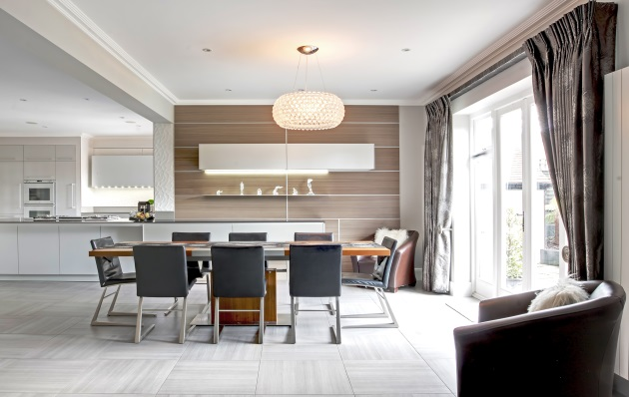
Planning interior with consideration to the orientation of sunlight will always give an everlasting effect.

Student Name: | Salma Mohamed Safaa
Student Number: | 1170
Course: | Interior Designing
Assignment NO: | 6
Page NO: | 7
Case Study:
Planning Light Scheme for Brandon & Alisha's Living Room:
By studying the requirements of Brandon & Alisha's family for their living room, the designer was able to apply the furniture on the following layout.
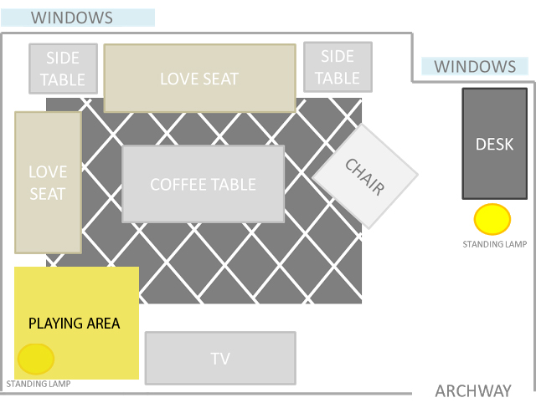
Once the furniture is shown on the plan, a designer must be aware of all the activities that will happen in the living room to create a well-planned lighting scheme and to select the appropriate type of lighting in different areas of the room.

Student Name: | Salma Mohamed Safaa
Student Number: | 1170
Course: | Interior Designing
Assignment NO: | 6
Page NO: | 8

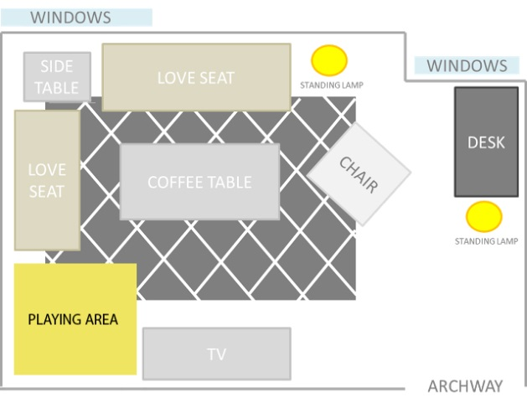
- Selecting the type of lighting for the different areas of the room:
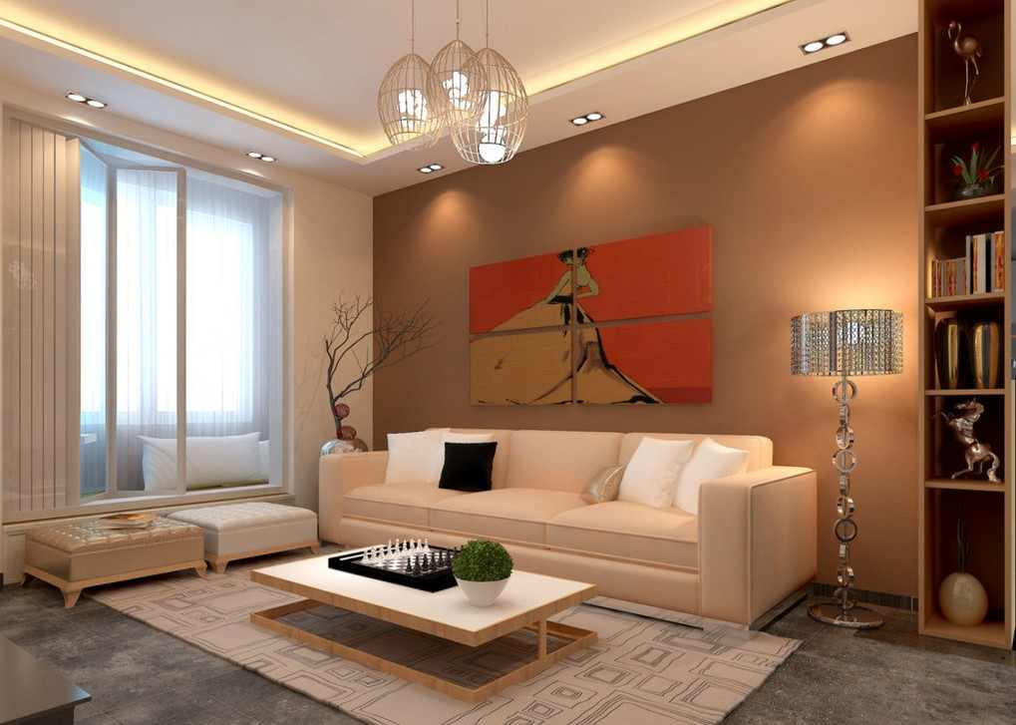
- Ambient lighting to provide the overall lighting of the room for example a suspended pedant or chandelier in the center of the ceiling above the main squared area of the living room to provide a soft background lighting.
- Adding to that indirect lighting and light fixtures along the squared area to increase the general lighting if needed.
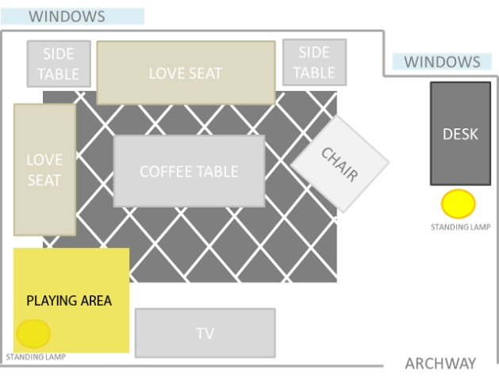
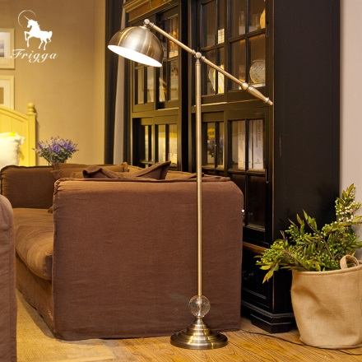
- Tasking lighting : using a desk lamp or a swing arm lamp to illuminate the desk . An adjustable side lamp on the side table or a floor lamp in the corner between the two sofas to adjust for a more practical reason such as reading while sitting on the love seats or the sofas.

Student Name: | Salma Mohamed Safaa
Student Number: | 1170
Course: | Interior Designing
Assignment NO: | 6
Page NO: | 9

- Lighting the dark corners of the living room:
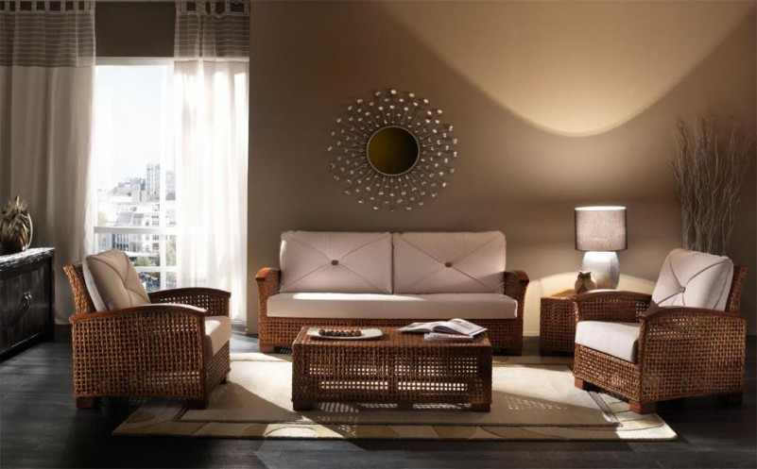
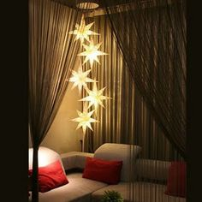
Shown on the layout the dark corners 1,2 and 3 in the living room and the suggested types of how to light each corner.
Corner 1: is dark even when there is still sunlight coming from the window but by using a side lamp on the side table it would be well illuminated.
Corner 2: is dark ,by using a standing lamp on would be perfect to light up this zone ,also an adjustable floor lamp could be used instead to direct light on the desk beside it.
Corner 3: this wide corner was the best space to be the playing area for the two children. But it needs to be lighting that is appropriate and safe for a playing corner, so it is best to use downwards suspended lamps that are away from the children's reach.

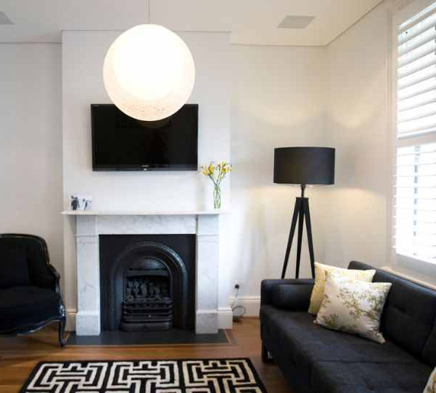

- Standing lights: offer an easy-to-add lighting solution for any space, even if you don’t have much room. They’re easy to move around. It's advisable to have at least one in a family living room, to light a dark corner or to focus it on specific area.
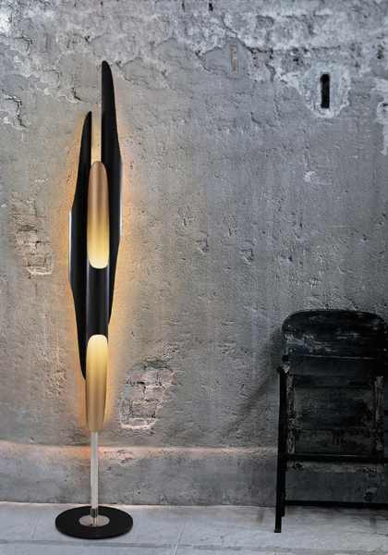
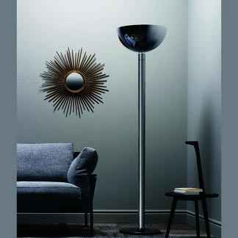
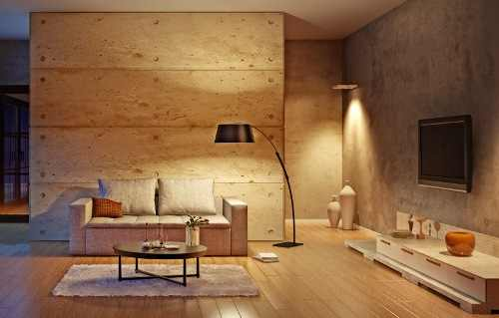

Student Name: | Salma Mohamed Safaa
Student Number: | 1170
Course: | Interior Designing
Assignment NO: | 6
Page NO: | 10

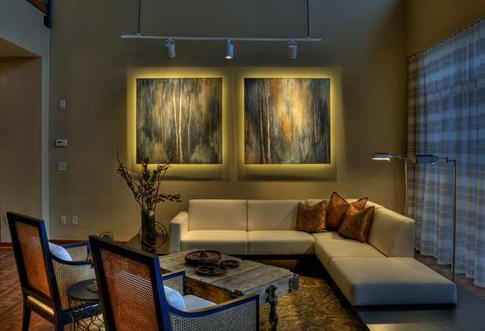
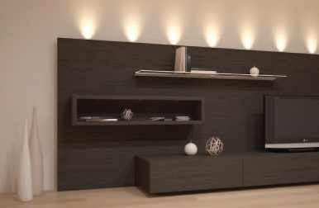
- Enhancing the decorative effect of the room using:
Using a down lighter focusing directly on decorative pottery beside the TV.
Using a Track lights focusing on the drawing on the wall above the sofa
using uplighters on the TV unit
Accent lighting for example:

