
Assignment Cover Sheet

Student Name: | Elizabeth Abidemi Akinlabi
Student Number: | 1380
Course: | Diploma in Fashion Design
Assignment NO: | 10

Marking Criteria:
We expect the learners to write minimum one well expressed point in three lines against each allocated mark. This means one needs to write 15 lines with 5 well expressed points to get high grades for a 5 marks question.
For high grades use examples and illustrations where appropriate.
Please insert your completed assignment ( in word format) here:

ELIZABETH ABIDEMI AKINLABI
1380
ASSESSMENT 10
PAGE 1
Q1. Multiple choice questions;
- A fashion figure is *Eight to ten feet tall.
- The best rule to follow in sketching the face is to; omit as much detail as possible.
- The fashion artist exaggerates the; length of the figures and maximizes the width of the hand.
2. What is the most important thing to consider when sketching for dressing the figure?
It is imperative that the artist have a proper understanding of the human body, the way our joints move to create poses, poses that give fluidity to how the garment looks on an actual body, this is the most important thing to consider when sketching for dressing the figure.
3. How does fashion design sketch help a fashion designer? Fashion design sketches helps the designer take his ideas from thoughts to visuals ideas on paper, the rough ideas can be improved on, until the designer translates his/her imaginations completely. It also helps the designer choose fabric for the garment; the sketches also aid the designer as they can be used as part of the blueprint to garment production for the manufacturing companies.
4. How should the bottom of the skirt be sketched? Why is it important to harmonize the mood and action of the figure with the clothes in which the artist draws her? Explain giving at least one example. When sketching a skirt, the fullness, or flow can be established using rhythmic of strokes and lines to create a life like feel of how it would be on a body. It is important to harmonize the mood and the action of the figure with clothes on because it depicts how and where the garment will be worn, for example in my activity, I created a scenario in my mind, of a marketing executive in the city, probably attending the launch of a new product, she wears her touch of Ankara (African fabrics) to express her roots, in this sleeveless six piece skirt and peplum blouse ensemble.

Activity
Sketch a fashion dress for a female, showing all the details required in that garment. Then sketch a fashion figure dressed in same outfit.
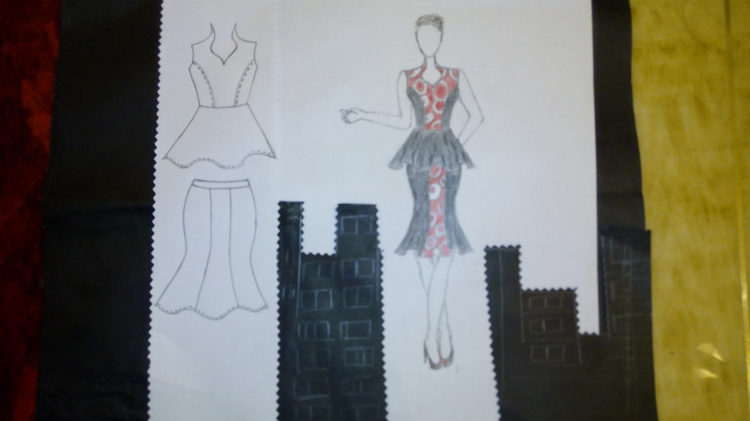

Student Statement:

By submitting this assignment, I confirm that this is my own work.

Student Signature | Elizabeth Abidemi Akinlabi | Date | 13-08-2015

For Tutor / Assessor Use Only
Total Marks
Marks Obtained
Percentage / Grade

