
Assignment Cover Sheet

Student Name: | Sumbal jamil
Student Number: | 1149
Course: | Fashion design
Assignment NO: | 6

Student Statement:

By submitting this assignment, I confirm that this is my own work.

Student Signature | Sumbal jamil | Date | 26-12-2013

For Tutor / Assessor Use Only
Total Marks
Marks Obtained
Percentage / Grade

Short Answers
a. How is the formal balance achieved in dress designing?
Answer. Formal balance is achieved in dress designing when one side of dress is a mirror image of other side. Garment is visually being split down the middle and sides are exactly same. Formal balance is also called symmetrical balance; it is easier to create but may not be as interesting as informal balance. In dress design the feeling of dignity or formality is created by formal balance.
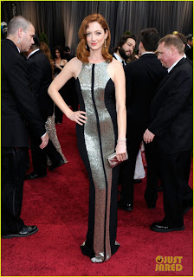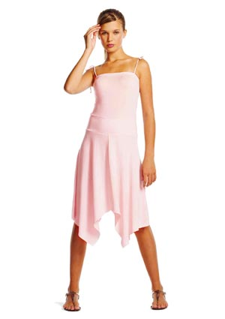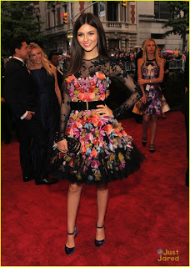

b. How can harmony be created in a design?
Answer. Harmony can be created in a design when unity and variety are effectively combined.
Harmony = Unity + Variety
- Unity: Everything works together
- Variety: It captures attention and creates interest.
Harmony is achieved by the combination of two or more elements to make visually pleasing outcome. Variety is achieved when the art elements are combined in various ways to increase visual interest. Unity is the underlying principle that summarizes all the principles and elements of design. It also the coherence of the whole, the sense of all the parts are working together to achieve a common result, a harmony of all the parts and at the end to form o successful design.

c. What is the relationship between the principles and elements in a design?
Answer. Elements of design: are the parts. They structure and carry the work.
Principles of design: are concepts. They affect content and message.
The major relationship between principles and elements is that principles are rules we have to follow and elements are things that will help us complete those rules for the best project outcome. The principles of design are the recipe for a good work of art. The principles combine the elements to create an aesthetic placement of things that will produce a good design. The principles of design help us to carefully plan and organize the elements of art so that we will hold interest and command attention. Principles of design are guidelines for the use of the elements of design. Successful design is achieved when all the elements and principles work together. In an effective application of the principle, each garment enhances the others, rather than distracting from the design.

d. Describe at least three ways for creating rhythm in dress designing.
Answer. Rhythm: It is the pleasing arrangement of the design elements. It produces a feeling of continuity or easy movement of the observer’s eye. Specific applications of rhythm are classified in following categories:
- Gradation
- Opposition
- Transition
- Repetition
- Radical arrangement
Three ways for creating rhythm in dress designing:
- Rhythm-Opposition: It is the rhythm that is created with multiple lines converging to form a right angle. One of the most common uses of this form of rhythm is found in a plaid shirt or other plaid or check pattern.
- Rhythm-Gradation: It refers to a design pattern that gradually increase or decrease in size, shape or color. An example is when designers use gradient-dying techniques that uses a gradual change in color from light ti dark across the textile. It is also called progression.
- Rhythm-Transition: It is a rhythm created when a curved line leads eye over an angle. Transition is technique used to move between different parts of a design at a more gradual pace rather than an abrupt change in direction. An example of this would be a continuous line creates by a scarf, ruffle or gathers.
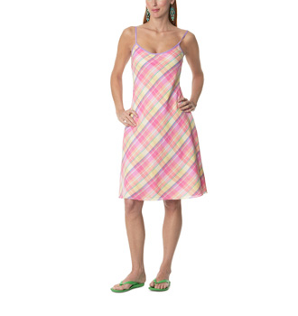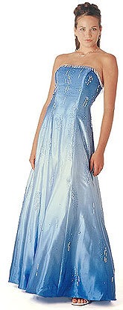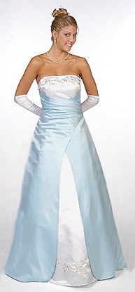
Opposition Gradation Transition

Q.2.What is the principles of design? How do they help a designer analyze the effectiveness of a design?
Answer. Principles of design: The principles of design are essential to the development and production of clothing used by individuals and families around the world. Each principle has a specific role in creating an aesthetically pleasing garment or ensemble. The principles of design consist of: balance, proportion (also referred to as scale), emphasis, and rhythm. When a garment or ensemble uses the elements and principles of design to create a visual unity, harmony is achieved. Garments often integrate more than one principle, while drawing from the elements of design to create a cohesive look.
(1).Balance: This principle of design refers to the visual equalization of the elements in a work of art.
There are three major forms of balance:
- Asymmetrical balance: where equilibrium is achieved by the balance differences in the art elements within a composition.
- Symmetrical balance: where the art elements in a composition are balanced in a mirror-like fashion (it does not have to be exact but close).
- Radial balance: a kind of balance where the elements branch or radiate out from a central point.
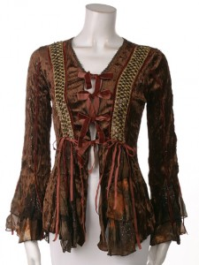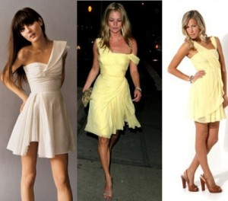

(2).Proportion: Proportion in fashion design is the principle that holds that the size of various components of a garment or fashion accessory must look good together. Proportion is one of the most important principles of fashion design for the petite woman because when she selects garments, their proportion (or size/scale of the garment or various components of a garment or fashion accessory) should be relative to her small stature. For example, a tea-length, full skirt would have so much volume that it would be overwhelming on a petite woman.
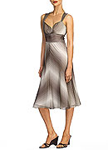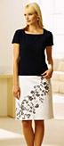

(3).Emphasis: Emphasis or a centre of interest draws attention to the focal point of the garment. It marks the locations in a composition which most strongly draw the viewer’s attention. A centre of interest should be related to the total structure of the garment. A focal point can be achieved by color accents, significant shapes or details, lines coming together, groups of details or contrast. If fashion designer is working on particular client, and the client has some interesting features e.g. — very beautiful shoulders or neckline, then the designer could add some interesting features or emphasizing the garments that will enhance the clients best part of the body.
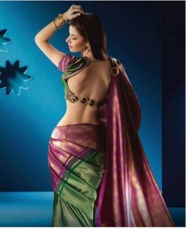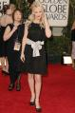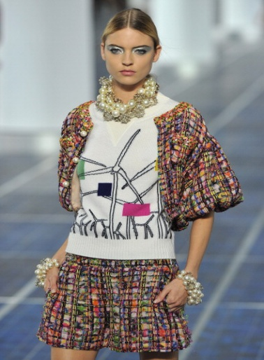
(4).Rhythm: The pleasing arrangement of the design elements so the eye moves well over the apparel. It directs the flow of eye movement.
- Repetition: Can be a repeat of lines, shapes, colors, or textures
- Gradation: Also called progression. An increase or decrease in design elements.
- Transition: A fluid rhythm created when a curved line leads the eye over an angle.
- Opposition: hen lines meet to form right angles.
- Radial Arrangement: Line comes from a central point.
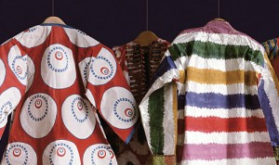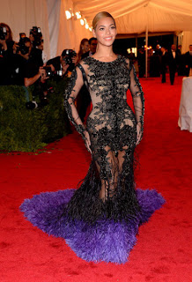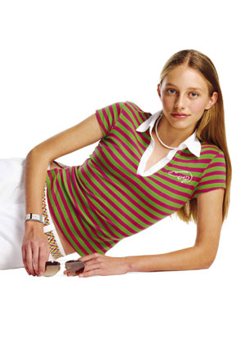

(5).Harmony: Harmony occurs when the overall design, garment, or ensemble achieves visual unity when the elements of design (color, shape, line, and texture) are
Used effectively within the parameters of the principles of design (balance, proportion emphasis, and rhythm) harmony is created, All parts of the ensemble need to work together to achieve the desired look. Whether an ensemble is harmonious or not depends upon the subjective opinion of the observer. This principle refers to the visual quality of wholeness or oneness that is achieved through effective use of the elements of art and principles of design
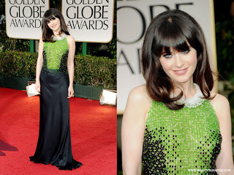

Q2(b). The principles of design serve as guidelines for applying the elements of design to a design-related task. Clothing and fabric designers utilize these guidelines in order to achieve a visually pleasing or harmonious design that the consumers will integrate into their personal wardrobes. Whether designing clothing or mixing and matching clothing in a personal wardrobe, the principles of design can be a useful tool to simplify the process of looking one’s best. Designers may not consciously think of these principles as they work, but when something is wrong with a design, they are able to analyses the problem in term of proportion, balance, repetition, emphasis or harmony. The first four principles work together to create the ultimate goal of harmony. These principles are flexible, always interpreted within the context of current fashion.

Activity (part 1)
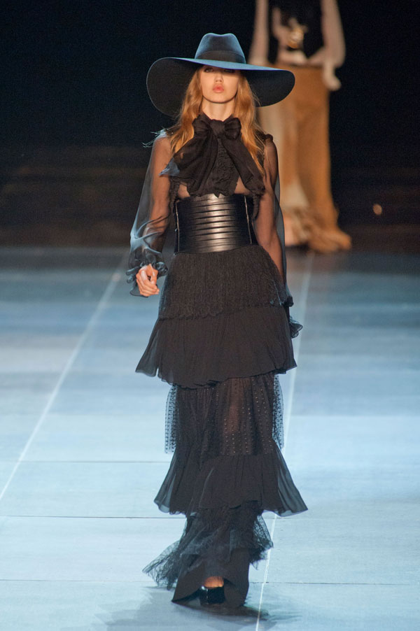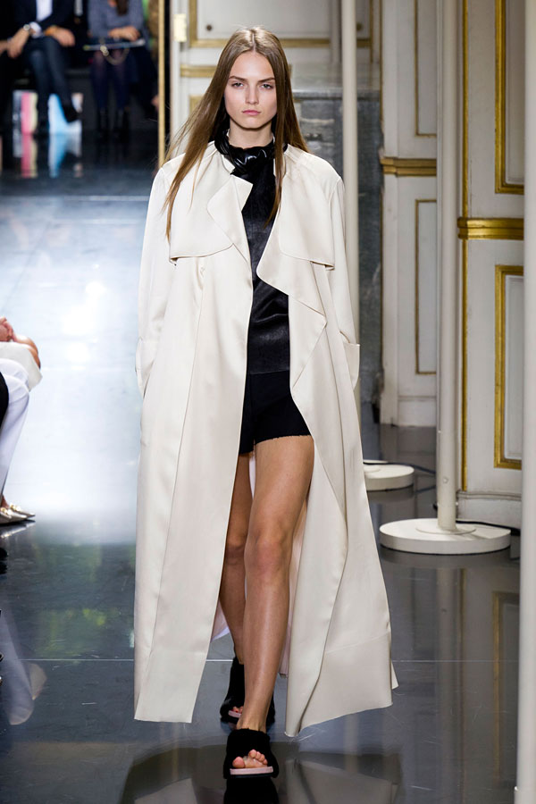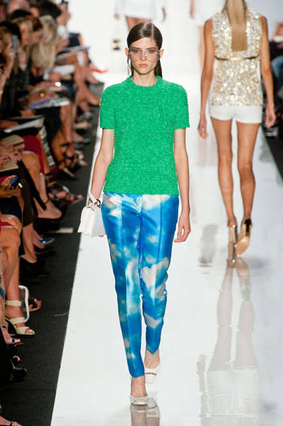
Dress (a) Dress (b) dress(c)

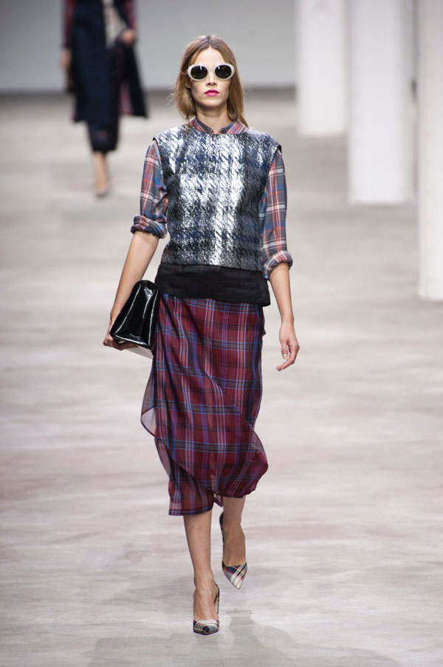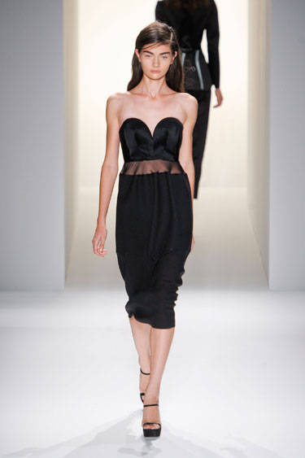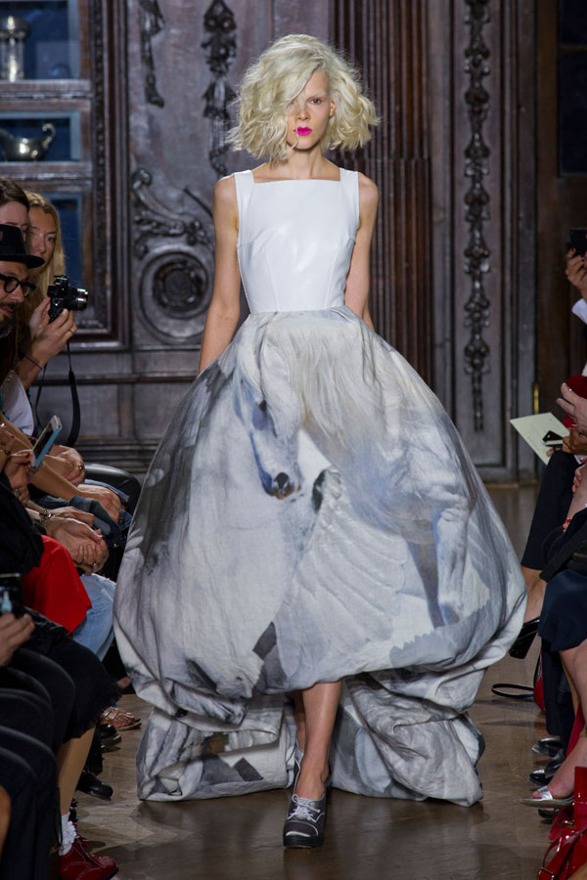

Dress (d) Dress (e) Dress(f)

Dress (a): There is a touch of Dom in the dress. For all the frills, ruffles and layers of tulle, there is a severity in the leather belt and notched stilettos that suggested something tough and uber sexy. The principle Rhythm is dominant in this dress and harmony is achieved.
Dress (b): There is no strict silhouette in this dress. Everything has a little extra room-the oversized button and zip-free coats; the long sexy dress with frayed hems and waist-deep.
Dress(c): In this dress the color story is bright and primary, the look working like color blocking combo is rich green sweater and pant looked like a cloudy sky. The element color is dominant in this dress.
Dress (d): This dress start with the plaid and a balance of slim and louche silhouettes and a touch of shine. Here the principle Rhythm is dominant in this dress and the harmony worked.
Dress (e): In this dress there are sheer strips across model’s mid-riff, acting like the middle ground between two concepts. The bustier above the waist is tailored and strict. The fabric below the waist is slightly gathered and moved easily. The element silhouette is dominant in the dress and all the elements and principles worked together.
Dress (f): This dress is ball gown dress with a prim mid-calf hem is printed or textured with Pegasus and birds. The element Texture is dominant in this dress.

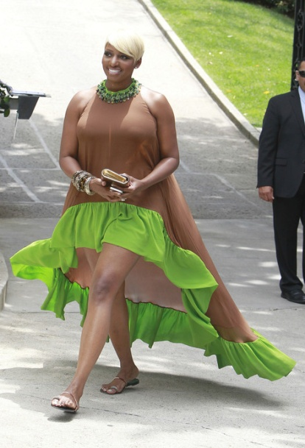
Activity(part 2) Unsuccessful dresses:
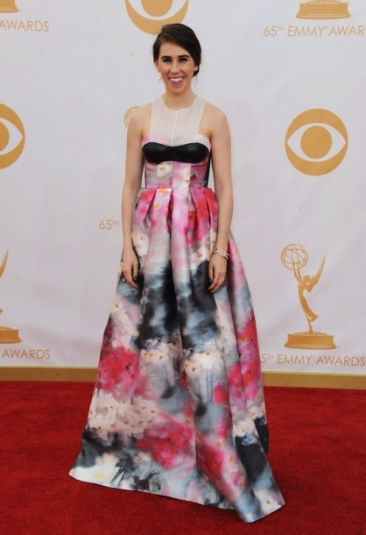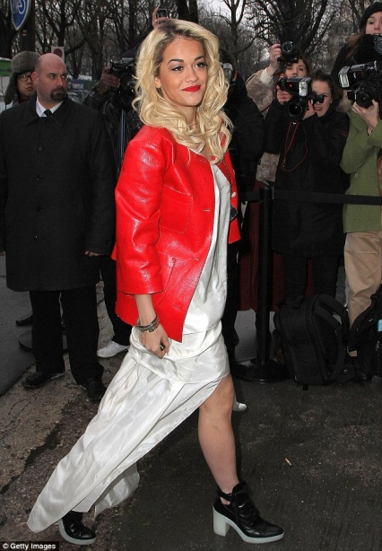
Dress (a) Dress (b) Dress(c)
Dress (a): I like the colour, but the lime green trim and the uneven cut from front to back makes her look larger than she really is. Here the principle Proportion is not used properly.
Dress (b): I like the bottom half of this dress so much. And then there’s odd thing going on in the bodice, which seems to be saying, “Hello. I have small breasts. If the black leather is there in case she needs an extra shoe or something. Harmony is not achieved here.
Dress(c): a floor-length white wedding dress is teamed with a red leather jacket and pair of black thick heeled shoes that featured a luminous white sole. Combination of white wedding dress with red leather jacket is bad. Here the element colour and texture is not used properly.

- Yes, it is true that all the elements and principles work together harmoniously to form a successful design. Harmony can be created in a design when unity and variety are effectively combined. Unity is blending elements in a pleasing way and everything works together. Variety is achieved when the art elements are combined in a various ways to increase visual interest. Harmony is achieved by the combination of two or more elements to make visually pleasing outcome. The first four principles work together to create the ultimate goal of harmony.

