
Assignment Cover Sheet

Student Name: | Elizabeth Abidemi Akinlabi
Student Number: | 1380
Course: | Diploma in Fashion Design
Assignment NO: | 9

Marking Criteria:
We expect the learners to write minimum one well expressed point in three lines against each allocated mark. This means one needs to write 15 lines with 5 well expressed points to get high grades for a 5 marks question.
For high grades use examples and illustrations where appropriate.
Please insert your completed assignment ( in word format) here:

ELIZABETH ABIDEMI AKINLABI
1380
ASSESSMENT 9
PAGE 1

Q1: Write short notes on the following topics:

- Engraved roller printing: The engraved roller printing technique applies designs to fabric by using separate rollers, these rollers engrave each color in the pattern and as the fabric passes through the printing machine, the design is rolled unto it.

- Flatbedscreen-printing:This expensive form of fabric printing, utilizes a screen over a frame. The fabric in the frame is made up of porous nylon, which allows the color to pass through the screen, and the areas that are not to be printed are coated with enamel. To achieve this method of color distribution, a squeegee is worked back and forth.

- Rotary screen-printing: The rotary screen-printing method is a faster mechanized version of the flatbed screen-printing. This method uses a porous roller on the areas to be printed, as the roller rolls over the fabric, dye is forced through the roller cylinder and porous screen, with this method it leaves no

ELIZABTETH ABIDEMI AKINLABI
1380
ASSESSMENT 9
PAGE 2

breaks between screens, in this method of printing, the pigment is attached to the fabric surface with a resin, this is unique to rotary screen printing.

Q2; what is the difference between weft
knitting and warp knitting? With weft
knitting the loops run across or in a circle,
they are also made in a variety of single and
double knits, and can also stretch more than
warp knits. While with warp knitting, several
yarns are used and the loops run vertically.

ACTIVITY

- Examine the fiber content labels in the clothes in your wardrobe. How many garments are made from natural fiber? How does the fiber content affect the care of the garments? I have some dresses and T-shirts made from 100 percent cotton which is a natural fiber, because the fiber content is a 100% natural, it is important to note that cotton shrinks over time, especially when

ELIZABETH ABIDEMI AKINLABI
1380
ASSESSMENT 9
PAGE 3

not dried naturally with sunlight, the dryer
quickens the shrinkage.
On my care labels, most manufacturers recommend, that clothes be washed by hand in room temperature water, and if that is not possible for the wearer a light spin using the delicate button on the washing machine, this care will give longevity to the garment, most of my other outfits are made from synthetic fiber, blends of mostly polyester which are quite easy to care for, machine wash or hand wash, sun dried or machine dried, polyester still holds up, it is a very durable fabric.

- Visit a local store and find examples of weaves, a twill weave, a satin weave and a non woven fabric, collect swatches of each type.

No 1. This satin swatch is an example of a satin weave.
No 2. The felt sample is a non-woven fabric.
No 3. The swatch of jeans fabric is an example of twill weave.

ELIZABETH ABIDEMI AKINLABI
1380
ASSESSMENT 9
PAGE 4

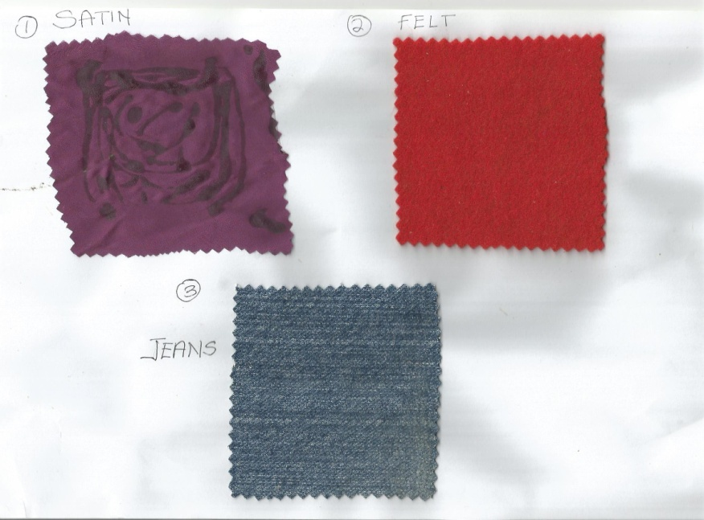

Student Statement:

By submitting this assignment, I confirm that this is my own work.

Student Signature | Elizabeth Abidemi Akinlabi | Date | 22/07/2015

For Tutor / Assessor Use Only
Total Marks
Marks Obtained
Percentage / Grade

