
Brent
Assignment Cover Sheet

Student Name: | Mery Ann Alaba
Student Number: | 1406
Course: | Fashion Design
Assignment NO: | Assessment 9

Marking Criteria:
We expect the learners to write minimum one well expressed point in three lines against each allocated mark. This means one needs to write 15 lines with 5 well expressed points to get high grades for a 5 marks question.
For high grades use examples and illustrations where appropriate.
Assessment 9

Question 1

- a.) Engraved roller printing – is a separate roller engraving used for each
- colour in the pattern. Designed is rolled onto the fabric as it passes
- through the printing machine.

b.) Flat-bed screen printing – This using by the technique screen spread over
a frame. The portions of the design to be printed are made of porous
nylon that allows the colour to pass through the screen.

The areas are not be printed are covered or created with the enamel.

Colour is poured into the frame shell and is forced through the nylon by
means of a squeegee worked back and forth.

Flat-bed screen printing is versatile but expensive.

c.) Rotary Screen Priority – A mechanized version of bed screen
this is a mechanized version of flat-bed screen printing. In this method,
the roller itself is porous in the areas to be printed. Dye is forced into the
roller cylinder and through its porous screen as it rolls over the cloth. This
method is faster than flat-bed screen printing and is continuous, leaving
no breaks between screens.

Question 2

The difference of weft knitting and wrap knitting are when the loops run across or in a circle the process called weft or circulating knitting. This is the least expensive method of conveying yarn into fabric as well as weft knits are made in a wide variety of single and durable knits and gradually have mote stretch than wrap knits, While wrap knitting multiple yarns use the loops run vertically it is include tricot and raschel. In company one weft or wrap knit fabric with another people in the trade refer to the cut or gauge the number of needles per inch the none needles there are, _______-and closer the knit loops are.

Activity 2.

- Most of my clothes in my wardrobe are made in natural fibres, maybe because it is more convenient to ware, also I notice many people wear natural fabrics primarily for ecological reason but we know there also verified health reason for placing only natural fires against our skin. The inherent characteristic of natural fibres advantages in breathability, temperature regulation, durability, water absorption, antimicrobial properties and more rather than synthetic fabrics. Man-made fibre will affect the environment and new fibres that not only possess important health attributes comparable to natural fibres, but also are manufactured using the principles of sustainable management and high environmental standards.

- Plain Weave – It is simplest most common weave

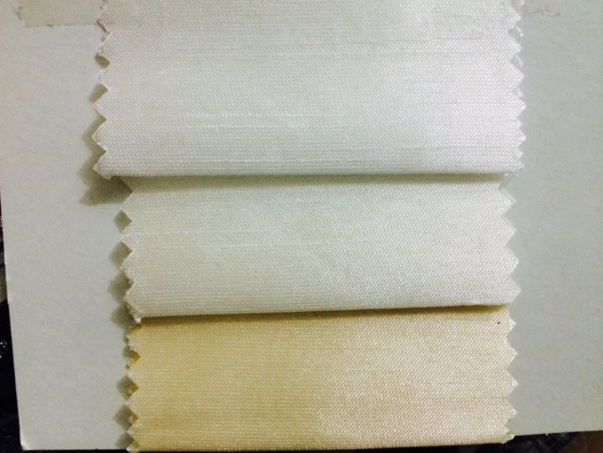

Twill Weave – Filling yarn passes over a number of warp yarns before going under gone

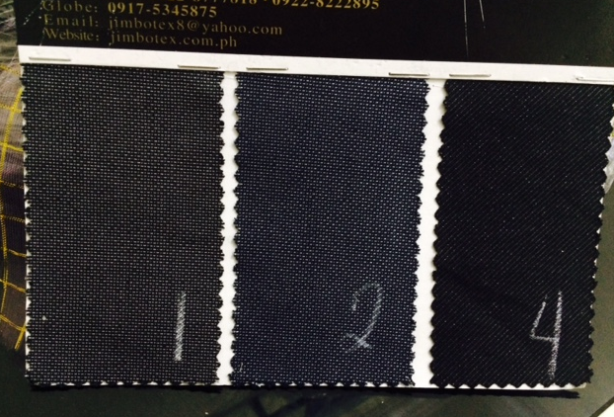

Satin Weave- It is achieved by one warp yarn crossing over several filling yarns, creating floats on the face side of the fabric. The floats give the fabric lustre and smoothness.

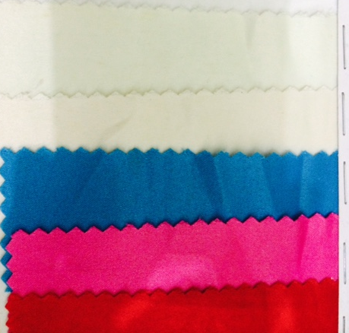

Non woven fabric – (or engineered) fabrics are made by either bonding or interlocking fibres filaments, or yarn into a web or sheet by mechanical (pressure), (chemical, thermal (heat) , or solvent means.

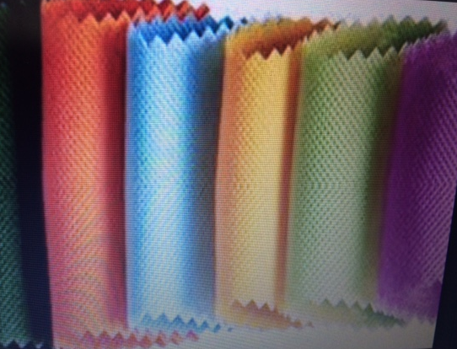

Student Statement:

By submitting this assignment, I confirm that this is my own work.

Student Signature | Mery Ann P. Alaba | Date | 20 Dec 2015

For Tutor / Assessor Use Only
Total Marks
Marks Obtained
Percentage / Grade

