
Assignment Cover Sheet

Student Name: | Omnia Rafiq
Student Number: | 1343
Course: | Diploma in interior Design
Assignment NO: | 4

Student Statement:

By submitting this assignment, I confirm that this is my own work.

Student Signature | Omnia Rafiq | Date | 5/12/2014

For Tutor / Assessor Use Only
Total Marks
Marks Obtained
Percentage / Grade

Q.1.I. What do you understand by the term ‘human dimensions’? How important it is to consider for an interior designer when planning interior schemes?

A designer needs to be familiar with the amount of space there would realistically be required for certain activities in order to create spaces that are comfortable for the end-users. The amount of room required for certain activities- putting a baby into a cot, shrugging on a coat, towel drying after shower or making a bed. Also the most convenient height of a working surface or storage access-all has to be considered at initial planning stage of a project.
In all planning sufficient space needs to be allowed around furniture for the opening of drawers, windows and cupboard doors.

For example, The dimensions of a dinning place:

The Place setting is made up of a studied arrangement of dinnerware and related accessories. During the dinning process, It is transformed into a state of disarray, Covering a larger zone of the table than at the beginning. This group of photos drawings figuratively labelled shows these zones in relation to tables of varying depth. The centre strips represent the surface available for serving dishes, flowers, etc. If we allow for the intrusion of these elements into contiguous zones, a smaller depth will be adequate for their comfortable placement.

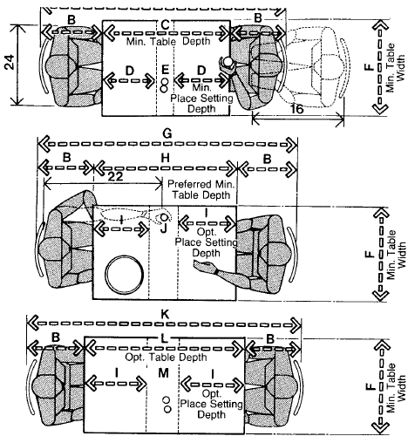

Another example for dimensions that an interior designer must be familiar with:
Total space needed for office furniture, with enough storage space, Good circulation plan must be obtained, Top working surfaces heights chosen must be adequate with eye level, for obtaining comfortable placement...

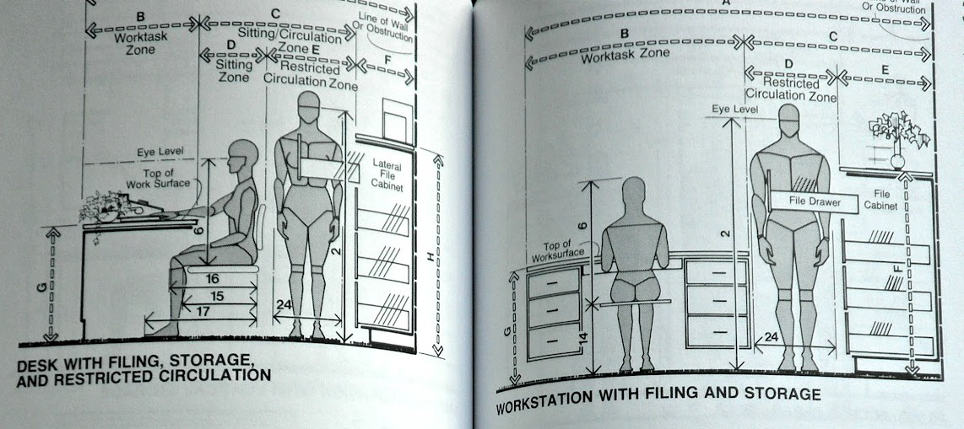

Q.1.ii. How different contrasts can be introduced into an interior scheme? What is their importance in a design scheme?

Contrasts can be introduced into interiors in many ways: for example, contrast of form, different shapes, heights and sizes, contrast of colours, contrast of textures and contrast of light and shades.

Skilful Use of contrast examples:
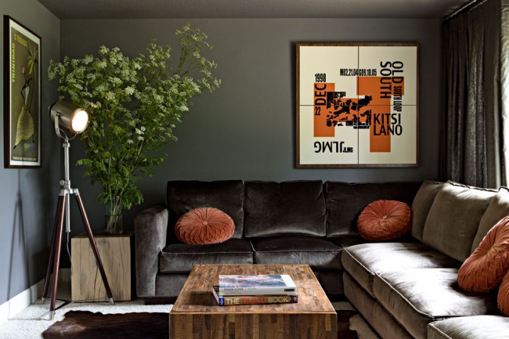

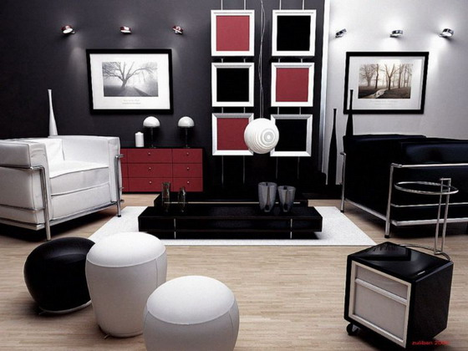

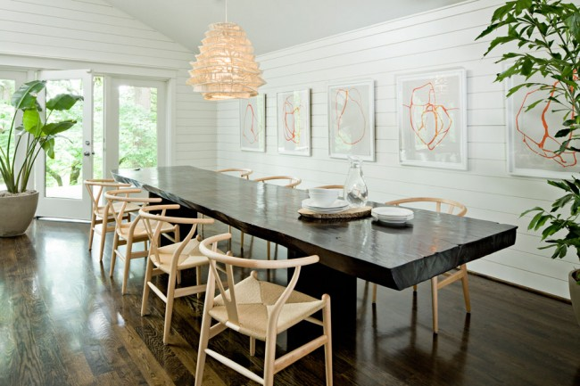

Q.1.iii. What is repetition and how it can be used in an interior scheme to achieve rhythm?

Repetition is the simplest way to attain rhythm and can be achieved by using of same element more than once throughout a space. (line, colour, texture and pattern, light, and scale and proportion) or other design concepts in an organized and regular way. Taking into consideration that Too much repetition unrelieved by contrast of some sort leads to monotony and too little repetition leads to confusion and that repetition with variation is interesting, without variation repetition can become boring. If you wish to create interest, any repeating element should include a degree of variation.

To add personality to a room, use the design principal, repetition.
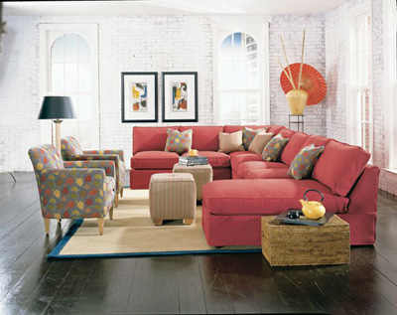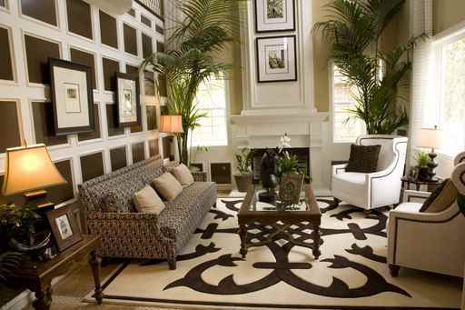

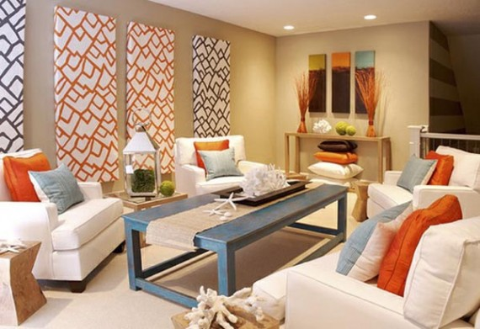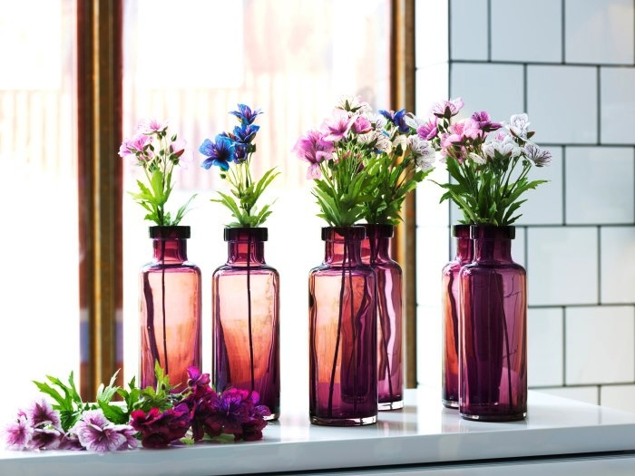

Q.1.iv. ‘Progression is taking an element and increasing or decreasing one or more of its qualities'. Give two examples explaining this above statement.

Progression is taking an element and increasing or decreasing one or more of its qualities. The most common example of this could be one type of item used in different sizes. The most obvious implementation of this would be a gradation by size. A cluster of candles of varying sizes on a simple tray creates interest because of the natural progression shown. Progression can also be achieved via colour, such as in a monochromatic colour scheme where each element is a slightly different shade of the same hue. Progression can also be achieved through the order of similar artworks increasing in height along a staircase, leading the eye to the next level.

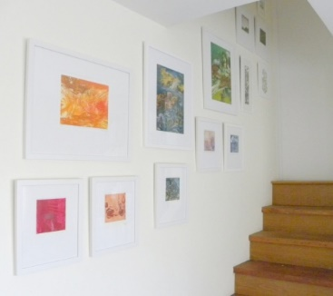

Progression achieved by using item in different sizes

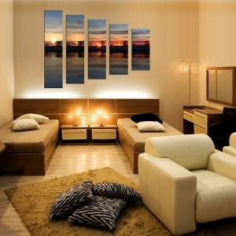

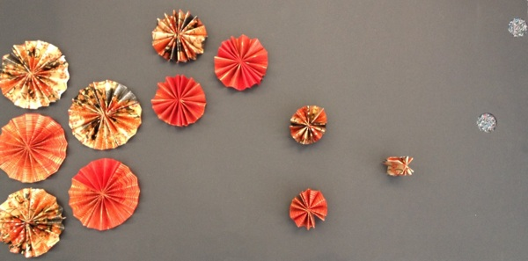

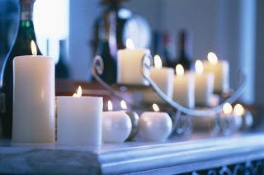

Progression achieved by using monochromatic colour scheme

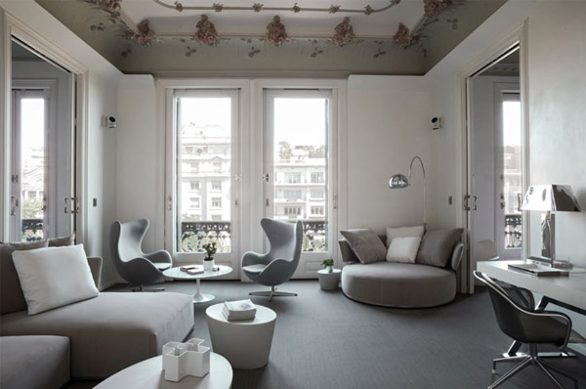

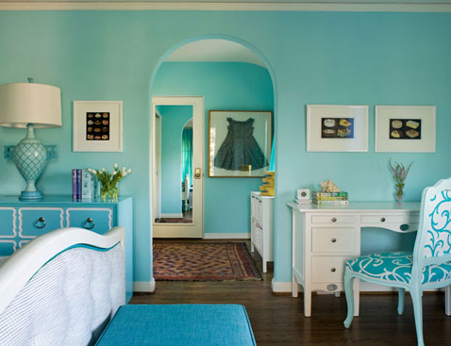

Q.1.v. ‘Too many disjoined elements can be dis-quietening to the mind’s eye’. How can an interior designer avoid this in an interior design scheme?

To avoid too many disparate and disjoined elements in a space, a designer can make use of rhythm. (Which is defined as continuity, recurrence or organised movement).
It’s the repetition of elements in space and time. There is always a beginning and an end to the pattern. By thinking of columns, or an organized grouping of photos. Also by creating balanced and harmonious interiors. There are different styles of balance: symmetrical, asymmetrical and radial.
To achieve rhythm, One has to think about repetition, progression, and transition. These mechanisms will impart a sense of movement to a space, leading the eye from one design element to another. Repetition is the simplest way to attain rhythm and can be achieved by repeating any of the elements of design (line, colour, texture and pattern, light, and scale and proportion) or other design concepts in an organized and regular way more than once. Progression is taking an element and increasing or decreasing one or more of its qualities. It can also be achieved via colour, Like using monochromatic colour scheme. Where each element is a slightly different shade of the same hue. Transition is a little harder to define. Unlike repetition or progression, transition tends to be a smoother flow, where the eye naturally glides from one area to another. The common example of this can be curved lines to gently lead the eye, such as arched door way or winding path.

For example,
Rhythmic interior design is here achieved by applying transition and repetition mechanisms
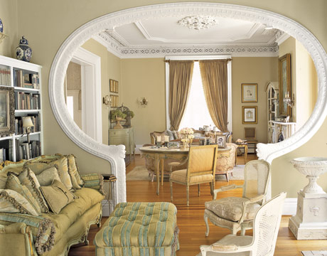

Here the interior designer has applied the repetition technique
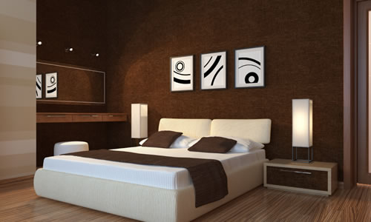

While here, Rhythm is achieved by applying harmonious colors and a well-balanced (radial) interior
Beside the progression of the small decorative elements.
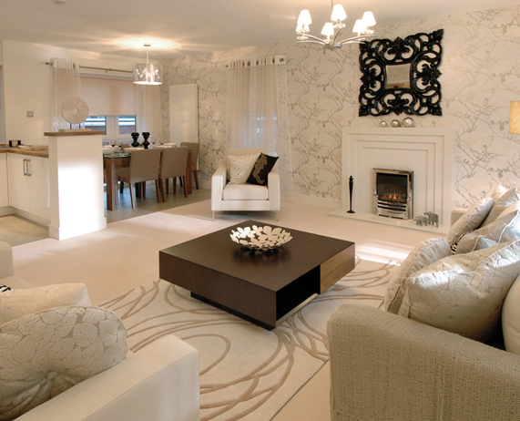

Balanced rhythmic design achieved by Symmetry and progression of elements.
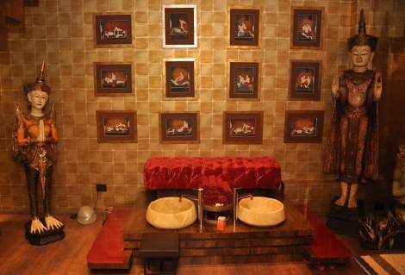

Q.1.vi. Why is it important to consider the purpose of an interior space when planning a design scheme for it?

Although a designer will be aware of the aesthetic and holistic aspects of any space being planned, function and practicality are the obvious priorities. An area must be planned for a particular purpose or set of purposes. Any place being planned must cater the needs and activities of the people occupying that space, with special attention given to any physically challenging users.

Q.2. ‘Circulation through a space is a crucial aspect of a design’. Elaborate.

Circulation Frequency refers to the number of times a route is repeated in any given period of time. Generally routes with high circulation frequency are short and direct in a good floor plan.
. A designer working on a restaurant, for example, might generate a traffic-flow plan to ensure that staff and guests can move about the space in comfort and safety, from entrance to the tables, from tables to the toilets and so on. In all planning sufficient space needs to be allowed around furniture for the opening of drawers, windows and cupboard doors.

Types of Circulation
- Family—follows each member of the household throughout home; most complex
- Work—kitchen is generally the hub of work circulation
- Work triangle—route between the sink, refrigerator, and range Should not exceed 22 feet in length

- Service—relates to the movement of people in and out of the home as they make service calls, deliver goods, read meters, take garbage out, etc…

- Guest—involves movement from the entry to the coat closet and to the living room with access to a powder room

Room Relationships
- Dictate how functional a space will be
- Examples:
  - Dining area adjacent to the living room for convenience in entertaining
  - Kitchen should be adjacent to the dining room for ease in serving food.
Bathrooms should be located close to bedrooms for convenience and privacy

Effective Circulation Guidelines:
- Rooms should not be cut in half due to circulation paths.
- Related rooms are close together.
- Bathrooms should be located next to bedrooms.
- Locate the kitchen near the garage and service entrance.
- Excessive hall space is avoided.

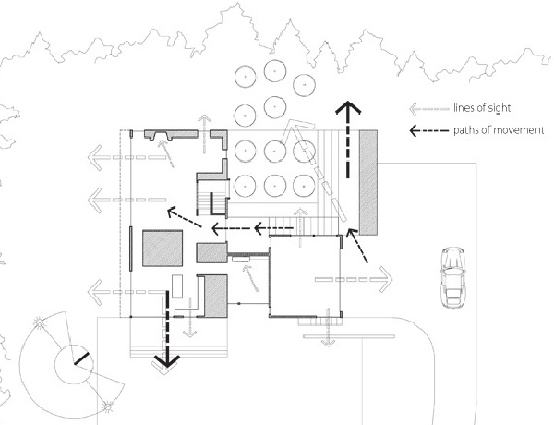

Q.3. At which stage of a design project should the services like heating, lighting, plumbing, electric etc. be considered?

The services though often unseen and perhaps the most appealing part of the planning process, have to be considered at the outset of a project. These services include heating, lighting, plumbing, drainage, electric, air conditioning, security and integrated entertainment or communication systems. A designer cannot be an expert in all these fields at the same time, especially in this era of advanced technology, it would usually be necessary to work with specialist companies. However in order to make design decisions and to communicate with specialists on site, the designer must ensure that they are as well informed in these areas as possible.

