
Assignment Cover Sheet

Student Name: | Martin Selley
Student Number: | 1328
Course: | Safety In The Workplace
Assignment NO: | 1

Marking Criteria:
We expect the learners to write minimum one well expressed point in three lines against each allocated mark. This means one needs to write 15 lines with 5 well expressed points to get high grades for a 5 marks question.
For high grades use examples and illustrations where appropriate.
Question 1 - What is a work place safety culture?
Answer -
A work place safety culture can be briefly described as “The way(s) that safety is seen, and managed at the workplace”. It can be seen as the attitudes, values and beliefs that the company, and its employees strive to attain.
A safety culture, typically, embodies the companies and employee’s attitude and beliefs in terms of health and safety performance. It comprises elements such as individual and group values, patterns of behaviour and shared perceptions.
The following are key fundamentals to achieving/maintaining a successful Safety Culture:
- Management commitment
- Employee participation
- Open and visible communications
- A no blame culture
- Visibility – Management leading by example
- Audits/performance reviews
- Relentless pursuit in the identification and elimination of hazards
- Training, as/if required
- Rewarding success
- Continuous improvement/learning cycles
It must be made clear that a ‘Safety Culture’ is not the policies, procedures or workplace practices that companies use on a day to day basis. These programs and policies’ are in place to underpin the values and beliefs that form part of a Safety Culture in the workplace.

Question 2 - a. What organization governs occupational health and safety in your area?
b. What areas do they have legislation on?
c. What other safety resources are you aware of?
Answer -
a. In my area; Oil and Gas Sector, Basra, Iraq - the Organisation that Governs Occupational Health and Safety is The Ministry of Oil. To my knowledge the Draft Hydrocarbon Law (2007) was approved by the Iraqi Cabinet, but disagreement between various parties has prevented the Law being approved by the Iraqi Parliament. However the Draft forms the backbone of guidance to Operating companies. For the Kurdistan region; the Organisation that Governs Occupational Health and Safety is the Kurdistan Regional Government, through the KRG’s Oil and Gas Law of 2007.
In the main the Ministry of Oil puts the onus for Occupational HSE with the International Operating Companies, IOC’s. The IOC’s primarily work under the Governance of the Laws/Regulations applied in their home/base countries.
b. The areas they have legislation on include, but not limited to, the following:
- The Management of Petroleum resources
- Exploration & Field Development operations
- Hydrocarbon Transportation
- Gas
- Environmental Protection & Safety
- Conservation

c. The other safety resources I am aware of are primarily those of the various IOC’s I have worked for in the past. As these Companies have mainly been either UK, or US based I have also had exposure to both the UK’s Health and Safety Executive and the US’s OSHA.
All of these Companies insist on; as a minimum, Safety Inductions and specific (task related) Training as appropriate. Each of these Companies also has Risk Assessed Control of Work/Permitting Systems in place, most of which these days are electronic. On my current assignment, as an example, all employees must attend ‘Safety Passport’ Training which covers the following areas:
- Personal Protective Equipment
- Driving
- UXO (Unexploded Ordnance)
- Lifting operations
- Working at heights
- Permit to work
- Energy isolation
- Ground disturbance
- Confined space entry
- Management of change
To compliment this type of training it is common to issue everyone with a Safety handbook as an aide memoire.

Question 3 - Outline the steps involved in Creating a Safety Committee
Answer -
- Determine that there exists the need for a Committee to be set up. Small organisations may not require a formal committee structure.

- Draft Terms of Reference to be created.

- Determine composition of committee; specify members, at this stage individuals do not have to be named, positions should suffice. (See image below for typical set up).
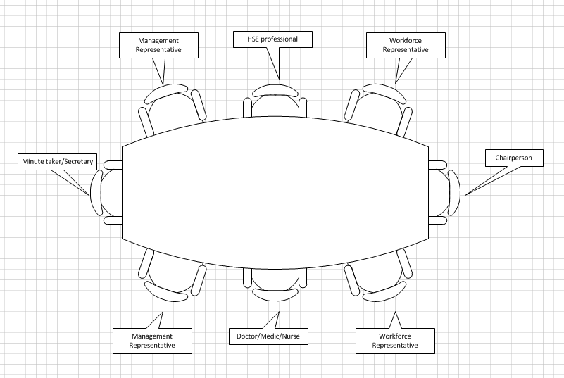

- Set time and draft Agenda for kick off meeting, determine frequency of meetings.

- Determine an auditable process to monitor that the committee is meeting its objectives

- Hold first committee meeting

The above steps outline the basic requirements for setting up a Safety Committee; what follows gives a bit more detail for each of the steps.

1 – Determining if a committee needs to be set up is down to agreement between the employer and their employees.
Things to be considered in this process include:
- The number of employees – consider shifts!
- Size/location of the workplace (multiple sites)
- The different types of work carried out
- The potential/inherent dangers that exist due to the nature of the work carried out
2 - Terms of reference/duties of the safety committee may include:
- Hold meetings at a regular frequency, minimum every quarter
- Clearly identify roles and responsibilities of committee members
- Put in place a process to review near misses, unsafe acts, first aid cases etc.
- Carry out safety audits
- Promote safety in the workplace, posters, campaigns, training etc.
- Identify high risk tasks and try to eliminate, or reduce, the risk through appropriate controls/procedures.
3 – Committee composition
The number of people on the committee will vary from company to company.
There should be equal representation from both management and employees. A chairperson should be appointed who has sufficient experience in safety matters and be someone high enough in the organisation that has the respect of both management and employees. There should be an HSE professional as part of the committee, assuming of course that the company employs such personnel. Someone from the medical profession, company Doctor, Nurse or Medic can provide valuable input. Finally there needs to be someone to perform the role of secretary/minute taker, preferably someone impartial.
4 – First meeting
The first meeting would typically run as described below, Agenda will have been distributed beforehand:
- Committee member introductions
- Opening statement from Senior management Group outlining reasons why committee was set up and its objectives
- Agree ground rules for conducting the meeting
- Nominate/agree Chairperson and Secretary
- Determine/agree tasks to be reviewed and actions to be recorded
- Agree location, time and agenda for subsequent meeting’s
5 - Define an auditable process
This is something that can be driven / defined by existing Auditing procedures that the company may already have/comply with. An HSE professional should work with this group/individual to provide a process that the committee can review and agree on.

Student Statement:

By submitting this assignment, I confirm that this is my own work.

Student Signature | Martin Selley | Date | 21-APR-2015

For Tutor / Assessor Use Only
Total Marks
Marks Obtained
Percentage / Grade

