
Assignment Cover Sheet

Student Name: | Annur Zara Liyana Othman
Student Number: | 1227
Course: | Diploma of Fashion
Assignment NO: | 5

Student Statement:

By submitting this assignment, I confirm that this is my own work.

Student Signature |  | Date | 5th June 2014

For Tutor / Assessor Use Only
Total Marks
Marks Obtained
Percentage / Grade

Elements of Design
Q: 1. Give short answers for the following questions:

I. What is meant by ‘weight and hand’ in textile industry?
In choosing the perfect fabric for making a garment, designer have to pay attention in few factors. Those are weight and hand. These are the terms in textile industry.
Weight can be refers as the weight of the garment. Different fabrics offer their own weigh. For example, Duck Cloth fabric known as heavy, plain-woven cotton fabric. Its used a lot in making pants and jackets. Those garments that made from Duck Cloth are very strong and hard to tear up. Meanwhile the fabric like Fleece is very lightweight even its look like heavy. This fabric is widely used in making garment especially for cold season. It dries quickly, able to insulate even when wet, and its machine-washable. It’s very comfy to wear because its so light.
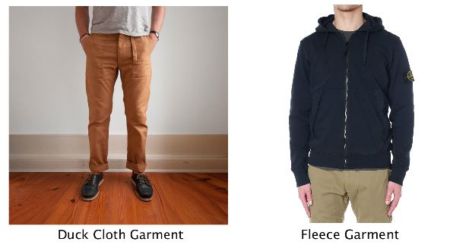

Example of heavyweight and lightweight garment

Hand can be refers to the feel of the garment. Its very important because how the fabric going to feel will influence the whole garment. For example, fabric like Silk, which made from a natural protein fibre, some can be woven into textile. Silk is smooth, glossy and beautiful. It’s also strong and vulnerable to fading and stains. Meanwhile the fabric like Tweed can give a rough feel when touching it. Its made in either plain or twill weave and may have a cheek or herringbone pattern. Tweed is desirable for informal and formal outwear, being moisture resistant and very durable.

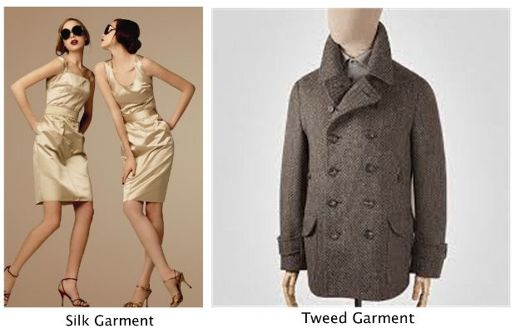

Example of smooth and rough garment

II. Name the warm colours. How best these can be used in dress designing?
Red, yellow and orange can be qualified into warm colours. Its because the these colours resemble with fire and the sun. It can give an aggressive, lively look which mean can stimulate the wearer mood.
Red
It resemble passion and its widely use for valentines, love and romance. Its also exciting, fiery, and dangerous. The colour can give high intense for clothes in very season. Its widely chosen for sportswear and evening wear. For dresses designing, designers tend to use red colour fabric because the colour itself can boldly represent the wearer mood and personality. Study says, person who wearing red tend to be a brave and confident.
Yellow
The colour itself can speak the mood. Its bright, sunny, cheerful, friendly and optimistic. However, most wearer have a common problem to wear this colour because its against the skin tone. The wearer should choose very well when they want to wear yellow because it can be so bright full and great or it can be super outstanding and awkward. For dresses, yellow dress is very popular in the spring season because it can resemble the flower and daylight colour. Its also give a bright feeling.
Orange
Known for well combination from yellow and red. Its give the bright yet warmth look. This colour also can be difficult to wear because it can be really tricky. For example, intense orange can be irritating and overpowering, it best tone to softer peach or apricot or limited to use in active wear. For dresses, this colour somehow really match the wearer wants. Let say the wearer want to wear a dress that can make she fell great and confident or a dress that can make she stand out but in the same time she want to look sweet and bright. So, in this case orange dress is a perfect answer.
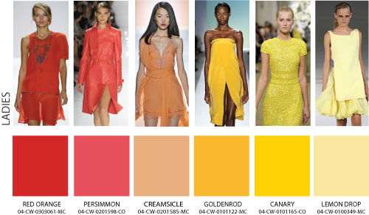

III. Why it is important for a designer to consider the scale of a pattern, when using patterned fabric in dress designing?
When designer design a dress for example, they have to decide either the pattern or the line & detail that they want to show more. Its really important to consider and give a big think for this matter because the last look of the garment is depending on these first decision. For example, if the designer wants a large print to dominate a design, the design shouldn’t be too much in line and detail. Since she/he wants to show the printed pattern on the fabric, so it shouldn’t be cut up with seams and the unnecessary details. In other words, the design should keep simple.
Meanwhile, for the designer who wants to show the line and detail, the fabric should be plain. So this way designer can freely design the line or silhouette without worrying about the fabric last look and can freely create the details.
For patterned fabric, the style of pattern is very important and the scale of the pattern should match the wearer scale. Its really important because this can change the look of the wearer. In other words, its play the big role in order to show the figure either height and width on the wearer. So, in conclusion, before creating the garment, designer should consider the scale of the pattern especially when using pattern fabric in dress designing.
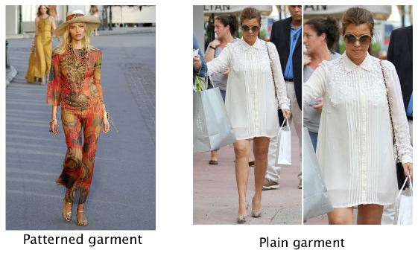

IV. What is the difference between conventional design and geometric design?
For decorative designs, conventional design and geometric design are the popular choices for anytime of garment.
Conventional design can be refers as ad adopted object from the nature and its became decorative.
Geometric design can be refers as the combination or based on circle, rectangle, triangle, parallel line and so on. This design is not derived from nature.

The differences
As the definition, conventional design is based on the nature and its being adapted in the garment design. Meanwhile the geometric design is totally far away from the nature because it basically created from the shape like mentioned before. The conventional design give a comfy and light look and the geometric design can give the interesting look such as futuristic and unique look. However, both got their own speciality yet its so different.
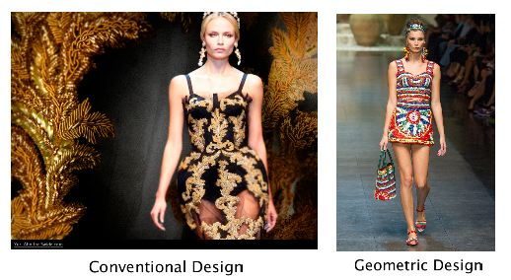

2. Define the term colour dimension. Explain the following terms;
Hue, value, intensity

Hue
Hue is somewhat synonymous to what we usually refer to as “colours”. Red, green, blue, yellow, and orange are the few examples of different hues. The different hues have different wavelengths in the spectrum. In other words, hues enable us to tell one colour from another

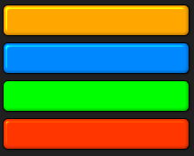

Example of hues

Value
The value is a measurement of the brightness of a colour. The brighter a colour is, the higher its value and the more light it emits. The value scale runs from white to black. For instance, a vivid yellow is brighter that dark blue, therefore its value is higher that that (blue). A good way to see the different in the values of colours is to look at the corresponding greyscale version. The lighter values are called tints and the darker ones are called shades. Close value contrast lend a more conservative, refined impression that is easier for the average person to accept.
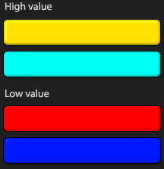

Example of Value

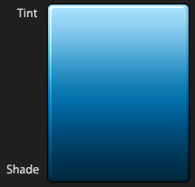

Tint and shade

Intensity
Intensity can also be called saturation. It is a measurement of how different from pure grey to colour is. Saturation is not really a matter of light and dark, but rather how pale or strong the colour is. The saturation of a colour is not constant, but it varies depending on the surrounding and what light the colour is seen in.
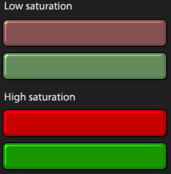

Example of Intensity/Saturation

3. Write short note on the following;
Basic Shapes in dress designing
There are seven basic shapes in dress designing

a) The Lean Column
It’s suitable for the straight body shape. With that simple line, it can make wearer look more slender. Example, long, straight, hanging in loose, graceful folds, ect
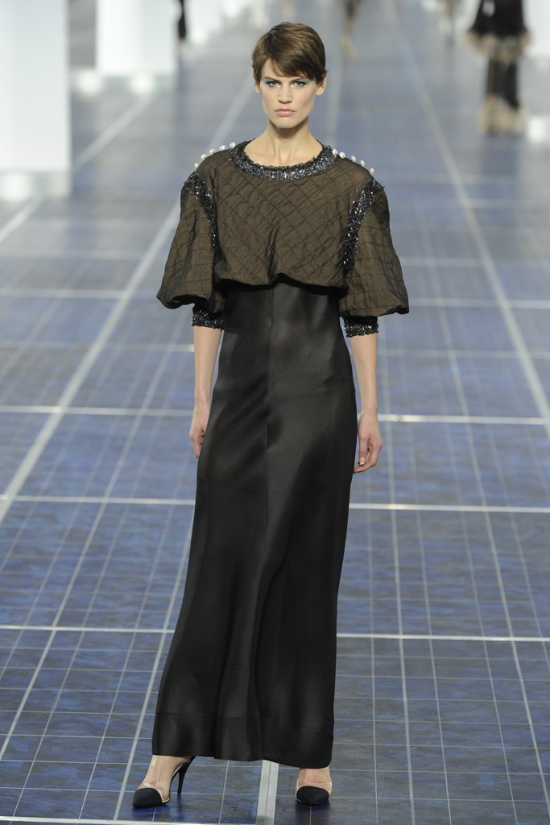

b) Triangle
Known as dress for pear body shape. This shape was invented for covering the bottom part of wearer body.
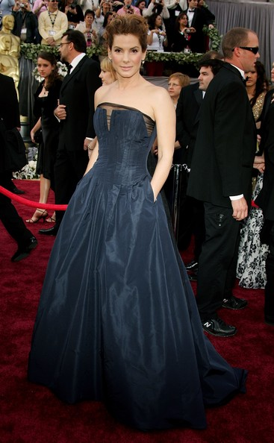

c) Invented Triangle
It created for give a symmetry look with that body shape. Its suitable for large bust.
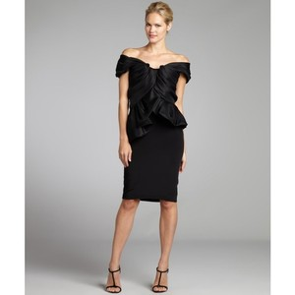

d) Oval
This is very feminine style. Mostly just draped softly moulded to body. Suitable for ideal figure and especially used for eveningwear.
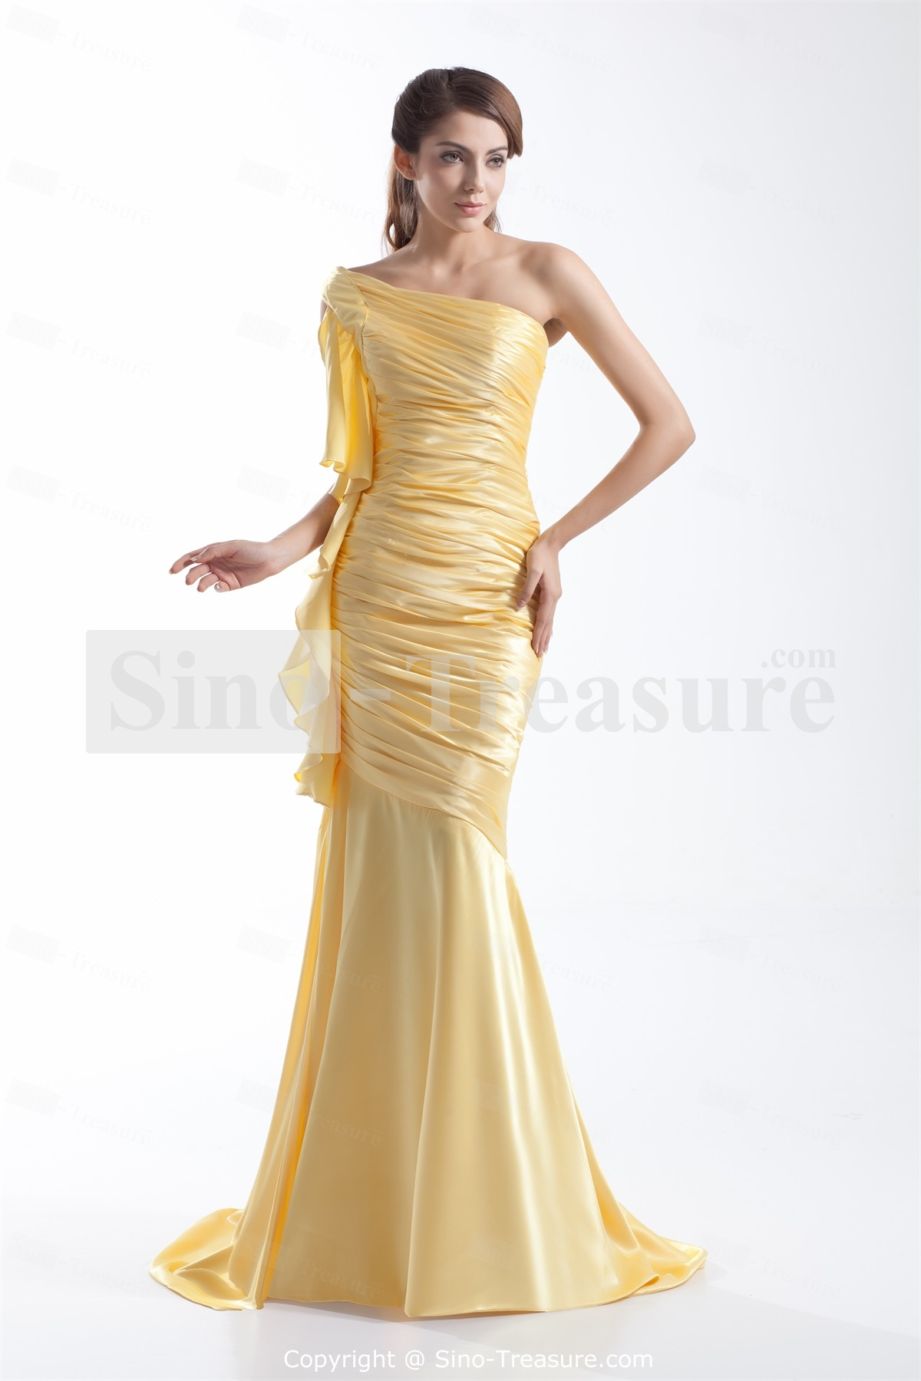

e) Square
A very tricky style that most of them are created for thin figure. However, the good dress can even be wear by various figures.
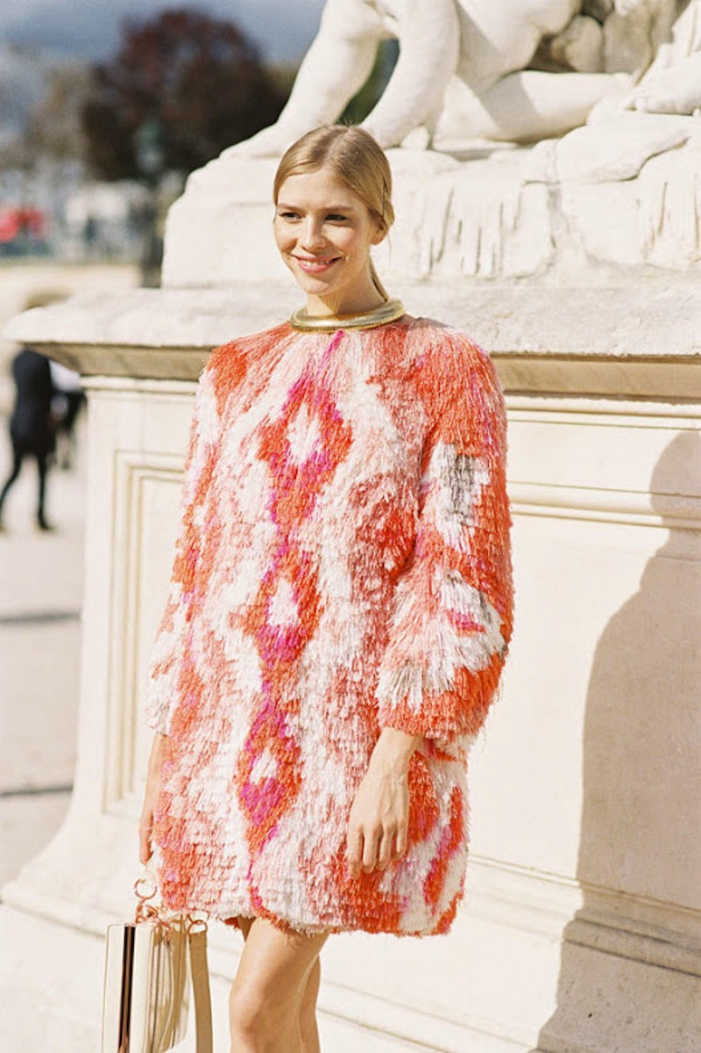

f) Round
Known as very outstanding design. Suitable for formal wear or afternoon frocks. Junior and adult who got a thin figure definitely look good on this design.
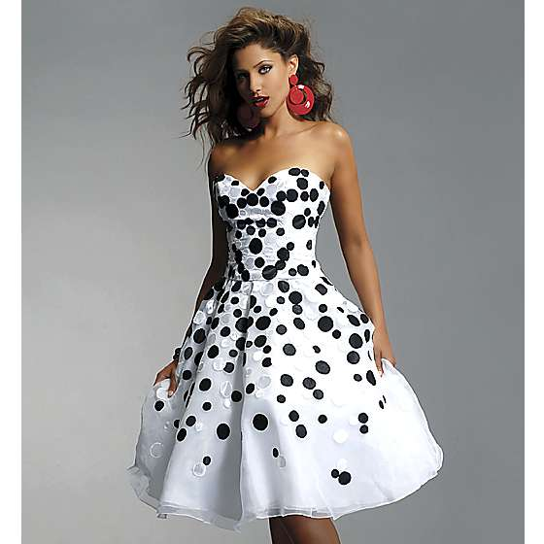

g) Hourglass
Known for a design made for model look-like figure. Its smooth fit over hip and full skirt at the bottom.
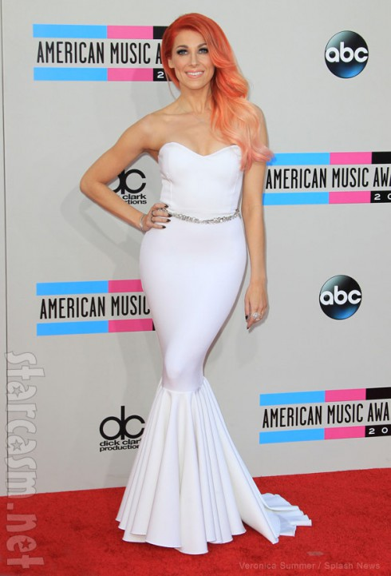

h) Combination
This is made from combining certain design according to certain body shape. Vertical lines tend to slenderise the body. Horizontal lines suggest width. Both repetition and extreme contrast of a line, shape, space or form produce emphasis.

Project
1. Look through costume books for pictures of an historic dress. Using these inspirations, design a garment using the line, shapes, colours and details from the historic garment in a new combination for our lifestyle.

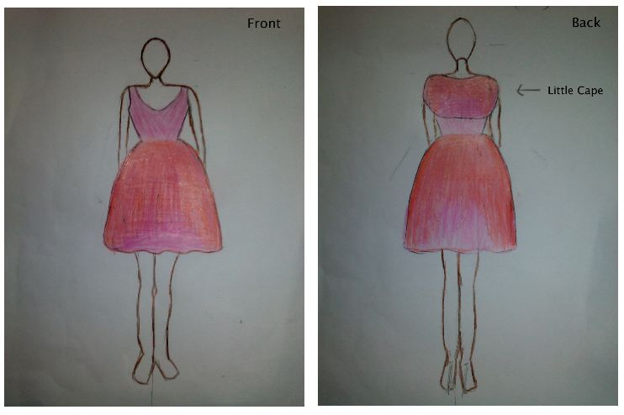
Line : A usual dress silhouette with a simple line.
Shape : Triangle + Round shape
Colours : Pink and red
Details : A little cape
This dress design was inspired by Audrey Hepburn pink dress. 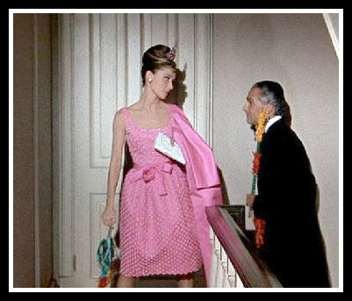
The colours was inspired by the French word Ombre that means shadow. This colour once became a trend and since its really successful before, it sure will come back real soon. I choose pink and red because the colours can tell the cute and sweetness by it looks. Since red colour define energy and passion, the usage of pink can softer a little bit power of it.
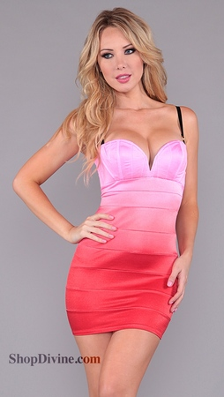
The details was inspired by a vintage dress design. Since the original is a little bit long are wide, I shortened the cape because the dress is pretty small and short and it also shape a little bit round on the bottom part so, if the cape is big it can be too crowd.
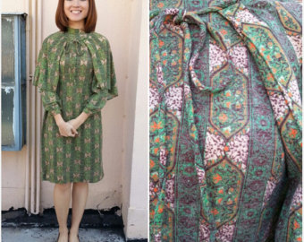

Reference
Information : BOLC unit 5 note, Wikipedia, Fashion magazine, Fashion magazine online, Fashion books.
Pictures : Fashion website, Fashion blog, Certain brand official website, Google Images

