
Assignment Cover Sheet

Student Name: | Sukhwinder kaur
Student Number: | 1282
Course: | Fashion design
Assignment NO: | 9

Answer a.
The piping simplest form of sewn decoration is a line or lines of two thread lock stich closely parallel to a seam or an edge. Gathering draws up fabric by one or more threads to produce frills on edges or hems. Tucks are folds of fabric, holding fullness and used for shaping appearing as pin tucks of very narrow width or graduated tucks on bodices, yokes and so on piping can be used on a seam or edge.
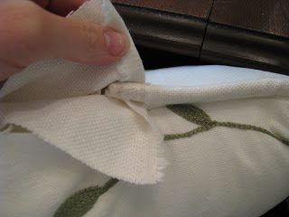
Answer b.
To sew the garments as with many products assembled from components, much of the technique of garment construction is designed to ensure the continuous, finished appearance of the product since fabric edges are often rough and unfinished and fray easily, they must be turned inside the garment. In order to sew a simple seam the edges of two components are positioned face to face stitched together continuously, and opened so that the face of the fabric is on the outside of the garment.

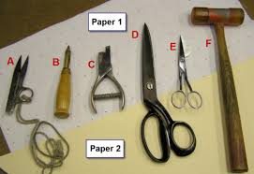
Answer c.
This category includes not only braided trims but also woven and knitted flat decorative trims that are heavier than ribbons. Braded trims are made by interlacing three or more yarms to form a flate narrow fabric. They include soutache, middy braid, braided cord edging,and rickrack. Knitted braids, made by a few needles on a warp-knitting machine, include both flat and fold over braids.
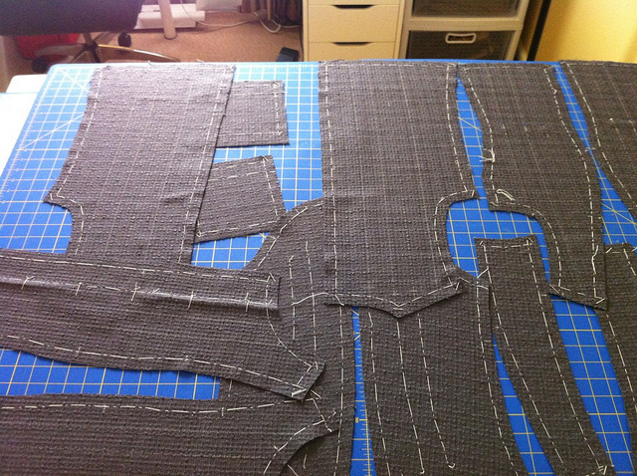
Answer d.
The reinforcement is needed to give a garment support and to keep it in shape longer. The most essential kindof inner construction is the interfacing-a layer of fabric placed between the garment fabric and its facing. Interfacings have always been an important part of garment production, especially for structuring and support in tailored jackets and coats.

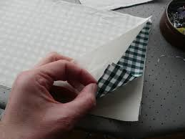
Answer e.
The interfacings are available in three weigth categories light, middle, and heavy. The choice depends on the weight of the garment fabric as well as the support and affect desired. The interfacing should never be heavier than the actual garment fabric.
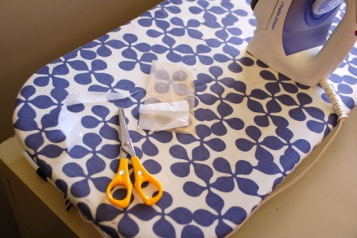
Answer f.
The first pocket which is simply sewn on to the surface of the garment, the patch principle, secondly the pocket which involves cutting through the surface of the fabric in order that the pocket bag may hang on the inside of the garment, the through principle, and thirdly the following parts essential to their function the mouth, which allows the wearer`s hand to enter the pocket.
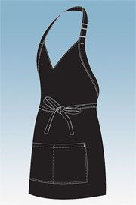
Answer 2.
The pockets are not an integral part of the construction of garment, but are additions which allow the wearer to carry coins, wallet, notebook, keys, comb, pens and so on .
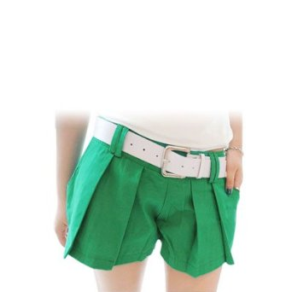
The belt are two types of belt manufacturers. The rack trade sell to retailers, and cut-up
trade sell less expensive belts to apparel manufacturers to be used on dresses, jackets, skirts, pants.
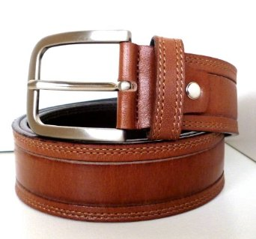
The care labels are the sources of indentification for garments.
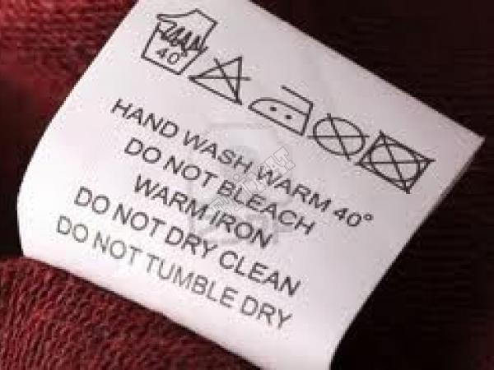
Answer 3.
The appliqué is an individual motif that can be used singly or in multiples as a top trim.
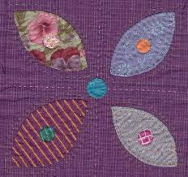
The banding is narrow fabric having two straight or decorative edges that make it, intertion, or accenting of a design line.

The beading is openwork trimming, usually lace or embroidery, through which a ribbon may be threaded.
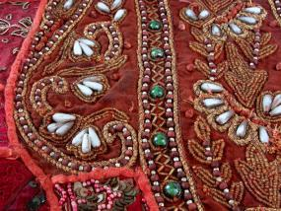
The galoon is lace, embroidery, or braid having two scalloped edges. It can be used as a banding, border, or design-line accent or can be applied just like insertion or a see-through effect.
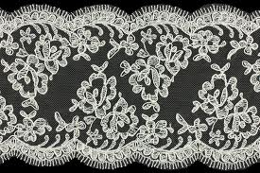
The medallions are a chain of trims with individual motifs that can be used continuously as banding, edging, or galloons, or clipped apart and used as appliqués.

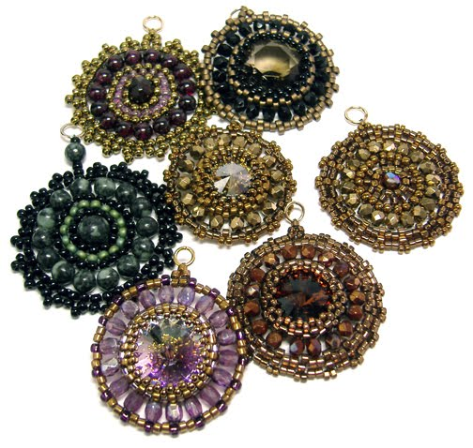

Student Statement:

By submitting this assignment, I confirm that this is my own work.

Student Signature | Sukhwinder kaur | Date

For Tutor / Assessor Use Only
Total Marks
Marks Obtained
Percentage / Grade

