
Assignment Cover Sheet

Student Name: | Omnia Rafiq
Student Number: | 1343
Course: | Interior design diploma - unit 3
Assignment NO: | 3

Student Statement:

By submitting this assignment, I confirm that this is my own work.

Student Signature | Omnia Rafiq | Date | 25-11-2014

For Tutor / Assessor Use Only
Total Marks
Marks Obtained
Percentage / Grade

Q.1.i) What is the difference between fashion and style?

Fashion is what is trendy right now,It’s a relationship to the external,
It can be linked to any specific object. Small details and suitability are not included, it’s all about a matching process between what’s out there, to what we already have. Style on the other hand, is unique to everyone. But, It shouldn’t be adopted for its visual effect alone.
It is cohesive and a pleasing whole, it is concerned about small details, It is something that has been modified and customized on an individual level Showing how well it suits the people living there, besides reflecting their lives and personalities. Considering that the style of every space depends mainly on its function.

Q.1.ii) How can the sense of style been created?

Having a sense of style is achievable by developing interest in this field and acquiring appropriate qualifications, By having a sense of understanding factors like colors, proportions, textures and patterns that should all merge together effectively.
To possess a good sense of style, as a first step is to look at and analyze carefully what pleases and suits oneself. Afterwards, the development of our sense of style follows quickly. All decorative possibilities will open wide after gaining self confidence about our own taste, having developed a good eye, and attaining a good knowledge of various furnishing styles. A proper training and hardworking can open up all the possibilities for an interior designer.

Q.1.iii) What is of great importance when mixing styles together?

Style mix is about choosing a certain style and mixing it with the elements of another style.Bearing in mind that the items from the other style should mix well and coordinate the scheme, without being excessively matched. By doing so, we get new styles, renewing the looks of today’s interiors, making it more refreshingly interesting, and new ideas of interior design to be added to the history.

These are rooms that carry old and new, antique and contemporary, serious and fanciful. For example, a heavy velvet Victorian armchair may be paired with a Lucite coffee table so as to highlight — through contrast — the independent beauty of each piece.

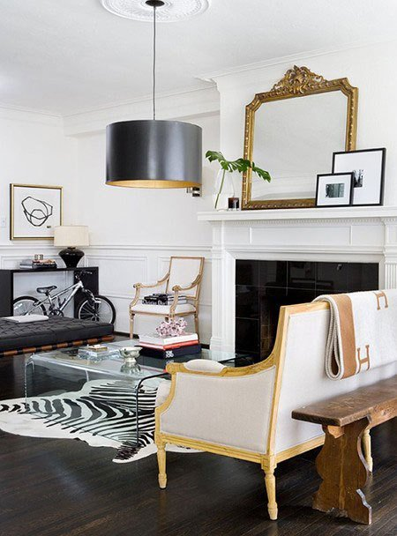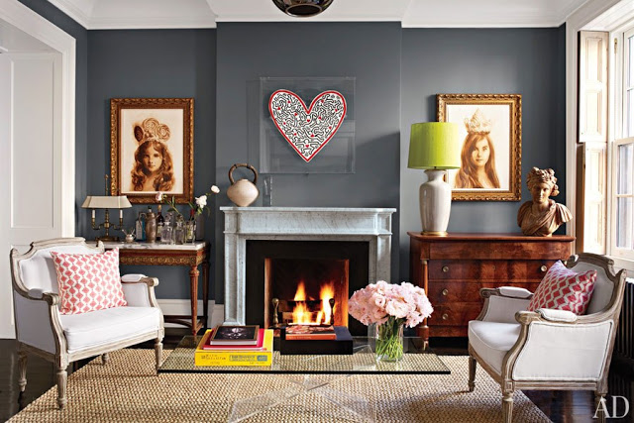

Traditional Furnishings with modern art mix.
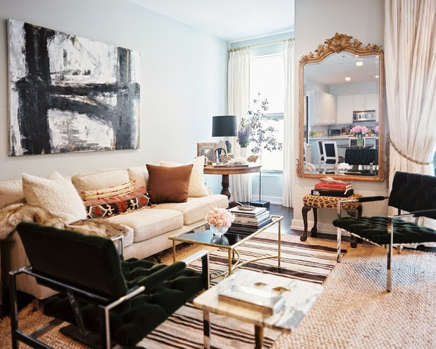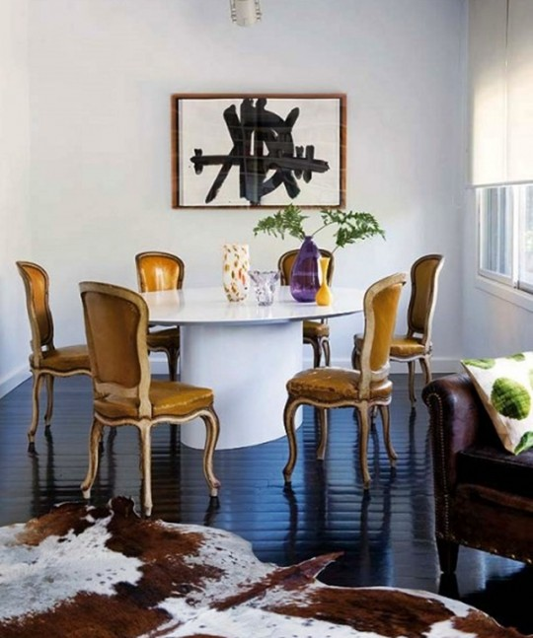

Mixing old and new styles.
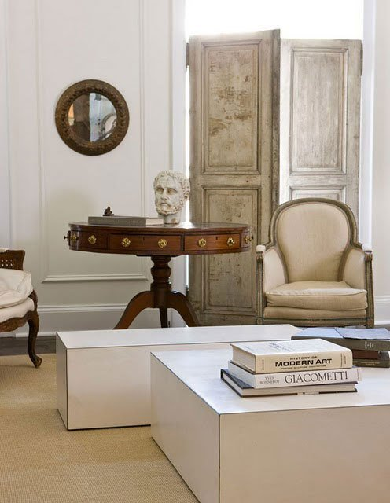

Q.1.iv) What are the key characteristics of American Country style?

The American country style is based on creating very homely and very practical interiors.The key characteristics are :

- Natural wood flooring decorated with plain or checked weave rug.

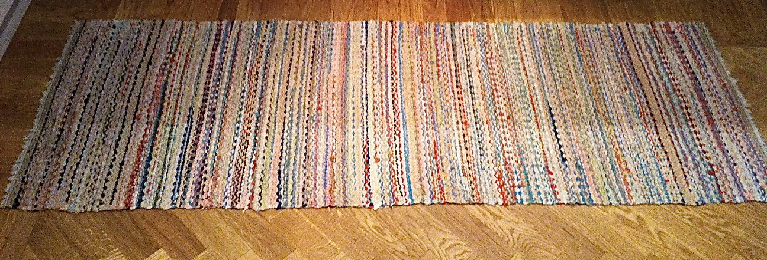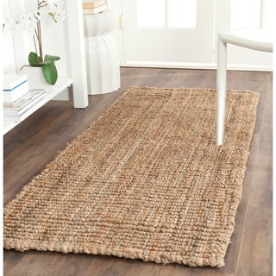

- White painted rugs.

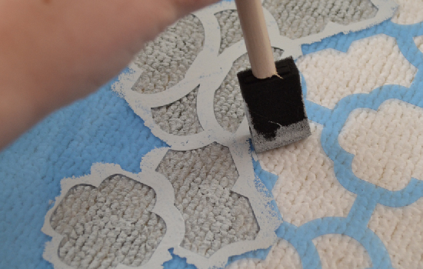

- Cross-stitch hand embroidery.

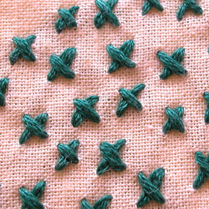

- Gingham and check materials used in subdued amounts for subtle interest.

Different gingham fabric styles
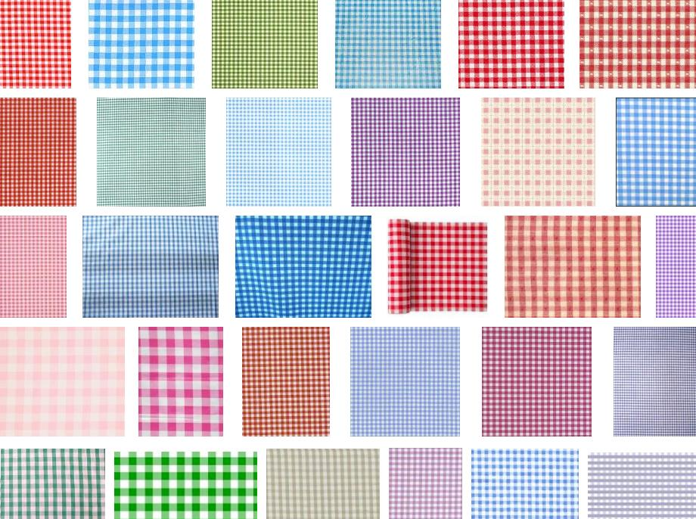

Different checked fabrics
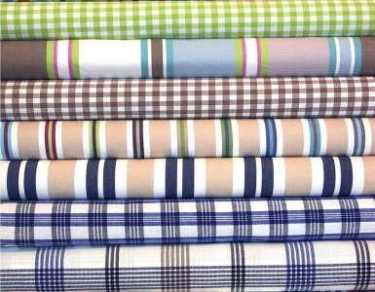

- Clutter free floor space.

Q.1.v) What is the best option for window treatment in Contemporary style?

This style emphasizes the architectural features, drawing attention to the shape and line of the window itself. Therefore the best option may be natural roll up blinds mounted inside the window frame,As they filter light and also introduce an element of texture. Simple Roman shades can also be considered.

Natural roll up blinds mounted inside the window frame.
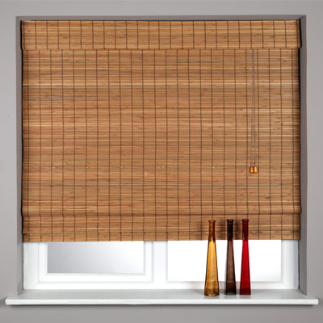

Simple roman shades
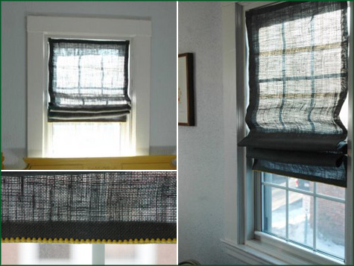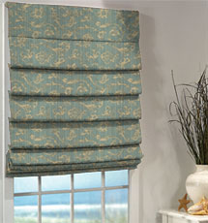

Q.2. Describe at least three characteristics of French Chic style.

French chic is elegant, romantic and ornate,For furniture and textures:

- Scrolled metal furniture in delicate designs is appropriate for this style. Look out for silver, soft gold or bronze rather than heavier- looking wrought iron.

Scrolled metal armchair
in delicate bronze design Scrolled metal Table
In soft gold design.

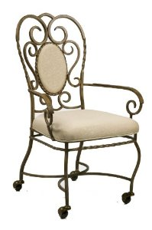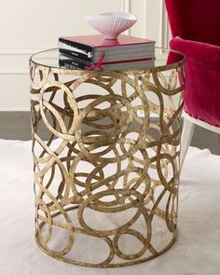

- Fabrics such as velvet, chenille, silk and linen, whether plain or with delicate self- patterns- are all appropriate for this design scheme.
- Pelmented or swaged window treatments are ideal with shimmering voiles or organza sheers.

Pelmented window treatment
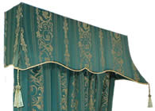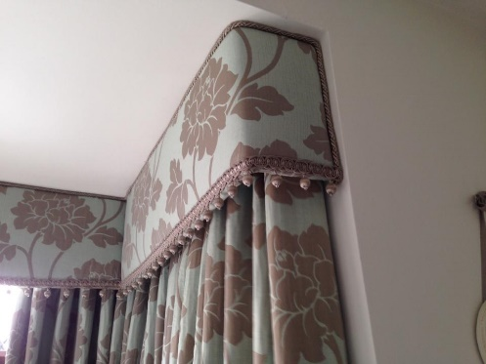

Swaged window treatment
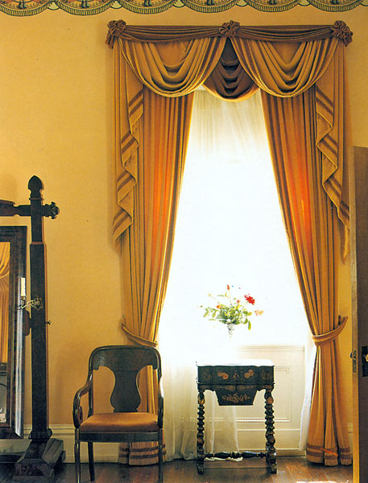

Some shimmering voiles Simple curtains in velvet.
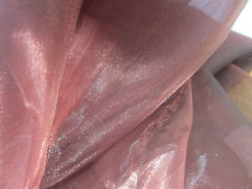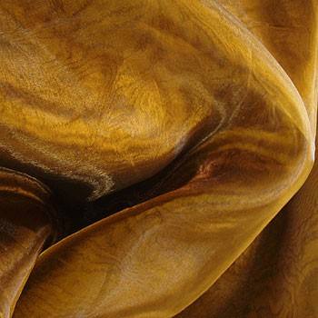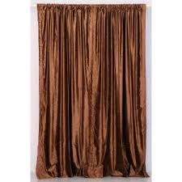

- Smooth textures, from sleek laminate flooring to velvet cushions and cool marble for work tops in the kitchen -are key to this style.

Textures and laminate flooring example.
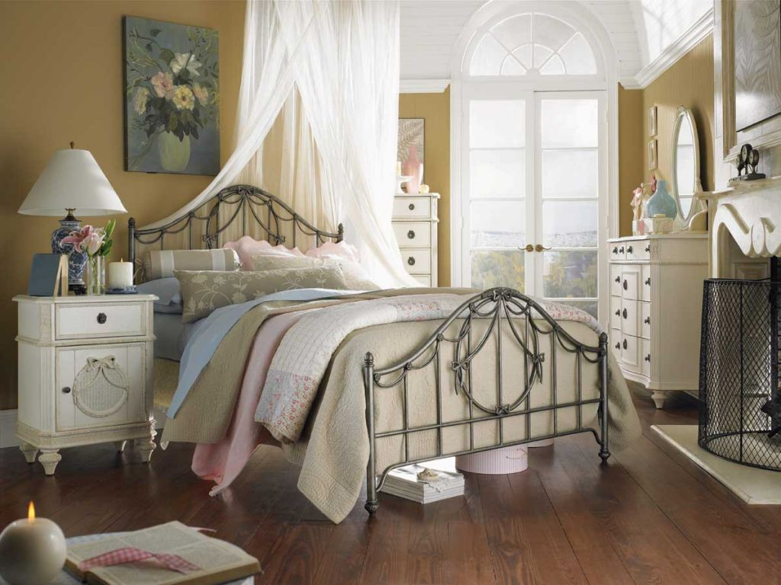

French chic cushions.
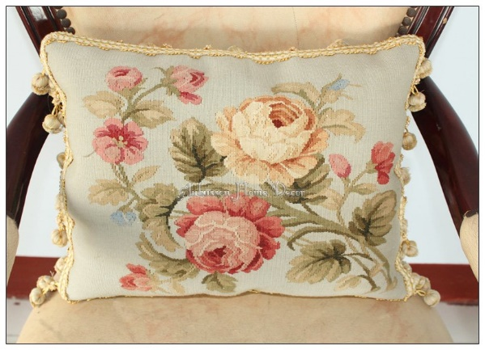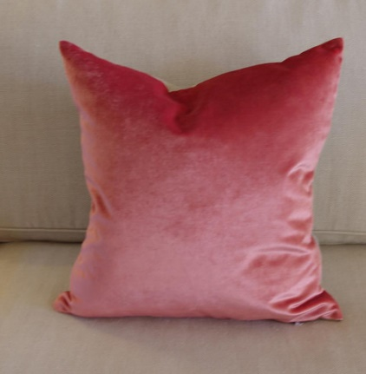

Marble for work tops in the kitchen.
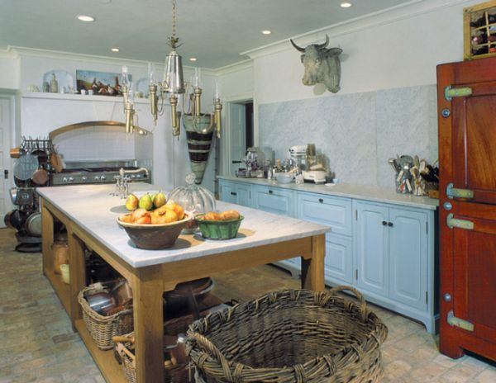

5. Mirrors are used to reflect light and candle lights to enhance the sense of luxury.
6. Careful choice of accessories is another distinctive feature of this look. ‘Less is more’ in this French look. Whatever is displayed should be of top quality.

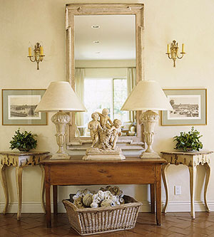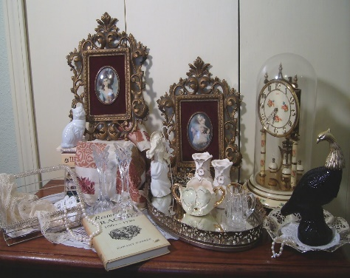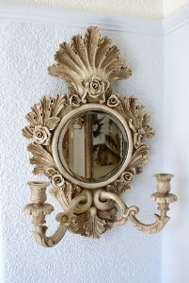

For colours Used :
Sophisticated palette of silvery grey- tinged pastels ranges from icy blue to sage green and mauve are preferred, No colour should be dominant.In this style ceilings can be painted in any soft colour other than white.

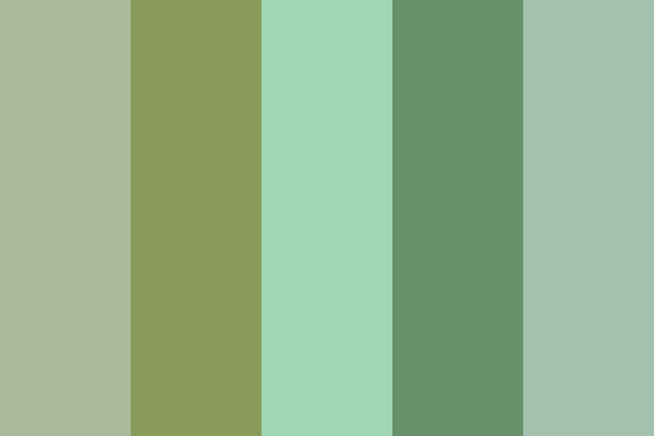

For the walls :
Matt painted walls in light colours suits best to this scheme. But silk emulsion or even pearlescent paint used in limited areas is a wonderful way to add glamour to this style

For the floors :
Flooring in this style should look and feel luxurious.Laminated floors covered with soft patterned rugs can be used

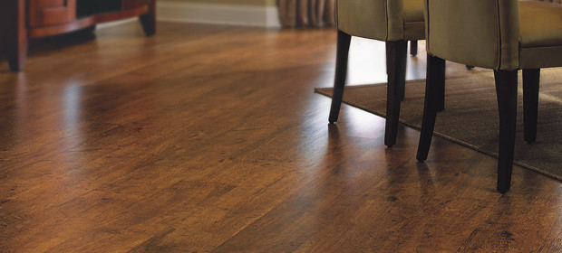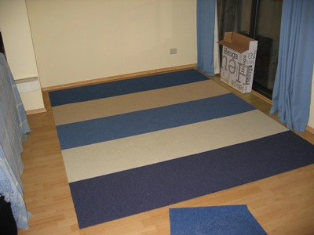

Case Study:

Laura has bought a new house but is a period property. Some of the architectural features are very interesting and Laura wants to retain them at the same time she wants to give the house a modern feel as well. Can she mix Victorian style with Contemporary style? If so how?

Yes, she Can. By mixing both of the interior styles design. Starting with one style then mixing it with elements of another one. In this case, she already has the house designed in Victorian style. First step she can do is to mix it with some contemporary elements. Giving it refreshing modern touch, without losing the Victorian style effect.

For example:

She can use black and creamy tones to show a touch of contemporary style.
Paint the walls with neutral tones instead of using wallpapers.
Choose drab colours for the ceiling to keep the Victorian style effect.
Mix some clean lined modern furnishings besides using the Victorian styled Mahogany furniture.
Simple roman shades can be used instead of the curtains hung from brass poles.
Use the hard wood or Marble floors and cover it with a contemporary styled jute area rug. A modern vase filled with coarse twigs, for example, can provide visual relief to the surfaces around it.

Victorian-Contemporary Style mix design ideas examples:

