
Assignment Cover Sheet

Student Name: | CHIPILU NDAFIKUMBWA
Student Number: | 1502
Course: | DIPLOMA IN BUSINESS ADMINISTRATION
Assignment NO: | 13

Marking Criteria:
We expect the learners to write minimum one well expressed point in three lines against each allocated mark. This means one needs to write 15 lines with 5 well expressed points to get high grades for a 5 marks question.
For high grades use examples and illustrations where appropriate.
ANSWERS
1.

BUSINESS PLAN

- EXECUTIVE SUMMARY

Chi & Li Bar will be dedicated to consistently provide high customer satisfaction by rendering excellent service, quality beverages and an enjoyable atmosphere at an acceptable price/value relationship. It will also be a very unique gathering place near the Mosi Water Falls where there is an amazing surrounding. Through our excellent service, various selection of beer, wines, whisky and different foods will be saved in a nice and friendly manner which will make the locals and outsiders to go to Chi & Li bar.
The owners of the bar have achieved so much in their lives and have also succeeded in their business of a bar having the experience of over 20years in the bar industry. Employee selection has been handled with care and trained to keep the place memorable, clean, make all the customers happy at all time and play the music customers would want to listen to.
However, the local market has over 10 million of market share and Chi & Li bar is planning to get at least 2% of the market share or $210,000 by the year end and an additional 2.1% and 2.81% for year 2 and 3 respectively. This will be achieved through serious advertising, signage, marketing campaigns and also by a word of mouth. One of the reasons as to why the place was selected is because of the following:
- Nice view
- Traffic of about 40,000 per day
- Near the border where beverages are cheap to purchase
- Reasonable rental rates
- Cheap labour
- There is a shopping mall nearby

1.2 MISSION STATEMENT

The Chi & Li bar will at all time give a friendly, comfortable and conducive environment so that the locals including the outsiders can come and have their fun. At Chi & Li bar we know team work enables us to serve our customers better and faster so that as people gather and relax, the bar can be their first choice. We are driven not by ego but by the accomplishment. It is a place where you can come and enjoy our variety of beverages and food. The bar is surely based on simple principles that ‘Life is to be enjoyed but responsibly’. Other different foods can be found at the mall near the bar so that our customers can enjoy their drinks while they are eating. We promise to pay close attention to the details of our services, maintain the highest standard in the cleanliness of our bar, exceed your expectations and keep you coming back for more!

1.3 GUIDING PRINCIPLE

Chi & Li bar’s philosophy is so simple ‘Enjoy life but responsibly and treat your neighbour as you would like or want to be treated’. These principles apply to all employees, customers, suppliers, stakeholders etc.
The management will always train all the employees and put them in their best suited places so that they can continue to love their job and make the customers enjoy their life. In addition, all the workers are to be trained to treat the customers professionally and with respect at any given time. The workers however will not be allowed to drink while on duty instead be sober minded at all times.

1.4 KEYS TO SUCCESS

They keys to success for Chi & Li bar are:
- Reputation: reputation of the owner for providing best services
- Outstanding customer care service.
- Customer satisfaction- Providing a quiet and relaxed environment where people can meet new friends and relax.
- Providing a vast offering of specialty beer, whisky and wine offerings
- Location: providing an easily accessible location for customers.
- Environment: providing an environment conducive to giving relaxing and professional service.
2.0 COMPANY DESCRIPTION
- The Chi & Li bar is going to be a locally owned bar operated by Chipilu Ndafikumbwa and Linda Sims.
- The bar will have a modern stage for other types of music like raga, reggae, jazz etc. which will be used on certain weekends.
- The seats will be all leather which will be purchased from china
- The walls will be painted with the traditional paintings.
2.1 OWNERSHIP
-Chi & Li bar is fully owned by Chipilu and the wife Linda.
-Both are active participants in the management decisions
-Both will bring their 20 years of experience of the bar industry.
2.3 LEGAL FORM
Chi & Li bar is registered with P.A.C.R.A in Zambia and is equally owned by Chipilu and Linda doing their business in the city of Lusaka.
2.3 START-UP SUMMARY
After spending several months searching for a bar to rent, the owners decided to start a bar from the ground up. The start-up capital will be used for the design, leasehold improvements, air cons, plumbing, flooring, electrical, smoke detectors and music system for the bar
Leasehold improvements will amount to approximately $32,500, and music system will cost about $27,000. The owner will invest $15,000 for cash-on-hand at starting date for the rentals and other logistics.
However the owners will seek to get a loan of about $100S,000 from a bank for the purchase for bar supplies and other needful items. $1,000 from the loan will be used for licensing requirements. The loan repayment including interest will be raised from the bar profits. The total cost to start the business is $80,000 and so far the owners have $75,000.
2.4 LOCATION
The location was purely chosen because of its demographic and geographic reasons. The place has the target customers. Located in the city of Lusaka, most people use the same route when going and coming back from work and most of them are between the ages of 25-75.

3.1 PRODUCTS/SERVICES
The Chi & Li bar will offer a variety of liquors, alcoholic beverages, wines, whisky that are available on the menu and will make sure to adhere to any popular demand of the beverages. We will make sure that our customers have what they need at any given time. We therefore give our customers the confidence that we will be there for them to help them enjoy their life.
3.2 COMPETITIVE COMPARISON
Chi & Li bar wants to set itself apart from other bars that may offer only one or two types of beer. There are a number of bars like ours, but they are mainly in the very high income parts of the city and surrounding areas. We do not intend to compete with these so called "Day Spas." We wish to offer a middle ground for those customers who can't quite afford those high-end luxury bars. Within 4 km from the Chi & Li bar, there are two other bars namely 365 bar and the Conner bar.
3.3 PRODUCT/SERVICE SOURCING
The bar will have three different suppliers of the food, alcoholic beverages, softies and water. It is important to have different suppliers because items will be delivered on time and at different prices. Sales will be cash or credit card sales.
3.4 FUTURE PRODUCTS AND SERVICES
The owners fully know that for any business to succeed a customer is key therefore, a suggestion box will be available in the bar, free calls and other options which will be available so that there can be that consistent communication between the customers and the management.
3.5 OTHER FUTUREREVENUE CENTRES
The location will also feature a number of amenities including a large LCD TV (for sports events), a jukebox, electronic darts, and two arcade games. These amenities are often found in many tavern style bars, and they will provide the business will an ancillary stream of revenue.

4.0 MARKET ANALYSIS

 |  | 2001 | 2012 | 2013 | 2014 | 2015

Potential Customers |  | Growth |  |  |  |  |  | CAGR
Locals |  | 10% | 20,000 | 22,000 | 24,200 | 26,620 | 29,282 | 10.00%
Outsiders |  | 6% | 40,000 | 42,400 | 44,944 | 47,641 | 50,499 | 6.00%
Tourists |  | 8% | 30,000 | 32,400 | 34,992 | 37,791 | 40,814 | 8.00%
Total |  | 6.39% | 170,000 | 180,800 | 192,336 | 204,662 | 217,836 | 6.39%

4.1Market Segmentation
The locals will be the regular customers. The outsiders will be coming most on weekends and the will be coming at any time of the day. The targeted people are anyone with the income of $10,000 is between 25 and 75 and lives near the Chi & li bar.

4.2 MARKET SIZE

The Zambian bar and nightclub industry has about 30,000 establishments with the total revenue of about $70 million. According to the laws, no major company should dominate or form the chains.

4.3 MAIN COMPETITORS

There are few bars, restraunts and night clubs which are competitors in the area. However, some of them are the closest and near to Chi & Li bar and provide quality.

- MOBZ Bar
The establishment is located 3km away from the Chi & Li bar. It also attracts some customers as it hosts widescreen TV’s when there are English premier games.

- K’M Bar
This offers the largest threat to the Chi & Li bar as it has its excellent reputation. It has a modern establishment which attracts young college crowd.

4.4 MARKET GROWTH

The Chi & Li bar opens each day at 09hrs in the morning and closes at Midnight. Usually revenue is quiet low from Monday to Thursdays and increases on Friday and the weekend.

5.0 MARKETING STRATEGY AND IMPLEMENTATION

The Chi & Li strategy is to leverage its existing advantages of location, establish clientele, reputation and also to enhance appeal to attract more people to the Chi & Li bar. The company seeks to bring in new customers to achieve both higher margins than previously experienced and to increase overall profitability through new customers.

5.5.1 SWOT ANALYSIS

The following is the summary of the SWOT analysis. SWOT stands for Strengths, Weaknesses, Opportunities and Threats. A SWOT analysis is a method for strategic planning that evaluates these four elements as they relate to the business objectives.

5.5.2 STRENGTHS

- Targeted, specific focus on its customers creates a memorable experience for its patrons resulting in a repeat business.
- Relatively easy entry and low capital outlay.
- The owners are so committed and will combine their 20 years’ experience in the industry.
- The Chi & Li bar will be so unique.

5.5.3 WEAKNESSES

- The patrons can potentially harm both business reputation or cause collateral damage
- High turnover in a bar industry where many bar come and go
- Very specific target market whereby if the target market was broader the owners could increase market share in the segment that was the strongest.
-Employee theft can make or break a bar business therefore the management should put a system that reduces or eliminates the risk.

5.5.4 OPPORTUNITIES

Opportunity to obtain a share of $210,000 market.

5.5.5 THREATS

Another new entrant could potentially hurt market share as competition is fierce.

5.2 MARKETING STRATEGY

Our marketing strategy is so simple one: satisfied customers are our best marketing tool. The following is our marketing strategy:
- Advertising
- Outdoor Sianage
- Grand Opening
- Word of Mouth as it is priceless.
5.2.1 PRICING STRATEGY

Pricing of our alcoholic beverages must remain initially competitive with our rivals. Management does however plan to price our in-house beers somewhat more than our other products to reflect production costs. This is typical within the industry and can create higher margins. If Chi & Li is able to capture a significant number of newer customers, then management will consider a rise in overall prices to reflect our established unique position

5.2.2 Advertising and promotion:

The most successful advertising will be with killer weekly. Additionally, strategic relationships will be developed with companies such as Phelim Club as well as use of a grassroots promotion system. Once the bar is up and running, management will determine which night needs a boost.

5.2.3 WEBSITE

The Chi &Li will have a website featuring the menu items, phone number, and hours of operation, events calendar and map. The website will also have the links to its Facebook page and twitter
6.0 SALES STRATEGY
Customers will be greeted at the door upon entering the bar as a way to make them feel at home and be a place where everyone knows your name. Customers will then be led to the seats and asked for their drink and food order. When employees are trained in the customer service, they will feel motivated as they will know their roles and the revenues will increase. The bar will be unique and will strive to make the customers happy. From time to time, employees will be going to the tables to ask the customers if everything is ok.

7.0 EXIT STRATEGY

If the bar sales drop to more than 6% in more than three consecutive quarters, then the bar will have to go under liquidation. The employees will be paid first followed by the selling of the furniture, music systems and other assets in order to pay the bar lenders.

8.0 Management Summary

Chi & Li bar has five employees including Mr. Mike and four bartenders and table attendants. Starting in November of this year Mr. Given will be hired as stores man and Mrs. Joseph, one of our table attendants, will be trained by him as an assistant. There are no further plans for personnel changes and all bookkeeping, accounting and advertising will be outsourced.

9.0Management Team
Mr. Mike is from Copperbelt Ndola to be specific, having graduated from the University of Lusaka in 1990 with degree in Business Administration. He subsequently worked with a number of firms in the food industry including Spar, Hungry Lion and Bonjour specialty foods, and Fisher ways. Mrs. Chipilu will see the day to day running of the business together with his husband Mr. Chipilu.

10.0 Financial Plan
Growth will be supported by a long-term loan of $100,000 for the proposed of the bar. This will keep initial growth slow and manageable, and will allow the management to have complete control over the bar.

10.1 UNDERLYING ASSUMPTIONS
• The Bar will have an annual revenue growth rate of 16% per year.
• The Owner will acquire $100,000 of debt funds to develop the business.
• The loan will have a 10 year term with a 9% interest rate.

10.2 PROFIT AND LOSS
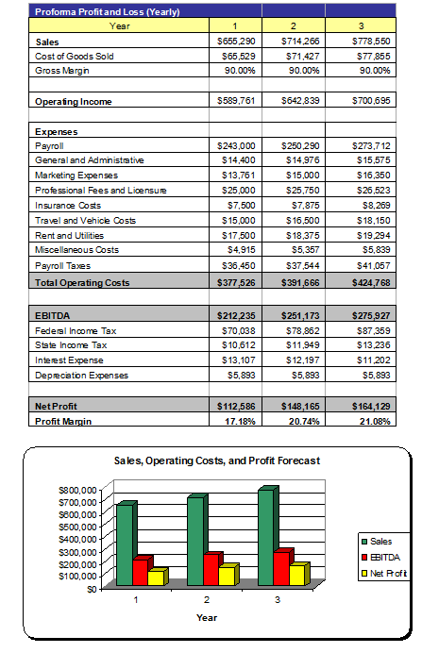

10.3 CASH FLOW ANALYSIS
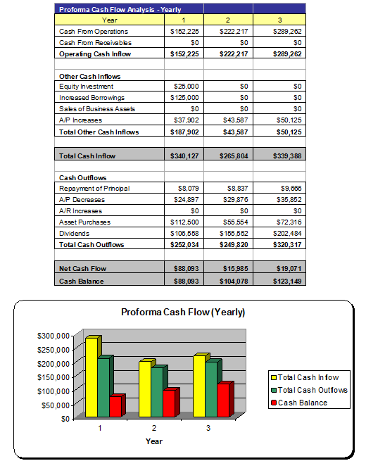

10.4 BALANCE SHEET
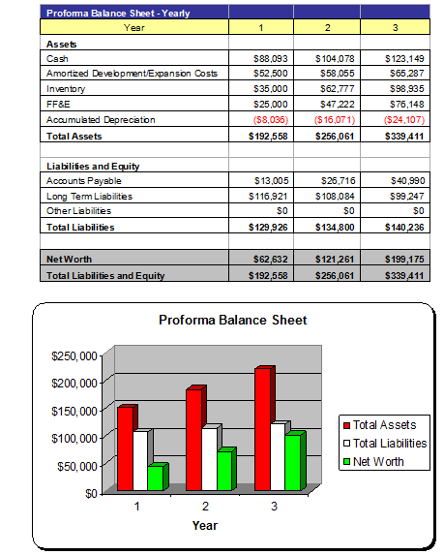

10.5 Break-even Analysis
The Break-even Analysis chart and table show that if the costs stay at the current, or relatively stable, level McKnight's will be able to make an increased profit by the second year. The break-even point is approximately $70,000 per month.
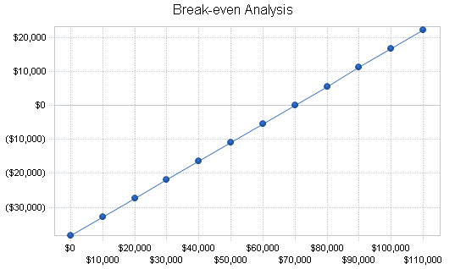

2.
1. THE INFORMATION I WOULD EXPECT TO SEE IN THE BUSINESS PLAN
- Who the owners are
- The available resources
- Type needs they aim to fulfill e.g. interior cleaning, vacuuming, detailing etc
- Their objectives
- The mission
- Company summary
- Legal form
- Start up fee
- Company ownership
- Market analysis summary e.g. location, targeted group etc
- Market segmentation
- Target market segment strategy
- Other competitors
- Strategy implementation
- Their competitive edge
- Sales strategy e.g. discounts and special offers
- Sales forecast
- Management summary
- Personnel plan
- Financial plan
- Break even analysis
- Projected cash flow
- Projected income statement ( profit and loss)
- Projected income
- Balance sheet
- Ratios
2. IMPORTANCE OF BUSINESS PLANS
- An opportunity to test out a new idea to see if it holds real promise of success
- A clear statement of your business mission and vision
- A set of values that can help you steer your business through times of trouble
- A blueprint you can use to focus your energy and keep your company on track
- Benchmarks you can use to track your performance and make midcourse corrections
- A clear-eyed analysis of your industry, including opportunities and threats
- A portrait of your potential customers and their buying behaviors
- A rundown of your major competitors and your strategies for facing them
- An honest assessment of your company’s strengths and weaknesses
- A roadmap and timetable for achieving your goals and objectives
- A description of the products and services you offer
- An explanation of your marketing strategies
- An analysis of your revenues, costs, and projected profits
- A description of your business model, or how you plan to make money and stay in business
- An action plan that anticipates potential detours or hurdles you may encounter
- A handbook for new employees describing who you are and what your company is all about
- A résumé you can use to introduce your business to suppliers, vendors, lenders, and others

Student Statement:

By submitting this assignment, I confirm that this is my own work.

Student Signature | CHIPILU NDAFIKUMBWA | Date | 20/10/2015

For Tutor / Assessor Use Only
Total Marks
Marks Obtained
Percentage / Grade

