MISS ELIZABETH AKINLABI
1380
ASSESSMENT 2
FASHION DESIGN- PRINCIPLES OF FASHION

PAGE 1
(1) Give short answers for the following questions.
(i) What is a fad?
Fad is fashion that is fleeting, it never becomes a key component of any wardrobe in essence, and it lasts for only a short period of time.
(ii) Define the term 'fashion forecasting'?
Fashion forecasting involves the prediction of 'colours, fabrics and styles' that will become popular in seasons to come. It is an integral part of fashion which guides consumers in making purchases and it also helps businesses and designers make sales.
(iii) How would you differentiate fashion forecasting from trend forecasting?
Fashion forecasting deals with the prediction of fashion trends on all levels of the fashion industry, from haute couture to ready to wear. While trend forecasting encompasses all other industries home furnishings, automobiles etc.
(iv) What is meant by fashion trends?
Fashion trends are common style ideas, which run similar in all the major collections designed and produced by notable fashion houses.
(v) Outline the basic practical considerations that a customer takes into account when selecting fashion garments or accessories?
1. Price; this is very important to the consumer as the price of the accessory or garment should be worth the fashion appeal.

MISS ELIZABETH AKINLABI
1380
ASSESSMENT 2
PAGE 2
2. Fit; since sizing is not a guaranteed fit, as there are several types of body shapes and sizes that differ from one individual to the next, it is important that the consumer takes advantage of the fitting rooms available in clothing stores.
3. Appropriateness; Dressing for the occassion is a practical consideration that prompts the consumer to make a choice, the consumer might be going for a dinner party or to the beach, the garment of choice must fit the occassion.
4. Brand; A lot of consumers associate fashion that suits their tastes, to a brand, which is simply a way a manufacturer makes his/her products known to the consumer.

(2) What is the difference between fashion and style? Explain with examples.
Fashion is the 'changing form of clothing', while style is 'the overall appearance'. Style is created by the designers, while fashion is when these creations are accepted by the consumers. Fashion is what is in vogue at the moment, but style becomes individualistic, somewhat personal, with little detail changes, an outfit, may appeal differently to different consumers. For example, take these denim skirts;
Skirt (A).
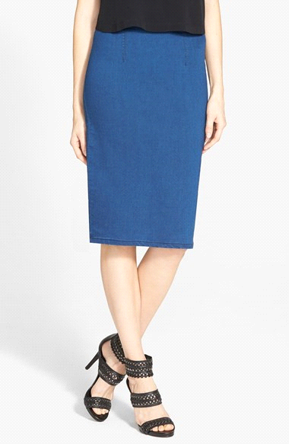

MISS ELIZABETH AKINLABI
1380
ASSESSMENT 2
PAGE 3

Skirt (B).
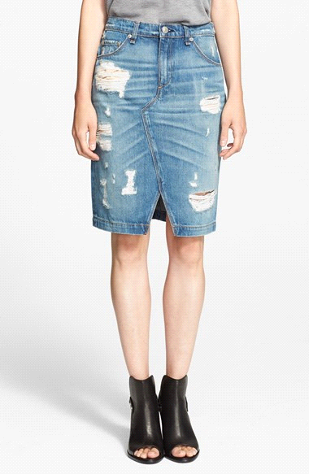

Skirt (C).
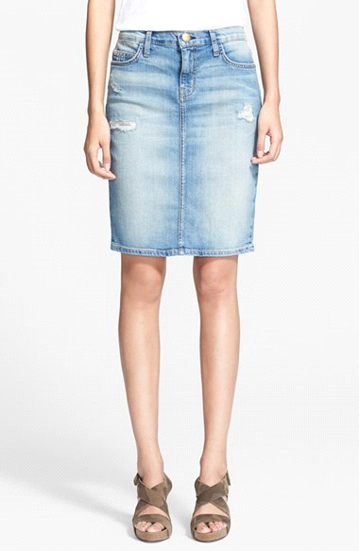

MISS ELIZABETH AKINLABI
1380
ASSESSMENT 2
PAGE 4

Pencil skirt (a) falls on the knee and is a deep blue. Pencil skirt (b) is ribbed and distressed and is shorter than (a). Pencil skirt (c) the denim is lighter around the thigh area, slightly distressed with no ribbing.
'These are all characteristics of the garment, which is style', but becomes fashion when it is accepted.
Another example will be the current fashion of crop tops; they come in so many different styles;

(A).
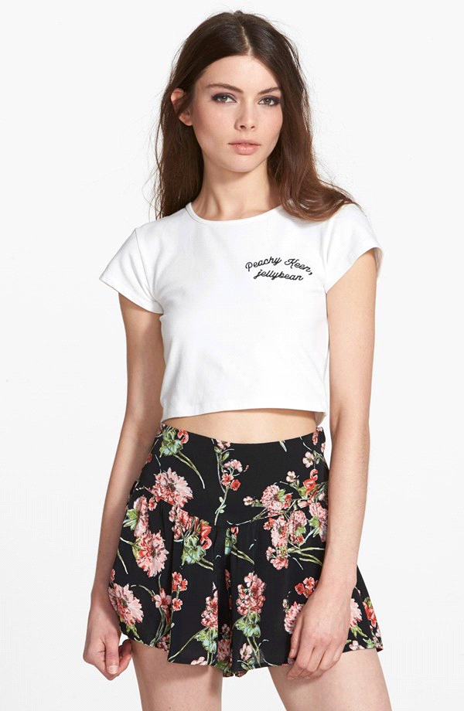

MISS ELIZABETH AKINLABI
1380
ASSESSMENT 2
PAGE 5

(B).
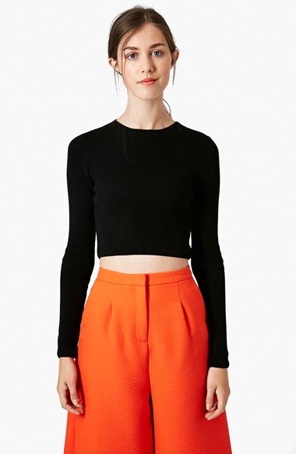

(C)
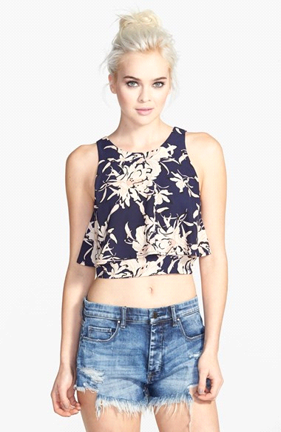

MISS ELIZABETH AKINLABI
1380
ASSESSMENT 2
PAGE 6
Crop top (a) is a crop tee with short sleeves. Crop top (b) is a long sleeve round neck fitted top, and crop top (c) is a sleeveless tank like flowy tank top.
Again they all have their style characteristics, but they are in fashion.

References; www. Nordstrom.com

