
Brent
Assignment Cover Sheet

Student Name: | Mery Ann Alaba
Student Number: | 1406
Course: | Fashion Design
Assignment NO: | Assessment 4

Marking Criteria:
We expect the learners to write minimum one well expressed point in three lines against each allocated mark. This means one needs to write 15 lines with 5 well expressed points to get high grades for a 5 marks question.
For high grades use examples and illustrations where appropriate.
Assessment 2

- Question

- Market segment is a creation of a prototype pattern in design activity, based on the technology of block patterns or modeling

The search for useful market segments nowadays, divides a population by income, social class, occupation and place in the family life

Also manufacturers and retailers shop as well want to see what is selling and why.

They also compare the styling, price, fit and quality of lines that complete with their own.

Analysis of a new collection is a biggest impact as well into the market, to records the sales and to have a surveys.

- Visual thinking, broadly defined exploration theory visual information about design

You must to visualize the upcoming new fashion trends before getting a higher order to every manufacturer and retailer.

Mostly they need the concrete proof of sales figures to show current trends.

Awareness is the key to developing good design. Designers must learn most of all to keep their eyes open, to absorb visual ideas, and Translate them into clothes their customer will like.

- The Designer must also be able to imagine how the garment will look three
Dimensionally, when made up in fabric. First is work sketching, drafting and flat pattern method.

The prototype is made by a sample maker, the best of the factory sewers. Design staff works closely with the sample maker to solve construction problems.

Construction methods must be tested as the garment is sewn, some sample need to be test for fir and total effect.

Model as well needs to ware in this is comfortable and looks good, all designer his or her own best critic.

- CAD is software place to manual drafting with an automated process.

Use of computer system to assist in creating, modification, analysis or
Optimization of a design.

And also using for drafting & flat pattern

It is programme to sketch designs and automatically make the first pattern
from the sketch.

Project: Market Research

- I try to wear two dress in difference department, .1) Mango Dress is the best fit in terms of quality and suitability, it gives satisfaction, right contoured, and better price, the textile are more reliable, durability visual and perceived quality of the garment.

It is more innovative, more standard and when it comes to customer
Expectation like me is more encouragement to buy and to wear with this
Brand

And with another brand of clothes 2) Max Dress it is fine the size and fitting to
my body, but when it comes to giving rate in 0-10 in a total materials I can
give 5 the price is higher into the materials that they used it is not much
satisfied when you wear it.

Idea of wearing or buying this items is not much better because I cannot used
longer.

Mango Dress

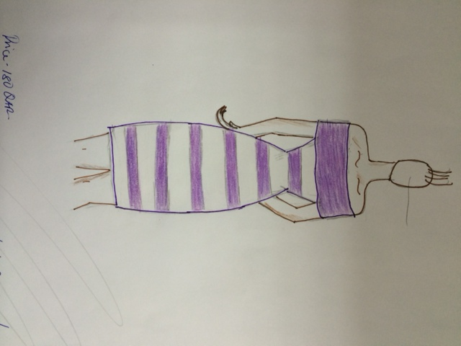

Max Dress

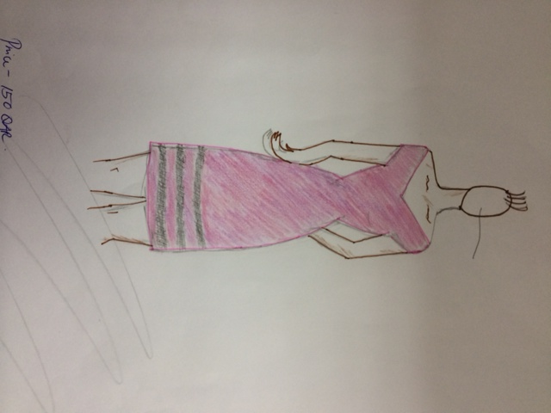

b.) Contemporary

Adidas
Nike
Converse
Reebok
Puma

Vans
Champion
Speedo
Jordan

Junior

Forever 21
Guess
Aeropostle
Hollister
Pink
H & M
Bebe
Camue
Oisis
Victoria Secrete
Promod
Mango
Zara

The difference between Contemporary and Junior are contemporary is a fast-breaking fashion, can mean fashionable sportswear it is better less individualistic, both women and men can wear

Into Junior it is for junior growing up that who didn’t feel comfortable in either junior clothes or her mother clothes, more misses full-cut missy styles were for mature women.

Student Statement:

By submitting this assignment, I confirm that this is my own work.

Student Signature | Mery Ann P. Alaba | Date | 4 June 2015

For Tutor / Assessor Use Only
Total Marks
Marks Obtained
Percentage / Grade

