
Assignment Cover Sheet

Student Name: | Annur Zara Liyana
Student Number: | 1227
Course: | Diploma of Fashion Design
Assignment NO: | 8

Student Statement:

By submitting this assignment, I confirm that this is my own work.

Student Signature | 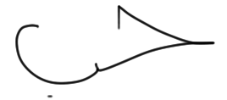 | Date | 25th June 2014

For Tutor / Assessor Use Only
Total Marks
Marks Obtained
Percentage / Grade

Colour & Dress Designing
Assessment 8 Total Marks: 30
Give short answers for the following questions:

I. What is meant by ‘binary colours’?
Binary colours also know as secondary colour. A colour created by mixing two primary colours is called a secondary colour. The primary colours are red, and blue and when two of this colour mix together it create another colour and that’s is binary or secondary colour.
For example red(primary) mix with yellow(primary) can create orange(secondary). Meanwhile if red mix with blue it can create violet and yellow mix with blue can create green. There are so many tones of colour itself, but only a true primary colour can create a secondary colour by mixing it together.
The secondary colour appear and add a interesting colour in the colour wheel.
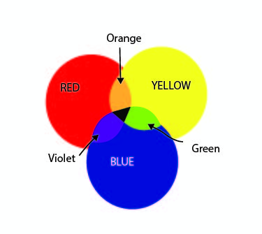

Example of Secondary colours and created by the mixing of primary colours.

II. Grey colour is formed when black is mixed with white. Is it a warm or cool colour what do you think and how best it can be used in creating an attractive colour scheme?
Grey colour can be form by mixing while and black. Grey is categorizing as cool colour. Usually grey can be with other colour and create a good harmony. The colour look restful and calm and if it use with bright colours such as red and yellow, it will help to blend the whole look together. In other words, it softens and gives a nice tan.
Using grey colour in a garment is a good idea especially for an average person, they tend to wear something that not too bright yet not too boring. However, be careful in choosing the tones and amount of grey colour because overusing it will create a muddy look.
In other case, by adding grey in a bright colour such as red can make red look more dramatic. A garment in black looks so elegant and dark for sure. But, adding white and its will turn grey will relaxing the look. Its not too strong as black neither too pure as white. People also tend to wear a grey colour garment rather that strong black or pure white.
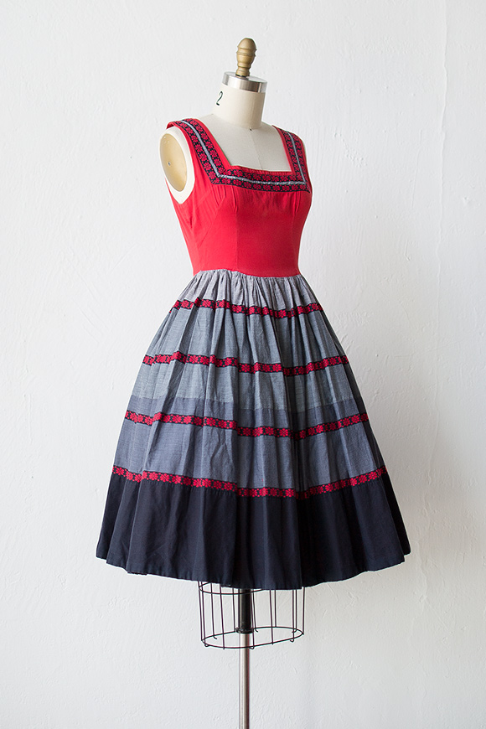

Example of a garment in red and grey.

III. Which of the following colours should a stout person wear? Dark or light. And why?
For a stout person, dark tones colour as the best for them in order to look more slender and thin. Cool colour tend to reduce size of the figure visually. The cool colours are blue, green, white, gray ect. The colours should be in shades in value. This is because the brighter the colour, the bigger figure will look. Using a dark colour such as black in the line can create a illusion of thinner.
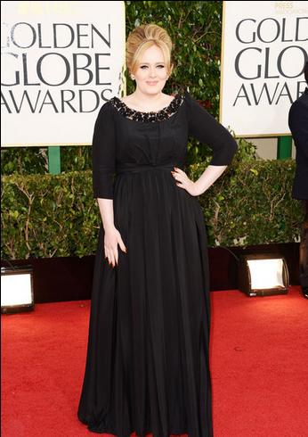

IV. If you want to create an illusion of height and slimness using colour, how would you do it?
Sometimes a big figure can look slim by using a right colour in the garment. For example, the dark colour such as dark blue, black and dark green can make the body become slimmer in visually. The different tone in a garment also play a important role. Traditional line in the silhouette can make the wearer look thinner. The vertical stripe especially in dark colour is a good choice.
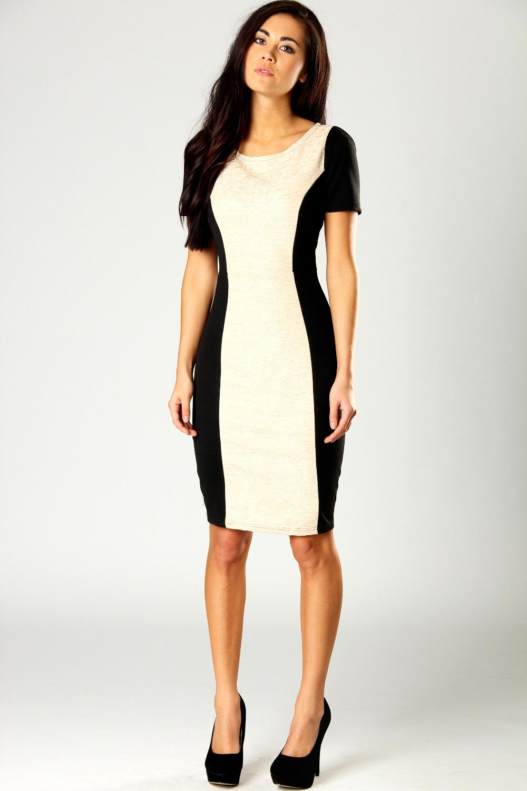

Example of illusion in a dress that make the body look slimmer.
Meanwhile for looking higher visually by using colour of the garment, the colour should be in the same from upper part to the lower part. A one-piece is one of the best cloth for looking higher. If wearing a two piece, avoid using a very contrast colour for the upper and lower part. The design could be a different colour in vertical line in the large space of the garment so the eye will travel up and down. It’s a same case with stripy style.
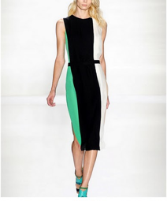

Example of a dark line in the huge space of the dress that make body look taller.

V. ‘Wearing black for a grey haired lady is the most suitable choice’. But how should she wear this in the best possible way?
For grey haired lady, black is the best choice. The colour of black gives an elegant look. But if it too black for example all-black dress somehow going to make the emphasis of the whole look by the grey hair. Its will create an unbalance look. The best way to wear black for grey haired is to add a white colour in the garment. For example, yoke and collar can be white in order to create harmony from black to the hair colour. Also, the dull warm colours suit them well too. The using of all-grey dress maybe will create a plain look since the colour is same with the hair.
If the dress come in all black, they also can wear a white, silver or grey colour of accessory in order to harmonize it with the hair colour
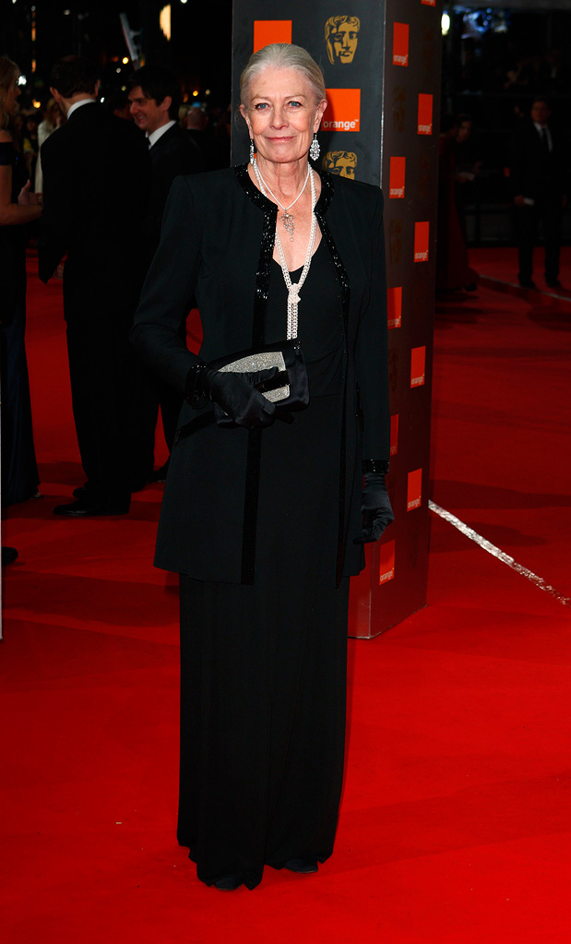

Example of a black dress on a grey haired lady.

VI. For a person of sallow complexion which type of colours is best choice? And why?
For a person who have sallow complexion, the choose of colour in the garment is really important. The problem now is the plainness tone in their skin. The best choice is those which will reflect colour in the cheeks, and in order to do these choose warm tints such as red, shades of rose, a grey colour having a tint of pink or colours of this particular type. For this skin colour, avoid yellow, tans or browns because these colour will make the sallow look more yellowish. Shades of blue green, navy and blue will help to bring out the colour in the cheeks helping the skin look less yellow. But, be careful on choosing green because the light green colour is going into yellow hue so its going to make the sallow skin becoming more yellowish.
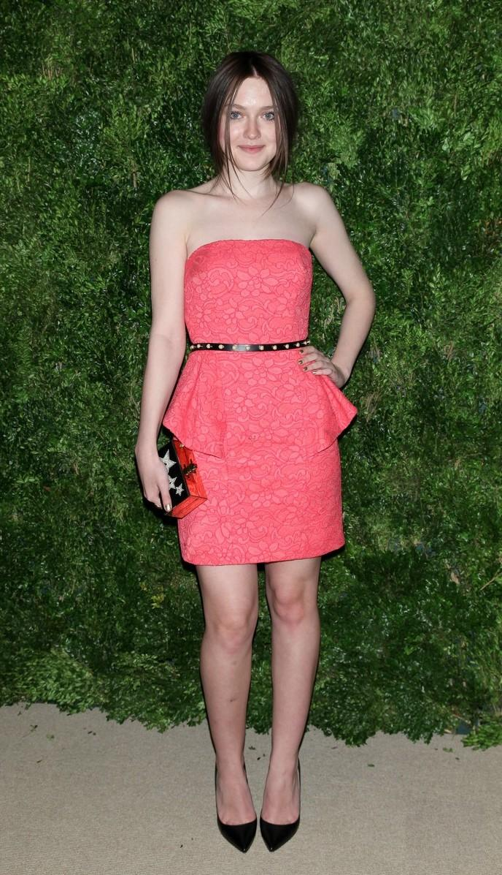

Example of a tint red colour dress on a sallow complexion.

VII. Which types of colours would be more suitable for a blonde person’s dress?
For blonde person who have grey, blue, or green eyes seem to be match well with the colour such as greyish colours, like, blues, greens and violets. Its suit better than the warm brownish tones. For the fair-haired person who got skin colour that in the middle between white and brunette, the shades of brown somehow look great on them. This hair colour type should not wear a tailored garment and to keep simple and soft is the best way to match with the hair colour. They also advised to not very a certain material on their cloth such as tweeds or the other heavy material.
The colour of the hair is define sweet and softness, so they look best in the small and simple especially in simple stone jewellery than a heavy looking one like a statement necklace with colourful colours in it.
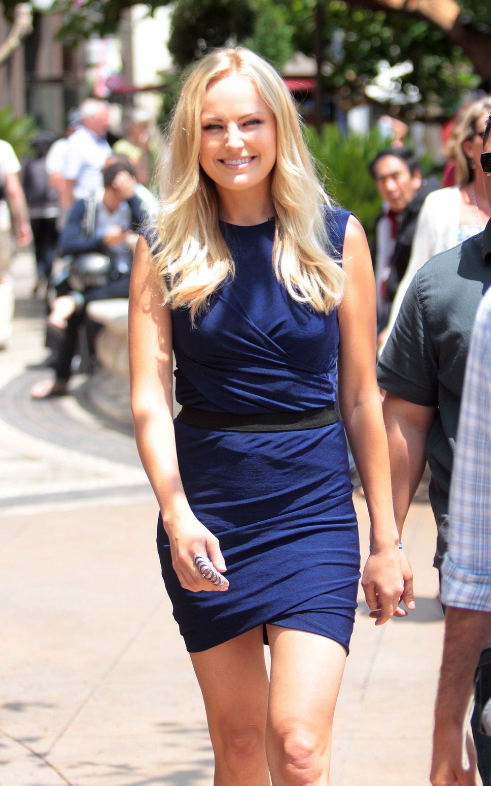

Example of a blonde haired in a blue dress.

Activity
Collect fabric swatches for different colour harmonies. Also name the colour scheme. Create a contrasting colour harmony using at least three colours of your choice. Design a fabric using at least three colours.

I’m using Analogous Harmony in may design. The colour choosen was blue as a primary colour, blue-purple as tertiary, and purple as secondary colour.
Analogous color schemes use colors that are next to each other on the color wheel. They usually match well and create serene and comfortable designs. Analogous color schemes are often found in nature and are harmonious and pleasing to the eye.

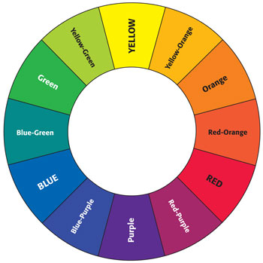
A colour wheel that included primary, secondary and tertiary colours.
Front
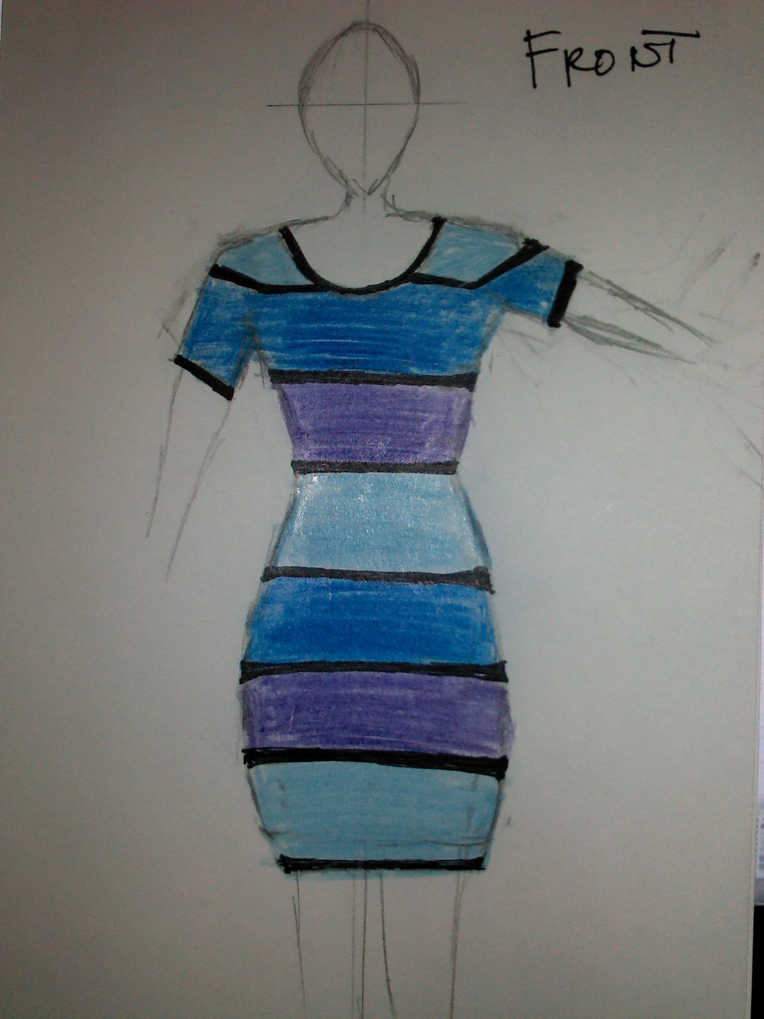

Back 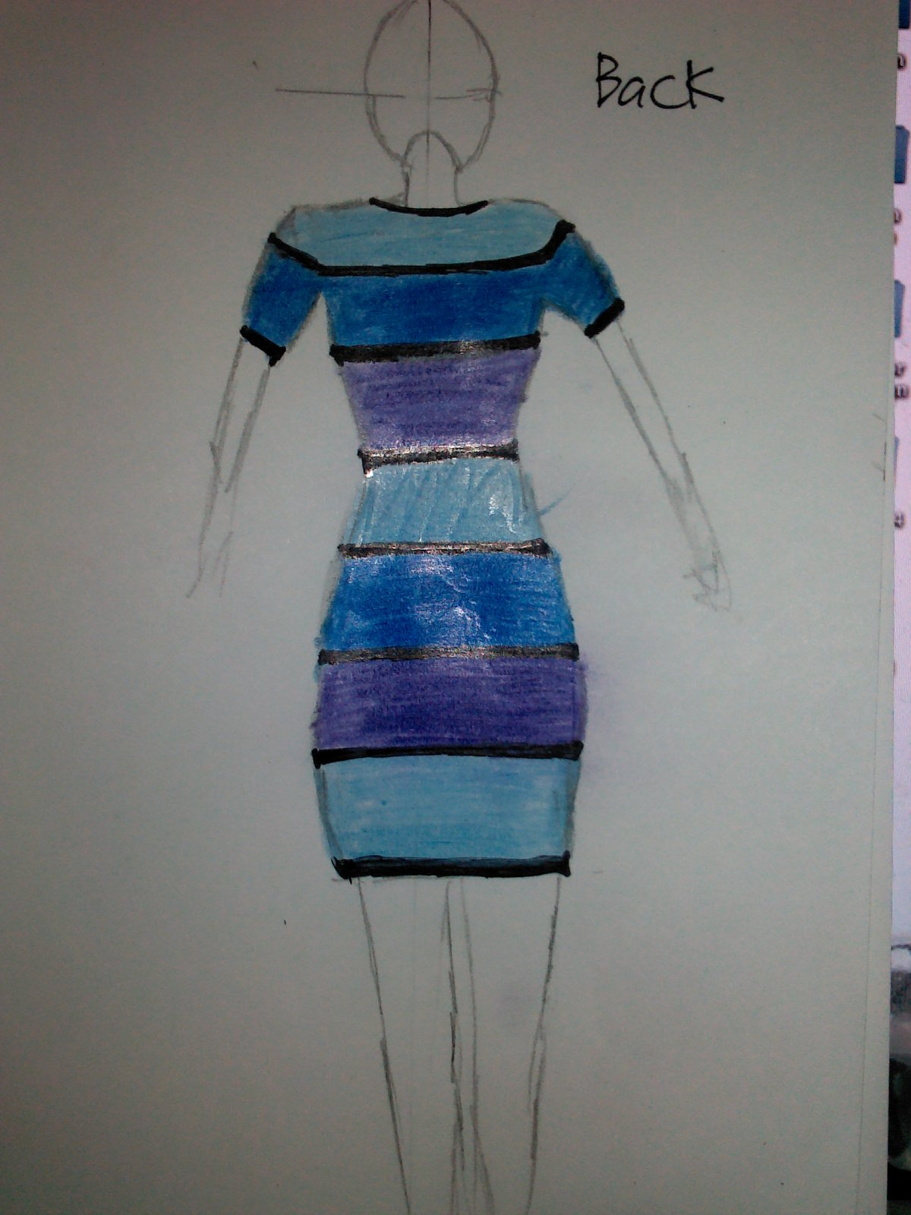

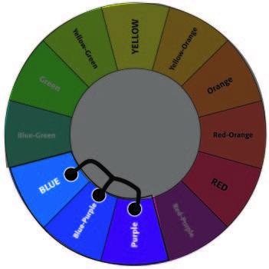

Colour scheme chosen was BLUE, BLUE-PURPLE and PURPLE. This design combined the same colour tone which give a pleasant look to the eye. The colours are the cool colours with the horizontal lines that’s separate hue. Its suitable for a tall and slender person and its also match well with many types of hair and eyes colour.

Reference
Information: BOLC Unit 8 note, Fashion Lecturers at Hongik University South Korea, Fashion website, Fashion blog.
Picture: Fashion magazines offline and online, Fashion books, Google Images.

