

Student Name: | Onkemetse Tshenyego
Student Number: | 1313
Course: | Project management
Assignment NO: | 3

Question 1
- A project plan is used in the Execution process group as project guide, in the
Project plan one can find project overview, Project organization, Schedule, Budget, Scope or Work to be done, Management and technical processes

- The stakeholder analysis document carries information about all the stakeholders, name, organization, identifies the level influences each stakeholder has on project (determined by the four-square grid), expectations, needs, and desires, from which, more specifics regarding the project goals and deliverables can be drawn easily.

- Outline the main objectives of integrated change control process

Integrated Change Control process is a tool to Monitoring and Controlling processes throughout project. its main objectives are as follows

-To identify and drive the change initiating factors to bring about the positive change by making trade-offs between the main project dimensions such as scope, quality, time and cost.
-To determine when change takes place, time stamping them and keeping track of the changing factors and keeping updated reports of the status of each process
-To manage change as it occur

- What are the major tools and techniques that help managing integrated change control process?
Change control system: Basically this is a collection of agreed formal, documented procedures that defines the necessary paperwork, tracking system, processes, and approval levels necessary for Authorizing changes. Why is this necessary? Proper planning will help reveal all the important aspects and compelling needs of the project for the agreed scope otherwise stakeholder will continually be changing this and that in the project, and the project will never finish.

Configuration management: This in most cases manages approved changes and project
baselines. Configuration Identification part of this process for example describes the
characteristics of the product or service as an output of the project, the description
agreed serves as the reference point of the agreement and can therefore be used to
manage any proposed change by the customer.

- Briefly describe the outputs of integrated change control process

Project plan updates: some approved changes or corrective actions have direct impact on a project baseline and such changes should reflect changes from the day of effect and forward in the change control system or the configuration management system and if need be status reports be forwarded to the stakeholders

Corrective actions: Though execution and control, actions are taken to keep process details in line with the objectives both in the present and in the future, these actions are corrective actions to adjust work in progress to fall within the desired deliverables limits

Documentation of lessons learned: It will be a huge mistake to underestimate a company’s experience built over time, with proper documentations of set point deviations from the past, along with corrective measures to counter steer in such winds of change, the company stand a good chance of dealing with change once assigned similar projects.

- What is ‘work break down structure (WBS)?
A well designed deliverable-oriented hierarchical decomposition of the work to be executed, to accomplish the project objectives by building the required deliverables and it is designed with total scope of the project in mind.

- What are the out puts of project plan development?
Just to mention a few
-A project charter
-Cost estimate
-Performance benchmarks.
-Key staff required for successful implementation.
-A clear and precise statement of scope
2. “Project integration management means tying together all of the other aspects involved in a
project to make it a success.” Discuss
This knowledge Area is concerned with coordinating the project plan. It involves identifying and defining the work of the project and combining, unifying, and integrating the appropriate processes, according to K.Heldman, it does all its functions through developing project charter, developing project management plan, directing and managing project execution, monitoring and controlling project work ,performing integrated change management, and proper project closure. The idea is to meet the stakeholder’s specifications of the project by persistently applying some of the processes listed above like project work monitoring and control, managing change forms a huge this knowledge area. The project charter is established based on the ongoing operations of the organization therefore this will provide the bases of the nature of how work is carried out throughout the project, as according to the company’s standards, planning and execution drives the projects through its objectives to attain the desired results through effective resource allocation and coordinating work done. Identifying stakeholders in the project charter, having identified the level of impact each can have in the work in progress, is a great step in integrated change control process as it identifies who can initiate a change proposal when needs compel. Change control impacts has a rippling effect on the project as some approved changes or corrective actions have direct impact on a project baseline and such changes should reflect changes from the day of effect and forward in the change control system or the configuration management system, which in turn impacts the current work of the project, which in turn can impact the project management plan, so managing changes really should be documented for a sound project integration management. This will help in keeping in line with project scope by managing only the work of the project not changes from adjacent work in similar projects in the organization, this is why work breakdown structure is important right until the project closure.
3. Describe the processes involved in project integration management.
Processes involved in project are;

Developing Project Charter-it has been established in the previous chapters that project charter is a formal acknowledgement of the existence of a project, now in this process (in the initiation process group) we look at how it is developed prior to presentation of approval by an executive board. Developing project charter inputs are generally informational and some of them are project statement of work, business case, Enterprise environmental factors and Organizational process assets. The output of this process is mainly report of the Project charter itself which will then be submitted for approval.

Developing Project Management Plan: Developing project management plan involves defining and documenting the processes (e.g. cost management plan) to be used in managing the whole project. This process brings all these subsidiary plans together, the inputs of this process are Project charter, Outputs from planning processes, Enterprise environmental factors, Organizational process assets. Through all these inputs project management plan gets to define how the project is executed, how it’s monitored and controlled, and how it will be closed.

Direct and Manage Project Execution: is the action process where the project comes to life. The work is authorized to begin, resources are distributed according to the project plan, result, or service of the project starts to emerge. These is achieved through the four inputs: Project management plan, Approved change requests, Enterprise environmental factors, and Organization process assets. Project management plan has details on how the project is monitored and controlled to meet its exit criteria. The outputs of this stage are Deliverables, Work performance information and other updates.

Monitor and Control Project Work: Work process is concerned with monitoring all the processes in the Initiating, Planning, Executing, and Closing process groups. This is done through collecting data, measuring results, and reporting on performance of various processes. The inputs here include project management plan, performance reports and organizational process assets and the outputs are project management plan updates, project document updates.

Perform Integrated Change Control: This process is the foundation for all the control processes, such as Monitor and Control Risk, Control Costs and Control Schedule. It reviews change requests impacting the project and appropriate actions are put into place to realign the objectives.

Phase Closing This process is mainly concerned with making sure that the work of the project was completed correctly according to the objectives and goals. Close Procurements supports the Close Project or Phase process and also verifies that the work of the project was completed correctly and the deliverables accepted.

Activity

As an electrical engineer the graduate that we receive needs and extended training to certify them as useful maintenance technicians and engineers therefore we propose the following change
Project title: Modification of educational system in Botswana
Statement of the problem: The government of Botswana is sending students abroad to become design engineers while the country is not having any industry that produce materials at even the lowest scale. This as a result increases unemployment of highly qualified people as companies are training their maintenance technicians on site to suite their maintenance labor requirements.

Objectives
To acquire all the maintenance needs of all the companies in sample group of engineering companies.
To provide a direct link between the Ministry of education, department of labor and home affairs, universities, technical training colleges and the industrial companies.
To change the syllabuses of the universities and technical colleges to suit the needs of the industries in Botswana.

Stakeholders: The local Government, Ministry of Finance Ministry of Education, Ministry of labor and Home affairs, universities, technical colleges and the student body at large.

Description of the project deliverables
The deliverable of this project will be an educational system that can fully produce graduates that are fit the description of the work force required by the engineering industry in Botswana.

Project execution plan
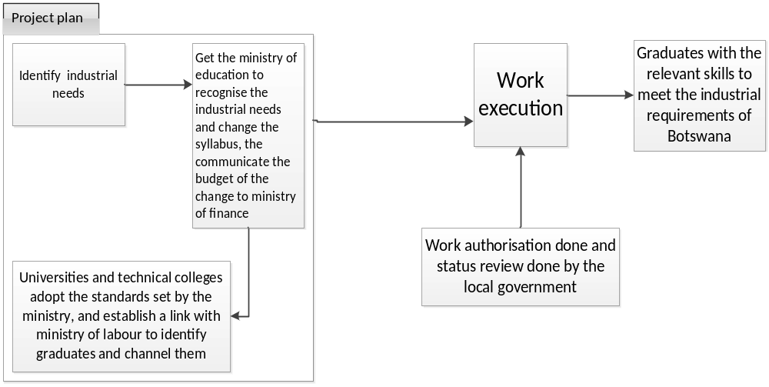

The greatest challenge process is the communication management that should exist by virtue of having relationship with the ministry of education, it is disorganized hence forth by carrying out this project there is an opportunity to build it and come up with a set guidelines to govern the nature of communication and the route it should take. This affect day to day productivity in that the graduates are not as competent as we expect and the only to mend this is through the universities and the ministry of education.

Student Statement:

By submitting this assignment, I confirm that this is my own work.

Student Signature | Onkemetse Tshenyego | Date | 22/10/2014

For Tutor / Assessor Use Only
Total Marks
Marks Obtained
Percentage / Grade

