
Assignment Cover Sheet

Student Name: | Annur Zara Liyana Othman
Student Number: | 1227
Course: | Diploma of Fashion Design
Assignment NO: | 16

Student Statement:

By submitting this assignment, I confirm that this is my own work.

Student Signature | 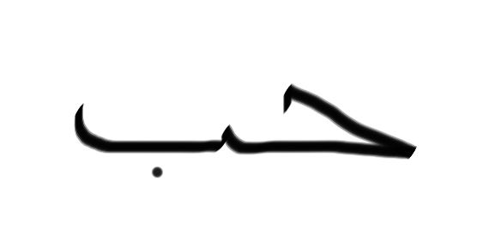 | Date | October 7th 2014

For Tutor / Assessor Use Only
Total Marks
Marks Obtained
Percentage / Grade

Running The Business

Assessment 16

1. Give short answers for the following questions:

- Define the following terms and concepts as discussed in the module: Sales promotion, advertising, publicity, formal fashion shows.
Sales promotion
Promotional activity helps a business to provide potential customers with information about its products with a view to making a sale. Sales promotion including advertising, scheduling and planning, media, newspaper advertisement, magazine advertisement, radio and television advertisement, direct mail advertisement, cooperative advertisement, art, copy, production, advertising agencies, and publicity.
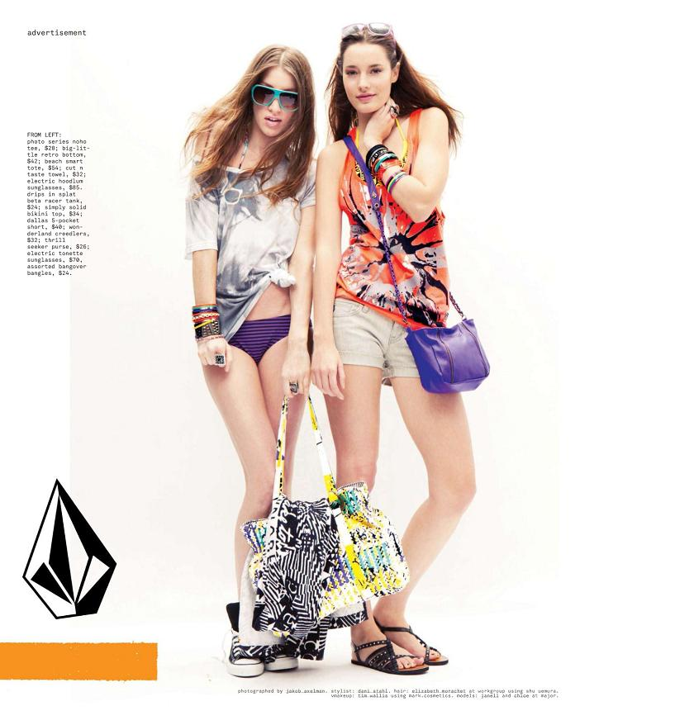
The example of magazine advertisement.

Advertising
Advertising is a paid promotional message by an identified sponsor. It appears in media such as newspapers, magazines, television, and radio. Local and regional retail stores use mostly local newspaper and radio ads. The ads are usually prepared by each store’s advertising department. Nationwide retailers and textile and apparel manufacturers often use television and national magazine ads, which are more expensive than local newspaper and radio ads. The TV and magazine ads are generally prepared by advertising agencies. Companies may also use online advertising, such as banner ads or search engine advertising, as a way to attract customers.
Sometimes textile and apparel manufacturers share the costs of cooperative advertising with retailers. The retailer benefits by paying only part of the advertising costs. The manufacturer. shares the costs and benefits by having its name or product linked with a known and respected retailer. In a clearer way, advertising includes this step, aspect and process, scheduling and planning, media, newspaper advertisement, magazine advertisement, radio and television advertisement, direct mail advertisement, cooperative advertisement, art, copy, production, advertising agencies, and publicity.
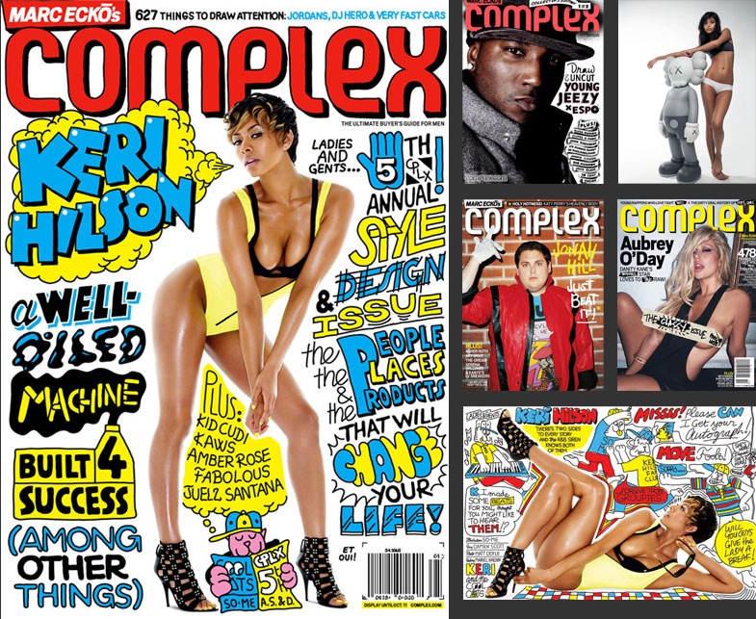
The example of a cover of magazine that used illustrator’s work to make this kind of look.

Publicity
Publicity is the voluntary spreading of information about people, special events, or newsworthy topics through various communications media. Publicity helps promote the sale of fashion merchandise by making a style, manufacturer, retailer, trend or other aspect of fashion better known to the public. Media editors choose the material they will use because they think it may be of interest to the community. The media also dictate how, when, and where the message will be used. Nowadays we have so many celebrity that have their own fashion business. Some are very successful because of their popularity. So the media will pay attention more on their brand. For a normal and small fashion business, its no fee to gain publicity but obviously it’s the hardest to obtain. In my country, the new fashion business tend to fall a lot because of they doesn’t have this thing. Unless they got a very good design in their rack and its make people want to spread the news.

Formal fashion show
Fashion shows can be define as special events that communicate a fashion story. There are two basic types of fashion shows.
The formal fashion show or it called runway show are normally be done by a big fashion company. Some companies that start small nowadays don’t have the formal fashion show. Soon when they brand known well by consumer, they maybe will have their fashion show. Some companies that also a new company but they start big a big budget, normally will have a fashion show even from their first collection. The existing fashion company like Chanel, Prada, Versace, ect will have fashion show on every new fashion seasons.
For formal fashion show, many things should be plan in advance. Such as, booking models and fittings and arranging for a runway, scenery (if desired), lighting, microphones, music, and seating. Rehearsals are necessary because these shows have become increasingly theatrical. Also, there must be advance publicity and advertising to ensure that the show will have a large audience. If the main objective of a fashion show is sales, it is best to have the show in the store-if possible, in the department whose clothes are being shown. If the primary purpose of the show is goodwill, such as in a charity event, it may be held outside the store in appropriate facilities. Fashion shows may be organized by the special events office, the fashion office, or both.

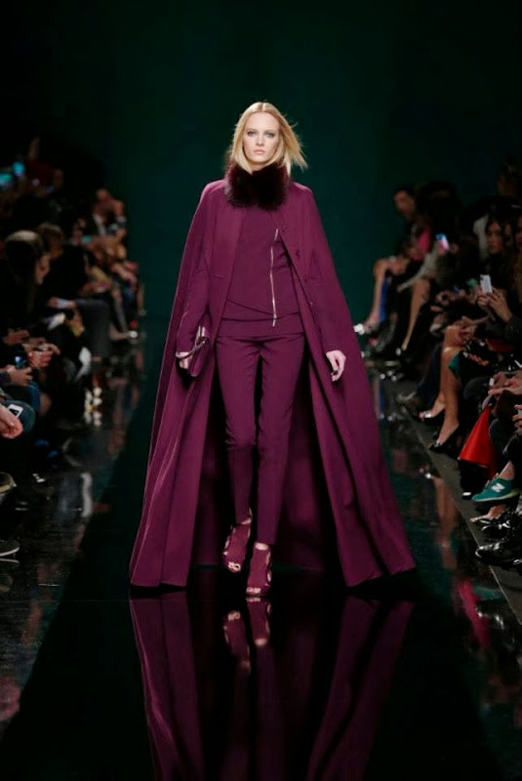

The example of the Formal Fashion Show.

- What is the purpose of fashion promotion?
The purpose of fashion promotion is to make people interested in particular apparel products, so they will want to buy them. Promoters want people to feel as if they have to have the latest items. Fashion promotion includes advertising, publicity, visual merchandising, special events, video merchandising, and electronic merchandising. Using this kind of promotion, fashion company will promote their products like showing to the costumer what they have with the very good vision. Making the right person to wear the garment and promote it in that way going to make consumer think that they will look as good as they see.

- Explain the difference between advertising and publicity?
Advertising can be refer as the effort to tell the brand to customer. Advertising itself got many kind in it. The bigger the company, the highest effort they advert their product. By doing this, the product can be show to people and this will increase the sale.
Meanwhile publicity is something cant be obtain in a short time. Yes, its kind of related to advertising too but in different effort way. By publicity, the massage or product can be easily deliver to customer by the media help. Its definitely help the sale.
- When supplying apparels to the retailers sometimes financial problems are created. How?
When retailers buying the material from manufactures, they normally can make the payment from 30 to 60 days. This way somehow is very good for retailer since they can get the gap time to prepare the money. However, for the manufacture companies, sometimes they have financial problem because it delaying their income. Which lead these people to use bank as the middle people. When the retailer buys the material, they will make a loan with mostly bank. The bank will pay first for them and the manufacture companies will get their money on time as they make the sale. So retailer will be in debt with bank that offers many type of payment method. This is win win situation.

- ‘Textile sales people encourage manufacturers to make a commitment early in the season to buy a specific amount of yardage ‘Why?
Textile sales people encourage manufacturers to make a commitment early in the season to buy a specific amount of yardage. Ordering in advance ensures the availability and on-time delivery of a popular fabric, which may subsequently be in short supply. Volume orders usually require a seven- to eight-week lead time for delivery. Popular fashion fabrics and yarn dyes can require as much as a six-month lead time. The manufacturer must also consider how much fabric may be needed for possible reorders. There is not enough time after reorders are in to wait for another fabric shipment. On the other hand, the manufacturer takes a great risk by stocking up for anticipated orders.

- How the fabric should be inspected when it is received.
As fabric is received in the factory, it must be carefully counted to make sure the total order has been received. In large factories, special equipment automatically counts the fabric yardage as it rolls from one bolt to another. The fabric is then pulled by rollers over large viewing tables so that it can be checked for flaws. Flaws are marked with coloured threads or flags at the side of the fabric so that they can be avoided in cutting. If there are too many defects, such as holes or shading, the fabric is returned to the mill for a refund. (The manufacturer may pay a premium to have the mill do this inspection.) Some companies build a strong reputation on the reliability of their product. They perform washing, dry- cleaning, steaming, and pressing tests to check tensile strength, durability, colour cracking, colour fastness, and shrinkage. They also test how the fabric holds up during sewing- whether needles pull it or edges fray excessively. Colours in coordinates must match. Coordinating tops and bottoms should be cut from the same dye lot, and at the very least shipments to the same store must be within acceptable variations of colour if from different dye lots. In the other words, this process is really important. If the fabric tested and the result is as their expected, they will proceed to the next process. If not, they will return to the manufactures. Which is will take lots of time, so that’s why fabric purchased many months before the season in advance.

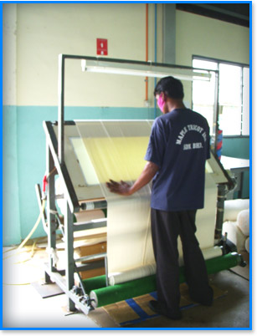
The fabric being inspected before it will be sold to retailer. But retailer also will do the self checking after receive the fabric.

2. Describe various types of media and their role in fashion promotion.
When people are doing fashion, they have to be known. So the media play the important roles. In advertising, media is a general term used to cover all methods of transmitting a sales message. Advertisers must choose the medium that will best promote an event or best reach a specific target market. The media include newspapers, magazines, radio, television, billboards, displays, and direct mail. Generally, fashion advertising is visually oriented, the philosophy being "why tell it if you can show it." Decisions are made not only about which general medium will be used, but also about which particular radio or television station, newspaper, or magazine will reach the appropriate customer for specific merchandise. Each consumer group has unique tastes, ideas, and interests, and consequently responds to different media. Advertising departments or agencies must determine the best possible combination of media to reach a particular target market. Several ads are usually placed in different media to support each other and strengthen the campaign. To balance the spot radio commercial aimed at the car commuter, the store might also place an ad covering the same material in the newspaper, for bus and train commuters to read. Repetition is a necessary part of advertising, for it maintains public interest. Consistency is equally important. The same ad read at the same time every day on the radio, or a fashion ad in the same illustration style every week on the same page in the newspaper, makes people keenly aware of the store or brand name, as well as of the fashion message. Nowadays, people are using media maybe 90 percent of their sale promotion. Through the television, or through the radio still cant beat the media through Internet. the picture of new collection already shown on the Internet even though the fashion show for that upcoming season now happens. It show how fast they want to show their product to consumer.

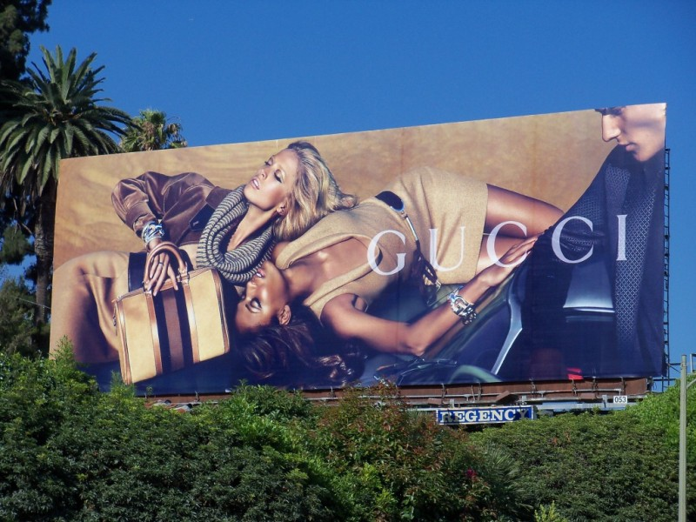
The example of billboard advertisement done by Gucci.

Projects

1. Find at least two examples of co op advertising from a fashion magazine.
Cooperative advertising is the sharing of costs for locally placed advertising between a retailer or wholesaler and a manufacturer. Many manufacturers have a set amount of cooperative advertising funds available per year, distributed as opportunities for collaboration arise. Manufacturers report, however, that much of this money goes unspent, as relatively few retailers and wholesalers pursue cooperative agreements.
Cooperative advertising can be a very powerful tool for the small business owner, especially one with limited means to support the kind of advertising campaign which can be vital to the survival and success of a business enterprise. The added funds from such a cooperative agreement can improve the quality of advertising or broaden the scope of its distribution. It can create important links between products and the small wholesaler or retailer who handles the product for the manufacturer. Above all, it can attract customers loyal to a certain product to a vendor whose name had not before been associated with that product. Most large retail stores have in-house advertising departments. The director of the advertising department supervises three divisions: art, copy, and production.

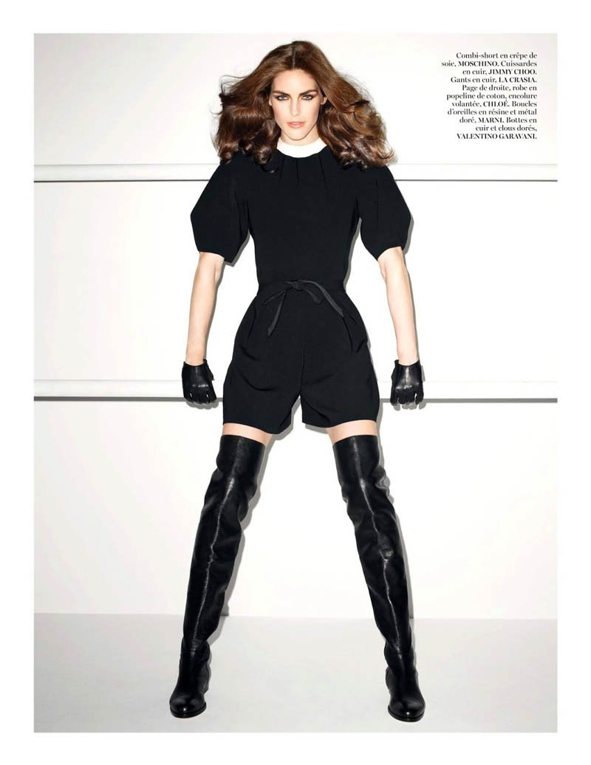
Picture 1.1
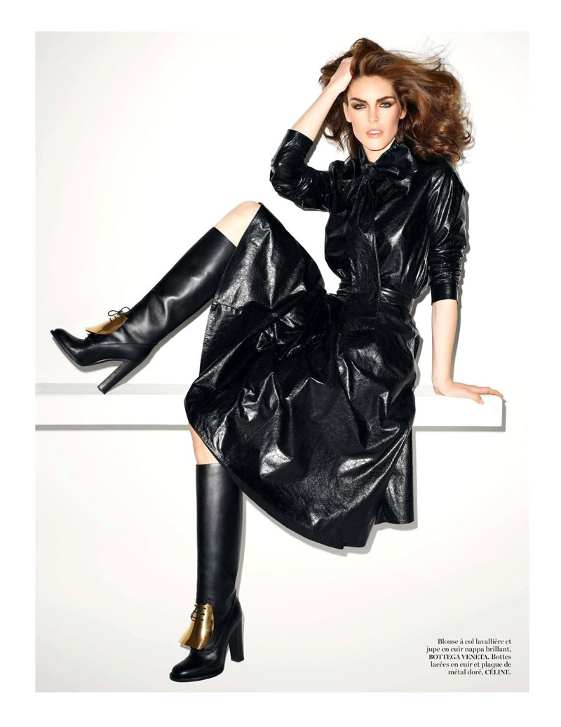
Picture 1.2
Picture 1.1 and 1.2 are example of coop advertisement. It’s the picture for advertisement photographed by a world famous photographer, Terry Richardson. This advertisement was fro Vogue Magazine. Picture 1.1, The model who wear the cloth was Hilary Rhoda, an American model. The combi-short from Moschino and the shoes from Jimmy choo.
1.2, The model who wear the clothes was Hilary Rhoda, an American model. The clothes belong to various fashion house. The dress from Bottega Veneta meanwhile the boots from Celine.

2. Analyse the advertising campaign by a fashion designer in newspapers and fashion magazines. Do they have a high fashion image or popular appeal? Do you feel that the advertisements were effective? Do they use photography or the artists’ illustration? (write a report and produce the images of the campaign)
The Fashion designer I choose is Jeremy Scott and the collection is from the collaboration between Moschino and Scott. This is Ready to wear spring/summer 2015 collection. After the fashion show, few magazine advertise this new collection. For this time, the concept chosen was ‘ I’m a Barbie Girl’ which means Moschino and Jeremy Scott collaborated with Barbie Co. In the magazine, they have the high fashion images rather than popular appeal. The advertisement really works because the products itself are good. With the combination of a good Photographer, the well known models, and the popular magazine it sure a worthy advertisement. Those are images from the fashion show use for the official advertisement for Vogue Magazine.
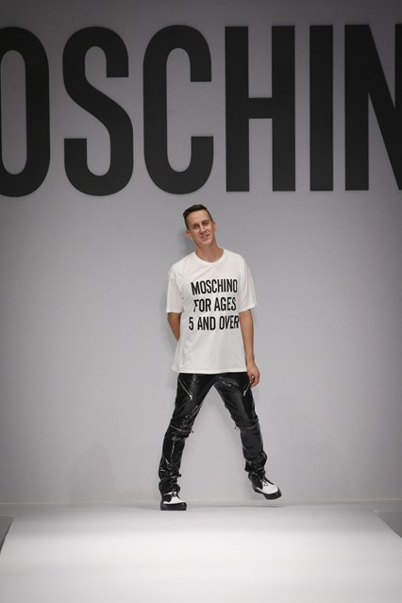
Jaremy Scott, Fashion Designer
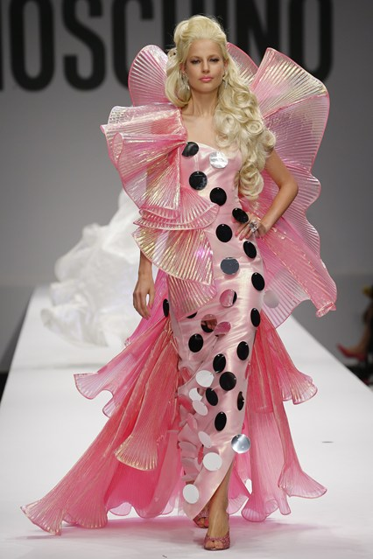
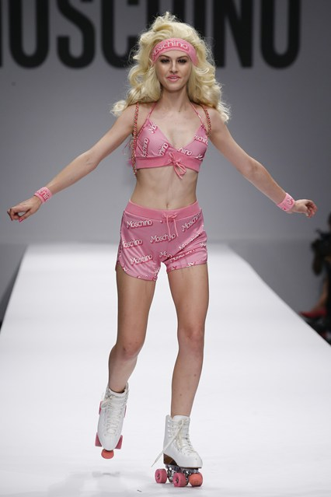
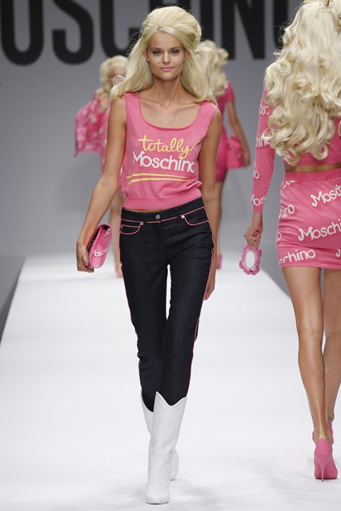
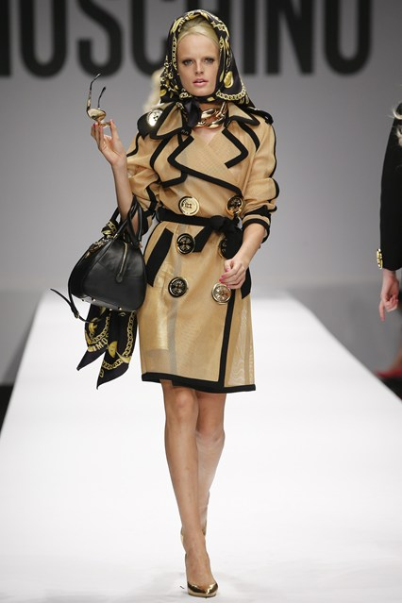

3. Visit local designer, evaluate the display techniques, both in windows and interiors. Is lighting used effectively? Is the merchandise arranged attractively? (Produce a report on your observations)
This is the report for my observation to the local fashion store near my place. The store name is Sponsered by ODDS. This store have many brances all around Seoul, South Korea. This store provides a very in-style fashion and those clothes are very pactical in wearing. The quality prove by people keep buying it and this brand name keep rising up. The display teqniques are very good in both windows and interior. The lighting used very practically which is they use the main light for overall lighting sourse and use the spotlight for certain clothes on the rack. The merchandise arraged very attractively by classified them in the same colour. Its looking profesional and easy for people to shop. They also have the discount rack and bags are nicely placed all around the store. Take a look on the images for this store;
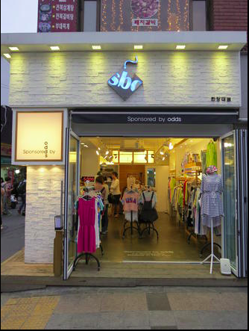
The store from outside

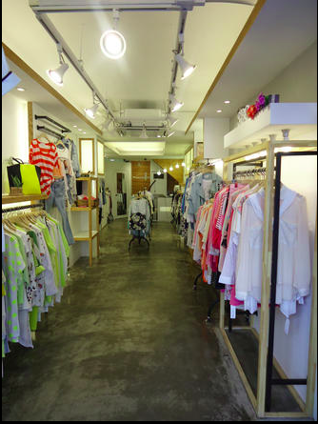

The interior

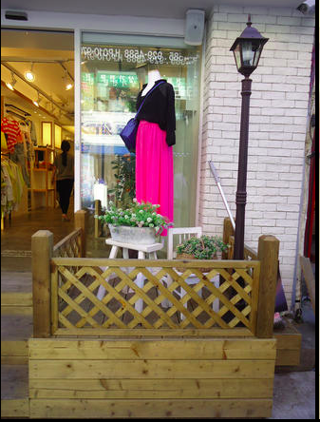
The display
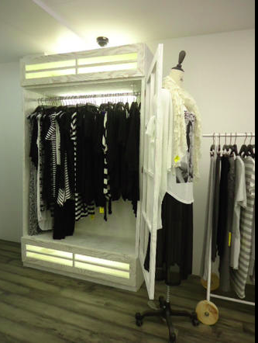

The merchandise arranged by the colour and the lightning used effectively on the top on the rack.

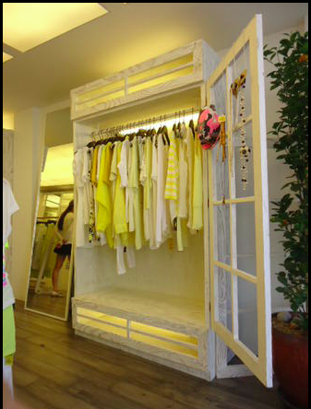
The merchandise arranged by the colour and the lightning used effectively on the top on the rack.

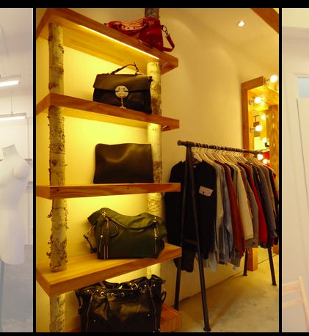
Handbags placed in the separate rack so customer can choose in ease.
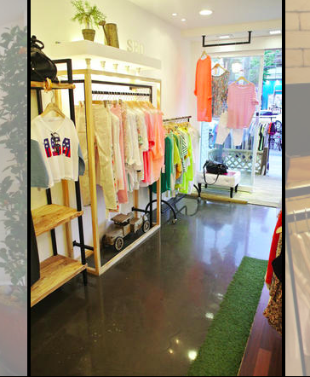
The merchandise arranged by the colour and the lightning used effectively on the top on the rack.

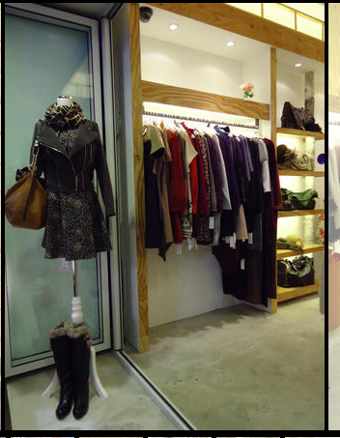
The merchandise arranged by the colour and the lightning used effectively on the top on the rack. They use few mannequins and put the in-style clothes on.

References
Information: BOLC unit 16 Note, Fashion lecturers of Hongik University, Seoul South Korea, Fashion websites, Fashion business websites.

Images: Fashion magazine online, Self-pictures, Google images.

