
Assignment Cover Sheet

Student Name: | Drew Wilkins
Student Number: | 1318
Course: | Diploma in fashion design
Assignment NO: | 4

Marking Criteria:
We expect the learners to write minimum one well expressed point in three lines against each allocated mark. This means one needs to write 15 lines with 5 well expressed points to get high grades for a 5 marks question.
For high grades use examples and illustrations where appropriate.
Please insert your completed assignment ( in word format) here:
Fashion Forecasting.

How the income groups influence fashion?
Income groups influence fashion a lot, for instance if someone has a high income they will buy designer, higher priced clothes frequently. Whereas the people who get a lower income will stick the high street stores such as River Island, top shop etc. They might buy one or two higher priced items like a designer piece but it wouldn’t be a regular thing because they wouldn’t be able to afford it.

Why is awareness of fashion forecasting important for the designer and the buyer?
The designer must be aware of the coming fashion forecast, if they are not up with the coming trends the buyer will not be interested in buying from them, and won’t know what’s fashionable or not. It is also important for the buyer to know because they are going to want to be up to date with current trends.

What is meant by fashion trend?
Fashion trend is when more than a few shops bring out the same type of clothing whether it be same style fabric or colour. Or a certain fashion trend like leather jackets, high wasted jeans etc. That is now a trend because it’s everywhere at the same time.

What are the different factors that affect fashion trend?
The different factors that affect fashion trends are, the age ranges of the people buying them as some trends will not be suitable for all age ranges for instance crop tops and high waisted skirts an older lady or a younger girl might not wear them. The income level and lifestyle will affect it also because depending on people’s income if it’s too expensive they won’t buy it or if they haven’t got a job or going to uni and have a budget.

Define the following terms;
Classics - Some styles never become completely out-dated, they will make a comeback decades later for instance the Ralph Lauren classic polo first made an appearance in 1972, but now we can see they’ve made a huge comeback. Even with some high street shops making a cheaper version of them.
Fad – fad is a short lived trend. A piece of clothing that stays in fashion for a short period. They lack the design strength to hold the customers attention for a very long time.
Interrupted cycles - this is when manufactures and retailers do not stock fearing risk, consumer buying is halted prematurely, normal progress might be interrupted by a social upheaval, economic depression or war.
Recurring cycles – this is when a fashion will die down, and reappears years later. It is reinterpreted for a new time whether it be a silhouette or proportion may recur, but it is interpreted with a change in fabric and detail. Old designs with a new look to it.
Fashion adaptation – Will be based depending on the consumers age range how their life style and income level will affect the trends. Also this will depend on their fashion preferences.
Traditional adoption – a designer might make a piece of clothing that’s not suited for everyone and not many people will want to buy this piece but for example if they did a high waisted trouser, not everyone will want to buy it but it could make an interest for other high waisted pieces of clothing. The traditional adoption theory is based on the fact that most high fashion is expensive and not affordable for everyone. So they will produce these pieces of clothing a cheaper way and it will get copied again and again cheaper, which is the downfall to traditional adaption because it then loses its new look and become unrecognisable.
Reverse adoption – a reverse adoption is when the designer will get there fashion trends from the consumer, they will influence the fashion industry.
Dissemination – this will be advertising particular trends to the consumer worldwide.

Forecast for the future
If I was to predict the fashion for 6months time I would expect to see thicker fabrics such as wool, cable knit jumpers and dresses and maybe even some denim. Also fur will make a comeback especially on collars and cuffs. You will also see some trench coats and parkers. The silhouette will be oversized jumpers and snug coats skinny fit jeans and tight fitted midis.
Tops and jumpers will be matched with thermal leggings, skinny fit jeans and midi skirts. Midi dresses will be a major trend during this season with some 15 denier tights or go all out there with some knitted tights. The colour will stay dark such as blacks and navy’s with an added splash of some golden tones. Added with some block heel ankle boots and knee highs.

Examples of high fashion.
Here are a few examples of high fashion.

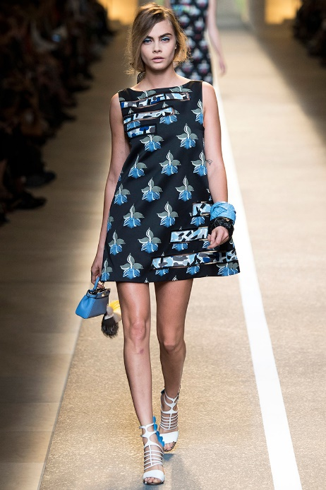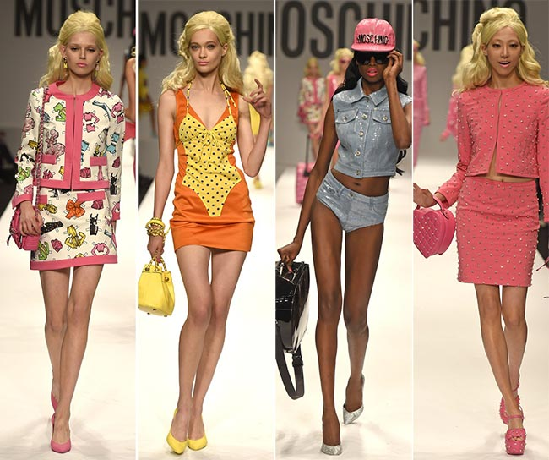

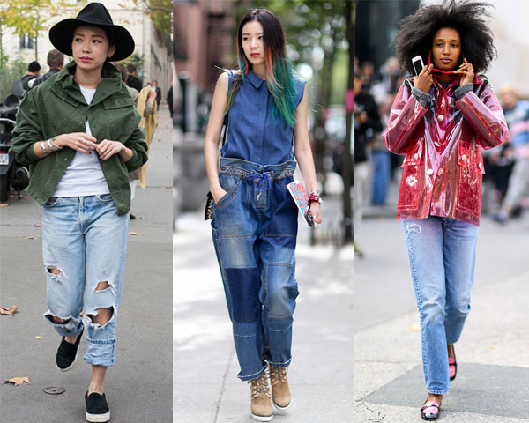
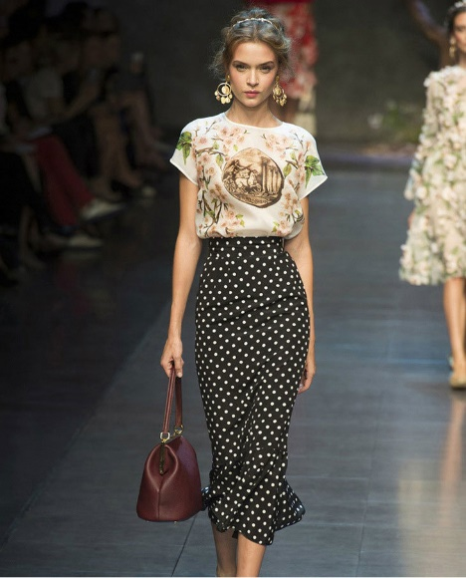

Mass fashion.
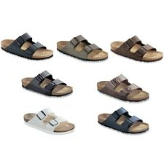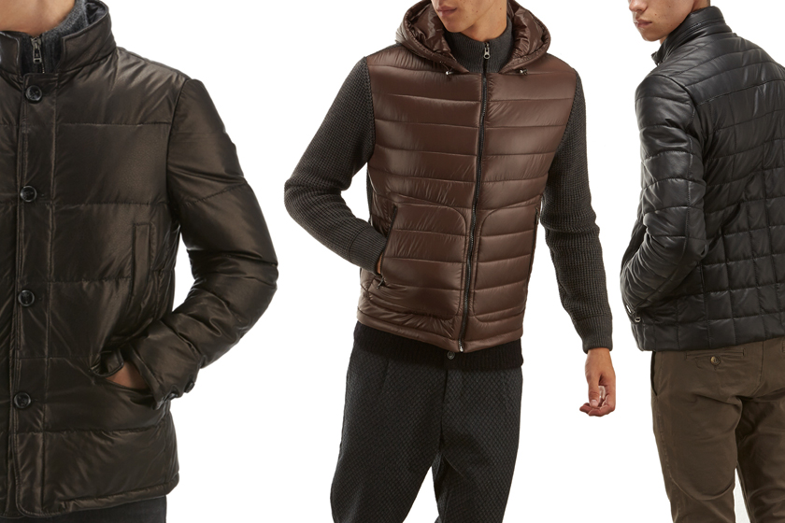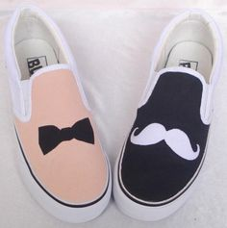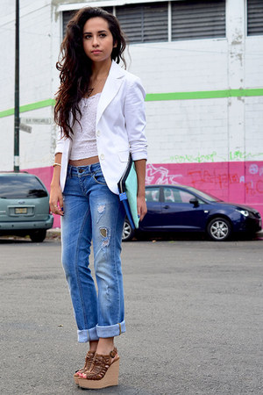

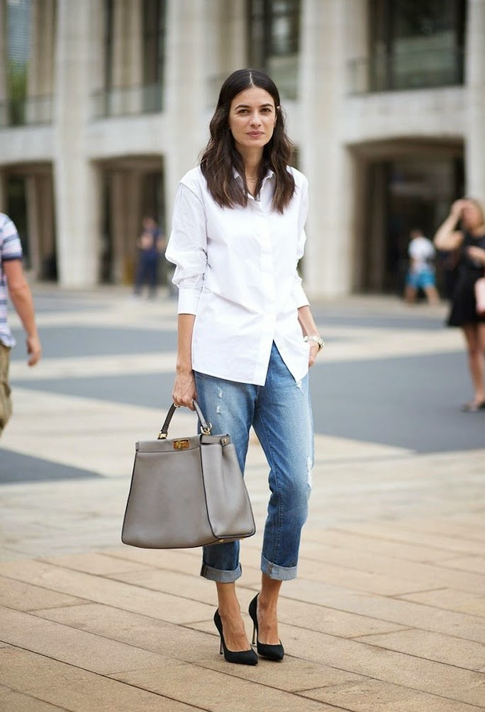
Classic fashion.
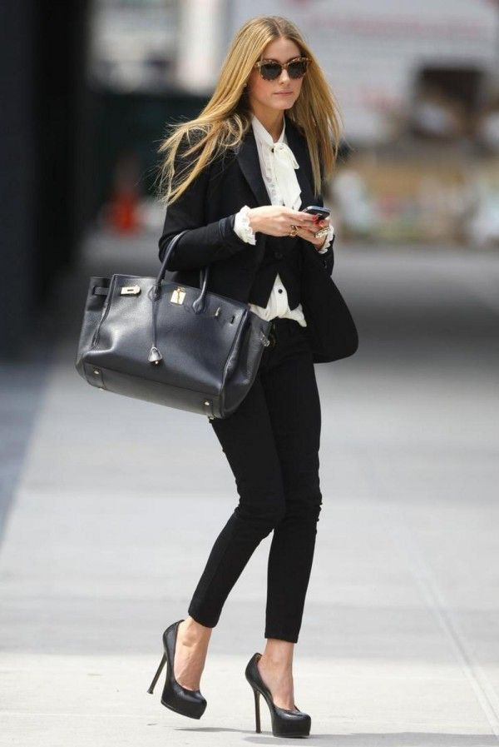

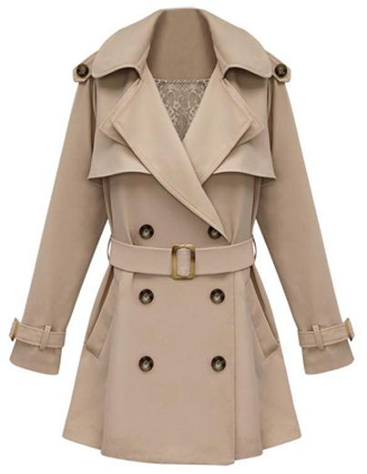
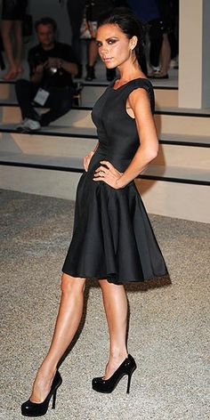


Fad.
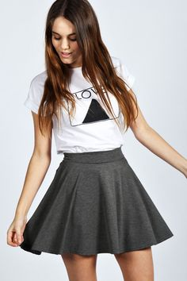
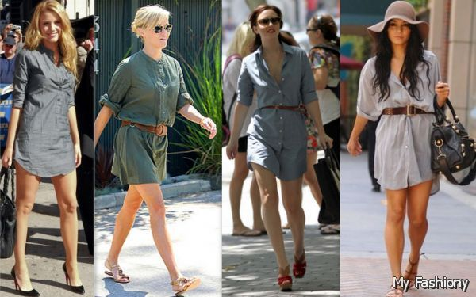

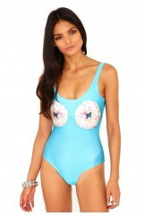
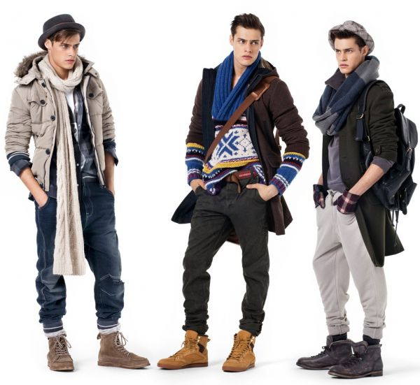

Student Statement:

By submitting this assignment, I confirm that this is my own work.

Student Signature | Drew wilkins | Date | 13/08/2015

For Tutor / Assessor Use Only
Total Marks
Marks Obtained
Percentage / Grade

