
Assignment Cover Sheet

Student Name: | Salma Mohamed Safaa
Student Number: | 1170
Course: | Interior Designing
Assignment NO: | 7

Student Statement:

By submitting this assignment, I confirm that this is my own work.

Student Signature | Salma Mohamed Safaa | Date | 17/09/2015

For Tutor / Assessor Use Only
Total Marks
Marks Obtained
Percentage / Grade

Student Name: | Salma Mohamed Safaa
Student Number: | 1170
Course: | Interior Designing
Assignment NO: | 7
Page NO: | 1

Interior Designing Course
Unit 7: Colour
Q.1. Short Questions:
I. It is very important to consider the function of the room when designing its colour scheme. Understanding the function carefully helps knowing the mood and the feeling that is required, also knowing how much time is to be spent in that room. This is an important aspect because it enables the designer to pick the right colors and their appropriate intensities to create the perfect colour scheme of that specific room.
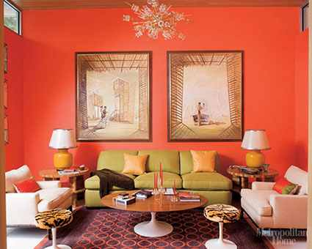
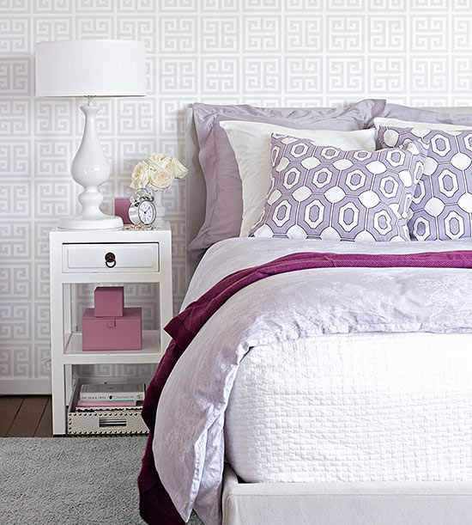
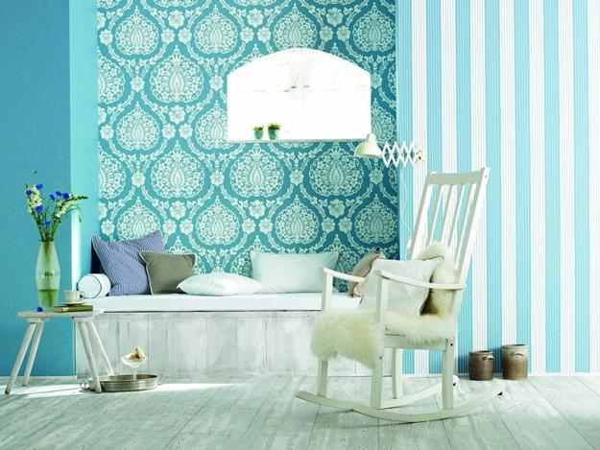
For example; if the a room is designed to be a bedroom or a reading room that is a place to rest and relax, soft and pale cool colours are the best to choose to evoke the sense of calmness and relaxation.

But if the room is a more public space as the living room, it might be best to consider more warm colours to reflect passion, happiness, enthusiasm, and energy.

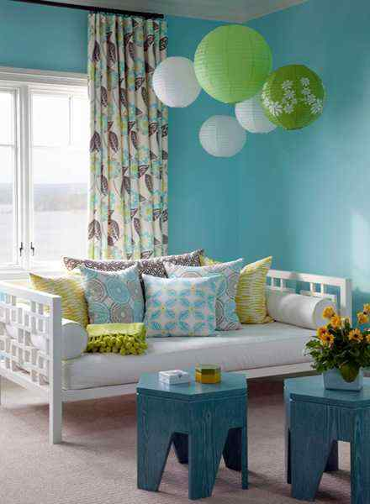
II. South-facing rooms: The southern sunlight brings in a warm orange-red glow that lasts the longest and can become intense at mid-day.
It is best to contrast that warm glow with cool colour schemes; blue, green & purple, with all their tones. Dark tones will look brighter; lighter tones will virtually glow.
Student Name: | Salma Mohamed Safaa
Student Number: | 1170
Course: | Interior Designing
Assignment NO: | 7
Page NO: | 2

III. North-facing rooms: Light from the north is indirect and cool, and can appear grey depending upon where you live. To counterbalance this effect, it is suggested to choose colours from the warm side of the wheel; such as red, oranges & yellow.
IV. Colour is used in adjusting the size of a room. Designers consider colour as a magic tool that fools the eye, it makes the proportions of a space appear different. Colour has the power to change your visual perception of the shape and size of a room.
If a room is very large and doesn't feel comfortable, paint the ceiling a darker color than the walls to make it appear lower and choose warm dark wall colors to bring the walls and ceiling in. This will make the space feel smaller and more intimate.
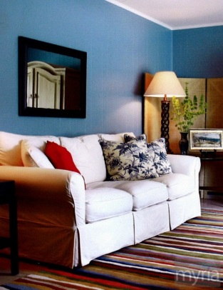
Conversely, if a room is very small, paint the ceiling a light and pale color, which will raise the apparent height of the ceiling. Choose cool paint colors e.g. blues and greens make the room seem more distant. Also by painting the walls and ceiling the same color, this enables your eye to travel continuously around the space, making the room look larger. 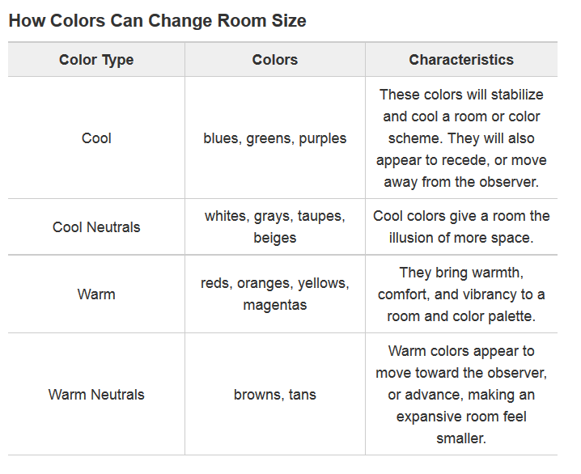

Student Name: | Salma Mohamed Safaa
Student Number: | 1170
Course: | Interior Designing
Assignment NO: | 7
Page NO: | 3

V. When planning a colour scheme for a room; it is important to consider the natural sunlight which the room is exposed to because the appearance of colours will vary depending upon the sun's position and the direction of the light. As the amount and angle of the sun changes, so will your room colours.
That's why it's always wise to look at how the colour changes in the actual space under the different lighting conditions.
VI. For the best test, it is recommended to paint a sizable area on the wall of the room. Observe how the colour looks at different times of the day, in the morning and evening, in natural and artificial light.
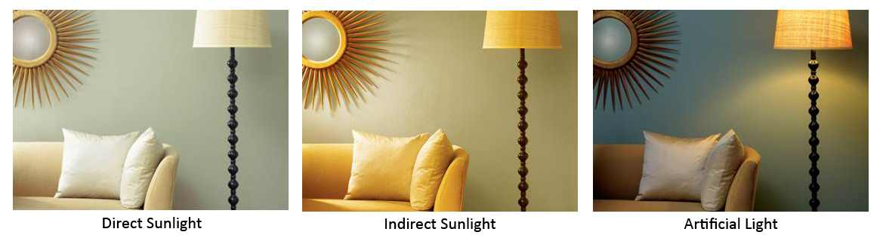
Only then will you get a true sense of what your room will look like throughout the day and save a lot of time and money.
The picture above shows the same paint on the wall in three different lights—one being direct sunlight, indirect sunlight, and artificial light.
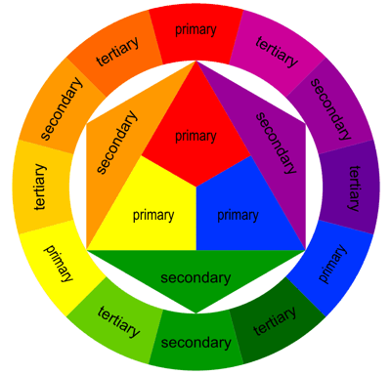
VII. On the colour wheel; there are warm colours as red, orange & yellow. On the opposite side of these warm colours on the wheel are violets, blues and greens ; known as the cool colours.
Cool colours are often more subdued than warm colors. They are the colors of night, of water, of nature, and are usually calming, relaxing, and somewhat reserved.
Blue is the only primary color within the cool spectrum, which means the other colors are created by combining blue with a warm color (yellow for green and red for purple).

Student Name: | Salma Mohamed Safaa
Student Number: | 1170
Course: | Interior Designing
Assignment NO: | 7
Page NO: | 4

Q2. Colour is a very important aspect when it comes to planning a space.
When the color's right, it can:
- Modify perceived temperature — make your space feel warmer or cooler
- Transform proportions of the space; make your small space feel larger, and your large space more cozy and intimate.
- Illuminate dark areas
- Create mystery and romance in dull areas
- Energize static areas
- Recalls the conscious to a certain mood or a certain period
- Enhance feelings of health and wellbeing
Before planning a color scheme in your personal environment, make a questionnaire. Your answers are 50 percent of the design because your colour choices depend on them.
1. Where is the room?
2. How many windows are there and which direction do they face?
3. Is there landscaping outside that will have an effect on the colors in the room?
4. Who will use the room, and what will they do there? Is it private or community space?
5. Will it be a sociable and active place, or a peaceful place? How do I want it to feel?

These questions' answers will lead you to your colour scheme.

Student Name: | Salma Mohamed Safaa
Student Number: | 1170
Course: | Interior Designing
Assignment NO: | 7
Page NO: | 5

Q3. The Colours to choose to give a cozy atmosphere in an interior design;
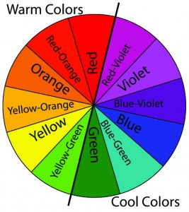
Red, Red-Orange, Yellow-Orange and some Yellow Green are warm colours with all their different tints, shades and tones are used to give a cozy atmosphere to the space.

