
Assignment Cover Sheet

Student Name: | Sara Spiers
Student Number: | 1486
Course: | Diploma in Wedding Planning
Assignment NO: | 2

Marking Criteria:
We expect the learners to write minimum one well expressed point in three lines against each allocated mark. This means one needs to write 15 lines with 5 well expressed points to get high grades for a 5 marks question.
For high grades use examples and illustrations where appropriate.
Please insert your completed assignment ( in word format) here:

Q1. i. Outline at least two advantages and disadvantages of having a double wedding.
Siblings who are both engaged can share their wedding celebration together and bring both couples closer together as a family, making their day a memorable one that everyone will remember. There is also an element of support from one another in terms of planning and decision making. Also, their parents can avoid the unnecessary expenses of two separate weddings and wedding guests who may live further away and couldn’t afford to make two journeys for each sibling’s wedding.

Whilst the concept of a shared occasion seems like a nice idea, it may not be to everyone’s taste. Most couples like the idea of their wedding day to be about them and their relationship, however, the spotlight would be shared at a double wedding and it no longer becomes about you. Furthermore, all anniversaries also become shared occasions which again may not suit a couple’s ideals.

On the wedding day itself, your ideas and tastes may not come to fruition, especially if the other sibling has conflicting tastes. It then becomes a case of compromise in some instances for the other.

ii. Why do couples go for themed weddings?
Couples can choose to have a theme to add something extra to their wedding and make the event more memorable for all of the guests who attended. There are many common themes that couples use, however, combining many different ideas to create one theme is unique to that couple.

The couple may choose to have a theme that is symbolic of their relationship which becomes the forefront or core of the event, or that displays their traditions. The ultimate aim is to make an enjoyable event for their guests and to show their respect and thanks to the guests for being a part of their day.

iii. How does a themed wedding help set the mood for the wedding ceremony?
The theme dictates the level of formality of the event and the social behaviours of the guests who are attending, and therefore sets the overall mood and atmosphere of an event. Ideas that contribute to the theme which influence the mood can include the dress code, music, and dining.

A themed dress code can represent the formality of the event and which can influence the mood. For instance, black tie sets a more formal mood for guests, whereas smart attire is less formal. More unique themes such as a medieval theme are very informal and creates a highly joyful atmosphere.

Also, the type of music played at a wedding can also influence the atmosphere. Classical music can give the impression of a more formal affair, whereas folk, pop, rock and dance music sets a more informal mood. In addition, a theme which entails finger food makes for more informal environment, as opposed to a banquet sit down meal which is more formal.
iv. Outline the major factors that may influence the choice of a themed wedding.
Media including TV, digital and magazines give couples ideas from other people’s weddings to help them form their own theme. Not only do these magazines contain have photographs, they also have articles on the latest trends and ideas that work well together, and real life stories and opinions of couples who have used these ideas in their own weddings.

Friends and family are always on hand to offer support and this is no exception when it comes to wedding planning. They are always on hand to offer ideas, particularly those who are already married and offer their experiences, and those who are newly engaged and share their own ideas (MBA Bride, n.d.) It’s also common for brides to discuss ideas with their maid of honour, bridesmaids, their mother and mother-in-law to be.

The overriding factor, however, that influences the theme for the wedding is the couple themselves and their lifestyle. It is their decision at the end of it all which theme suits them best, with the helping hand of the aforementioned influences.

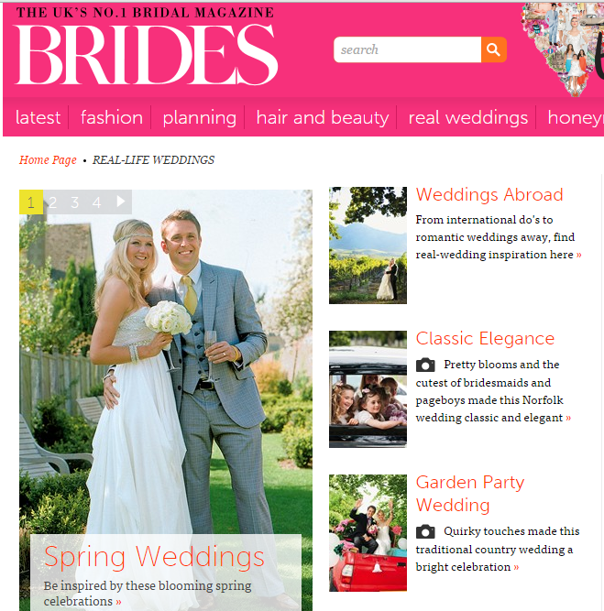(Brides, 2015)

v. Outline the important points to consider when choosing a wedding venue.
The venue is arguably the most important aspect of the wedding as without this, the wedding would not take place. The most important factor to consider when choosing the venue is its availability on a convenient date for the couple and the guests, and depending on the couple’s beliefs, wishes and budget, whether the venue is suitable and large enough to host both the ceremony and reception.

Should the couple choose to have the ceremony elsewhere, such as a church or registry office, the choice of venue for the reception must be chosen on the basis of its distance from the ceremony location, its facilities including its size and catering options, its timing restrictions in accordance with its license, nearby accommodation and transport and parking available for those who will not be staying overnight.

Q2. “Planning a themed wedding can be a challenging task for a wedding planner.” Discuss.
There are many popular themes for weddings including certain colours and palettes, seasons, floral and traditional which many try to put their own spin on. However, some couples choose a highly unique theme and the planner must be able to meet their needs and bring a theme that may not have been done before to fruition. They may only be able to verbally explain their ideas which the planner must be able to physically show in design plans. Alternatively, some know what they want and have ideas for the day down to the finest detail which can be advantageous to the planner. It is then up to the planner to obtain items that fit the theme.

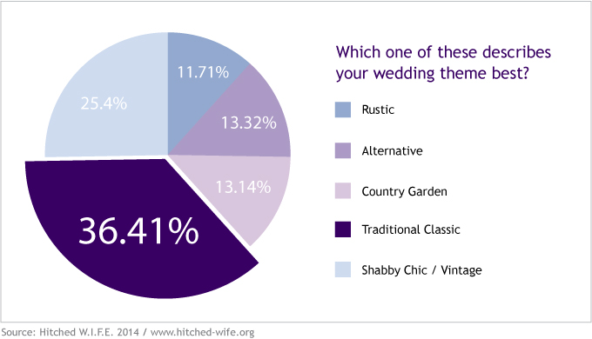

Another challenge for planning a themed wedding is being able to create the theme within the couple’s budget which sometimes can be small. Some venues are limited in the types of food they can offer for weddings. External caterers may be able to create a banquet package which contains food that matches the theme, however, this may cost extra. Also, the décor costs may be higher if the couple chooses to go with a certain theme. It is thought that the average budget for reception décor in 2013 was £500 (Ideal Bride, 2013) and is thought to have doubled to £1,000 in the space of two years (Perfect Wedding, 2015). Venues often provide some décor, however, hiring or purchasing décor from external companies to directly match certain themes can cost more.

The couple and planner must also consider whether the chosen venue could clash with the theme if the venue is decided upon first. This may result in adjusting the theme slightly or changing the theme altogether, however, it can be avoided by choosing a venue which is like a “blank cavas”. On the other hand, this also has its challenges as the couple would need to spend more and the planner must organise the décor to ensure the room doesn’t look bare.

Q3. How can the wedding theme be made evident in wedding invitations? Give at least one example with a designed wedding invitation.
The invitation gives the first impression of the wedding and what guests should expect when they attend, therefore it should reflect the theme. For example, a beach theme should be reflected on the invitation by using a design and colour scheme that represents the sand and sea. Couples can use various shades of blue and green, as well as creams and golds, and use designs of shells, starfish and palm trees to emphasise the theme. They can also use straw to represent seaweed.

 (Elegant Wedding Invites, 2013)
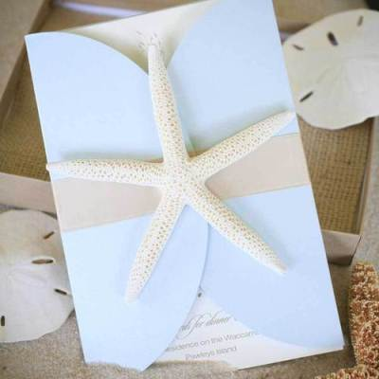 (My Harusi, 2012)
Alternatively, a music theme can be conveyed through the invitation in various ways, depending on the formality of the event. There are many different genres of music, ranging from more formal genres such as classical, through to more the more informal, such as rock. Classical themed weddings can be conveyed through music sheet-styled invitations, whereas rock themed weddings can be conveyed through invitations that are shaped like instruments, CDs and records.
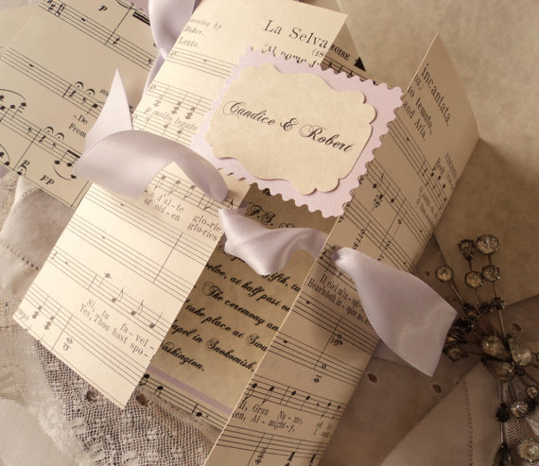 (Inked Weddings, 2013)
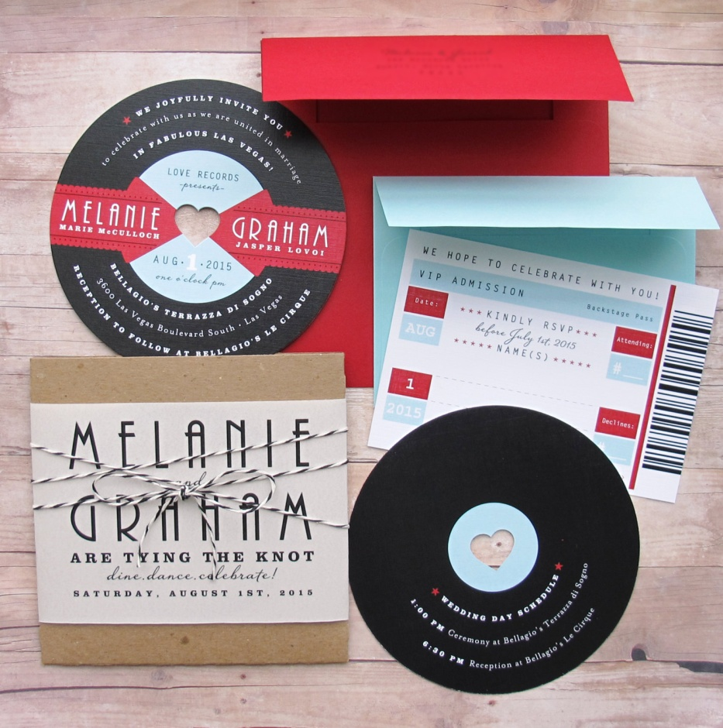 (Etsy, n.d.)
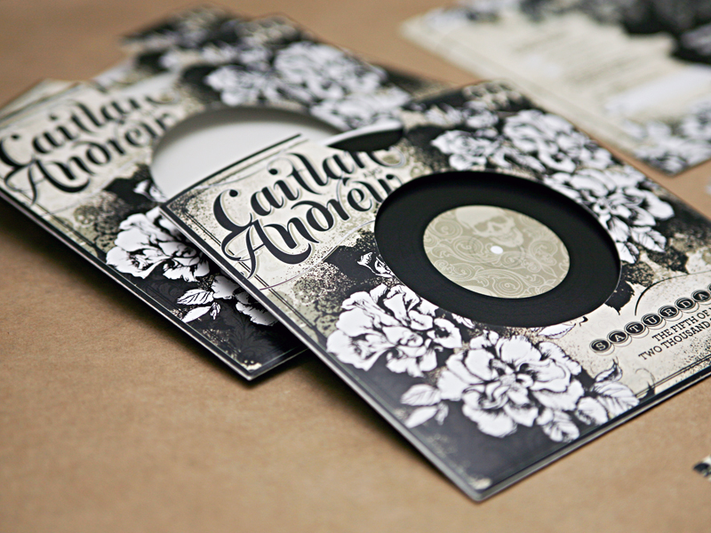 (Oh So Beautiful Paper, 2011)

The couple must not solely focus on the important information about the timings and place of the wedding in the invite, but also provide information in terms of dress code which also gives guests an idea of the theme and formality of the event.

Case Study
How will you help them in choosing the location?
During the first consultation, I would get to know the couple and their reasons for choosing to have a destination wedding as opposed to a home wedding. It’s vital to ensure the couple knows both the benefits of a destination wedding as well as the disadvantages, and to ensure they have considered all of the factors including the laws of the country, whether there is any political unrest and the costs involved.

I would then get to know their favourite things to do as a couple, where they most enjoy going on holiday and where they perhaps haven’t been before but would very much like to visit. Following on from this, I would provide them with different example locations that fit their top 4 location types and expected costs. Giving examples, including photographs of each location, helps to set the scene in the couple’s minds and this, along with more information on the location and costs, can help them in choosing which destination suits them best.

What are the benefits of having a destination wedding?
The biggest benefit of a destination wedding is being able to do something different for your wedding and being able to experience another part of the world at the same time. There are many beautiful places around the world for couples to choose from for their wedding and potentially go on to experience further as a part of their honeymoon. The couple and their guests are get to travel to the location, often a week to a few days in advance, meaning that they have more time to celebrate the wedding and possibly longer if they choose to roll the wedding and honeymoon into one long holiday.

Destination weddings are often much more casual than hometown weddings which reduces much of the stress of wedding planning, and also reduces the costs in things such as wedding attire, food, venue hire and decorations. Moreover, as the wedding is more casual, there are no real rules to follow, aside from obtaining a marriage license and having a licensed officiant. Couples don’t have to follow traditions, meaning they can plan their day exactly as they wish, and even save money on parts of a “traditional” wedding that they may not necessarily like or want to do.

Why do you think a destination wedding is cheaper than a formal wedding? When there is travelling and accommodation costs involved as well?
Despite the travel costs, it is thought that destination weddings cost less. This is for a number of reasons. Firstly, there are less guests in attendance which reduces costs for the couple as they just pay for themselves. This means less money needs to be spent on food and transport. Also, destination weddings as much more casual and there often isn’t a need for a wedding reception. As it is usually only close family in attendance, they may choose to have a small dinner celebration or even just spend an evening on the beach which reduces costs in food, decorations and venue hire. Furthermore, casual weddings usually mean that there isn’t a need for formal wedding attire which also saves the couple money.

It is important for you as a destination wedding planner to have awareness about the local politics and laws where the wedding is to take place. Why?
Whichever country a couple gets married in, they must abide by their laws, therefore, it is important to do research on the country in the planning stages of the wedding. For example, some countries only allow local officials to conduct ceremonies and in order for the marriage to be valid in their home country, there may be further action taken. Furthermore, some countries require proof of a person’s eligibility to marry, including their age and that they are not already married to another person (U.S. Department of State, n.d.)

Also, to ensure the safety of the wedding party and guests, the couple must research the current political stability in the country they plan to get married in. Many countries including Sudan, Libya and Yemen are currently in extreme political unrest which makes these locations highly dangerous to visit. Despite security potentially being stepped up in these destinations, governments advise their citizens not to travel there.

References

Hitched W.I.F.E. (2014). UK Couples Prefer a Traditional Wedding Theme. Available URL: http://hitched-wife.org/wedding-facts-economics/trends/uk-couples-prefer-a-traditional-wedding-theme/. Last accessed 8th August 2015.

Ideal Bride. (2013). Average UK Wedding Budget 2013. Available URL: http://www.idealbride.co.uk/features/2011-05-01-wedding-budget.php. Last accessed 8th August 2015.

MBA Bride. (n.d.) What’s influencing your wedding decisions? See the 5 wedding forces model. Available URL: http://mbabride.com/whats-influencing-your-wedding-decisions-see-the-5-wedding-forces-model/. Last accessed 6 August 2015.

Perfect Wedding. (2015). What is the average cost of a wedding? Available URL: http://www.planyourperfectwedding.com/article/budgeting/what-average-cost-wedding. Last accessed 8th August 2015.
U.S. Department of State.(n.d.) Marriage Abroad. Available URL: http://travel.state.gov/content/passports/english/abroad/events-and-records/marriage.html. Last accessed 11 August 2015.

Student Statement:

By submitting this assignment, I confirm that this is my own work.

Student Signature |  | Date

For Tutor / Assessor Use Only
Total Marks
Marks Obtained
Percentage / Grade

