
Assignment Cover Sheet

Student Name: | Sukhwinder kaur
Student Number: | 1282
Course: | Fashion design
Assignment NO: | 10

Answer a)
The average human figure is about eight heads tall, whereas a fashion figure may be from eight to ten heads tall,-in extreme mannequin types, as many as twelve heads. However the height of the fashion figure should be governed by the length of the head and the width of the shoulders. This added height lends sophistication, grace and smartness to the figure-qualities that are envied by the majority of woman and therefore enhance the appeal of an advertisement.
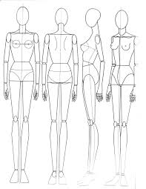

Answer b)
The best rule to follow in the sketching the face is to omit as much detail as possible in order to avoid a photographic likeness. Remember you are sketching-not trying to reproduce a detailed likeness of anyone. Detail tightens keep your sketch free and loose. Omit part of the outline of the face you may even leave out the nostrils of the nose be a little abstract. Such things will tend to give your work .
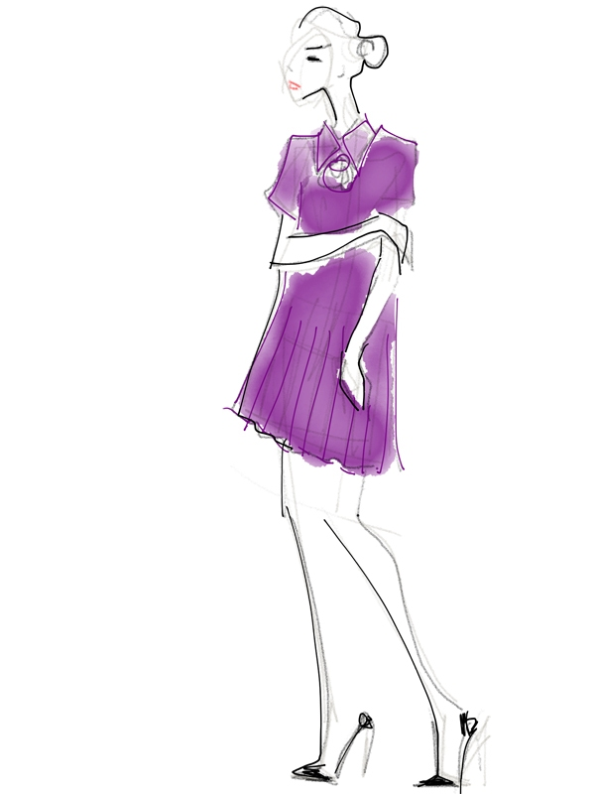

Answer c)
The hand is composed of two large masses the hand proper and the thumb. These should be blocked-in first in sketching the hand. The length of the hand, including the wrist, is equivalent to the length of the head. It is three-quarters the length of the fore-arm. The flower each finger has three bones. The middle finger is the longest and is the same length as the palm. The fashion artist exaggerates the length of the fingers and minimizes the width of the hand. Long and graceful is the creed for fashion hands.
Answer 2.
The most important one for the artist. Without spending too much time on it, he must be able to get the effect of the material used-to catch the spirit of the fabric. The chic of the crisp taffeta evening costume would be entirely lost if it were illustrated as a soft clinging fabric. Nearly all fashion sketches with the exception of the evening clothes, are made with hats, bags and gloves. This necessitates the artist keeping up to date on developments in accessories as well as apparel. An important point that should be stressed here is the necessity of harmonizing the mood and action of the figure with the clothes in which the artist draws her. If the woman is presented in sports clothes, she should be depicted actually engaged in some sport.
Answer 3.
Fashion design sketches help us paint the picture we have in your mind. Before one can actually designs a good dress, he must visualize it first and once it is done, he can slowly try recereating the image using pen and paper. The reason fashion design and design sketches are around is so that one can have a rough idea of what is in his mind and then using his imagination and creativity he can make alterations accordingly. Be it shoes, tops, belts, pants, shorts, dresses, skirt, coats, or whatever it is must start with a sketch or two besides that, the fashion design sketches are what you will submit to your manufacturing companies to produce you design.
Answer 4.
The bottom of the skirt should never be sketched straight across, but, rather, should have the general feeling of a rectangle. If it is drawn straight, it has the effect of being on something flat instead of being on a body that has thickness. Curve the rectangle at the sides to lend the appearance of going around the figure. The hemline will appear to be longer over the leg in the foreground or the foot nearer the artist. Strive for rhythm in the lines expressing the folds of the skirt. If the belted and the belt fits snugly, make your sketch of it on straight lines across the front, curving it on the sides. But it is not unusal that sketch appears to be sleeveless because of the mission of this detail. If garment is trimmed with buttons, count them and sketch the same number. A few points to bear in mind when sketching a dress on a figure are. for example;
Where is the neckline-high or low, does the costume have a collar which shape , what is the style of sleeves-short, long , tight, does it have a normal shoulder line.

Answer activity
Sketch a pose for for your drawing. Remember that you will be drawing a human figure using basic shapes. This time, though, the figure is going to be thinner and taller than the average person.

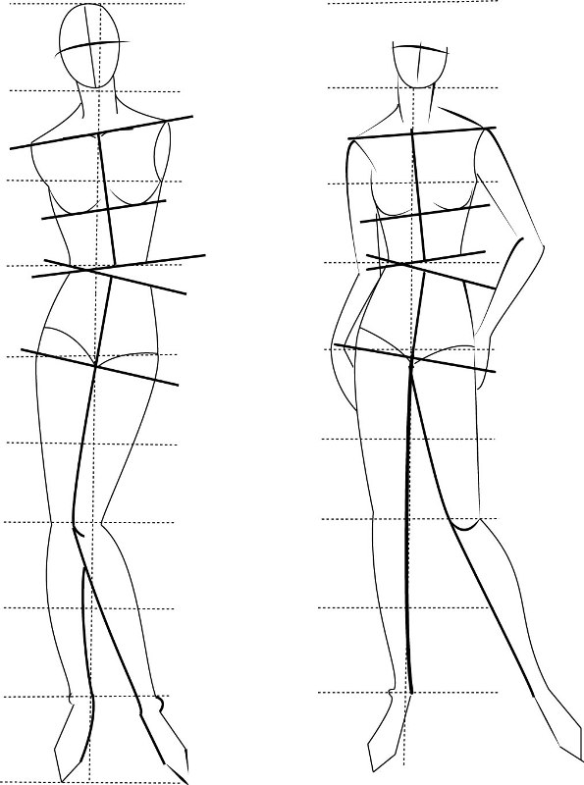
Add in shapes as shown. Notice how thin the figure is and how long the legs are compared to normal human drawing.
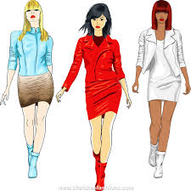
Sketch an outline of your image. You don`t need to add in too much detail on the face or hands etc. you are welcome to add hair if desired but it`s by no means necessary.

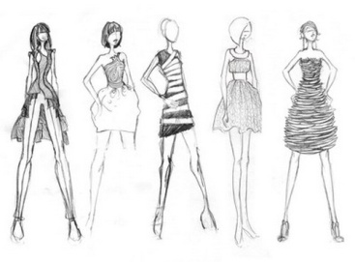
Add in clothes you have in mind. Think of the figure as a mannequin.
Outline the whole drawing and erase guidelines.
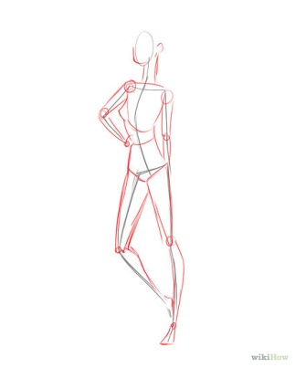
Where is the neckline-high or low.
Does the costume have a collar which shape.
What is the style of sleeves-short long tight.
Does it have a normal shoulder line .
Where is the waist line above or below the normal.
Does it have a belt tight or loose.
Which type of skirt is it-circular pleated.
How long is the skirt .
What type of trimming does the garment have.
Which type of fabric it is.

Student Statement:

By submitting this assignment, I confirm that this is my own work.

Student Signature | Sukhwinder kaur | Date

For Tutor / Assessor Use Only
Total Marks
Marks Obtained
Percentage / Grade

