
Assignment Cover Sheet

Student Name: | Sumbal Jamil
Student Number: | 1149
Course: | Fashion design
Assignment NO: | 2

Student Statement:

By submitting this assignment, I confirm that this is my own work.

Student Signature | Sumbal Jamil | Date | 22-10-2013

For Tutor / Assessor Use Only
Total Marks
Marks Obtained
Percentage / Grade

Sumbal Jamil
Student no: 1149
Assessment no: 2
Course: Fashion design
Sumbal.jamil94@yahoo.com
1. Objective Answers
a. May or may not know how to sew or make patterns
b. Customers
c. Colour
d. Price
e. Informal fashion shows
f. Pattern cutter
g. Customers must buy and wear a style to make it a fashion
Answer no: 2
Difference between fashion and style:
- Fashion: It is what is currently in fashion and trendy right now, that is what is being featured in magazines, on TV and on the fashion runways.
Fashion is not something that exists in dresses only. Fashion is in the sky, in the streets. Fashion has to do with ideas, the way we live, what is happening. (Coco Chanel)
- Style: It is unique to everyone. This is the person’s own opinion, their own choice in clothing and accessories. Style is something that has been modified and customized an individual level to suit each person’s own personality and body.
Style is knows what we are, what we want to say and not giving a damn. (Orson Welles)

According to Oscar de la Renta:
“Fashion is about dressing according to what’s fashionable; style is more about being ourselves.”

According to Toledo:
“Style is an effective way to carve out our individuality. It belongs to no one, and to everyone. A person with true style is displaying a fertile and thinking mind.”

- Fashion is ever-changing: There are no constants, no staples in fashion. Fashion is difficult to keep up with, as it changes by the decades, the year the season, sometimes even by the week. What is considered in fashion today could possibly be difficult tomorrow .There’s no sustainability in fashion and one could so far as to say fashion can be wasteful. Wasteful as in a closet full of barely used clothes, left unloved because they’re no longer fashionable. Or wasteful as in the stacks of money spent chasing trends because everyone is doing it. It seems the worst followers of religion of fashion aren’t really true to themselves; they seem to wear things or carry things or like things because these things are “in”, popular and everyone else wants it.
Fashion change like leaves on the bough, some of which go and others come .(Charles Churchill)
- Style is personal and doesn’t change with fashion: It is personal. Style is all one’s own and no one can say otherwise. Style is comfort, confidence and consciousness all in one. Conscious of its own story and disinterested in anyone else. Style isn’t directly affected by trends. It doesn’t change with the direction of the wind and it can adopt and adapt to certain trends. The truly stylish man knows, understands and respects the rules, yet knowingly defies and breaks them, bends them and interprets them as he pleases. Great style means not taking oneself or one’s garments too seriously.
Style is very personal. It has nothing to do with fashion. Fashion is over quickly and Style is forever. (Ralph Lauren)
- Fashion is the relationship to the external: It is concerned with “what’s out there” means fashion items in the stores. It’s a matching process between what’s out there to what we are wearing.
- Style is the relationship to the internal: It is about what’s in here means sense of self, identity, our perception of who we are. The matching process is between what’ s in here and how that is reflected and expressed in what we are wearing.
Fashion is very versatile: It keeps on changing .A person is only fashionable if they are following the current fashion, a thing hard put to do as is for a limited time only. One must constantly keep changing their wardrobe to keep up with all the current fashions. It doesn’t matter if the trend is ugly ,if it doesn’t go with our personality, if it ‘s flattering to our body shape, if the colour that is in season doesn’t go with us at all, one must conform to it ,in order to be considered fashionable.

- Style is permanent and timeless: It is considered more permanent and timeless, as it doesn’t need to change. It may only change when the person does or the style or personality is redefined. Style is not dependent upon clothing; it can be associated with anything that makes us look stylish. A stylish person wouldn’t necessarily care about what is in fashion right now. He
Will be more concerned about what suits his body type better or his skin tone or hair color etc.
Fashion fades, only style remains the same (Coco Chanel)
Key difference between fashion and style: It is easy to see that there’s a huge difference in the orientation of our focus if it’s on fashion vs. style. Fashion .Fashion takes our attention away from ourselves while style brings our attention directly to ourselves. With fashion, it’s on the clothing; the items demand to be fashionable. With style it’s on the person. There are many people who are fashionable however they may or may not be stylish. There are two people who follow fashion blindly, without any regrets to whether the fashion actually suits them or not. However there is also number of people who are stylish but they are not considered fashionable. Style has dynamic nature but its dynamism has to do with the expression of who we are and our sense of self. It’s about honoring our uniqueness. I believe that fashion has the capacity to erode our self-esteem and confidence because by its very nature it assumes a gap between where we are and what we should be. Fashion releases an unattainable looks on women with realistic bodies whereas style is about utilizing the best aspects of us. So that’s my take on the real difference between fashion and style.
The real difference between fashion and style is quality (Giorgio Armani)
Examples:
- , Sienna Miller is a girl who always stamps her style on any ensemble. Be it a red carpet or the muddy fields of Glastonbury, Sienna’s eye for quirky fashion and purposefully undone hair and beauty have made her a staple on the fashion pages. Everyone loves this look, where she makes a strong red lip and blunt fringe look casual and effortless.

- From child stars to fashion trend-setters, Mary-Kate and Ashley Olsen know their style and aren’t afraid to show it. From their own fashion designs to their appearances in the front row of fashion week, the sisters each have their own unique take on trends, but both share a love of the fringes of fashion.
- Miranda Kerr might be known in her professional, modeling life for being primped and perfectly groomed, but Miranda Kerr’s personal style is a lot more carefree. She looks just as stunning on the high street, if not more, and has made motherhood look more glamorous than ever this year.

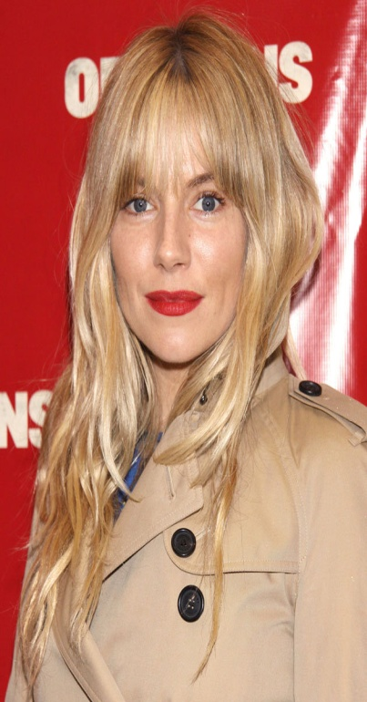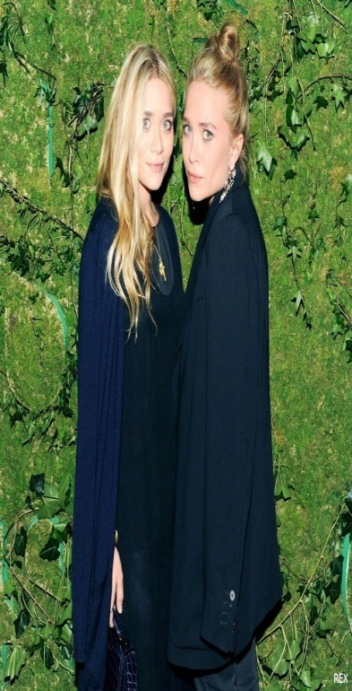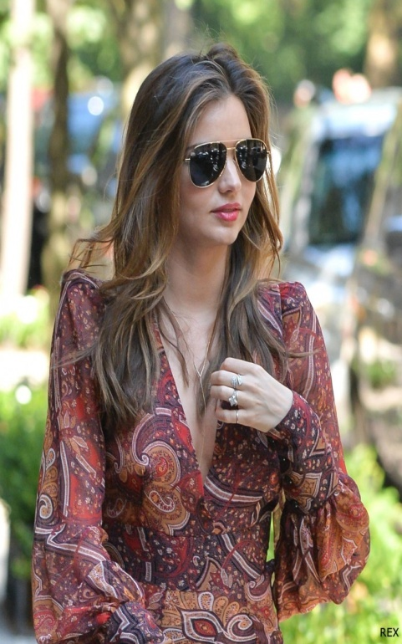
Sienna Miller, Mary-Kate and Ashley Olsen, Miranda Kerr
- Rachel Billson has the IT factor. Whether she's on screen or off screen running errands, her style is consistently enviable). Her signature staples are rolled or cropped shinnies, any form of booties, and jacket over her casual booties and distressed shinnies is genius: a blend of hi and low style that a clean fresh face...elements that she uses in this Steal Her Style outfit. Adding a short boucle jacket over her casual booties and distressed shinnies is genius: a blend of hi and low style that makes a tailored piece relaxed and fun for the streets.

