
Assignment Cover Sheet

Student Name: | Christina Kechagia
Student Number: | 1574
Course: | Diploma in Fashion Design
Assignment NO: | 6

Marking Criteria:
We expect the learners to write minimum one well expressed point in three lines against each allocated mark. This means one needs to write 15 lines with 5 well expressed points to get high grades for a 5 marks question.
For high grades use examples and illustrations where appropriate.
Assessment 6
1: Give short answers for the following questions:
- How is the formal balance achieved in dress designing?
Formal Balance It is called symmetrical balance. When identical objects are equidistant from a centre point or otherwise called as the exact mirror image of the other half. In dress design the feeling of dignity or formality is created by formal balance. The upper and lower portions of the design are so arranged, as to give an effect of balance. Thust here should not be the effect of too much of weight at the bottom or a heavy appearance.
- How can harmony be created in a design?
Harmony between shape and form is necessary for good design. Functional aspects of harmony imply that a garment is comfortable, moves easily and breathes with body, performs any specialized duties effectively and fits well. In physical effects of harmony, garment parts are in scale; their combined proportions seem to belong with each other and the figure.
In order to achieve harmony in any garment, the three aspects of design- function, structure and decoration must be in accordance with each other. This means that occasion, climate, size, gender, age, personal colouring, life style and personality of the wearer should be considered while designing the garments. However complete identicalness in a garment, be it colour, texture, shape or space may create boredom. To avoid this monotony a small area in contrast colour or a garment part cut in contrast of texture can often add interesting element in the design.

- What is the relationship between the principles and elements in a design?
Principles of design are the laws of designing anything! In other words, to have a good design, you should consider these principles for the best design possible. Elements of design are things that are involved within making a design. The principles are rules you have to follow and elements are things that will help you complete those rules for the best project outcome.

- Describe at least three ways for creating rhythm in dress designing.
Rhythm can be created in a garment with repetition, gradation, transition, opposition or radial arrangement of various parts of design and fabric design.
Rhythm through Repetition Rhythm is achieved by repetition or regular repeats of motifs of design, shapes, buttons, tucks, pleats, laces, edgings, colour, textures, fabric designs etc. This can be done with all parts having the same shaped edges. They might be squared, rounded, or scalloped.
Rhythm through Progression Rhythm is also created by progression or by gradation. Gradation implies a gradual increase or decrease of similar design elements. Colours can go from light to dark or textures from fine to coarse or vice versa. Shapes may range from small to large, and lines may range from thin to thick. The gradual changes provide continuity while giving a feeling of movement
Rhythm through Transition: Transition is a fluid rhythm created when a curved line leads the eye over an angle. The curved lines of transition cause the eye to change direction gradually rather than abruptly. Transitional lines and shapes sweep and glide over the figure in an undulating rhythm leading the eye gracefully and easily from one area or direction to another.

2. What are the principles of design? How do they help a designer analyse the effectiveness of a design?

Principles of design are guidelines for the use of the elements of design. They are used for creating, discussing & evaluating garment designs on and off the individual. In order to arrange the elements of design well, application of principles like balance, proportion, emphasis and unity/harmony are essential. These are not abstract art terms but specific guides that help to create attractive garments. The principles of design are useful in creating different forms of expression in an artistic manner, which are pleasing and attractive to the eye. Following are the principles of designing. 1. Balance 2. Emphasis 3. Harmony 4. Proportion 5. Rhythm.
Principles of design serve as guidelines for combining elements. Designers may not consciously think of these principles as they work, but when something is wrong with a design, they are able to analyse the problem in terms of proportion, balance, repetition, emphasis, or harmony (the first four principles work together to create the ultimate goal of harmony). These principles are flexible, always interpreted within the context of current fashion.

Activity
Find pictures of some dresses from fashion magazines. Describe the beauty of each in terms of line, silhouette, shapes and spaces, colour, and texture (fabric, pattern, and trims) as well as balance, proportion, rhythm, and emphasis. Do all elements and principles work together harmoniously? What elements dominate? Find two garments that you feel are unsuccessful. Analyse them in the same way to discover what element or principle has not been properly used.

I
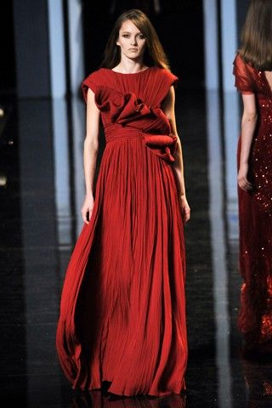
This dress is a perfect example of harmony. It involves color, texture shape and line. The color dark red gives out the classy and elegant style, the flowy shape of the dress gives out an soft texture. The dress overall gives a really comfortable feeling from its texture.
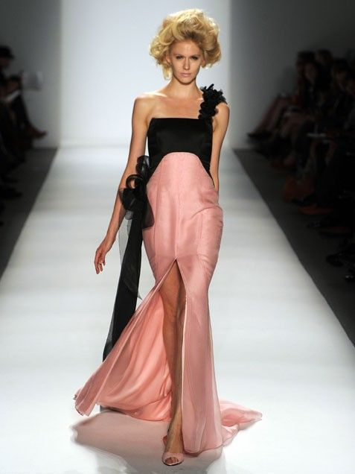
This is a perfect example of asymmterical balance. Over here, we see that the design isn't as formal or stable. Instead, the design brings out a lively and active sense. It is a more modern type of clothing, the balance design of the clothing would make you feel young, confident as well as being fashionable.

. 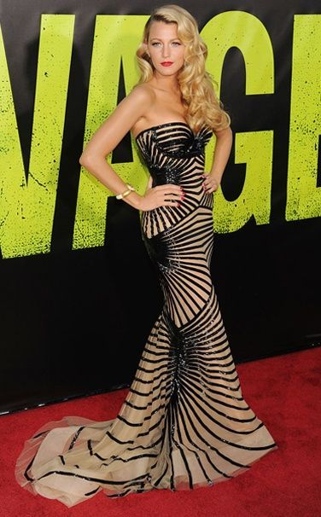
The dress applied to line, colour, and shape which ecourages the eye to move easily through out the garment. The lines helps to creat a movement to the dress. Also gives it a good body hugging shape. Makes Blake looks classy, sexy elegant but not too much at the same time.
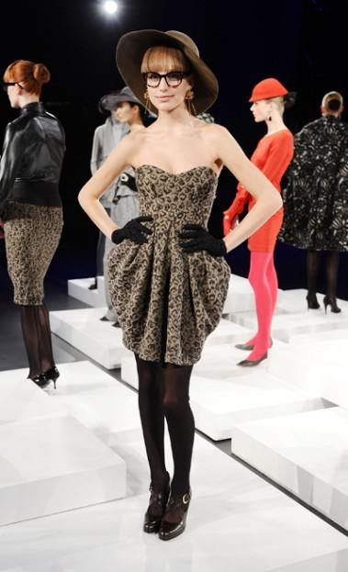
This design is a great combination of all the elements and principles of design. The color scheme is made of brown and black, adjacent colors on the color wheel. The textures mix well together, with the softness of the dress.There are lots of curved lines in the design to create a softer, funner look.. The shoe straps, the bottom of the dress, and the gloves form horizontal lines. The dress is a great example of symmetrical balance, giving this outfit a sense of formalness and classiness. The main focal point of this dress is the skirt line. Repetition rhythm makes this outfit look great!.
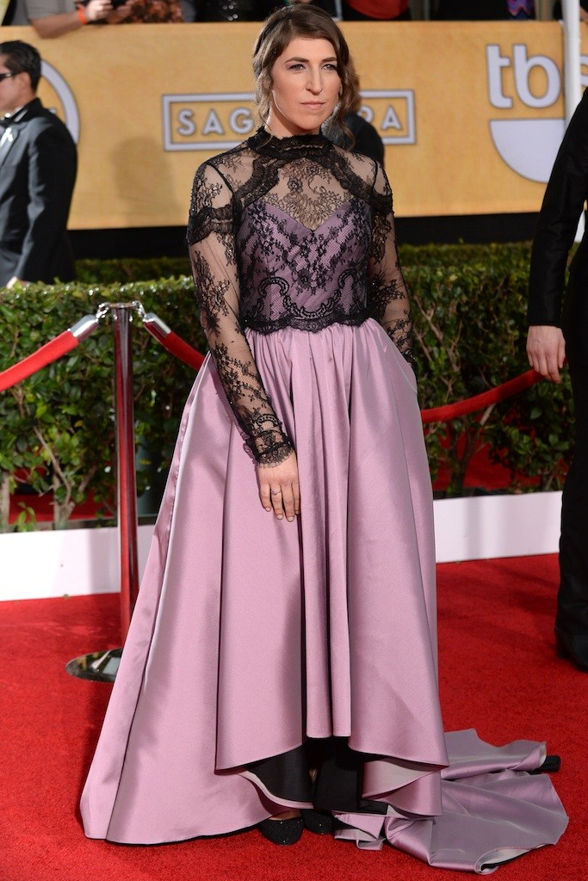

This is an unsuccessful dress. It has bad fit. The skirt is oversized , bad color and bad cut. It’s a gothic-inspired lace purple and black gown that looked more like a costume. The textures don’t mix well together and it hasn’t got harmony. The asymmetrical balance and the different colour of the skirt doesn’t help her figure.

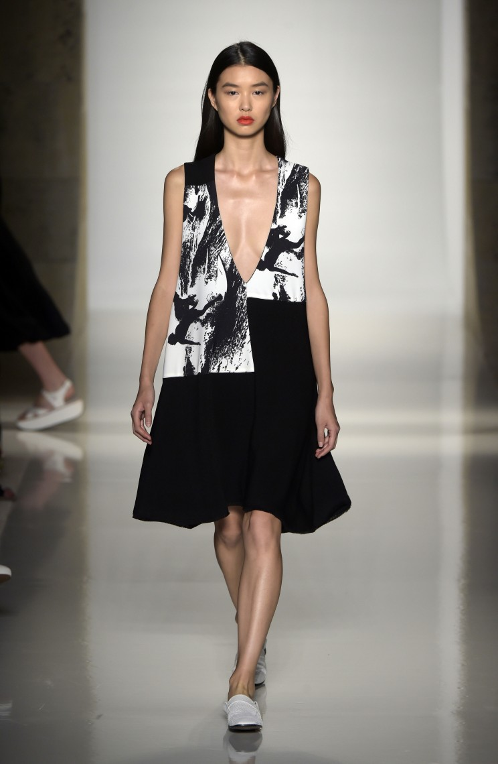
This look uses very slight asymmetry and a large amount of negative space, but it maintains balance through the full, black skirt. It makes the model looks short.

Student Statement:

By submitting this assignment, I confirm that this is my own work.

Student Signature | Christina Kechagia | Date | 8/3/2016

For Tutor / Assessor Use Only
Total Marks
Marks Obtained
Percentage / Grade

