
Assignment Cover Sheet

Student Name: | Omnia Rafiq
Student Number: | 1343
Course: | Diploma in interior Design
Assignment NO: | 16

Student Statement:

By submitting this assignment, I confirm that this is my own work.

Student Signature | Omnia Rafiq | Date | 15-5-2015

For Tutor / Assessor Use Only
Total Marks
Marks Obtained
Percentage / Grade

Q.1.i. Q.1. Multiple Choice Questions:

I. How would you accurately visually convey a room scheme to a client?
a) produce a sample board

ii. for the very pre-liminary ideas there is no substitute for
a)sketching

iii. What document is formulated by the designer after all the relevant information
Is gathered?
c) a client brief

iv. Once the designer is clear about the availability of budget he can ask the client
some questions to know exactly;
a) the client’s needs

v. if there is a pet in the house a designer should know about it because;
b) this affects the finishes and surfaces used

Q.2 Short Questions:

I. The information collected at the “information gathering stage” usually relates to
The four areas. What are they?
Before deciding upon any scheme, a designer requires a complete and thorough understanding of the client’s mind and needs. A designer who is asked to improve a home scheme or to plan one from scratch would start by finding out their client’s tastes and the factors that can make them feel more comfortable, how they live their lives, how they would like to live their lives in an ideal world and how much they are prepared to spend. One can start with the availability of budget and can then work backwards from there, in the light of money available for the project. Once the designer is clear about the availability of budget he can ask his client the questions to find out exactly what the client’s needs are. The questions must cover the four main aspects of the work:
- Function
- Practicalities
- Aesthetics
- Budget

ii. How important it is for the designer to know about the client’s budget and at
Which stage should he try to know about it?
At the information Gathering stage, The designer must know about the client’s available budget, and this can be done by asking him some questions, which include:
- Knowing the maximum which the client can spend on the project.
- Reassuring if the client is comfortable with the budget
- Asking him if he researched the current prices for merchandise and services
- Getting to know what must be spent? Where can the client save?
- Knowing if he Can make sensible compromises on items that could be recycled to less
Important rooms if it means that better things can be afforded in the furniture?
- Asking them to mention some luxuries they are dreaming of, and what they think will make their home look more attractive.

iii. How is decorating schedule different from the sample board?
A Decorating Schedule is considered to be a reminder of exactly what is to be done. Decorating schedules can be prepared at the same time as the sample board and can be kept with the sample boards for daily reference. This can be created by writing the room’s name at the top and following headings down the side of the paper, leaving enough space between them for clear descriptions:
- Walls
- Floors
- Ceilings
- Woodwork
- Window treatments
- Lighting,
- and so on
While it is important for sample boards to reflect the right mix and balance of colors and materials in a scheme. Assembled in the same way as a collage, they tend to comprise of magazine cuttings, photographs, and sketches that evoke the style or theme of the intended design. These boards successfully convey the essence of a design in a way that the more conventional presentation materials may not. They are usually put together in the same way as a collage with an assembly of cuttings from brochures, newspapers, magazines, photographs, and
Sketches that convey the style or theme the designer has in mind. These boards can also
Incorporate interesting textural items such as paper, fabric samples or leaves.

iv. What do we call the process of gathering information from the client which then
Becomes the back bone of the designing scheme?
We call it Questionnaire, it’s considered to be the first and most important process, Since the design depends totally on it.

v. A------ board is a designer’s visual response to a brief. This may consist of
Magazine cuttings, photographs and sketches.
A Sample (mood) Board is considered to be the designer’s visual response to the client’s brief.

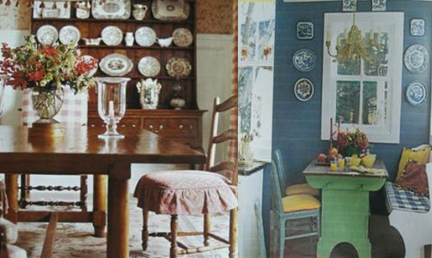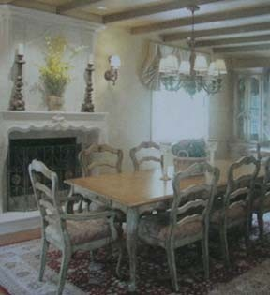FRENCH COUNTRY:

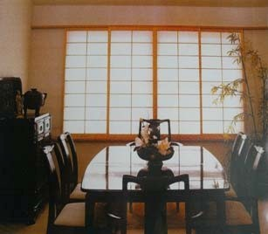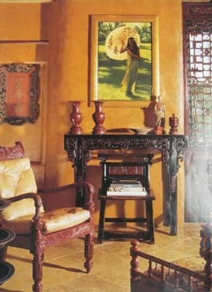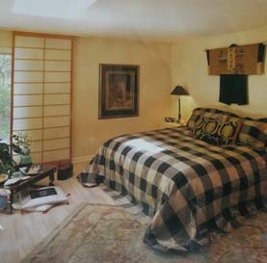ASIAN:

EARLY AMERICAN:

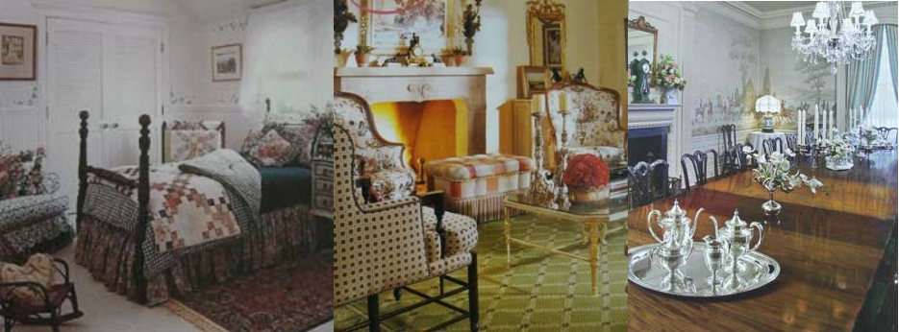
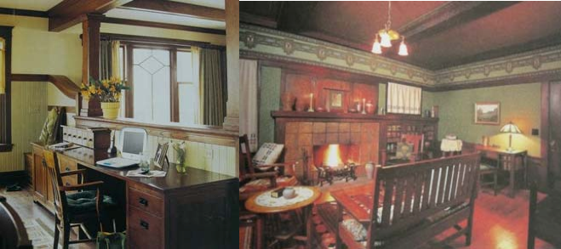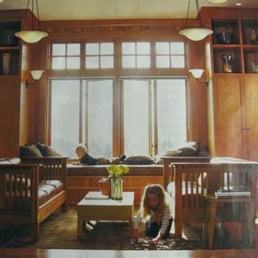MISSION:

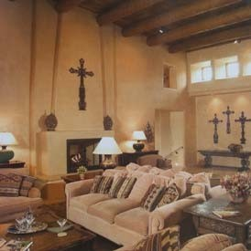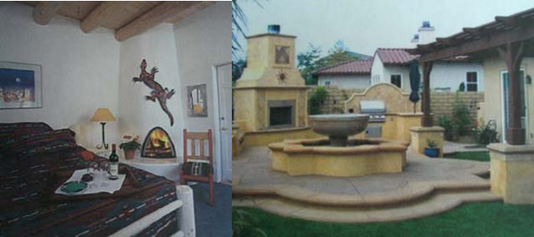SOUTHWESTERN:

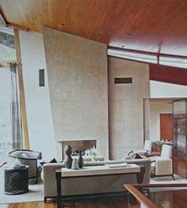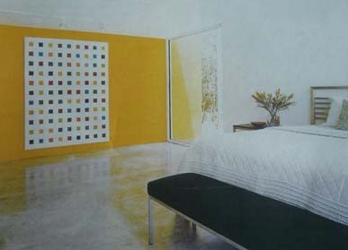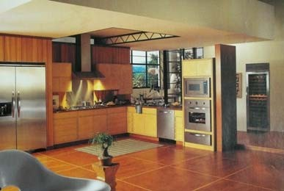INDUSTRIAL:

