
Assignment Cover Sheet

Student Name: | Christina Kechagia
Student Number: | 1574
Course: | Diploma in fashion design
Assignment NO: | 1

Marking Criteria:
We expect the learners to write minimum one well expressed point in three lines against each allocated mark. This means one needs to write 15 lines with 5 well expressed points to get high grades for a 5 marks question.
For high grades use examples and illustrations where appropriate.
Please insert your completed assignment ( in word format) here:

Assessment 1
1
I.How did the First World War influence fashion? Which types of changes were brought about by it?
After the First word war a big change came in fashion. After all those years in depression people wanted to feel free .The clothes started to become more practical and comfortable.
Women discarded to wear ornate toilettes with beads and embroideries for simpler styles, they wanted to keep themselfs well dressed but in a more economical scale. The length of the skirt shortened. Easy clothes with the available stock, They adopted a military style influenced from the war with coats, boots and capes.
The flapper style became very popular especially in young women They started to dress like boys even their behavior or the way they stand or sitting in a chair was completed different. 20s the decade of decadence and fun
Sportswear became very popular for men and women as a more comfortable look.

II. Describe the characteristic features of the twentieth century’s fashion.
At the early of this century cloths started to become more practical short skirts, waist lines lowered to the hip . These changes accompanied the boyish ,revolutionary flapper style.
During World War II, luxurious fabrics were highly regulated and women's skirts and dresses were often made out of anything that could be found within a home (like curtains or bed sheets)

At the mid twentieth century the people started to take care more of themselfs . They needed lighter textiles and garments and eventually, synthetics, were introduced ,the length of the skirts were knee-length, but became shorter and shorter until the mini-skirt of 60s and colorful patterns became very popular. The style of the time was simple, clean cut, and young.
In the 80s the fashion silhouette was defined by over. Women joined the professional work force business suits . Designers started to produce ready-to-wear lines at the end of 90s.

2.
Write brief note on the works of main fashion designers of 1970s.
America:
Sonia Rykiel. Pullover with reversed seams, fluid knitted garments, dark blacks, rhinestones, long boa-like scarves, and little crocheted hats.
Bill Blass. Costume designer with disciplined style and workmanship
Britain:
Punk style and Laura Ashley which consisted of long flounced skirts and high-necked blouses in floral prints .
Italy:
Giorgio Armani his first collection was a men's clothing line. His clothes were revolutionary with a more natural fit and using a subtle color palette.
Nino Cerruti. a name synonymous with modern restraint. Industrialist-designer, was once known as "the madman of fashion.

3.
How the 19th century influenced fashion industry. What major changes came about in fashion industry in the early 19th century and why?

Dress during the nineteenth century changed dramatically. The change was influenced by the introduction of machines to the construction of clothing. Until that time the designers went to costumers homes in order to make costume garments but Worth desided to change things. He was the first that organized a show at his fashion house, the first to sew on a label with his name. Many design houses began to hire artists to sketch or paint designs for garments. If the client liked the design, they ordered it
Sewing machines, steam power, electricity, new dye formulas, and other inventions increased the speed and ease of clothing manufacture.

Activity
Look through some old magazines cut out pictures showing fashion in the last two decades. Also find some photos from the latest fashion shoots and compare them. How does the modern fashion dresses differ from those of the past? Discuss in a report.

There is not a dramatically changed in fashion between two decades. The latest decades are often described as a mash up where trends saw the fashion of previous styles.
More and more ready to wear cloths and modern materials such as duffel and cotton, leather and furs exotic natural and synthetic fabrics. The past remains always a source of inspiration. The people used their cloths to express themselves. Cloths are a way for people to show where they came from and how they were raised.
The most obvious function of clothing is to improve the comfort. Most of the cloths of the 21 century are made to protect people from the weather conditions. In hot climates, clothing provides protection from sunburn or wind damage, while in cold climates its thermal insulation properties are generally more important.
1990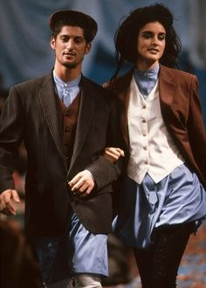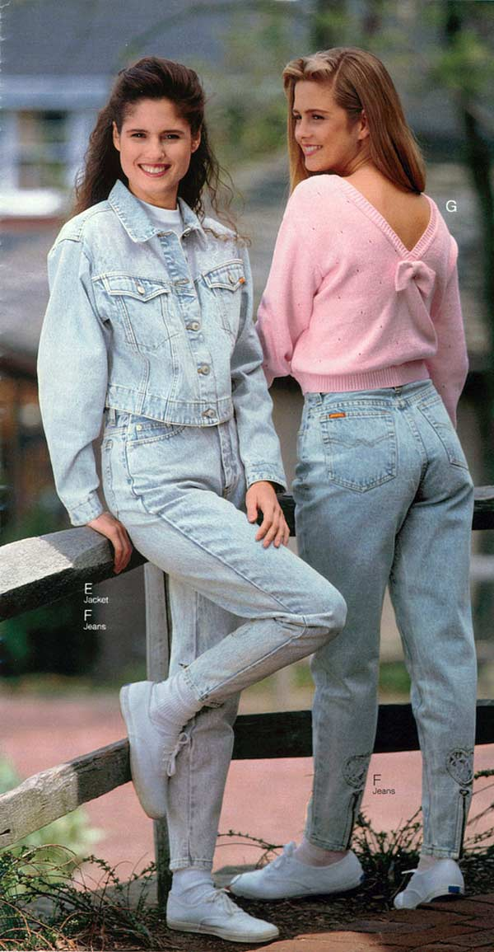

2010
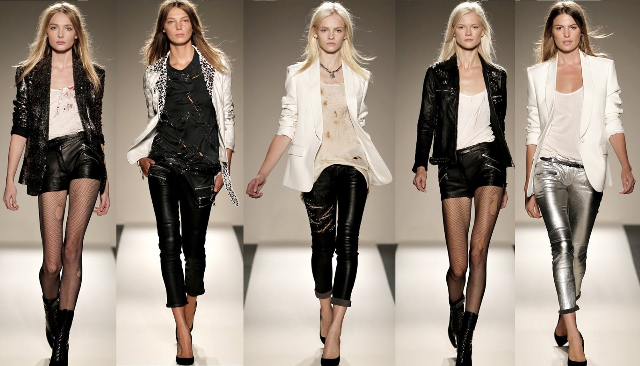
2015 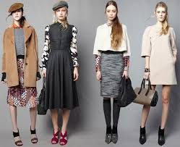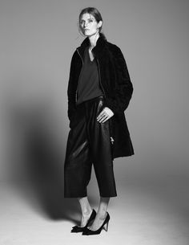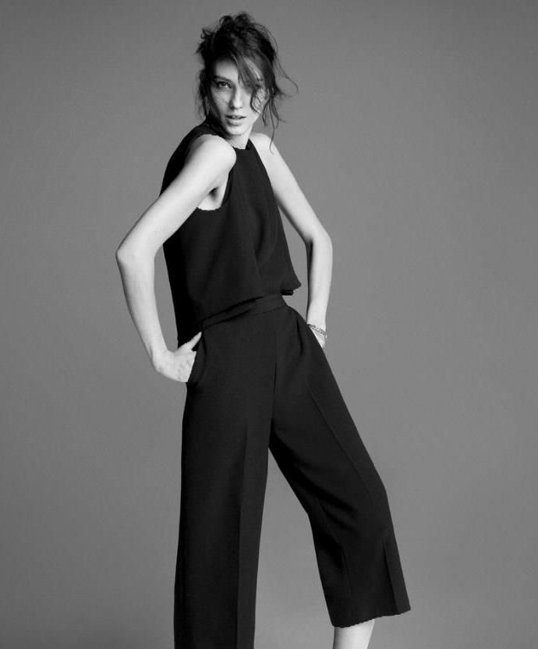

Student Statement:

By submitting this assignment, I confirm that this is my own work.

Student Signature |  | Date

For Tutor / Assessor Use Only
Total Marks
Marks Obtained
Percentage / Grade

