
Assignment Cover Sheet

Student Name: | Ray Wilson
Student Number: | 1250
Course: | Construction Management
Assignment No: | 03

Student Statement:

By submitting this assignment, I confirm that this is my own work.

Student Signature | Raymond Wilson | Date | 12 July 2014

For Tutor / Assessor Use Only
Total Marks
Marks Obtained
Percentage / Grade

Assessment 3 Total Marks: 30
1. Give short answers for the following questions: (10)
i. What is meant by estimating and why are estimates necessary?
Estimating, in construction terms, is to determine the approximate resources required for the project. Resources needed, but not limited to, include labour, materials/consumables, equipment and time (schedule).
An accurate estimate is necessary, prior to construction commencing, so that all the stakeholders are aware of the cost of the work to be undertaken. This will enable the owner to provide sufficient funds, the consultant to advise on contractor selection and charge for appropriate fee’s and the contractor to make a reasonable profit as well as in conjunction with the owner compare tenderers submissions so that the most competitive price can be obtained.
ii. What is bill of quantities?
A bill of quantities is an itemised list showing the items, activities, quantities and unit of measurement such as m2, linear meters, metric ton etc.
This statement of fact is accompanied by the project specification that will enable the various departments such as planning, procurement and construction to formulate accurate estimates of the scope, materials and manpower resources required. Sample BOQ below.
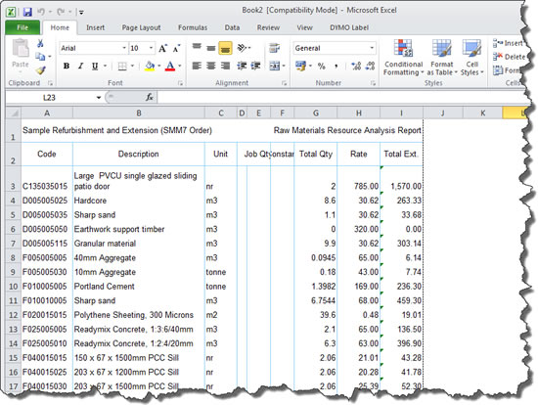
iii. Explain the term approximate estimates and how they are prepared?
Approximate estimates are carried out prior to the feasibility stage to establish whether the project is a viable proposition. They are truly “approximate” and carried out over a short space of time that do not add much assistance to the construction team during execution.
This approximate estimate method is usually determined by the gathering of general parameters needed, such as meters, length or numbers and multiplying this by a cost of such by known costs per unit. This cost data is provided from previous project information obtained during the execution stages and often referred to as a “norm” but taking into consideration numerous variables that could affect the estimate such as price variations, labour costs increases and the like.
iv. What is meant by project budget? How it is prepared?
A project budget is the total sum of money allocated for the particular purpose of the project for a specific period of time. The aim of budget management is to control project costs within the approved budget and deliver the expected project goals.
The budget is prepared by determining direct labour costs such as hourly rates, materials and travel as well as indirect costs such as office support, equipment and administration overheads. From analysing these needs a detailed programme of expenditure can be developed which constitutes a project budget that can be used and administered by during the execution stage.
v. Explain the term administrative approval and technical sanction.
The estimated cost of a construction project, which compliments a project overview report, will need appropriate approvals/sanctions as follows,
- Administration is the first stage which entails the submittal of area layouts, preliminary drawings and specifications by the Engineer to the Owner along with cost estimates for review and approval. Upon approving this stage of the process the owner is indicating that the funds required to proceed are available to the Engineer.
- Once the administration approval is obtained the Engineer commences the detailed design stage of the project using the provided deliverables which ends with a project report that will need to be approved by the department authorities within the engineering organization. This is known as the sanction stage.

2. How are the estimates made for the following? (10) a) A material rate
A qualified estimator will determine the quantity of specified material for each unit needed. This rate is calculated by the specification of the item and prices obtained from selected supplier quotations. This rate will have add on costs which takes into consideration transporting, handling, storage and a percentage for wastage caused by breakage, mistakes, loss and the like. Once all the above information is gathered together a material unit rate is estimated.

b) Labour rate
Labour rates developed for unit items are dependent on the category and number of labour required. Although the category of labour is straight forward rates are historically difficult to plan and forecast as it depends on a number of factors such as the site organization, skill level of the labour required and prevailing weather conditions (to name but a few) as well as unseen factors a supervisor cannot control which can adversely affect the labour output required to complete a unit of work. Historic data is useful for the estimator to calculate the day rate (labour rate) which is influenced by the “going rate”, down time due to inclement weather, overtime and sickness pay, insurances and accommodation and travels costs and must be considered. A sample labour rate calculation follows,
PRODUCTIVE TIME CALCULATION
The estimate of productive hours used in calculating recharge rates is determined by deducting vacation, holiday, and sick hour’s usage from available working hours. Also deducted are non-productive hours used for items such as training, general maintenance, clean-up, etc. The productive hours are those hours that are expected to be rechargeable. When determining productive time the following method should be used:
Annual Salary |  |  |  | 32,974
Projected Merit and/or Range* |  |  |  | 1,026
Portion of FTE Devoted to Activity |  |  |  | 100%
Total Salary |  |  |  | 34,000
Benefit % |  |  |  | 24.96%
Benefit Amount |  |  |  | 8,486
Total Salary and Benefits |  |  |  | 42,486
Hours per year |  |  |  | 2,080
less:
Vacation hours |  |  |  | -120
Holiday hours |  |  |  | -96
Sick Leave hours |  |  |  | -64
Non-Productive hours |  |  |  | -100
Portion of FTE Devoted to Activity |  |  |  | 100%
equals: |  | Chargeable (Productive) hours |  | 1,700
Total Salary and Benefits |  |  |  | 42,486
divided by: |  | Chargeable Hours |  | 1,700
equals: |  | Hourly Recharge Rate |  | $24.99
The department needs to take into account differences in employee vacation accruals and non-productive hours. Determination of sick-leave usage and non-productive hours can be estimated using past experience of the department as a guide.
A description of the activities included within non-productive hours must be included within the rate proposal to support the productive time calculation.

c) Equipment rate
The rates for equipment are calculated on hours required per item (variable dependent on the quantity of the item) and the output of the equipment under certain conditions. Either a unit rate or an hourly rate can be utilised.
In developing the rate the following needs to be considered,
- Capital investment costs
- Depreciation and Equipment insurance
- Fuel, lubricants, maintenance and repair costs
- Operator costs
- Allowance for idle/down time
- Other miscellaneous costs such banks man, mobilization and demobilization transportation costs.

3. Discuss estimating procedure in details. (10)
Estimating is the process of looking into the future and trying to predict project costs and resource requirements. To minimize errors, a consistent procedural approach for preparing an estimate is needed to minimize errors and achieve reliable results. A typical WBS (work breakdown structure) lay out, of which the estimating process is a part of, is shown as follows,
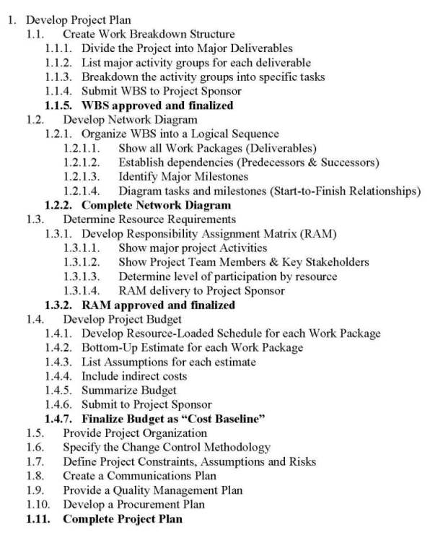
From Engineering drawings and specifications an estimator will prepare a listing of activities, units, to be performed i.e. a bill of quantities. Activities would include surveying and marking, excavating, piling, rebar laying, concrete pouring, and so on depending on type of project being undertaken. For each of these items a unit of measure is developed for estimating which will be used during various stages of the project at a later date such as tendering and progress payments. Measurement of these units can be selected from volume, length and number or similar and a WBS, as shown above, can be used to group these items into discipline and/or area packages.
Overall dimension take-offs are then produced making allowances for changes of design and other locations were a unit dimension can be influenced, such as door and window openings. This will result in list of items, quantities needed and the unit as illustrated in question 1 ii. Above.
Material, labour and equipment rates are also then developed as outlined in question 2 and all of these costs are then taken into consideration to produce a cost for the proposed project.
At this stage a project report will be produced with an estimated cost included that requires approval from appropriate authorities that in Construction projects are administrative and technical. A typical flow diagram is shown below.
