
Assignment Cover Sheet

Student Name: | Dinah Maekopo
Student Number: | 1274
Course: | Diploma In Accounting And Finance
Assignment NO: | 9

1. What is fixed and flexible budget? Why fixed budgets are preferred in government departments?
Discuss the benefits of both types of budgets
Fixed Budget- is a budget that does not change with the level of activity and is bases on the standard or fixed level of activity. It can be an unrealistic estimate of future figures in case of the volume of sales or production is not actually the same as the expected or th budgeted or expected level.

Flexible Budget-is a budget that contains a budgeted cost for any level of activity, that is; it is designed in such a way that it changes with the changing level of production. It considers both the fixed and variable aspects of costs and estimate changes that will occur in them at different levels of operation.
Why fixed budgets are preferred in government departments?
- Accountability: Public is not taxed any more than that required for appropriate government functions
- Prioritization: Identify those public functions to which scarce resources should be allocated
Discuss the benefits of both types of budgets
Fixed budgets
Allows you to plan ahead-a fixed budget will take into account all of your expenses and allow you to plan according to your goals and needs. if you want to take a nice vacation every year for example, you can put money aside month to cover for the vacation.

Easier to track and keep your budget -tracking your budget each month is the most time consuming part of budgeting, However a fixed budget will make it easier to do this. The amount will not vary from month to month and you can breakdown spending limits into weekly categories for things like groceries and entertainment, which makes it easier to keep your budget.

No need to adjust your budget each month- a fixed budget will not change from month to month or year to year. When planning your fixed budget you will need to plan for annual expenses and establish a solid emergency fund. This makes your budget much more solid and the careful planning will make it easier to deal with emergencies and stressful situation.

Works for people on a fixed income-since the income will not vary from month to month, people on a fixed income need to spend their spending carefully for the entire year. A fixed budget will balance out to match each month’s income.

Flexible budgets
- A flexible budget enables management to analyze the deviation of actual output from expected output.
- The management can compare actual costs at the actual volume with the budgeted costs at the actual volume.
- The flexible budget provides a correct basis for comparison between actual and expected costs for an actual activity.
- Flexible budget helps to fulfill the objectives of cost control as it shows where the actual performance deviated from the planned performance.

2. What is zero based budgeting. Explain the process of zero based budgeting.

Zero Based Budgeting-it is the current level of expenditure and revenues, current operations and activities, which decides formulation of the budget. This budget usually increases year after year, despite declining efficiency, because an addition is made to the current figures in anticipation of future increments.

The process of zero based budgeting:-

Determining the objectives of budgeting- there can be various objectives for budget preparation, for example reducing costs, conducting through analysis of on-going projects and dropping the ones that are not efficient.
Deciding the scope of applications-the extent of application of zero based budgeting has to be determined that is it has to be decided whether the budget will apply to selected areas of the organization or across the board.
Developing decision units-decision units, on which a cost benefit analysis is to be conducted, are determined and then it is decided whether the programs in question will carry on or will be dropped. These units are independent of each other so that they can be discontinued without having any effect on other units
Developing decision packages- a decision line is developed along the followingline of questioning:-
- Is a particular activity necessary? If not then it is discontinued
- What was the actual cost of undertaking an activity and what were its actual tangible and intangible benefits?
- What were the estimated costs and benefits of that activity?
- Should the organization continue to perform that activity, and what should be the cost of continuing it?
- If the activity is going to continue, then should it be performed to the same way as it has been in the past?

3. How variance in budgets can be used as tools of controls in an organization. Explain it with illustrations

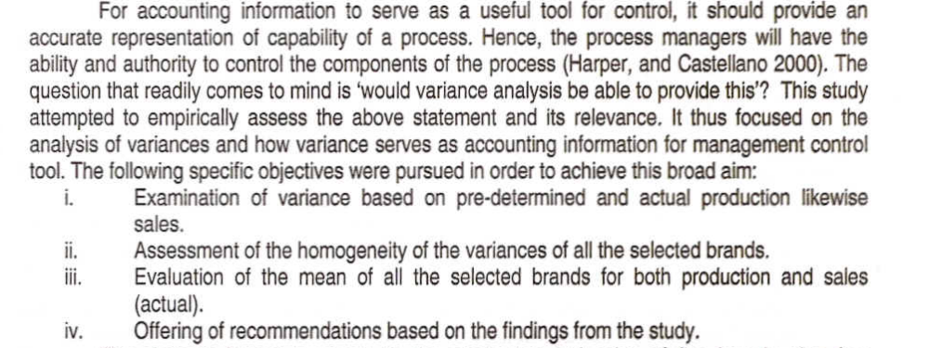

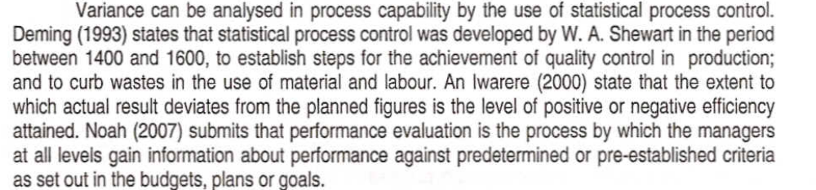

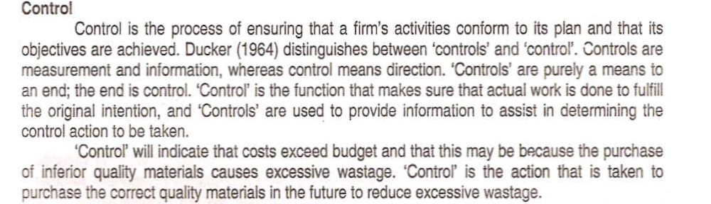

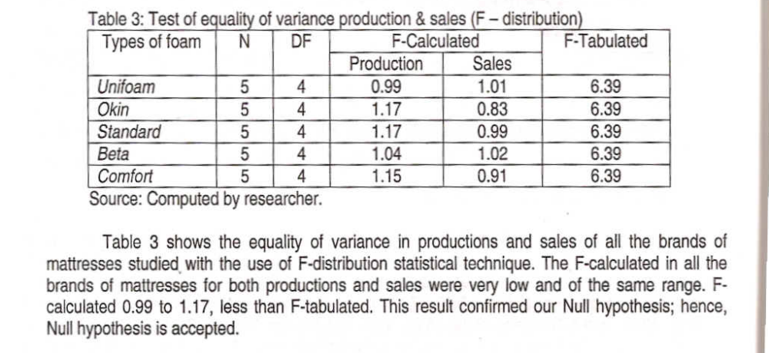

Student Statement:

By submitting this assignment, I confirm that this is my own work.

Student Signature | D.Maekopo | Date | 08/10/2014

For Tutor / Assessor Use Only
Total Marks
Marks Obtained
Percentage / Grade

