
Assignment Cover Sheet

Student Name: | SARAH ALLISON BAKER
Student Number: | 1186
Course: | DIPLOMA IN TRAVEL & TOURISM
Assignment NO: | 5

Please insert your completed assignment (in word format) here:

ASSESSMENT 5

1. Give short answers for the following questions:

QUESTION 1.I

I. What does a promotional activity aim at?

A promotional activity covers aspects including, but not limited to, advertising; direct mail campaigns; producing printed material such as brochures; sales and public relations. The activity must have a clear objective: it may aim to increase the profile, and perhaps also the reputation, of a location; establish the destination as the perfect place for a particular type of tourism (for example, cultural, health, conference, etc); aim to increase international or domestic tourism to a destination or review and improve relationships with retailers, tour operators and travel writers.

Whatever the objective, a well-planned and implemented campaign is then crucial and this will probably involve the country’s GTA to a greater or lesser extent. However, the ultimate objective of any activity is, of course, an increase in tourism and, in turn, the revenue that brings.

II. What does ‘GTA’ stand for? And what is its role in tourism marketing?

GTA stands for Government Tourism Administration. The private sector plays a huge role in tourism marketing but the GTA retains the responsibility for projecting the general image of the country in terms of tourism. It coordinates marketing policies and participates in product development. It guides the overall tourism product to meet its marketing objectives. The promotional role is to position the destination in the way desired by the GTA and also to differentiate it from its competitors; the destination needs to stand out as offering something special or distinct in a competitive and crowded marketplace. Collaboration between the GTA and the private sector ensures any kind of promotion fits the overall marketing strategy. The GTA aims to show the country in the best way possible and thereby encourage tourists to visit.

III. What is advertising and how is it different from marketing?

In order to answer this question, I would like to quote definitions of the two functions from the website maketing.about.com, as follows: “Advertising: the paid, public, non-personal announcement of a persuasive message by an identified sponsor; the non-personal presentation or promotion by a firm of its products to its existing and potential customers.” From this definition, we can see that advertising may include direct mail campaigns, putting up posters and, of course, adverts on TV, radio, the Internet and in newspapers and magazines.

The same website defines marketing as “the systematic planning, implementation and control of a mix of business activities intended to bring together buyers and sellers for the mutually advantageous exchange or transfer of products.” Therefore activities in marketing may include researching the potential market, preparing a product for market and defining the brand.

Marketing involves convincing people there is a product worth buying and this may therefore be considered the general term. Within the field of marketing there are areas such as market research, pricing, public relations and advertising, the latter being the way in which the existence and benefits of the product are communicated to the potential buyers. Thus it can be seen that advertising is one part of the larger overall marketing strategy.

IV. When preparing promotional material which points should be kept in mind?

Promotional material includes such items as brochures and posters. In order to prepare effective promotional material, it is necessary to keep in mind what the objective of that material is. It is also necessary to be clear about the message and image which is to be conveyed, the audience the material is being aimed at and how it will be distributed and used. All of these factors will have an impact on what is created.

Any material which is produced without first being subjected to a thorough checklist to ensure it will meet its intended purpose, runs the high risk of simply being a waste of money.

V. What is collateral material and which type of items are included in it?

Collateral material is a type of promotional material. Typical items include items such as: pens, postcards, badges, mouse mats, calendars and lighters and they are often available as a giveaway. However, although this material might be free, it still needs to reflect the image of the destination.

VI. Which type of information is contained in the travel agent’s manual?

The travel agents’ manual is a piece of printed material which contains a detailed description of a destination. It typically includes the following items:
- all inbound tour operators and travel agents
- accommodation and restaurants
- tourist attractions, ranging from museums to unspoilt beaches according to the destination concerned
- leisure and entertainment facilities, such as amusement parks, swimming pools, spas and theatres
- the tourism services available

Information on prices should be printed on a separate piece of paper to make updating easier and less costly.

Although a comprehensive manual will not be cheap to produce, it is a worthwhile investment. This is because it is an important reference guide and provides the information which is necessary for the travel agent to do business with the destination.

2. ACTIVITY

You are a tour operator and organise inbound tours. You want to run a campaign for summer season tours. Produce a detailed report about your plans; the promotional material used, different types of packages available and how the marketing campaign will be run.

This aim of this report is to explain in detail the three tours which we wish to offer to tourists visiting Spain this summer. For each tour, a rationale has been provided which is for internal purposes rather than for the customer. A full description follows each rationale which gives an indication as to how the tour would be presented to customers in either web or brochure format. Naturally refinements would be made with the input of experts, particularly in the area of website layout.

These tours will be publicised in a number of ways: via our existing links with tour operators in our target markets; through our website; through a You Tube campaign in which videos of the destinations are created and links to our website added; exhibiting at trade fairs; approaching the National Tourism Authority.

PACKAGE 1 – THE GREAT CITIES OF ANDALUSIA

RATIONALE: This tour includes the three cities which top the wish list of most visitors to this part of Spain: Seville, Cordoba and Granada. However, for the same reason, this is a tour offered by many operators and so it is necessary to differentiate this package in some way. Therefore, the following additional destinations have been added: Malaga which is relatively unknown beyond its airport but is a destination well worth exploring; Ubeda and Baeza, two UNESCO World Heritage Sites which do not often feature on a tour of Andalucia and, finally, a short stop in Ronda.

COSTING:
Tour manager @ 180 euros per day x 6 days = 1,080 euros (including room and meal allowance)
Driver/coach @ 500 euros per day x 6 days = 3,000 euros (including room and meal allowance)
Local guides @ 150 euros each x 7 = 1,050 euros
Airport transfer on final day = 50 euros
Total for tour manager, driver/coach & airport transfer = 5,180 euros

Based on 20 passengers – 5,180 ÷20 = 259 euros per person

Hotels @ 55 euros per person per night (based on 2 sharing) x 6 nights = 330 euros. Discount of 20%, leaving a total of 264 euros payable by the operator per person, per tour.

Entrance fees: Alhambra @ 15 euros, Royal Palace in Cordoba 4.50 euros and the Mezquita in Cordoba @ 8 euros = 27.50 per person
Plus Sacromonte dinner and flamenco show @ 22 euros per person
Plus tapas tour in Seville @15 euros per person
Plus farewell dinner in Malaga @ 25 euros per person

Total per person: 259 + 264 + 27.50 + 22 + 15 + 25 = 612.50
612.50 + 20% profit = 735
Sell for 725 euros per person

DESCRIPTION FOR THE CUSTOMER:

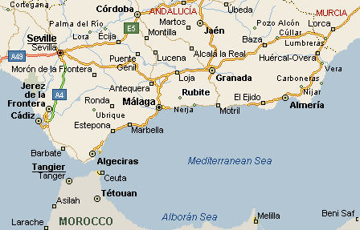Join us on a tour to some of the most enchanting cities in Andalusia. We offer comfortable accommodation on a bed & breakfast basis in three-star hotels chosen for their central locations and excellent reputations. All transport will be in an air-conditioned coach. You will be accompanied throughout by one of our professional tour managers and you will also benefit from knowledgeable local guides in each location

ITINERARY

Day 1 – Transfer from Malaga airport (or Granada airport upon request) to Granada city centre.

Drop your luggage off at our hotel and enjoy a welcome drink in the hotel bar with the tour manager.
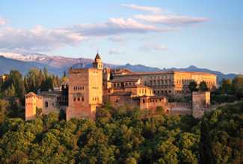
This afternoon, we will visit one of the most famous sights in Spain, the Alhambra Palace. Your entrance ticket is included in the price of your tour and we will have the advantage of being able to bypass the queues and discover the complex’s many delights with an expert local guide.

After our tour of the Alhambra, we will return to our hotel and check in. There will then be some free time during which you may wish to explore the city or relax for a while. In the evening we will meet in the reception and visit the Sacromonte quarter of Granada for an included dinner and a typical flamenco performance in one of the cave houses.
Overnight in Granada

Day 2 – Travel to Ubeda

In the morning, there will be a walking tour of Granada including a visit to the cathedral and royal chapel and the Albaicin district with its winding streets, whitewashed houses and fabulous views of the Alhambra. We will then leave Granada behind us and travel on to Ubeda which will take approximately 2 hours. On arrival, we will check into our hotel and there will be free time for lunch.
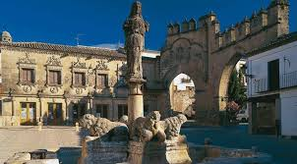
We will then enjoy an afternoon tour of Ubeda and nearby Baeza which are both UNESCO World Heritage Sites. We will have time to admire the outstanding Renaissance architecture of these cities in the company of our local guide.
You will have an evening at leisure in Ubeda following our return there after visiting Baeza.
Overnight in Ubeda

Day 3 – Travel to Cordoba
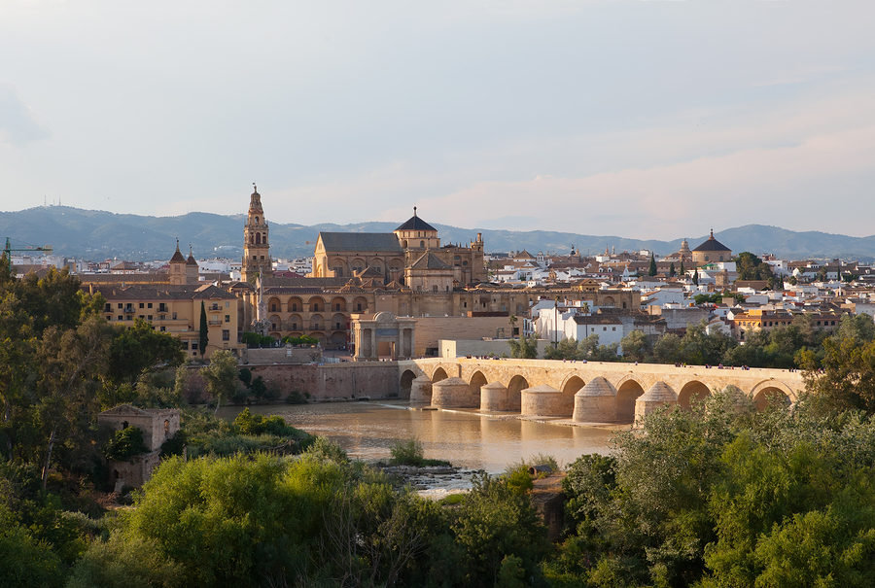Today we will set off for Cordoba and our journey will take approximately 2 hours. After checking into our hotel, we will go on a walking tour of the most interesting sights in Cordoba, including the Alcázar de los Reyes Cristianos (the Palace of the Christian Kings), the Roman Bridge and the whitewashed Jewish quarter.

Undoubtedly, the highlight of any tour of Cordoba is a visit to the Mezquita with its Gothic, Baroque and Renaissance elements and its unique interior. After our visit here, our guided tour of Cordoba will finish.

Entrance fees to the Alcázar de los Reyes Cristianos and the Mezquita are included in the price of your tour.
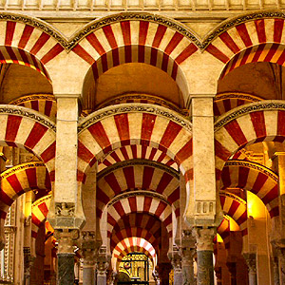
The rest of the afternoon will be at leisure which may be a perfect time to take advantage of the swimming pool at your hotel. Alternatively, your tour manager will be on hand if you need suggestions regarding additional sightseeing.
Overnight in Cordoba

Day 4 – Travel to Seville

This morning we will leave for the beautiful city of Seville which is approximately 1½ hours from Cordoba.

We will check into our hotel, after which we will embark on a walking tour of Seville. Among other highlights we will see the exterior of the Alcázar (Palace), the exterior of the cathedral and wander the streets of the lovely Barrio de Santa Cruz with its whitewashed houses and streets lined with orange trees.

The afternoon will be at leisure for further independent relaxation. You may wish to return to the Alcázar or the cathedral or you could join our optional cruise on the Guadalquivir River.
Overnight in Seville

Day 5 – Seville
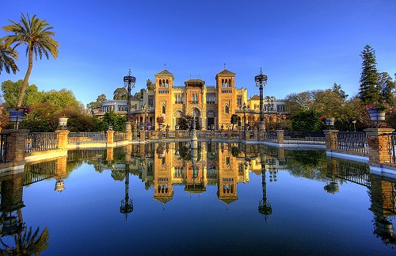
Enjoy a further full day in Seville. You may wish to visit more of the monuments or relax in one of the many attractive parks or squares and watch the world go by. Our tour manager will be able to help you with any questions you may have.

This evening we will go on an included tapas tour giving you the opportunity to try some of the best of these traditional Andalusian dishes.
Overnight in Seville

Day 6 – Travel to Malaga via Ronda
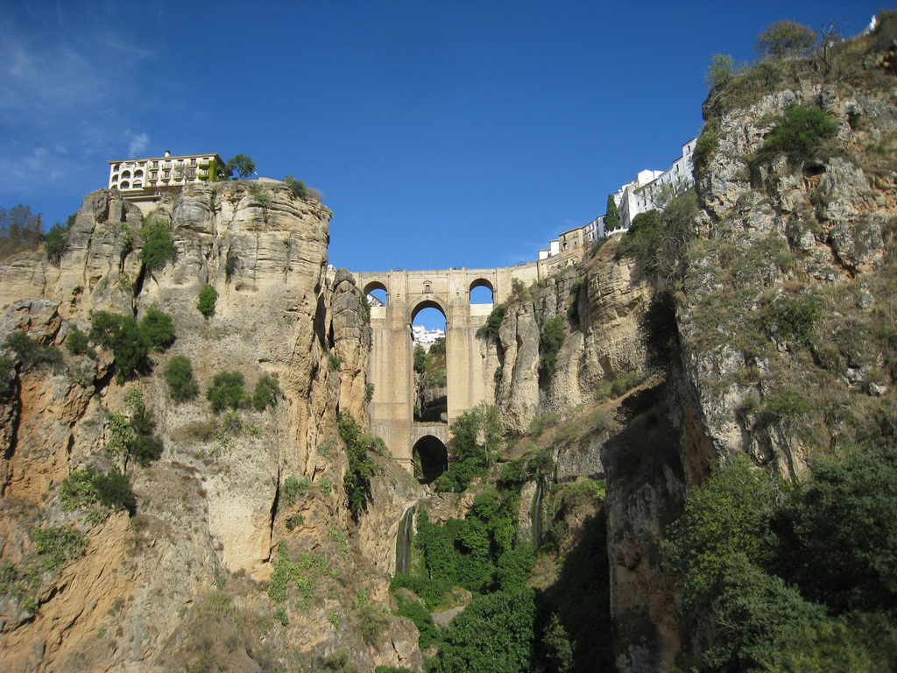
Our journey today takes us on a journey of approximately 2 hours from Seville to Ronda where we will break our journey and go on a short sightseeing tour followed by a coffee stop. You will have the opportunity to see the famous gorge which divides the town in two and the New Bridge which towers 390 feet over the floor of the gorge.

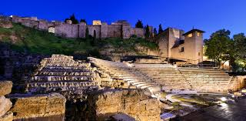We will then embark on the final part of our journey to Malaga which will take us approximately 1½ hours. We will arrive early in the afternoon and check into our hotel. There will be free time for lunch and then we will enjoy a walking tour of Malaga. Please note we will not be entering any of the sights on this tour. The rest of the afternoon will be at leisure. In the evening, there will be an included farewell dinner at a local restaurant.

Overnight in Malaga
Day 7 – Transfer to Malaga airport

At the end of the tour, we can also offer a number of other options:
- a transfer back to Granada airport or city centre
- additional nights’ accommodation in Malaga
- an additional 3 or 7 nights’ accommodation in Marbella, one of the premier beach resorts in southern Spain.
Please contact our office for further information and prices.

Included:
Accommodation in comfortable three-star hotels in central locations with breakfast
Visits to all the sights detailed in the itinerary including entrance fees where stated
All lunches, dinner and entertainment listed in the itinerary stated as being included
All transport as detailed in the itinerary by air-conditioned coach
The services of one of our professional tour managers and all local guides

Not included:
Lunches and dinners except where specified in the programme
Optional excursions
Entrance fees not stated as included
Insurance
Tips and gratuities

PACKAGE 2 – HIGHLIGHTS OF EXTREMADURA

Rationale: This is one of the least-known areas of Spain which presents both advantages and disadvantages. The potentially problematic aspect is that it might be more difficult to sell a less well-known destination to visitors new to Spain and keen to see the most famous places. However, for those who already know Spain to some extent or tourists looking for a more ‘off-the-beaten-track’ destination, I feel this tour would have a great deal of appeal. The two overnight stops are in Cáceres and Merida which are both UNESCO World Heritage Sites. Visits will also be made to other nearby places of interest. In addition, the opportunity to attend a performance at Merida’s famous classical theatre programme which takes place every summer would be offered. However, this would be an optional extra as it might not be to everyone’s taste.

COSTING:
Tour manager @ 180 euros per day x 4 days = 720 euros (including room and meal allowance)
Driver/coach @ 500 euros per day x 4 days = 2,000 euros (including room and meal allowance)
Local guides @ 150 euros each x 4 = 600 euros
Airport transfer on final day = 100 euros
Total for tour manager, driver/coach & airport transfer = 3,420 euros

Based on 20 passengers – 3,420 ÷20 = 171 euros per person

Hotels @ 50 euros per person per night (based on 2 sharing) x 4 nights = 200 euros. Discount of 20%, leaving a total of 160 euros payable by the operator per person, per tour.

Entrance fees: Theatre and amphitheatre in Merida @ 9 euros per person
Plus lunch in Evora @ 15 euros per person
Plus wine tasting in Cáceres @ 10 euros per person
Plus farewell dinner in Cáceres @ 25 euros per person

Total per person: 171 + 200 + 9 + 15 + 10 + 25 = 430
430 + 20% profit = 516
Sell for 495 per person

DESCRIPTION FOR THE CUSTOMER:

Join us on a tour of Extremedura, a beautiful yet largely unknown area of Spain which also includes the chance to travel over the border to the Alentejo region of Portugal. We offer comfortable accommodation on a bed & breakfast basis in three-star hotels in the two UNESCO World Heritage Cities of Mérida and Cáceres as well as visits to Trujillo in Spain and Elvas and Evora in Portugal. All transport will be in an air-conditioned coach. You will be accompanied throughout by one of our professional tour managers and you will also benefit from knowledgeable local guides in each location.

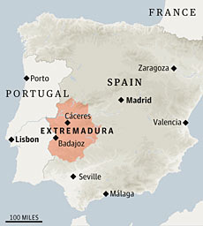

ITINERARY

Day 1 – Seville to Mérida

Pick up at Seville airport or, upon request, Seville city centre and transfer to Mérida which will take approximately 2¼ hours.
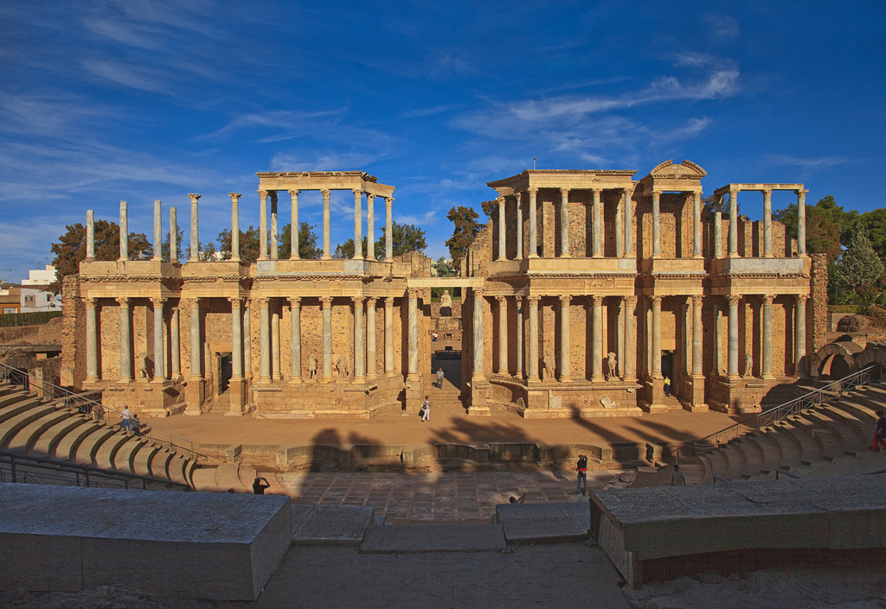
After checking into our hotel, you will have some free time for lunch and we will then embark on our walking tour of Mérida, which will include the many Roman monuments such as the theatre, amphitheatre, mosaics and the Temple of Diana. Our local guide will bring the rich history of this city to life for you.

Entrance to the theatre and amphitheatre are included in the price of your tour.

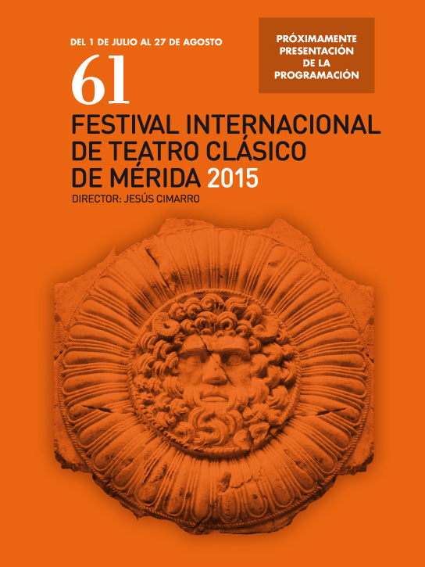
Mérida hosts a programme of classical theatre during the summer and in 2015 this will run from the 1st of July to the 27th of August. Guests who wish to attend may obtain further information from the tour manager about the programme and attending performances.

In the evening, enjoy some free time in Mérida or attend a theatre performance.
Overnight in Mérida

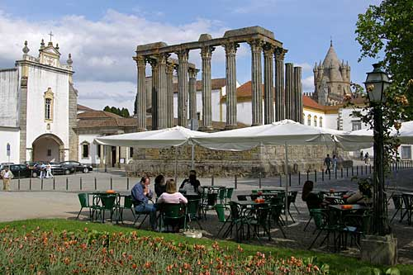Day 2 – Enjoy a full-day visit to the enchanting UNESCO World Heritage towns of Evora and Elvas in the Alentejo region of Portugal with an included lunch. Evora has a well-preserved old town which is still partially enclosed by its mediaeval walls. After our included lunch in Evora, we will turn back towards the Spanish border and make a stop at the Portuguese town of Elvas. Due to its proximity to the Spanish border, it was heavily fortified in the past and was defended by seven bastions and two forts which can still be seen.
Evening at leisure and overnight in Mérida

Day 3 – Travel to Cáceres

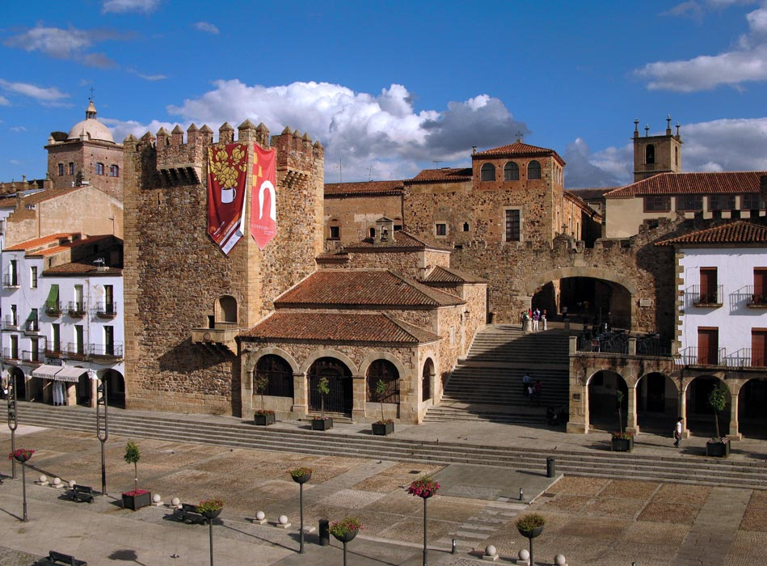Our journey to Cáceres will take us approximately 1 hour. Upon arrival, we will drop our bags off at the hotel and take a walking tour of the main sights of this wonderfully unspoilt UNESCO World Heritage city which was founded by the Romans in 25 BCE. After some free time for lunch and further independent exploration, we will meet for an included wine tasting in the early evening.
Overnight in Cáceres

Day 4 – Day trip from Cáceres to Trujillo
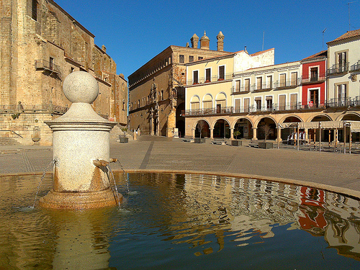
Our day trip takes us to the beautiful town of Trujillo which is approximately 40 minutes from Cáceres. Trujillo’s old town contains many fine examples of mediaeval and Renaissance buildings. We will have time to enjoy the historic centre and we will also make a stop at the old Arab fortress with its magnificent views over the town and surrounding countryside. There will then be some free time for lunch and further sightseeing before our return to Cáceres in the early evening.

This evening there will be an included farewell dinner at a local restaurant.
Overnight in Cáceres

Day 5 – Return to Seville airport or, on request, Seville city centre. The journey will take approximately 2¼ hours.

Included:
Accommodation in comfortable three-star hotels in central locations with breakfast
Visits to all the sights detailed in the itinerary including entrance fees where stated as included
All lunches, dinner and entertainment listed in the itinerary and stated as being included
All transport as detailed in the itinerary by air-conditioned coach
The services of one of our professional tour managers and all local guides

Not included:
Lunches and dinners except where specified in the programme
Optional excursions
Entrance fees not stated as included
Insurance
Tips and gratuities

PACKAGE 3 – GALICIA, A DIFFERENT SIDE OF SPAIN

Rationale: Galicia is part of the Spain often referred to as Green Spain. It is a world away from the hot, crowded coastal resorts and offers tourists the chance to experience a very different side of Spain. The cities and countryside of Galicia are outstandingly beautiful and the weather is seldom overbearingly hot even in the height of summer. There will also be an included day tour over the border to the cities of Braga and Guimarães in the Minho region of Portugal.

COSTING:
Tour manager @ 180 euros per day x 6 days = 1,080 euros (including room and meal allowance)
Driver/coach @ 500 euros per day x 6 days = 3,000 euros (including room and meal allowance)
Local guides @ 150 euros each x 5 = 750 euros
Airport transfer on final day = 100 euros
Total for tour manager, driver/coach & airport transfer = 4,930 euros

Based on 20 passengers – 4,930 ÷ 20 = 246.50 euros per person

Hotels @ 60 euros per person per night (based on 2 sharing) x 6 nights = 360 euros. Discount 20%, leaving a total of 288 euros payable by the operator per person per tour.

Entrance fees: The Palace of the Dukes of Braganza @ 6 euros per person
Plus lunch in La Coruña @ 20 euros per person
Plus dinner and gaita performance in Santiago de Compostela @ 25 euros per person
Plus lunch in Pontevedra @ 15 euros per person
Plus lunch in Guimarães @ 15 euros per person
Plus farewell dinner in Vigo @ 25 euros per person

Total per person: 246.50 + 288 + 6 + 20 + 25 + 15 + 15 + 25 = 640.50 euros
640.50 + 20% profit = 768.60
Sell for 755 per person

DESCRIPTION FOR THE CUSTOMER:

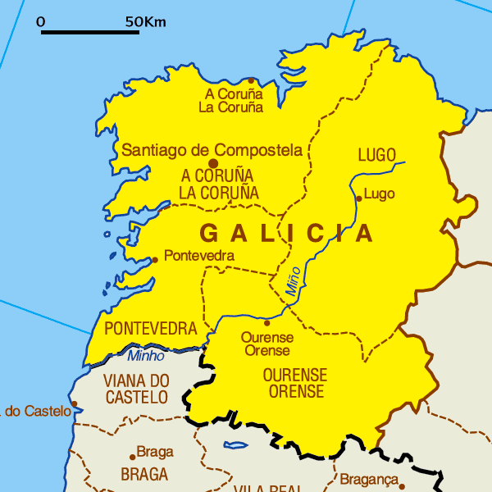

This summer why not experience a different side of Spain? Galicia, in the far north-west of Spain is a part of the country known as Green Spain. It is a world away from the busy resorts which are encountered in some areas of the country. Discover historic cities and romantic landscapes and take the chance to see a little of the Minho region of northern Portugal too. We offer comfortable accommodation on a bed & breakfast basis in three-star hotels. All transport will be in an air-conditioned coach. You will be accompanied throughout by one of our professional tour managers and you will also benefit from knowledgeable local guides in each location.

ITINERARY

Day 1 – Pick-up at La Coruña airport and transfer to your city centre hotel.
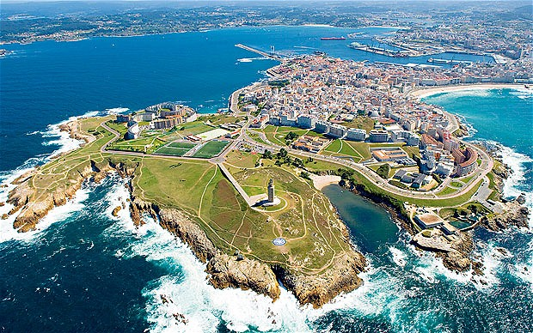
We will drop our bags off and take a short tour of La Coruña, situated on a peninsula jutting out into the Atlantic Ocean. We will see the Tower of Hercules which was converted into a lighthouse. After returning to our hotel and checking in to give you time to freshen up, we will have an included a three-course lunch in a typical Galician restaurant. In the afternoon, we travel to the Rias Altas to appreciate this scenic stretch of the Galician coast.
Evening at leisure and overnight in La Coruña

Day 2 – La Coruña - Lugo
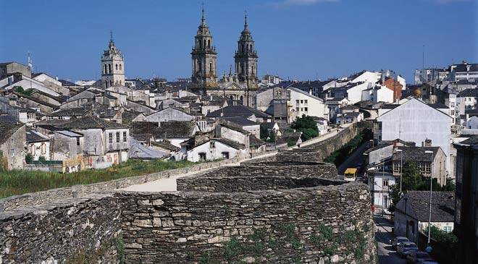Our journey to Lugo will take us approximately 1 hour. After our bag drop off, we will take a walking tour of Lugo which is a UNESCO World Heritage Site and is completely surrounded by intact Roman walls.

After our morning tour, you will have the rest of the day at leisure to explore this beautiful city further at you own pace.
Overnight in Lugo

Day 3 - Lugo - Santiago de Compostela
This morning we will continue on our journey arriving in Santiago de Compostela after approximately 1 hour and 45 minutes. Our included walking tour of the UNESCO World Heritage old city will give you the chance to see sights such as the central square, the Plaza del Obradoiro, with its cathedral which is the reputed burial place of St James and a centre of pilgrimage over the centuries. Entrance to the cathedral is free of charge.
Overnight in Santiago de Compostela

Day 4 – Santiago de Compostela
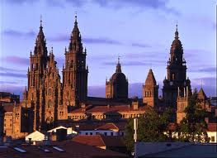
Enjoy a free day in Santiago de Compostela. Should you require any suggestions on places to visit, please do not hesitate to consult your tour manager.

In the evening, there is an included dinner at a local restaurant where you will have the opportunity to hear the traditional and highly evocative music of Galicia performed on a gaita, a type of bagpipe.
Overnight in Santiago de Compostela

Day 5 – Santiago de Compostela – Vigo, via the Rias Bajas, Sanxenxo and Pontevedra
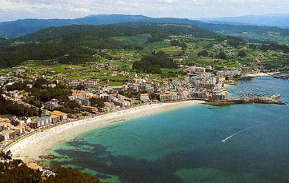
Today we will have an opportunity to see the Rias Bajas another beautiful part of the Galician coastline frequently referred to as the Spanish fjords. Our first stop, after approximately 1½ hours, will be in Sanxenxo which is regarded as one of the best and most exclusive beach resorts in Galicia.

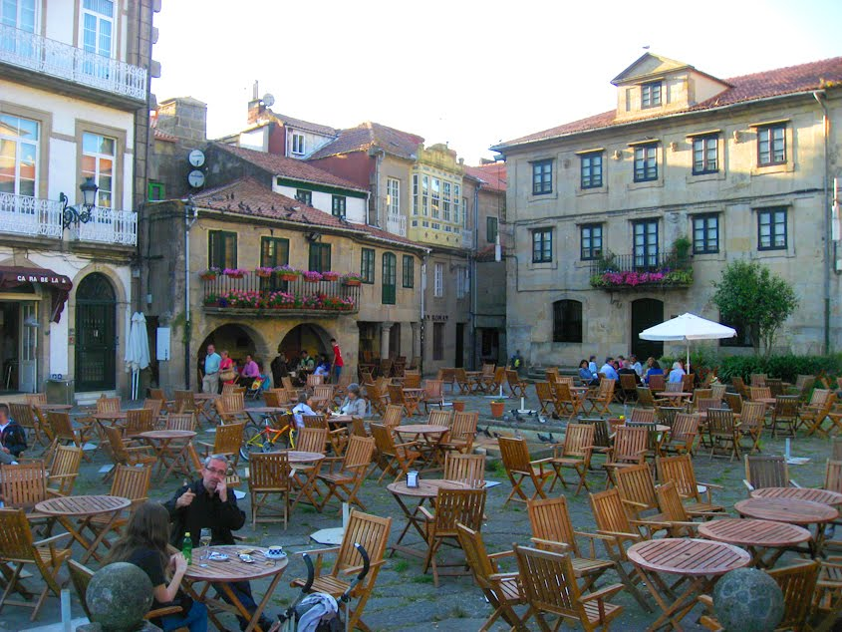 After time for some independent sightseeing and a coffee break, we will resume our journey. Our next stop will be in the city of Pontevedra, often described as “the definitive old Galician town”. We will have some free time here and then meet for an included lunch in a typical restaurant.

We then resume our journey with an easy 30-minute journey into Vigo. We will check into our city centre hotel upon arrival. After an opportunity to freshen up after the journey, we will take a short orientation tour around Vigo in the afternoon.
Evening at leisure and overnight in Vigo

Day 6 – Full day tour from Vigo to the Minho region of northern Portugal
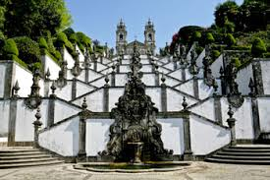
Our first stop will be in Braga which is about 1 hour from Vigo. We will see the main monuments of the city and then head out of town to the sanctuary of Bom Jesus with its extraordinary staircase and views over the city. We will take the funicular railway up to the sanctuary. Both the funicular and the sanctuary are free of charge.

We will also make a coffee stop at Bom Jesus before resuming our journey on to Guimarães.

Guimarães, just 15 minutes from Braga, was the European Capital of Culture in 2012 and is a UNESCO World Heritage Site. Guimarães is a city steeped in history and is often referred to as the “birthplace of Portuguese nationality”.
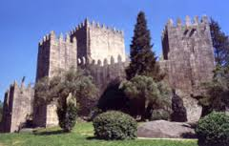
The city is rich in sights including Guimarães Castle and the Palace of the Dukes of Braganza. After a guided walking tour, we will enjoy an included lunch in a typical restaurant. We will then make our way back to Vigo which will take us approximately 1¼ hours.

Entrance to the Palace of the Dukes of Braganza is included in the price of your tour.

Once we have returned to Vigo, there will be some free time before we meet for a farewell dinner which is included in the price of your tour.
Overnight in Vigo

Day 7 – Transfer from Vigo to La Coruña airport or, upon request, La Coruña city centre which will take approximately 1½ hours.

Included:
Accommodation in comfortable three-star hotels in central locations with breakfast
Visits to all the sights detailed in the itinerary including entrance fees where stated as included
All lunches, dinner and entertainment listed in the itinerary and stated as being included
All transport as detailed in the itinerary by air-conditioned coach
The services of one of our professional tour managers and all local guides

Not included:
Lunches and dinners except where specified in the programme
Optional excursions
Entrance fees not stated as included
Insurance
Tips and gratuities

Additional notes for the tutor:
I have tried to present the materials for Activity 2 in as pleasing a manner as possible taking into consideration my somewhat limited IT skills. In addition, when I pasted my original word document into this Cover Sheet, I encountered some formatting problems which I was unable to overcome. If I were to set up as an inbound tour operator, I would employ the services of a company or individual able to give the materials a professional finish and set up, or add, the tours to my website with further information. On the website, I would have a number of tabs for each tour. These would provide: an overview of the tour; the detailed itinerary; further information about each place to be visited on the tour; the hotels; departures and prices plus what is and is not included in that price. The same information would be included in the brochure although, naturally, the layout would be different. I would also have posters designed for display at trade fairs.

The expected market for these tours would be those aged approximately 30 years old and over who are interested in seeing as much as possible within a relatively short space of time while still having some free time to explore independently. The tours are also aimed at those who are relatively price conscious and are more interested in places and cultural experiences rather than luxury hotels. The tours would use carefully selected three-star hotels, meaning the price remains relatively reasonable but the accommodation is still of a good standard. Emphasis would be placed on hotels which have a central location thus making independent exploration easier. Although I have not named specific hotels in this project, I have researched the accommodation available in each location and the prices quoted for good three-star city centre hotels are realistic.

In terms of the pricing, this was a more difficult aspect as I do not work in tourism and reliable figures are hard to come by. However, as the final prices I have achieved seem reasonable compared to other products on the market, I hope that the estimates I have used are not wildly inaccurate. I have assumed hotels would give a discount for regular bulk sales but I have erred on the side of caution by assuming that no discounts would be given on any entrance fees or group meals. I used a 20% profit margin as a starting point but then made a final adjustment to the price to make it more attractive.

Website Sources:
Marketing.about.com
Google Images
Booking.com
Expedia

Student Statement:

By submitting this assignment, I confirm that this is my own work.

Student Signature | SARAH ALLISON BAKER | Date | 01/03/15

For Tutor / Assessor Use Only
Total Marks
Marks Obtained
Percentage / Grade

