
Brent
Assignment Cover Sheet

Student Name: | Mery Ann Alaba
Student Number: | 1406
Course: | Fashion Design
Assignment NO: | Assessment 10

Marking Criteria:
We expect the learners to write minimum one well expressed point in three lines against each allocated mark. This means one needs to write 15 lines with 5 well expressed points to get high grades for a 5 marks question.
For high grades use examples and illustrations where appropriate.
Assessment 10

Question 1

- a.) The average human figure is about Eight to ten heads tall.

b.) The best rule to follow in sketching the face is to Omit as much detail as
possible in order to avoid a photographic likeness.

c.) The fashion artist exaggerates the Length of the figures, and minimize
the width of the hand.

Question 2

Important thing to consider when sketching for dressing the figure are the following;

Consider a normal ideal height, Human figure is about eight heads tall, whereas a fashion figure may be from eight to ten head tall in extreme mannequin types.

Head is the most useful unit for measuring the figure, it will be used as a measuring unit for all other proportions.

Draw a vertical line lengthwise through the center of your drawing papers, construct an egg shaped oval at the top of this line with larger part of the oval at the top

Mark off eight head on the vertical line, numbering each head on the left of the page i.e.

As you fill in the proportions mark in the identifications on the right hand side. i.e shoulder line and waist line.

Drop down one half of the second head for the shoulder line. Also located the pit of the neck the shoulders should be approximately one and three quarter head wide the arms extended slightly over this mark.

Question 3

Fashion design sketches help us paint the picture we have in your mind. Before one can actually designs a good dress, he must visualize it first, and once it is done, he can slowly try recreating the image using pen and paper.

The reason fashion design and design sketches are around; is so that one can have a rough idea of what is in his mind and then using his imagination and creativity he can make alterations accordingly.

Question 4

The button of the skirt should not be sketched straight across, but rather, should have the general feeling of a rectangle. If it is drawn straight, it has the effect of being on something flat instead of being on a body that has thickness.

It is very important to harmonized the mood and action of the figure with the clothes in which the artist draw her;

Example: Dramatize the figure, particularly the feminine figure and the atmosphere of your drawing when possible, but don’t over – emphasis.

Activity

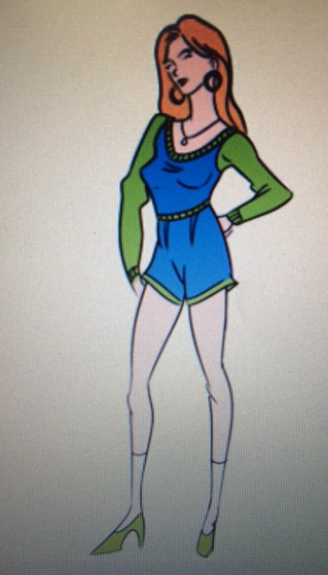

To emphasize the human figure if it is thinner or taller.

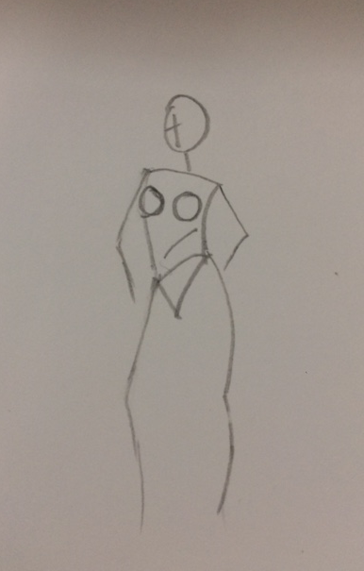

Comparing the sketch in a human figure

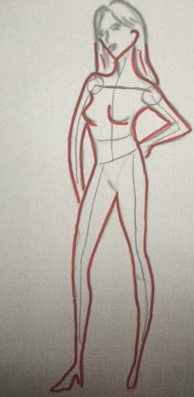

Sketching the outline, no need to much details

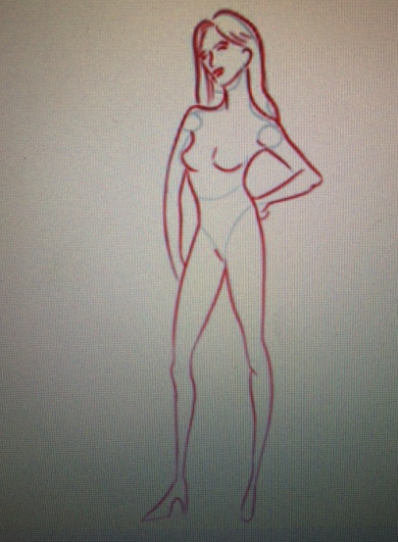

Think this figure is mannequin
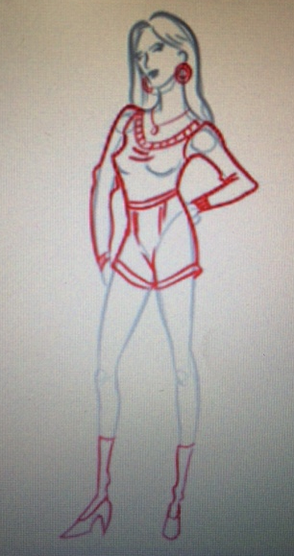
Outline the whole drawings

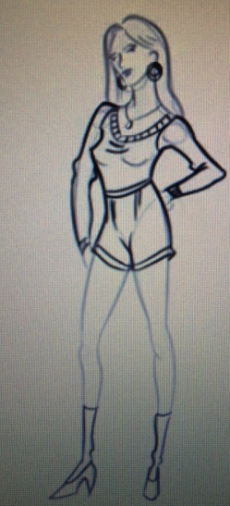

Adding Clothes

Color the Outline

Student Statement:

By submitting this assignment, I confirm that this is my own work.

Student Signature | Mery Ann P. Alaba | Date | 20 Dec 2015

For Tutor / Assessor Use Only
Total Marks
Marks Obtained
Percentage / Grade

