
Brent
Assignment Cover Sheet

Student Name: | Mery Ann Alaba
Student Number: | 1406
Course: | Fashion Design
Assignment NO: | Assessment 3

Marking Criteria:
We expect the learners to write minimum one well expressed point in three lines against each allocated mark. This means one needs to write 15 lines with 5 well expressed points to get high grades for a 5 marks question.
For high grades use examples and illustrations where appropriate.
Assessment 2

- Question

- Due to the high quality fashion is expensive, there’s an enormous influence on fashion for the income groups.

- Fashion forecasting is very important for both designer & buyer because it is a global carrer that focuses on upcoming trends. Fashion forecasters predict the colours, fabric and styles that will be presented on the runway and in the stores for the upcoming seasons.

Fashion forecasting is the prediction of mood, behavior and buying habits of the consumer.

It is no longer a question of identifying your customers by age, geography or income, but looking into how and why they buy, based on their mood, beliefs and the occasion.

- Fashion Trends are the styling ideas that major collections have in
common. They indicate the direction in which the fashion is moving.
Fashion forecasting look for styles they think are prophetic, ideas that
Capture the mood of the times and signal a new fashion trend.

They base their judgment on experience, awareness to trendsetting
designers, fashion cycles, and economic, social and technological
influences on both the garment industry the consumer.

- The difference of Fashion forecasting and Trend forecasting are;

Trends in lifestyle
Attitude and Culture in particular music, sport, cinema and television
Studying market conditions
Traditionally dominated fashion forecasting
Authoritative coverage of the media

- Classic- is characterized by simplicity of design, which keeps it from being easily dated.
Fads – usually affect only a narrow consumer group, begin in lower price ranges, are relatively simple and inexpensive to copy, and therefore flood the market in a very short time.
Interrupted Cycles- Fashion cycle is interrupted or prolonged by social upheaval, economic depression, or war.
Recurring Cycles – When a style reappars years later, it is reinterpreted for a new time, a silhouette or propotion may recur, but it is interpreted with a change in fabric and details.
Fashion Adaptation – There are three variations of the fashion-adoption process: traditional adoption, reverse adoption, and mass dissemination.
Traditional Fashion Adaptation – based on the fact that most high fashion is expensive, and therefore affordable to only a few people.
Reverse Adaptation - In 1960’s and early 1970’s young people in London and San Francisco influenced the whole fashion industry by creating unique combinations of old, new and handcrafted clothes.
Dissemination – Generally adapted from designer fashion through the traditional process. Styling ideas for active sportswear and denim wear are usually inspired by the consumer, through the reverse process. Junior fashion might be mass-disseminated, since the original ideas are often produced precisely for this youthful market.

Activity
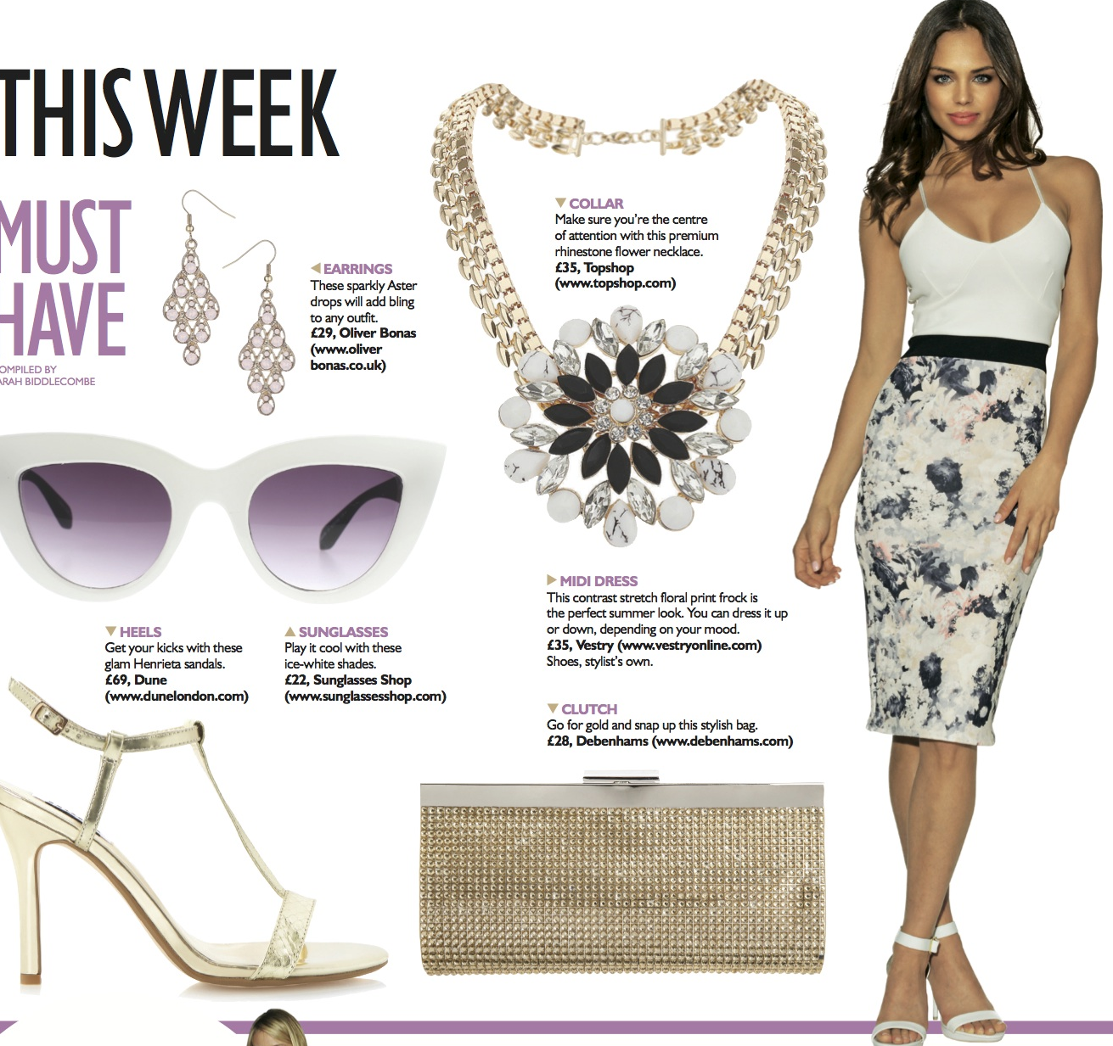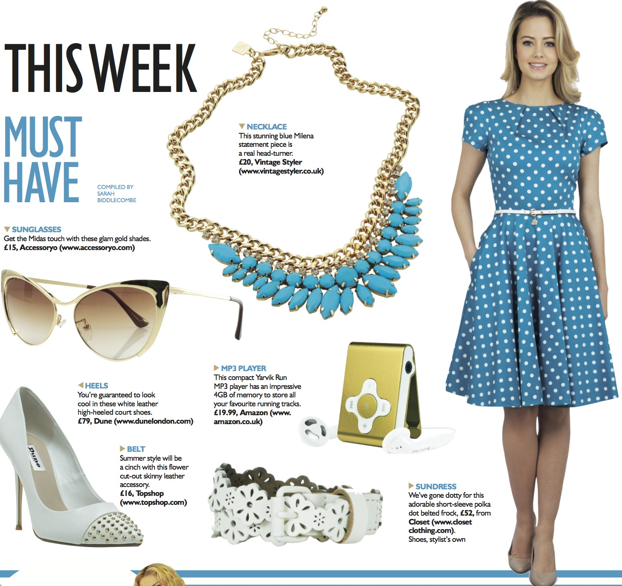

This is a sample for old fashion magazine and new fashion magazine, several designs move a similar fashion direction, use similar fashion elements such as colour or silhouette, because of common sources of inspiration based on current interest or events. Several designers simultaneously respond with similar ideas, to the same stimuli, may indicate a fashion trend.

The basic Fashion trend for me in the feature is more blue, violet light color and the fabric is cotton summer, painterly 1940’s style.

High Fashion

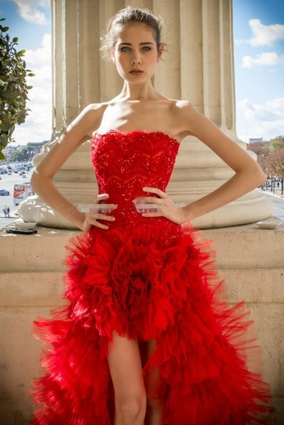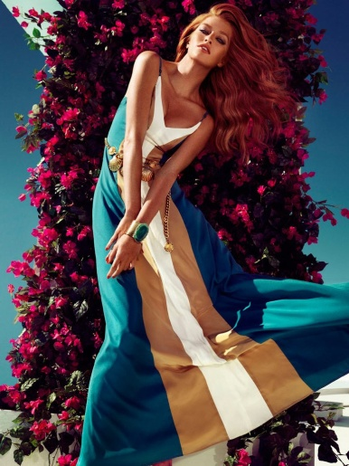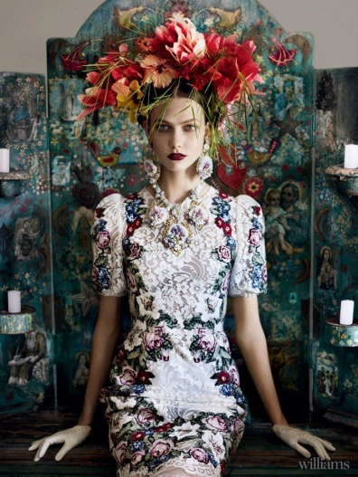

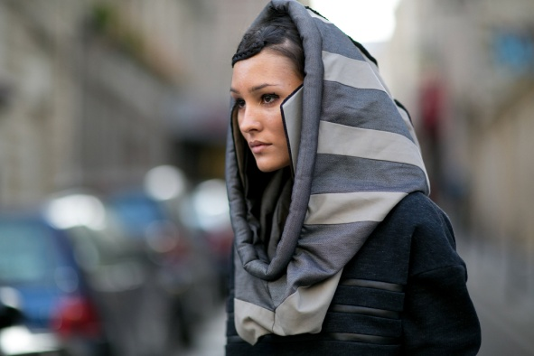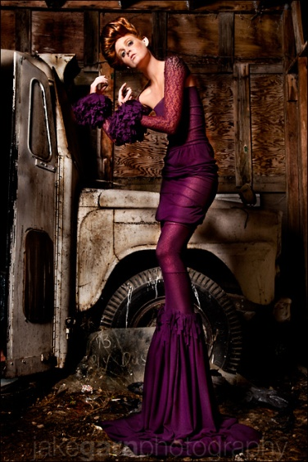

Mass Fashion

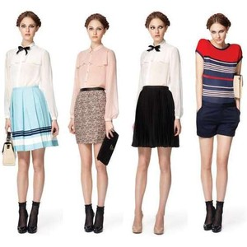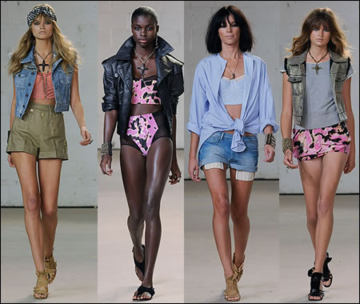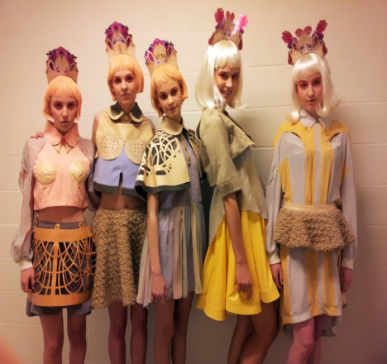

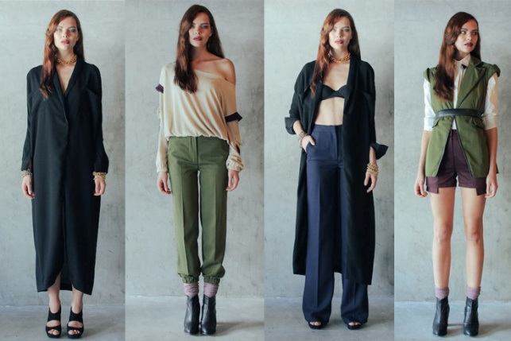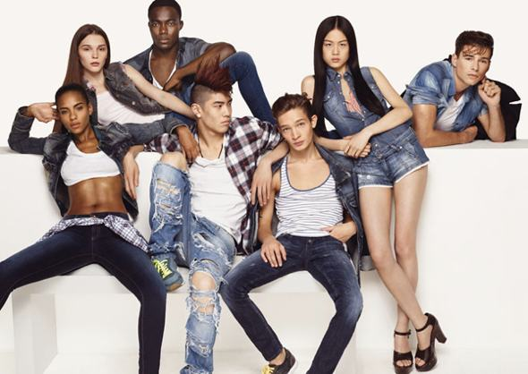

Classic Fashion

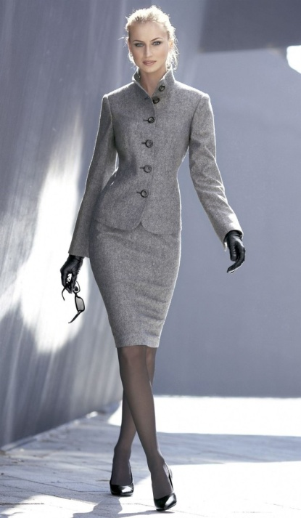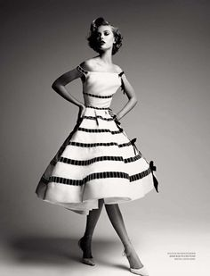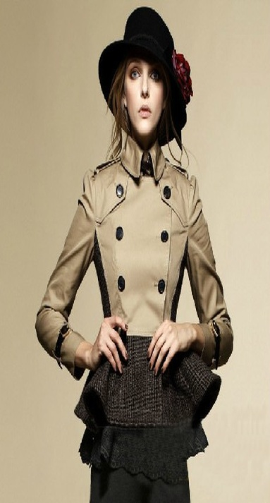

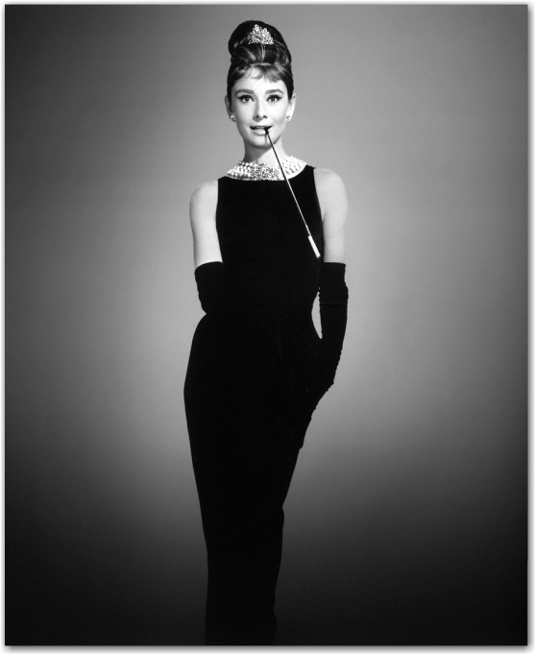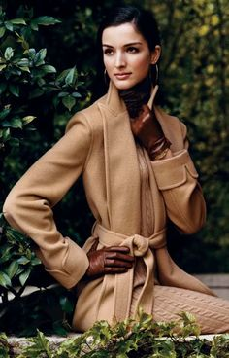

Fad Fashion

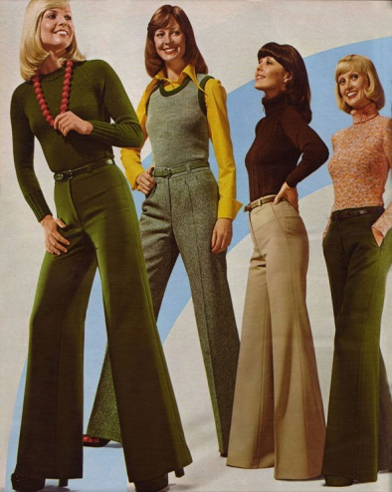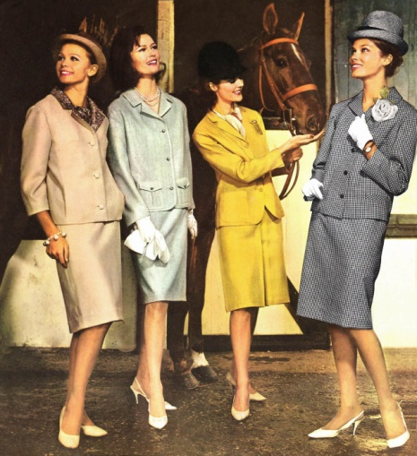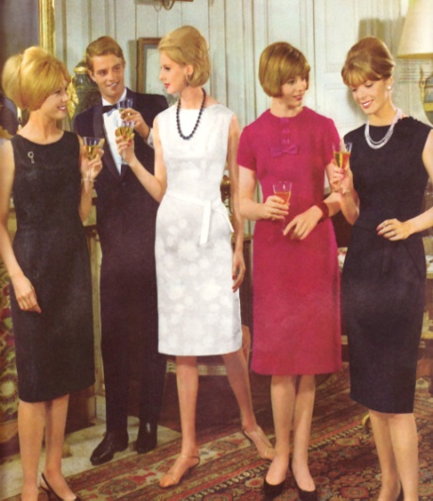

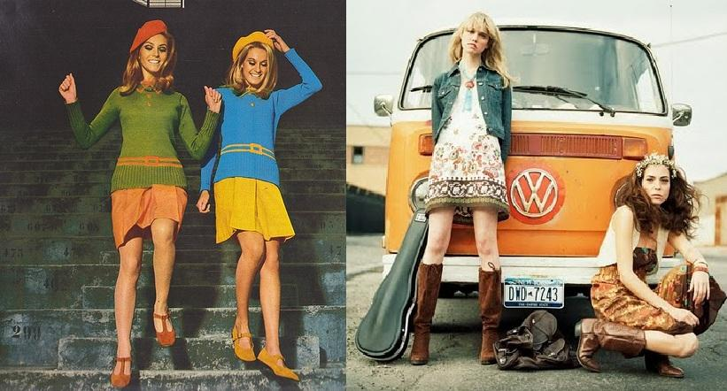

Student Statement:

By submitting this assignment, I confirm that this is my own work.

Student Signature | Mery Ann P. Alaba | Date | 4 May 2015

For Tutor / Assessor Use Only
Total Marks
Marks Obtained
Percentage / Grade

