
Assignment Cover Sheet

Student Name: | Christian Blackmore
Student Number: | 1394
Course: | Construction Management
Assignment NO: | 09

Marking Criteria:
We expect the learners to write minimum one well expressed point in three lines against each allocated mark. This means one needs to write 15 lines with 5 well expressed points to get high grades for a 5 marks question.
For high grades use examples and illustrations where appropriate.
Assignment 9

- Give short answers for the following questions:

I. Outline the various elements of purchasing with the help of suitable case examples.

To ensure the continuity of supply of raw materials and spare parts and at the same time reduce the overall cost of a project, well defined elements must be considered such as right price, right quality, right contractual terms, right time, right source, right material, right place, right mode of transportation, right quantity, and right attitude. For effective purchasing function these elements need to be considered equally.

The main concern of any company is to procure items at the right price but deciding the right price can depend on various factors such as extent of competition from other suppliers, demand & supply of item, quality, discounts offered and terms of purchase. Determining the most economical price depends not just on market knowledge but also a precise understanding of pricing process, a buyer must consider whether an item to be purchased represents the best value for money. Negotiations between buyer and supplier should transpire to reach an acceptable price if all other processes fail.

Depending on where materials are to be acquired transportation and material handling costs can greatly be affected. To minimise these costs selecting the right place for the purchase of material is of utmost importance. Choosing between a local and an outside supplier may arise, who are both able to fulfil the requirements of the buyer, opting for the local supplier would be more cost effective. Terms and conditions of purchase should clearly identify location and mode of delivery.

Choosing the right source is a very important concern in purchasing The right source for the procurement of materials is a supplier who can supply all items required of right quality, in right quantity, at the right time at which the materials were required to be supplied, at an agreed price with the supplier and who has necessary financial resources and adequate man-power to handle the order. To minimise delivery delays and higher transportation charges it is good practice to improve the personal contact between the buyer and the supplier. The source of material should be located within a reasonable distance from the buyer’s location. When selecting a supplier certain factors must be considered, storage facilities available with the supplier, credit worthiness of the supplier, size of the supplier’s firm and quality control. A personal visit to potential supplier’s premises will help to assess the capabilities of the supplier.

Knowing when to purchase at the right time is of vital importance, when it comes to items used continually, right time means the time when the stock has reached minimum level. Reorder level of material should be fixed for each item under the principle of right time. When items or materials reach reorder levels action should be initiated to replenish supplies.

Ensuring and maintaining a regular flow of materials is a vital aim of any purchase organisation. The right quantities of materials should be available always, excess purchases should be avoided as it results in overstocking and capital is unnecessarily blocked resulting in inventory costs rising. Inexpensive and slow moving items are generally purchased in bulk quantities to cover 3, 6 or 12 monthly requirements. Quality and price of items should be considered as should the relationship with the supplier before orders are made.

The quality of items can be measured by physical tests, chemical analysis or by any other methods depending on the material or item. The purchasing department should ensure that materials are purchased from quality suppliers at all times For standardisation, waste elimination and for better functional results, right quality purchases are essential. The right quality is the suitability of items purchased for a given purpose. The best quality of materials purchased need not be the right quality.

II What are the main objectives of purchasing?

The objective of purchasing can generally be understood as obtaining the materials in the right quantity, of the right quality, at the right time, at the right price and from the correct supplier. This in general indicates the scope of purchasing function.

Specific objectives are:-

- Obtain material, equipment and components at a reasonably low price but maintaining quality objectives.
- Maintain inventories as low as possible but comply with daily on site requirements.
- Secure a good supplier performance including prompt deliveries and quality acceptance.
- Develop an effective source of supply and establish a good relation with them.
- Ability to locate new materials or components as required.
- Establish correct purchasing procedures with adequate controls and purchasing policies.
- Implement programmes such as value analysis, cost analysis to reduce costs.
- Maintain management informed of material developments which could affect company profit or performance.
- Establish a high degree of co-operation and co-ordination between all departments.
- Prevent duplication of orders.

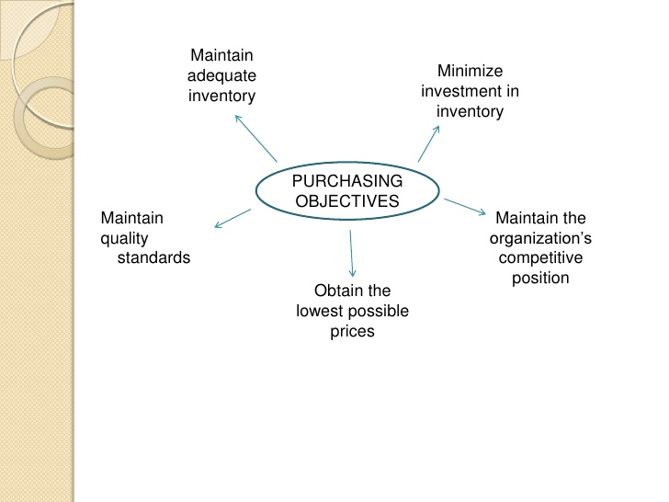

III What are the various prerequisites for becoming a good purchase manager?

The warehouse and purchasing manager is responsible for the efficient receipt, storage and dispatch of a wide range of goods including materials, tools, machinery, PPE and clothing, while implementing measures to increase the company’s effectiveness and efficiency.

As warehouse manager they are required to manage people, processes and systems. They ensure productivity targets are met and maintain a computerized administration and automated storage and retrieval system. They ensure workplace health and safety requirements are met and take responsibility for the security of the building, facility grounds and commodity stock. They also oversee daily operations in the warehouse.

A purchase manager will have all responsibility pertaining to buying quality equipment and components as required for effective functionality of work at the most competitive rate. Being able to negotiate with suppliers and the monitoring of a purchase budget is very important. The purchase manager will need to have a well organised approach to work and the ability to analyse data (cost analysis, quality analysis)

The manager will be required to supervise purchasing personnel in his department assuring correct procedures are being executed. Research of suppliers to ascertain the best option for productivity will be essential. Ability to create purchasing and budget reports will be necessary as well as purchase related recommendations to management.

IV What are the objectives and functions of stores?

The storing process refers to physically storing material in a warehouse on pallets, shelves, racks or boxes with the objective to retrieve at a further date for use. For a warehouse to be productive it should be able to supply operatives with materials, components with the right quantity, right quality and at the right time that they are required.

Some of the main objectives and functions are:-

- Maximise utilization of storage space whilst providing adequate care and protection of materials.
- Reception of tools, components, raw materials and equipment should all be accounted for.
- The storage facility must have a system to enable ease of identification and retrieval of items.
- Proper codification, preservation and handling of items with minimise obsolescence, surplus and waste.
- The principles of FIFO (First-In-First-Out) must be implemented, most materials have a shelf life for example; cement.

- Insure warehouse is well conditioned for receipt, issue, stocking and handling of all components.
- Environmental conditions within the warehouse should be conducive in terms of temperature, lighting and ventilation.
- Effective control methods should be implemented to ensure there is no abnormal consumption, discrepancies or stock accumulation.

- Physical stock taking must be undertaken, the objective of this is:-

- To verify accuracy of all stock records
- To disclose the possibility of theft, fraud or loss of items
- To disclose weaknesses in the stocktaking system and make improvements accordingly.
- To insure effective control of inventories

V Describe the general criteria adopted for the layout of stores.

Correct store layout criteria should be implemented to ensure safety & effective storage, this is achieved by:-

- Neat & tidy stores prevent accidents and can be a morale booster.
- Only authorised personnel should have access to storage area.
- Adequate fire fighting equipment should be available; personnel should be trained in fire fighting.
- Sufficient lighting must be installed
- Store layout should provide ease of access and of movement within to retrieve material.
- Extensive research should be applied of layout by comparing with similar store designs to reach an effective but economical option.
- Sufficient height room should be provided to aid movement of long equipment.
- All areas of the storage area should be properly marked out, e.g. loading & unloading bays, inspection section and bulk materials section.
- Security personnel are essential for the prevention of theft of stored materials.
- Sanitary facilities must be provided in the store.
- Maintenance & repairs areas must be provided.
- Communications between materials departments must be excellent to accomplish productive working conditions.
- Expensive materials or components should be in a locked and secured place.
- Suitable loading & unloading bays should be installed at close proximity to the store.
- Depending on store size, the doors must be adequately proportioned for access of lifting vehicles if necessary, a grid or drain at the door entrance will prevent water, sand or stones from entering on the vehicles pneumatics.

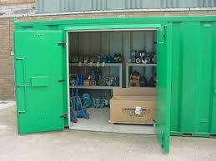

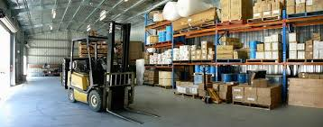

VI Differentiate between stock valuation and verification.

Stock valuation is the monetary equivalent of the stock of material in hand, whereas stock verification is the determination or quantification of all material in stock and checking its deviation with figures recorded in books.

All material, components and equipment needs to be valued correctly so as to establish the cost price; this is ascertained by using invoice records, etc.

Stock verification refers to physically checking the quantities of material or components stored in a warehouse and comparing them with stock records. Stock verification can be effective for all types of stored material, not just spare parts.

There are two types of common stock verification systems:-

- Periodic stock verification - This system allows for stock verification to be carried out at fixed periodic intervals. An end of year stock verification is executed by many companies making sure that annual accounts of the company reflect the correct stocks. To spread the work load evenly throughout the year some companies divide stock verification into 12 groups, then a specific month is allocated for stock verification of the items pertaining to that group.

- Perpetual stock verification – This is a method of recording stores balances after every receipt and issue, to facilitate regular checking and obviate closing down of work for stock-taking. It is a system of ascertaining current stock balance after recording every receipt and issue of materials through stock records. Perpetual stock verification is usually checked by a programme of continuous stock-taking.

- Discuss the different stages of “material procurement cycle”.

The process of procurement is part of a company´s strategy because the ability to purchase certain materials will determine if operations on site can continue. Procurement cycle consists of a series of steps that must take place to replenish stocks;

- A purchase is initiated by an indent being raised; this can be done by on site personnel or by head office. All indents should be uniquely numbered and a control file should be kept. The indent should provide all necessary information to initiate enquiry procedures. If the indent represents required materials for replenishing stocks it must have the stores reference information and date of delivery to site. If special requirements are necessary such as inspection and method of delivery this should be clearly shown on the indent. Indents are also used for cancelation of deliveries due to bulk orders; the urgency of delivery should also be clearly visible on the indent.

- Enquiry stage consists of the buyer’s preliminary order being sent to selected suppliers for prices to be allocated to each item, once this is concluded it is returned to the buyer for evaluation. All enquiries should be numbered and referenced to the relevant indent. The preliminary order should illustrate; Item required description of item, quantity, specification, time & location of delivery and terms/conditions regarding for example insurance, transportation, point of transfer from supplier to required location and the guarantees expected.

The preliminary order forms once returned to the buyer are evaluated and compared with their benchmark list, prices and terms on a fair and objective basis. These forms must be analysed correctly as in some cases the vendor may have agreed to the terms & conditions presented by the buyer but the price may be very excessive or on the other hand it may be very low as they have excluded costs such as transportation or insurance.

After the preliminary order forms have been analysed a purchase order (PO) will be created to send to the accepted supplier. This document will indicate types, quantities and all agreed prices for component or material the supplier will provide. Until the order form is accepted by the supplier a binding contract does not exist.

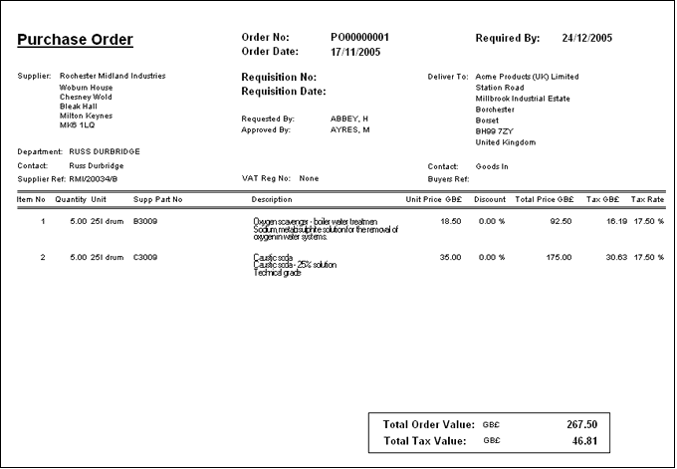

A cash purchase may occur for items which are essential to the continuity of certain work activities and for this reason cannot wait the time-consuming process of purchasing.

When items are delivered from suppliers a preliminary inspection must be carried out to ascertain that they meet the quality requirements stated in the purchase order. Only items which meet the quality requirements with be utilised, items which are damaged will either be returned to the supplier or stored separately so they are not used inadvertently and should be appropriately identified; taking photos of such items on delivery is a form of evidence that can be shown to the supplier to clearly identify the damage caused by transportation. To ensure quality procurement a buyer should; set correct quality standards, compare products performance with standards, correct any defects and develop a plan for improvement.

Most suppliers will operate on a credit basis when dealing with buyers. This means that when a buyer is charged for purchased items, there will be a grace period before the payment is due normally 30 days but can increase to 45 or 90 days depending on agreed contract terms. During this time, the supplier will not charge interest. According to the recent survey carried out by BACS Payment Services Limited, late payment is now the biggest threat to the survival of many construction firms in the UK, with over three quarters of businesses being forced to wait at least a month beyond their agreed contract terms before getting paid. This affects smaller businesses greatly as they are forced to pay their own suppliers and sometimes staff late, which has a domino effect on the rest of the industry, with end clients, construction firms and suppliers all being affected.

The storage of materials refers to an area; either being inside or outside in which items should be kept and protected to the best quality standards possible. The location of stores depends on site location.

- Centralised stores are usually used when more than one site is functional.
- Decentralised stores are located close to the site.
- Depending on site location a mixture between centralised & decentralised may be used.

Items are issued from Stores to operatives only if they are holding an issue order which will authorize them to acquire authorized items from stores. The objective of issue control is to ensure proper utilisation of materials by skilled operatives. Records should be kept of outgoing items in terms of quantity and to whom it was issued to. All required materials should be issued to the right planned activity at the right time, complying with the right quality standards and with the right quantity.

Inventory must be updated to ensure changes in stock are recorded as work progresses, this will also ensure activities are not brought to a standstill due to lack of materials.

Being aware of scrap, surplus & obsolete material is very important to all companies; correct procedures should be followed to control each process.

Surplus materials are items which are in excess of their requirements; they have no immediate use on site or at least in the foreseen future. Sometimes items accumulate due to bad planning, forecasting and purchasing. Often companies to save money make bulk orders of items resulting on many occasions in unused items.

Scrap is material not useful to the organisation sometimes used also for obsolete and surplus items when these are not useful to the organisation. Scrap is the residue from a construction site which cannot be used economically within the organisation. Typical scrap materials in the construction industry are empty tins, drums, and packing material etc.

Obsolete items are those which are not damaged and have economic value but are not suitable for the company's specific operations. For example, the spare parts of machines that have been phased out. Changes in product design, technological advancements and wrong codification are some of the reasons why obsolescence occurs.

Inventory waste is raw materials or items that have been ordered in excess of requirements due to bad materials management or taking advantage of discounts from suppliers and making a bulk purchase. This results in unused material or components on site and extra costs.
Construction waste consists of any substance, matter or thing which is produced as a result of any construction work undertaken. Typically it is a mixture of surplus materials arising from site clearance, excavation, construction, refurbishment, renovation, demolition and road works.
Construction waste can be utilised as back fill, this includes rubble, earth and concrete which is suitable for land reclamation and site formation.

- Explain the various tendering systems used for ordering the material.

A tender relates to a submission made by a supplier in response to an invitation to tender enabling them to supply materials or equipment. The main tender process for material requirements are:-

- Open tender – This method of tendering allows anyone to submit a tender, normally an advert will be placed in the local papers or trade journals to invite contractors to apply for tender documents. Open tender is a transparent process which ensures that only the contractor that meets all the technical requirements and offers the best price will win the tender. This method can be wasteful of contractor’s resources since many may spend time preparing tenders to no effect. As they are aware that chances of gaining the contract are small, contractors may not study the contract in detail to work out their minimum price, but simply quote a price that will be certain to bring them a profit if they win the contract, these contractors are known as ¨rouge bidders¨.

- Limited tender – This method refers to inviting tenders from a few selected well known suppliers only, as there is a limited selection of invited suppliers bidding quality of items is presumed to meet with all specification requirements. As limited tenders are not advertised rouge bidders will not be aware of its existence as in open tendering, this will generate greater confidence between supplier and buyer so that all there requirements can be satisfied. Tenders will be selected on a non-discriminatory manner and a sufficient number of suppliers will be chosen to ensure effective competition.

- Single tender – Use of this method of procurement is generally when:-

- The buyer is aware that a certain supplier has the rights to items or equipment required and no other alternative or substitute is available.
- Emergency situations being for example; the need for certain items is imperative to the continuity of works.

- For standardisation of machinery or spare parts to be compatible to equipment on site, advice from a competent technical expert requires items to be purchased from a selected supplier.
- There is an urgent need for items making it impractical to use procurement method because of time restraints.

Using today’s computerised systems for purchasing, supply and delivery of materials this process has become cost effective and a viable solution to utilise in general within almost all organisations:-

Instruction to
deliver issued
to driver

Order received
electronically by Supplier.
Instruction to
dispatch/load issued
electronically

Payment
authorised and
made
electronically to
suppliers bank

Goods checked
and verified
electronically on
arrival to site

Order and delivery
information matched
electronically within
database. Matched invoice
issued electronically

Order placed by phone or computer
Load checked and
verified
electronically on
dispatch
Web-based Information Management Database

Student Statement:

By submitting this assignment, I confirm that this is my own work.

Student Signature | Christian Blackmore | Date | 02-11-2015

For Tutor / Assessor Use Only
Total Marks
Marks Obtained
Percentage / Grade

