
Assignment Cover Sheet

Student Name: | Omnia Rafiq
Student Number: | 1343
Course: | Diploma in interior Design
Assignment NO: | 8

Student Statement:

By submitting this assignment, I confirm that this is my own work.

Student Signature | Omnia Rafiq | Date | 2-2-2015

For Tutor / Assessor Use Only
Total Marks
Marks Obtained
Percentage / Grade

Q.1.i. What is the best way of mixing patterns?
Simply it depends upon the relationship between density and scale. Scale is how big or small a pattern element is on the wall paper or on the fabric. This especially has to do with its size. The scale of a large flower is greater than a small rose bud.
While, Density is how tightly grouped together the elements of the pattern are. A rose bud pattern on an open solid colored back ground would be less dense than the larger intertwining pattern which shows little, in any background.
Here are some rules we must take into consideration when choosing and mixing patterns :

- First we should consider factors such as scale, color, tone and content when choosing pattern.
- Experiment with mixing and matching: try Stripes and checks, stars and stripes.
- Choose two dominant patterns of the same scale and you will find that they fight each other for your attention.
- As general rule the best results are achieved by arranging for the largest areas (walls floors, curtains) to take on the largest scale patterns and the smaller items correspondingly smaller patterns.
- Always view pattern from distance from which it will be viewed in a room. By holding the sample at a suitable distance from a mirror you will get the right effect.
- Curtain sample patterns are best viewed with some light behind them rather than facing the light. This will give a good idea of how the material will appear when hung at a window.
- When using several patterns in one room make sure that they are linked. Choose patterns with colors, themes, motifs or textures in common.
- We can also develop our own patterns, picking up motifs from other elements in a room. For example, we can trace patterns form china to use a guide for embroidering table linen, or cut out elements from a printed fabric to use to make appliqué designs.
- The simplest way to mix patterns is to choose a decorative pattern first, then co-ordinate a plain or semi-plain fabric or a stripe in a different scale, all in same color palette. You can then use combinations of all these fabrics for the window treatment, upholstered furniture and cushions. Consider using a checked fabric for sofa and then overlaying it with cushions in different combinations of patterns, for example stripes and checks foe a Floral with a small gingham check.

Combine white plus a coloured pattern Let neutral colours become your base when using large prints
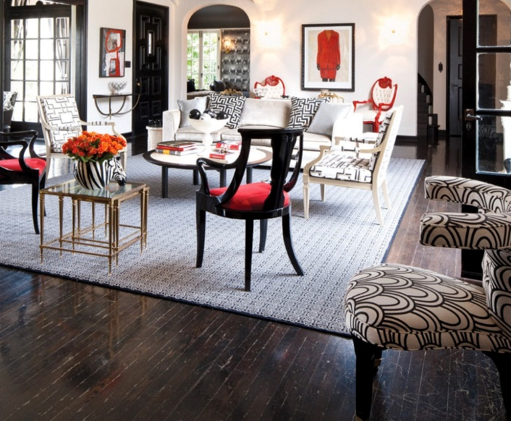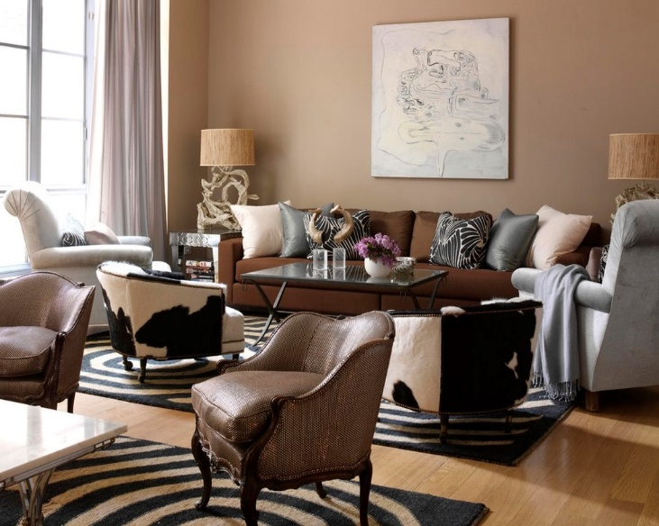

Don’t shy away from bold colours and prints Tone on tone colour helps prints neutralize your space
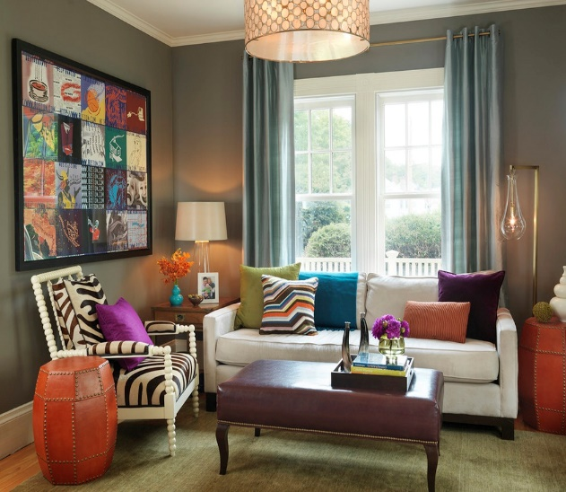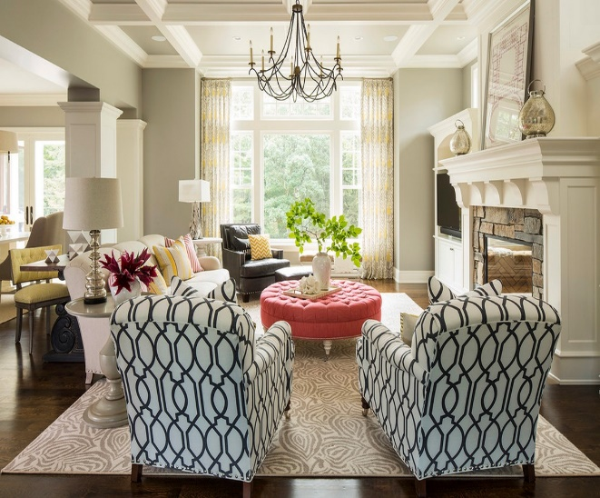

Q.1.ii. What is the density of a pattern?

Density is how tightly grouped together the elements of the pattern are. A rose bud pattern on an open solid coloured back ground would be less dense than the larger intertwining pattern which shows little, in any background.
Different Patterns with different densities
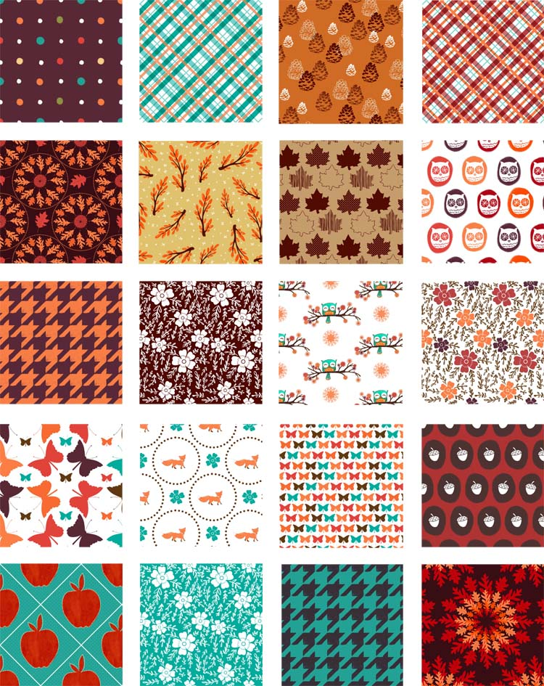

Q.1.iii. If you are to wall paper a room with a vertical stripe pattern would the ceilings Appear lower or higher?
This type of geometric pattern (stripes) is decorative yet it can also serve the purpose of deceiving the eye. It is also a space manipulation tool.Vertical stripes make a surface appear taller. Traditionally, vertical stripes have been the common way to go. They create the illusion of height thus making ceilings appear higher than they truly are. A tone-on-tone colour scheme (like cream with white, or a matte and glossy version of the same colour) creates a soft look that is classic and beautiful. As colours become more contrasted the look gets more powerful.
Horizontal stripes are a little more edgy and modern than vertical stripes. They make rooms feel wider and can elongate spaces. Horizontal stripes are also often considered more playful – when used in a variety of colours and widths, they feel bold, fun, and fresh.

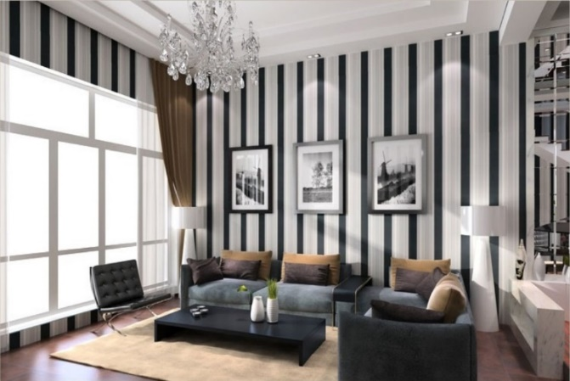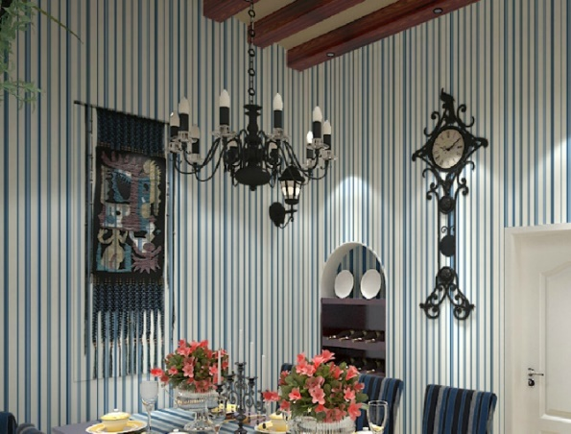
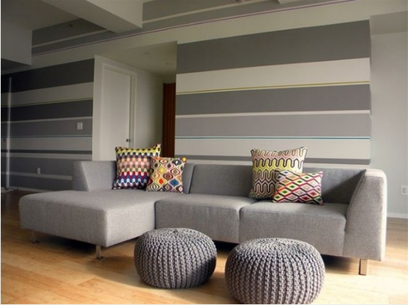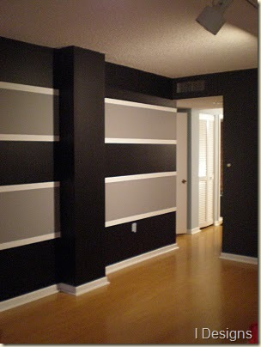

Tips for Decorating with Stripes
- Avoid using colors that clash. Stripes are graphic enough on their own to create impact, so it's important to use colors that either contrast, or come from the same color family (depending on what look you're going for). Clashing colors like orange and purple or red and pink will look cluttered and distracting rather than graphic and punchy.
- Use strong colors in small areas. If you're afraid to commit to a large space, a foyer or a powder room is a great place to experiment. People tend not to stay long in these spaces so the look doesn't become tiresome or overwhelming.
- Be sure to counteract stripes with less busy design elements. If you have striped walls, solid furnishings are probably the way to go. If you have striped throw pillows, add a couple of solids and dainty floral between them. The effect is cohesive, but it also gives your eyes a place to rest.
- When decorating with stripes consider the size of the room. The larger the room, the wider the stripes should be (when used on walls). Thin stripes can look too cluttered in a large room, while wide stripes can lose their impact in a small space.
- Subtle techniques like alternating flat and glossy stripes can add perceived depth and dimension to a room without being overly bold or confrontational. They are elegant and classic and work well in traditional spaces.
- Mixing wide and skinny horizontal stripes work really well on the walls of rec rooms and children's rooms. They create a very playful look.
- Floors are terrific places to include stripes. Striped area rugs add a great graphic element. If you don't want a large area covered, try a runner, a doormat, or layer a small area rug over another existing rug.
- If you're nervous about decorating with stripes, start small. Including a striped vase, lampshade, or other decorative element can be a super way to introduce the pattern into a room.
- Stripes have been described as the "neutral" of the pattern world. They can be incorporated into any style or size of room. They can be used in large doses or small, and they can work with just about anything. If you want to add some pattern to a room but you're unsure of where to start, stripes are always a safe bet.

Q.1.iv. How can textural depth be created in a design scheme?
Texture is a key element for making a space interesting and inviting. Textural depth can be created by mixing items of different texture in a design scheme. Texture can bring a touch of luxury, substance and interest, to an otherwise, nicely done, but flat and boring home decorating scheme. Here are some tips to be taken into consideration when using different textures in a design scheme :
- Use plenty of texture if you are decorating in one color - especially white. White without soft texture added, can look sparse and clinical. Add some texture and it is quickly transformed into a luxurious and loveable, interior decorating scheme.
- Shiny or glossy textures, like tiles, gloss paint, mirrors, glass furniture, chrome, lacquered dark wood, silk and satin, tend to lend a sophisticated feel to your interior design scheme.
- Shiny surfaces reflect light back into the room, making the room feel lighter and bigger.
- But, we should be aware that using too many glossy textures can make the scheme feel a little cold and clinical.
- Rough or soft textures, like natural or unfinished wood, many fabrics like chenille, hessian, linen, faux fur, fluffy cushions and rugs, natural stone and brick - bring added interest to a room.
- Rough textures are often suited to a more casual, rustic or country feel in an interior design scheme.
- Rough textures, can bring warmth and a cozy atmosphere to your home decorating. But, take care - too many rough textures can overcrowd and overwhelm, when decorating small spaces.
- Rough and smooth textures look great combined together - as well as with each other.

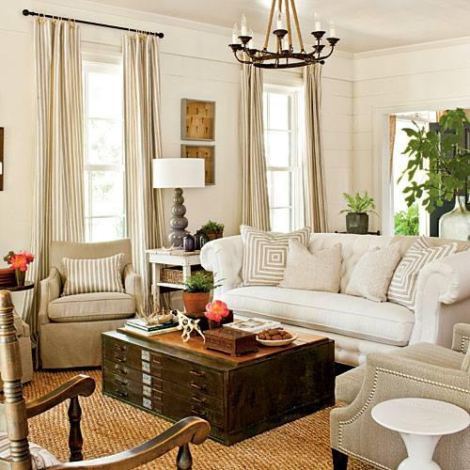In this room design, texture is added to an already light colored room by the design in the pillows, window treatments and the rug.
Additional depth is created by using complimentary wood tones in a darker color to ground the room and bring out the neutral colors, making the room feel inviting. Adding design elements with a pop of color makes the room complete and this entire design is pulled together. Simple accessories can by changed seasonally to create a completely different look and feel as well.

Q.1.v. ‘Texture in fabrics emphasize mood in a room’. Explain with examples.
Texture in fabrics can create and emphasize mood. Generally, Texture can suggest temperature: smooth and shiny textures which reflect more light and give a cool impression; soft, raised textures, which absorb more light, convey a sense of warmth. Rooms we would describe as ‘cozy’ usually include lots of texture.
Texture adds interest to a scheme – especially monochromatic schemes – they change the way a room ‘feels’ It gets rid of the two-dimensional look often found in carefully structured one colour themes or minimalist rooms. Unfortunately, these rooms can feel soulless – no matter how expensive or well crafted. A grand dining room is synonymous velvet, brocade, parsley and taffeta, whereas a romantic bedroom brings to mind voile, light weight cotton and ribbon trims. Texture can be used to create the smart town house look of smooth linen, and suede. Every fabric you choose has textural significance, so be aware of how you can use this to add another layer of interest to a room. This applies not only to foundation fabrics but also to smaller items-denim cushions embellished with wooden buttons are the prefect addition to a relaxed family room, for example, whereas cashmere ones trimmed with satin look sensational on a leather club chair. Textured fabrics can create warmth, set the tone, style and even use of a room. A grand dining room often needs rich velvets, brocades, paisley and taffeta to bring it to life while a romantic bedroom wants softer voiles, pique, lightweight cotton and ribbon trims.
There are hundreds of different fabrics, each with its own textural qualities. How you use them is up to you, but if you take advantage of their distinctive features, you’ll get the look you want, using less, more relaxed and less contrived. This applies not only to foundation fabrics but also smaller or detailed fabrics. Each additional fabric you choose with its characteristics creates a new layer of interest for your eyes to take in and appreciate.
Different textures examples that show their effect on the mood of a room
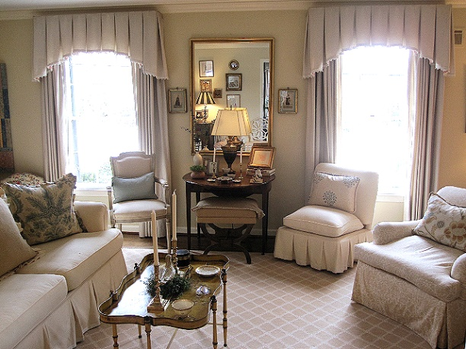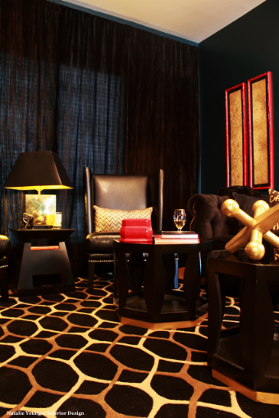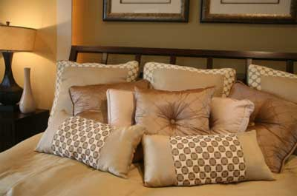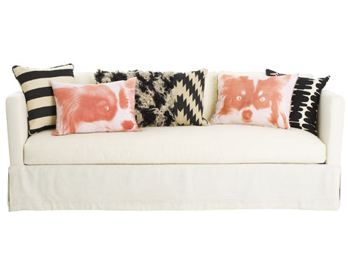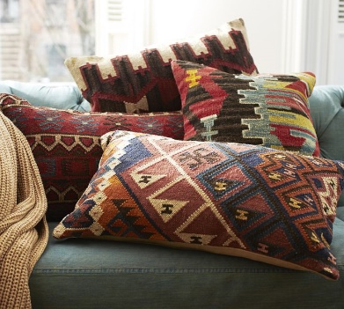

Q.1.vi. Sometimes the same color appears different in different types of light. What in
Your opinion could be the reason behind this?
Surface textures also affect the way we perceive a color – many textures absorb light, some reflect it; others filter and diffuse light. Sometimes the same color can appear quite different, depending on the way the surface reacts to light. It is another reason why you need to look at the fabrics, paints samples under the lighting conditions in which they will actually be seen. Many people think of texture as a purely raised, rough or sculptured surface. Actually all surfaces have a texture, even if perfectly smooth and bland, such as plastered walls that have been painted with matt emulsion paint. This texture absorbs light slightly, making a color look weaker. The same color on a shiny surface, such as gloss paint, silk fabric, glazed tiles, will look brighter and stronger, as the light is bounced back. The rough textures of exposed brick or stone walls, planks of wood, natural flooring and coarsely woven textiles absorb light, and therefore make the color appear darker, richer or in some cases duller. Light diffusing textures such as sheer muslin, voile fabrics, allow the light to pass through, making the color appear softer and more delicate. Heavily
Textured items can create very interesting effects.
Because of their uneven surface, light is reflected, absorbed and reflected differently across resulting in varying values of color. You can use this in a room where you want to add an extra visual element.
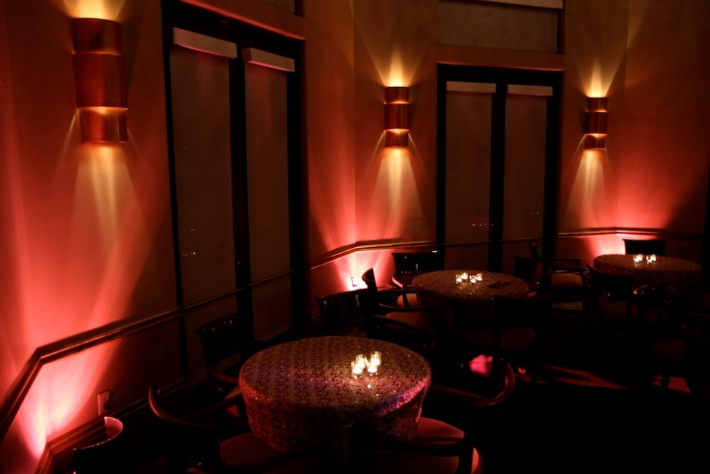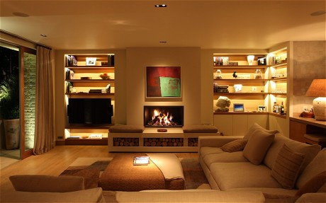

Q.1.vii. “Texture can work like color to bring surfaces forward or can give the impression That they are further away”.
Generally visual texture can be perceived as warm or cool, similar to colour. For example a glass table would evoke cool qualities because of its clear smoothness when compared to a cross- section tree trunk that is playing The role of a unique end table. Mixing warm and cool textures in a space can make it more sophisticated. The eye is drawn from one detail to another. Focusing texture to one side of the temperature spectrum can create a sense of
Harmony.Texture can also work like color to bring surfaces forward or can give the impression that they are further away. For example the shiny and silky textures - glass, brass and chrome- seem to come to you; whereas the rougher, soft and light absorbing textures- velvet, tweed and jute – do the opposite and seem to move apart. As a result the color of highly glazed ceramic tiles stand out much more than the same color on a bath towel.

Cool and warm textures mix
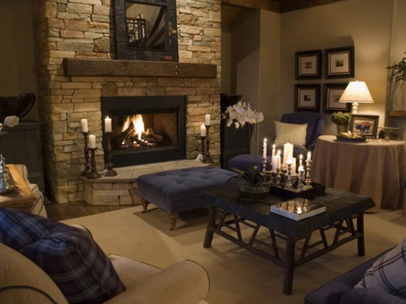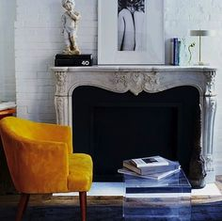
Silky texture Glass gives the feeling of larger space Jute
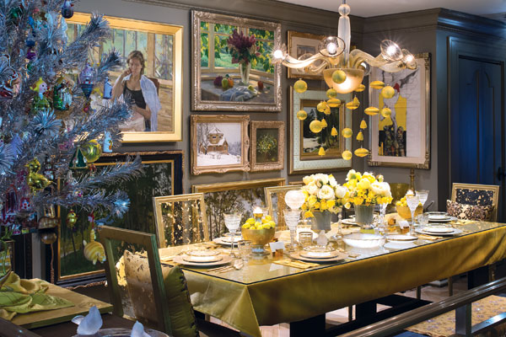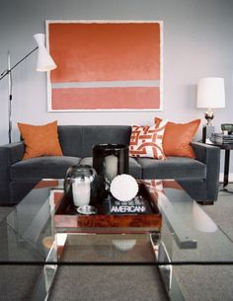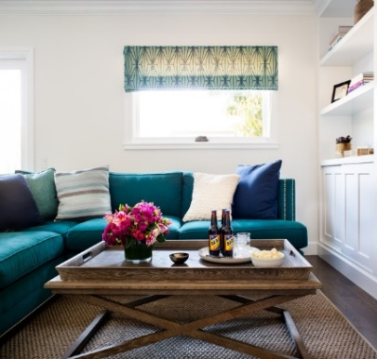

Activities

Activity 1
Shop around and bring back various samples of different materials like brick, tiles, matting or
Fabrics like silk, chenille, voile. Experiment with them and try out various contrasts.
- For the Brick: I’ve found out that brick is available in a wide range of sizes, shapes, colours and textures, brick can provide high style or a common touch. A variety of colours can give more character and is much more likely to occur naturally in handmade bricks. Old bricks with the patina of age can fit best into any design scheme. Some bricks can absorb like a sponge when painted, but as soon as they are sealed they effectively become plasticized. Whenever possible, it’s best to leave them untreated. If you do plan to paint brick, make sure you select a colour you can live with, otherwise it can be messy to sandblast bricks back to their original state. We have collected a variety of interior spaces with exposed brick to help inspire you to create your own beautiful interior. For example brick walls would better be contrasted with linen or cotton, or smooth white finish of shutters, than with silk, or velvet.
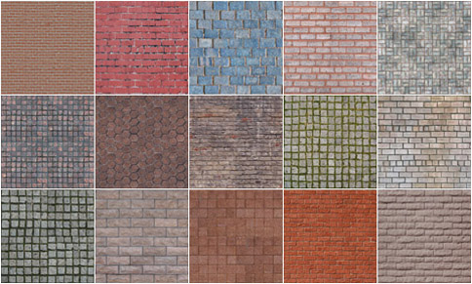

- For the Tiles: Not all tile materials are created equal. Each type has pros and cons that need to be considered when planning a tiling project. Here are some popular types and their benefits and drawbacks:

Marble
Real marble tiles have a beautiful, unique look like no other surface, with all their whirling patterns and shade variations Marble, like most stone tiles, has high maintenance requirements. It must be sealed and cleaned regularly; for cleaning, use only a mild detergent solution or a product specially designed for marble. Never set your drink down on a marble surface (it will leave a ring), and wipe up any spills immediately, as they can stain or etch marble’s porous surface.
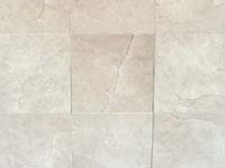Install Yourself? No
Best Use: Floors
Pro: Beauty
Cons: Expensive; high maintenance; can crack, stain and etch readily

Terrazzo Tile
Terrazzo is traditionally a flooring material made by exposing marble chips in a bed of concrete and then polishing until smooth. Now, however, you can buy terrazzo in tile form. It’s often used in public buildings because it’s long-lasting and can be refinished repeatedly.
Terrazzo is quite slippery and can cause falls, so it may not be a good flooring choice for families with young children or elderly members. Ask your contractor about applying non-slip additives to the surface.
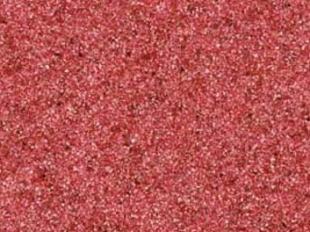Install Yourself? No
Best Uses: Flooring, walls, countertops, backsplashes
Pros: Unique beauty, elegance, longevity
Cons: Expense, can cause slips

Concrete
Concrete is a tough man-made mix of stone, sand, water and cement. It’s long-lasting, water-shedding, and hail-resistant and can be made to mimic the look of other building materials. It can be a good roofing choice for harsh climates.
Because it requires specialized tools and knowledge, and because you must ensure that the structure being covered can withstand the weight, concrete tile should be installed by trained professionals only.
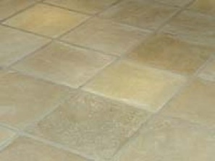Install Yourself? No
Best Uses: Floors, countertops
Pro: Durability
Con: Difficulty of installation

Terra Cotta Tile
Terra cotta is one of the oldest tile materials around, dating back before the birth of Christ, when it was sun-dried rather than oven-fired. It’s often used, glazed or unglazed, to create a rustic, weathered look.
While high-quality terra cotta will last forever, it’s difficult to assess the quality, even for pros. Buy only from a seller whose reputation you trust, though even then you may encounter problems.
For practical uses, it should be sealed, particularly in kitchens.
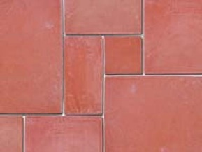Install Yourself? No
Best Uses: Flooring, countertops, walls
Pros: Beauty, longevity when well-made
Cons: Wide variations in quality

Porcelain
Actually a subtype of ceramic tile, porcelain bears a perception of high quality, but for residential applications its particular toughness is unnecessary. It’s nonetheless popular in the residential market because the manufacturing process makes for unlimited design potential.
The problem is that do-it-yourselfers typically install it with setting material designed for ordinary ceramic tiles, but porcelain’s low porosity means it requires a special compound for setting. Ask the manufacturer—not a salesperson—how to install it.
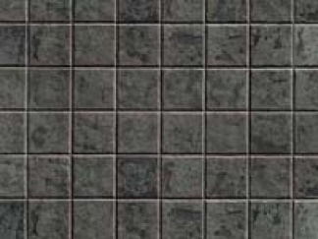Install Yourself? Yes
Best Uses: All-purpose; also commercial installations
Pros: Toughness, variety of design
Cons: Requires modified setting material to anchor it to substrate

Ceramic
Ceramic tiles are thin slabs of clay or other inorganic materials, hardened by oven firing and usually coated with some kind of glaze. Ceramic is best known for its durability, with some installations in the ruins of ancient Rome and Egypt still intact.
Ceramic tile is a great choice for kitchens and bathrooms because it’s easy to clean and doesn’t harbor germs. It’s manufactured in production runs; because of variation among lots, make sure the caliber number (indicating size) and lot number (indicating color) are the same throughout your order.
Ceramic tile is rated from zero to 5 based on hardness. Zero through 2 is suitable for wall tile, 3 is good for most residential uses, and 4 and 5 are hard enough for commercial applications.
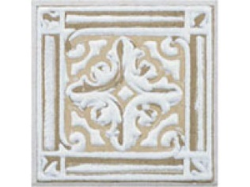Install Yourself? Yes
Best Use: Floors, walls, countertops, backsplashes
Pros: Durability, versatility, low maintenance, easy installation, low cost
Cons: Can vary in size and color from lot to lot

Slate
Slate tile is a popular roofing material with an air of prestige and a reputation for longevity. Although individual tiles sometimes crack, an entire roof made of slate probably won’t have to be replaced for 50 years or more. Properly installed, slate also makes dependable flooring.
Slate is a metamorphic rock with relatively weak bonds between layers, so tile made from it tends to split along those planes. For an installation to resist damage, it must be set on a solid surface with mortar.
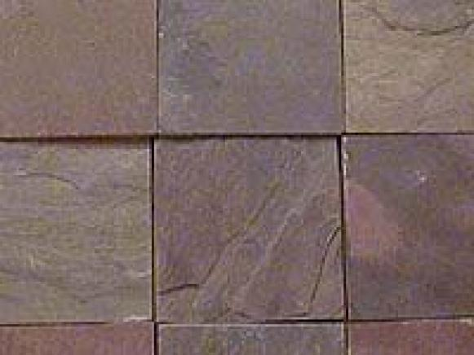Install Yourself? No
Best Uses: Floors, roofs
Pros: Beauty, longevity
Cons: Softness, tendency to split

- Floor Matting:
For outdoor use, you can always purchase an inexpensive welcome mat at your local super center, but you can also have one custom made. You can design a mat that offers a sentiment or displays a picture, or one that incorporates your family name or initials. You can choose the color and texture as well as the design to inject some personality and style into your floor mats.
You can also find woven floor mats. They come in many textures including straw, rattan and sisal, and many are quite decorative as well as functional. For outdoor use, you can also choose a reversible patio mat that allows you to flip it over and use the other side when one side begins to look dirty or worn, or simply to change the look with changing moods or seasons.
Straw Rattan Sisal
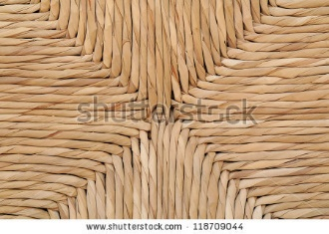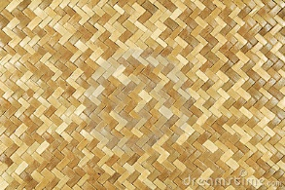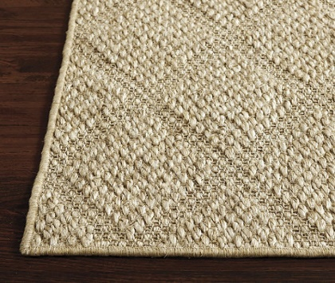
reversible patio mat Anti-Fatigue mats
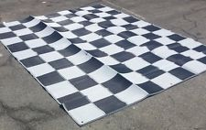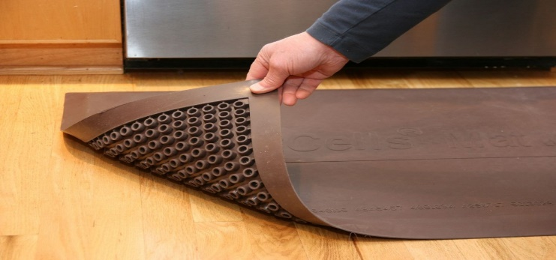
Floor mats are also available in other materials, such as rubber, vinyl and foam. The first two types of floor mat work great in front of the kitchen sink or utility sink, or in front of the tub to protect your floors from drips of water or soap. Foam mats are perfect for exercising or for lying on the floor while watching TV.
You may even want to consider commercial style floor mats, such as anti-fatigue mats. Place one in front of the workbench in the garage, use one in the basement workshop, or use one in the laundry room where you stand to sort or fold clothes. There are many different, attractive designs to choose from, whether floor mats are necessary for comfort and surface protection, or if you simply want to add some interest to your home.
Rubber Vinyl Foam
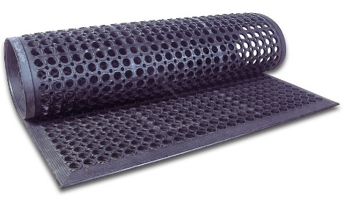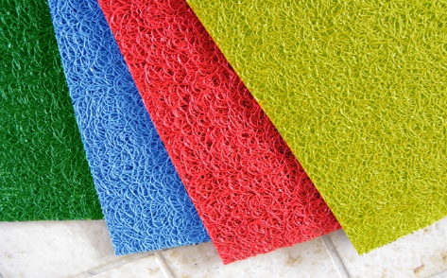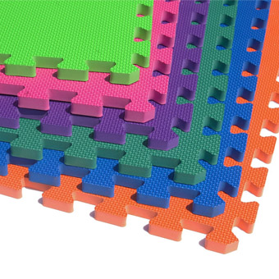

Activity 2
Observe different types of fabrics in artificial and natural lights of varying strengths. Write down
The outcomes of your observation. Attach the pieces of fabrics with your written observation.
Knowing that :
Rough/Course textures Smooth/Shiny textures
•Reflect less light & therefore feel ‘warmer’ •Reflect more light and so feel cooler
•Give an object more ‘weight’ •Make an object feel lighter
•Feel more ‘rustic’ •Feel more modern
Rough textures can be very harsh. We can soften them by using some light filtering surfaces. The softer and light absorbing textures sometimes appear claustrophobic, especially if they are on a dark colored surface. They will look more effective if contrasted by silks, shiny and light diffusing textures.
Also Before buying certain kind of fabric we must be knowing the answers of the following questions :
• What will the space be used for? • Will it be a high traffic area?
• Will it be used regularly or just when guests come over? • What type of light does the room have? • Do you have any pets? • Do you have any children?
For the Silk:
Well, we all know what silk is and it can provide a rich element to any room when you use it for window coverings, pillows or even as an upholstery covering. It has a soft lustre to it and the fibres themselves are actually prism like, which is why the material shines it reflects light at various angles. The main drawback of silk is that it is not very durable. It is prone to wrinkling and it will stain very easily. I would avoid using silk in high traffic areas such as family rooms.
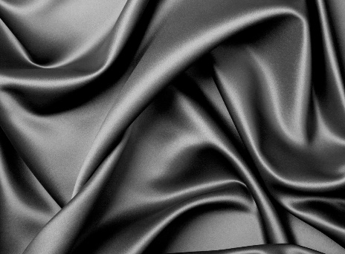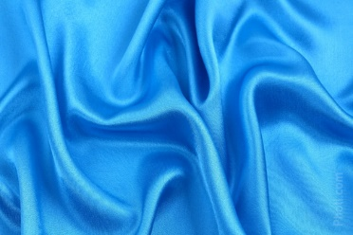

Rayon:
Also known to many designers as “art silk,” rayon is a semi-synthetic fabric that is a great alternative to silk. It has a bright shiny texture to it and is a great choice for many homes that is looking for something that is more durable than silk is. The one major drawback of rayon is that it will wrinkle so it is better to use it on a surface that won’t have a lot of people lounging on it.
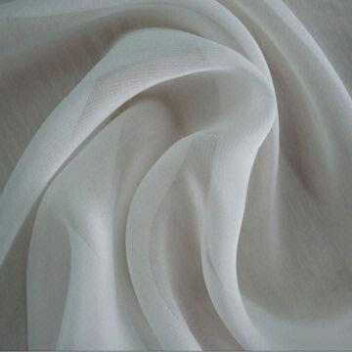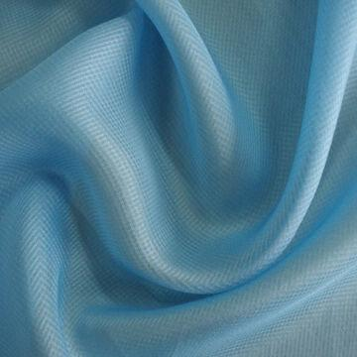

- Fabric upholstery is less likely to give a “shine” and reflect lights, while vinyl upholstery is normally easier to keep clean.
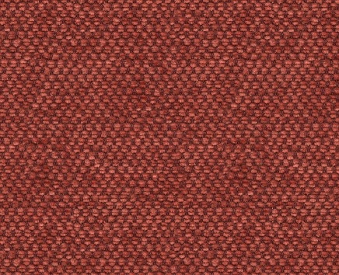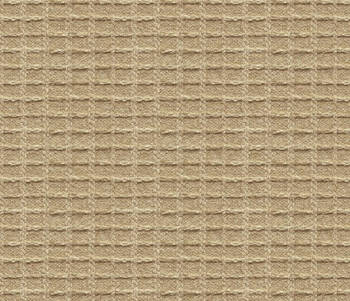

Voile:
Originally voile was made with natural fibres, such as cotton, linen and wool. Contemporary manufacturers of voile have expanded the fibre repertoire to include other long filament fibre, such as worsted silk and synthetic. The light-weight and semi-sheer nature of voile is what makes it perfect for curtains. It allows natural light at the same time can prevent it if used as many layers. It doesn’t reflect light since having a more open weave. With its dense weave of highly twisted fibres, voile still maintains a crispness that can sometimes feel wiry to the touch. Because it doesn't have the elegance of organza.
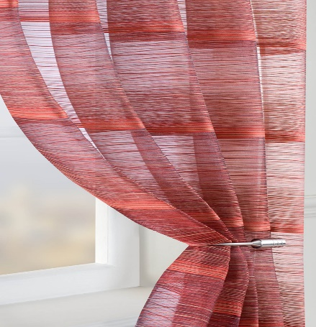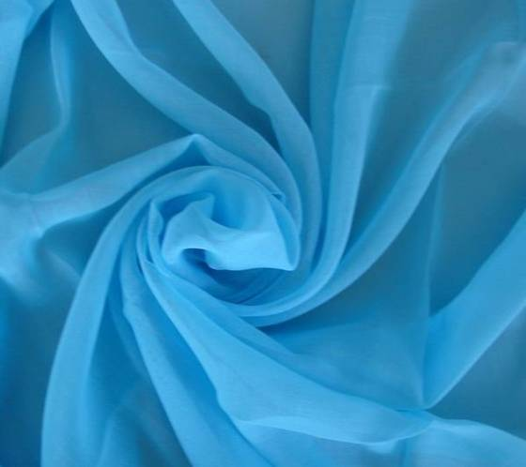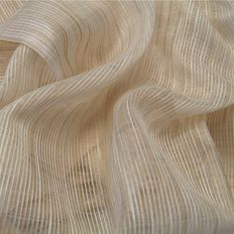
To avoid making bad choices for the fabrics or colors, We must know that for the Artificial Lights (overhead Lightings and lamp lights) :
Incandescent and halogen lights enhance reds and yellows and mute blues and greens. Fluorescent lights enhance blues and greens and mute reds and yellows. To further complicate things, wall colour lit from above is going to look a bit different than wall colour lit from floor and table lamps.

