
Assignment Cover Sheet

Student Name: | Saleema Choudrey
Student Number: | 1240
Course: | Fashion Designing
Assignment NO: | Unit 4 The process and structure of fashion Industry

The process and structure of fashion Industry

  - What is Meant by market segmentation

Market segmentation is a strategy that requires divided target market into different categories of consumers, business and countries in the fashion industry. They have common need and priorities and then the designing and follow up strategies to complete them all together.

  - “Design is a visual thinking, perhaps of a higher order than verbal thinking”. Explain:

Designing starts with visual thinking through getting inspiration from all over the world before you actually put it on paper. You can get inspiration from everywhere and everything around you to start designing.

  - Explain briefly the developing of a sample garment

- Sketching
Designers start their work with making a rough sketch which is an informal drawing.
The designer must be able to imagine how the garment will look like three dimensionally as well while making the sketches. Notes on the sketch are important for example: construction, measurements, lines, exact details, seam lines and trimmings.

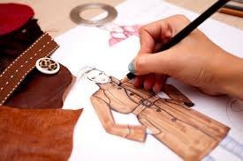

- The first pattern
Patterns are drawn on flat paper.

Sample sizes for patterns are:
Junior size 7
Missy size 10
Men’s trousers size 34
Men’s suits size 38

Draping and flat patterns are 2 methods that could be used by patternmakers.
The draping method is used with a muslin fabric on a figure dummy. Everything will be draped according the design that’s made by the designer on a sketch. After draping the design will still be cut out on paper with additional notes on it. Flat pattern method is used for patterns like sleeves, pant legs which are difficult to drape on a dummy.
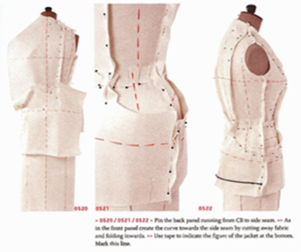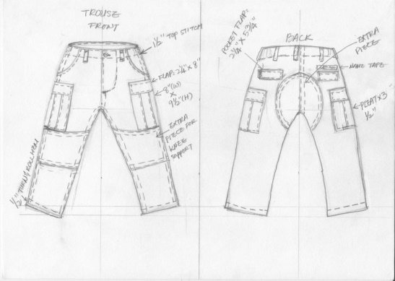
sample: draping Sample: flat pattern

- Sample garment
A sample garment is made out of manila paper or tag board. After sewing a prototype is made by a sample maker. A prototype sample garment needs to be checked on size and fitting. If there’s still anything that needs changing it needs to be done at this stage.

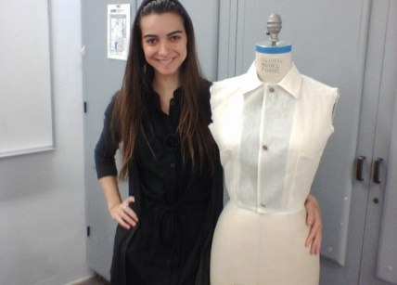

- Designer worksheet

Worksheets are included in all styles as a record for all the information. They include all the information that’s needed to know for the final product. The worksheets includes the following points:

1. designing date
2. selling season according the design
3. sizes
4. style number ( manufacturer code)
5. description of garment
6. Working sketch of the design to identify the designs.
7. colors/ color combination of the designs that’s included
8. Fabric swatches used in the garment.
9. material description
10. marker width
11. trimming information
12. labour cost

- Style board
Style board is a big essential master plan which includes sketches, color books, fabric and any important notes.

- Line selection
After designing more than 2 designs the management and designers still choose 1 best design amongst them all. The one that fits well in the category like price, fabric, silhouette, line etc. Even the best designs could be rejected because of the standard requirements.

- Duplicates
Duplicates means more than 1 original design. Duplicates are often sent to buyers all over the world to salesman, fashion shows, exhibitions to attract buyers. Duplicate garments are also very good for quality check.

- The couturier
Couture means designs made to order. Charles Frederick worth was a famous couturier. He was born in the United Kingdom but made it in France. His designs were made on order for the higher societies.

- Haute couture
Haute couture other word for “made to measure”. Haute couture is used for specific clients who can afford the expensive fabric that’s used. While placing the order it takes a while before it’s made. The garment is handmade and everything should be perfectly fit the client.

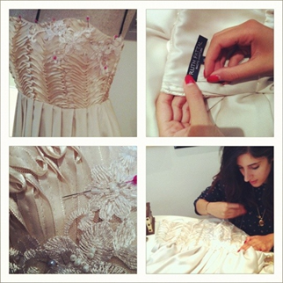

- Pret-a-porte
Pet-A-Porte another word for ready to wear. Haute couture and fashion houses also sell a line of pret a Porte. These are expensive ready to wear garments. Not everybody can afford it.

- Line
Line is important to create the perfect body shape on garments. It should not be too straight or too curvy. The lines should match the body line.

- Knock offs
Knock offs are copies of other designs which manufacturers buy from the designers and resell them in similar fabric but bigger quantities. The garments should sell well with rapid production capabilities and in lower prices.

- Avant grade
Avant grade are designers who develop their own style.

Sample of Avant grade:
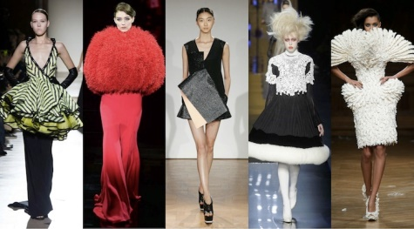

- Bridge
Designer fashion that’s created for people with less income who still can enjoy designer fashions. “Bridge” means a step down in price which can be done by using less expensive materials but still high street fashion.

  - What is a CAD system and how it has revolutionized the fashion industry?

CAD/CAM (computer-aided design and computer-aided manufacturing) refers to computer software that is used to both design and manufacture products.

CAD is the use of computer technology for design and design documentation. CAD/CAM applications are used to both design a product and program manufacturing processes, sp7ecifically, CNC machining. CAM software uses the models and assemblies created in CAD software to generate tool paths that drive the machines that turn the designs into physical parts. CAD/CAM software is most often used for machining of prototypes and finished parts.

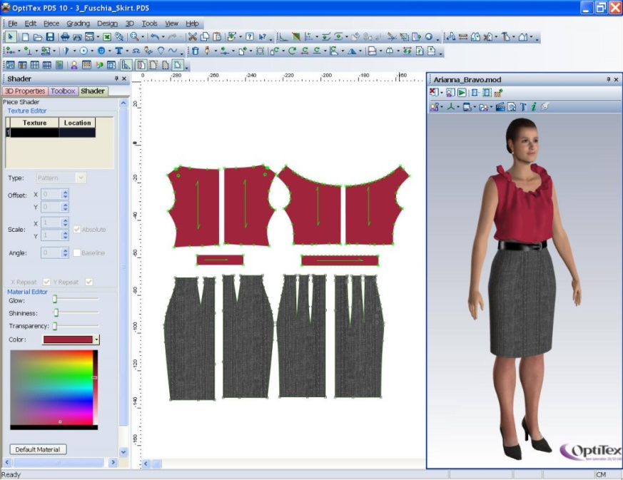
Sample of Cad/Cam

Project: Market Research

A.

- Dress 1

Brand: Primark
Color: brown/beige
Fabric: chiffon, animal print
Line: A-line fitting
Design: printed vintage tunic dress
Size: size UK 14
Price: £11

Dress 2

Brand: Topshop
Color: Fuchsia purple
Fabric: viscose
Design: plain tunic dress
Line: Oversized
Size : size uk 16
Price: £11

Dress 1: Animal printed fabric dress, size 14, Perfectly fitted on body. Color wise it will suit well on Asian women. Occasionally wear.

Dress 2: Plain oversized dress, size 16, loose fitted from the waist. Casual wear. Good for basics. Combine with anything to make it your own style. Also wearable as maternity wear.

The two dresses are totally different from each other. Length wise they are the same. The fitting on the body is according to the design.

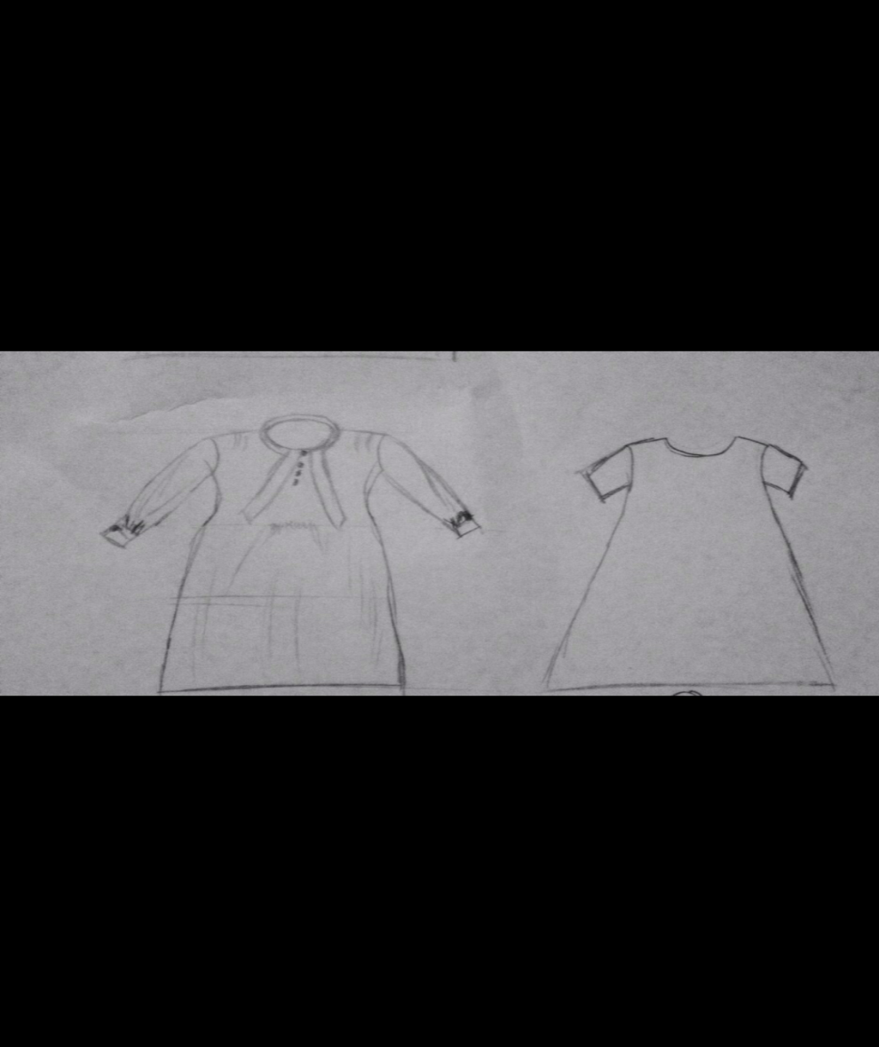

Sketches

Dress 1 and 2

B.

- Local department store : 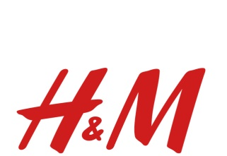

Contemporary fashion and junior fashion looks similar to me. The prices are high to affordable and the clothing lines are almost the same. As you can see the designs are similar but the sizes are designed according to the body type of that age group.

For example:

Junior chiffon dress H&M
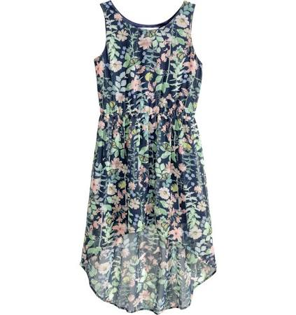

Ladies chiffon dress H&M
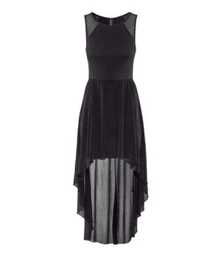

- Major manufacturers in department store H&M

Clothing lines are manufactured almost everywhere in the world. They are manufactured in countries like India, Bangladesh, China, Pakistan, Sri Lanka, Vietnam, Thailand, etc. For cheap labor work that’s called rear end business

Major manufacturers Contemporary department:

Bangladesh
India
Pakistan
Sri Lanka
Thailand
South Korea

Major manufacturer Junior department:
India
China
Vietnam

- General styling differences

Styling differences are the comic and cartoon designs on clothing lines in junior department
In contemporary department there is an exclusive line available for a season which is designed by a popular designer like Ralph & Lauren, Conscious etc. These are very expensive for local people with an average income. But there’s also affordable fashion available.

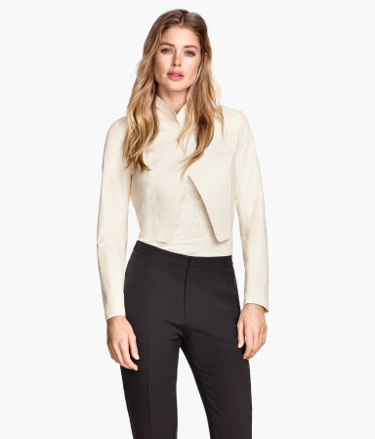
Conscious Exclusive collection short leather jacket by H&M £199.98

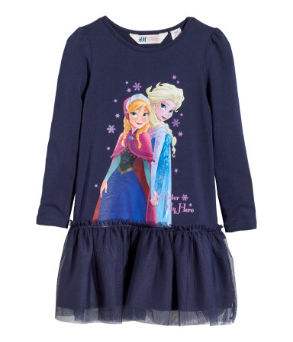
Dress with a tulle skirt £9.99

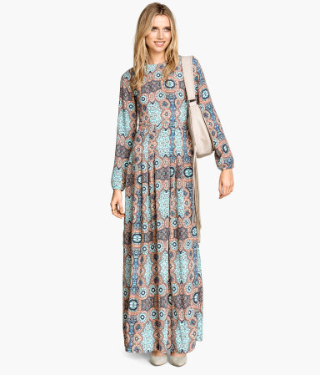
Long dress £29.99

References

http://gulnazahmad.hubpages.com/hub/CADCAM-for-Fashion-and-Clothing-Designing
http://google.com
http://www.inc.com/encyclopedia/computer-aided-design-cad-and-computer-aided-cam.html

http://www.google.co.uk/imgres?imgurl=http://upload.wikimedia.org/wikipedia/commons/f/fe/Charles_Frederick_Worth_(Mars_1895).jpg&imgrefurl=http://en.wikipedia.org/wiki/Charles_Frederick_Worth&h=450&w=359&tbnid=kTcaD2qzVFm00M:&zoom=1&docid=Tnns4yXfznZIMM&hl=en&ei=IxECVeasGoeCPOKqgfgK&tbm=isch&ved=0CC0QMygBMAE

https://www.google.co.uk/search?q=avant+garde+designers&biw=1366&bih=599&source=lnms&tbm=isch&sa=X&ei=fBUCVaifM8nqOIGSgagN&ved=0CAYQ_AUoAQ#imgdii=_&imgrc=dCshf8O0W8bMJM%253A%3BePbrRoxdAYcfaM%3Bhttp%253A%252F%252Funtitled-magazine.com%252Fonline%252Fwp-content%252Fuploads%252F2014%252F07%252Favantgarde-couture.jpg%3Bhttp%253A%252F%252Funtitled-magazine.com%252Fthe-best-of-paris-haute-couture-fw-2014%252F%3B725%3B401

UK textiles (Unit 4)

http://sustainability.hm.com/en/sustainability/downloads-resources/resources/supplier-list.html

Student Statement:

By submitting this assignment, I confirm that this is my own work.

Student Signature | Saleema choudrey | Date | 28/03/2015

For Tutor / Assessor Use Only
Total Marks
Marks Obtained
Percentage / Grade

