
Assignment Cover Sheet

Student Name: | Ray Wilson
Student Number: | 1250
Course: | Construction Management
Assignment No: | 04

Student Statement:

By submitting this assignment, I confirm that this is my own work.

Student Signature | Raymond Wilson | Date

For Tutor / Assessor Use Only
Total Marks
Marks Obtained
Percentage / Grade

Assessment 4 Total Marks: 30
Give short answers for the following questions: (25)
- Which types of buildings are included in residential building category?
The classification of buildings are generally based on type of construction and occupancy which is essential for planning and design purposes. For residential buildings (group A) this classification is based on any building that provides sleeping accommodation under normal circumstances. These buildings come under this classification whether or not they have bathing, eating or cooking facilities and have been sub divided as follows,
A1 – Lodging or boarding houses
A2 – Private family dwellings
A3 – Dormitories
A4 – Apartments/Flats
A5 – Hotels

- What is environmental impact study or EIS?

As in life, activities in construction can affect the environment either positively and negatively and site developers should consider many factors from the early stages of the project and ensure management tools from design through execution are put in place such as inspections, audits and actions that can mitigate the impact on the planet and environment.

An environmental impact study (EIS) should be carried out to consider factors such as,
- Good air quality provision, maintenance and monitoring
- Usage and the quality of water sources required.
- Waste disposal and recycling wherever practical.
- Impact on local roads and infrastructure.
- Power requirements and its origins.
- Critical area protection such as beaches, forestation, unstable land and the like.
- Impact on flora and fauna.
- Management of hazardous products and potential outputs such as radiation, oils, chemicals and other substances that can have adverse effects on the environments and life itself.

From these studies, surveys and inspections a report should be developed and findings should describe impacts, as well as ways to "mitigate" impacts. To "mitigate" means to lessen or remove negative impacts.

- What is the basic criterion for judging the suitability of the site for construction?
The suitability of a site location is becoming more complex due to development control rules that must be adhered to that are issued by various bodies at local, state and National levels. However a number of basic requirements are needed so that an assessment can be made on the suitability of a location regardless of the type of building to be constructed.
These are,
Climate effects such as wind direction, temperature, rainfall, humidity and effects of the suns radiation.
Physical considerations such as soil conditions and the contour/configuration of the site to be used.
Availability of resources such as power supply, material and water supply.

- What is topographic data about?
Topography is a field of study that describes surface shapes and features (especially their depiction in maps).
A visual inspection of an area is the basic form of topography however in the Construction Industry topography is concerned with basic local detail and surveys and maps are normally produced with regards to a number of items such as elevation (above sea level), orientation (west to south-west etc.), slopes (determined as percentage 0-5%, 5-10% as an example), hydrographic features (such as streams, rivers, drainage), valleys/hills/forests etc. that can affect line of sight and miscellaneous terrains such as peat bogs, swamps and plateaus.
This information needs to be taken into consideration whilst planning, designing, engineering and constructing of structures and buildings.

- Which type of buildings should be constructed on rocky sites?
Dam structures are suitable buildings for rock based site locations.
One of the most common types of major dams is the arch dam. These masonry or concrete dams are ideal for narrow and/or rocky locations because their curved shape easily holds back water via gravity without the need for a lot of construction materials. Arch dams can have one large single arch or they can have multiple small arches separated by concrete buttresses. A simple typical section is shown below
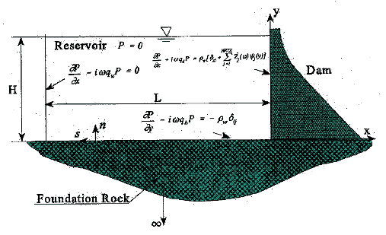

2. Give the classification under which the following buildings fall: (5)
a) Museum
Group D – Assembly buildings were people gather for recreational purposes
b) Hospital
Group C – Institution buildings used for people who need care or medical treatment
c) Hotels
Group A – Residential buildings which provided sleeping accommodation. Hotel photo below,

d) Library (public)
Group E – Business buildings used for record keeping, professional establishments etc.
e) Departmental stores
Group F – Mercantile Buildings such as shops, stores and markets used for selling merchandise.

f) LPG Cylinder storage.
Group J – Hazardous Buildings where the storage of flammable, explosive and highly combustible products takes place. Typical storage building set up below,