
Assignment Cover Sheet

Student Name: | Raymond Wilson
Student Number: | 1250
Course: | Construction Management
Assignment No: | 05

Student Statement:

By submitting this assignment, I confirm that this is my own work.

Student Signature | Raymond Wilson | Date | 22nd July 2014

For Tutor / Assessor Use Only
Total Marks
Marks Obtained
Percentage / Grade

Assessment 5 Total Marks: 30
1. Give short answers for the following questions: (20)

- What do you understand by the term ‘site organization’?
Once the location of the site is determined the requirements to ensure the site is organized should be put in place. This exercise (site lay out plan) should take into consideration all that is needed to ensure the site is well organized with respect to the following,
Proposed lay out of all facilities, offices, accommodation and plant parking so that safety, efficiency and cost can be optimised.
Access to the site, normally identified for visitors and deliveries, is also a major consideration especially with regards to the effect on the local community.
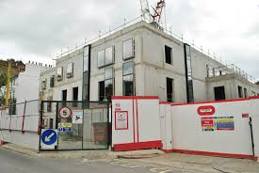
On larger projects a traffic management plan is normally produced so that the site traffic needs are identified, scheduled and managed so that its impact on the community and environment are mitigated. Personnel and labour transportation and timings are always a major consideration within such a plan.
Other items that need to be considered and organized are appropriate internal roads to cater for the type of plant needed during construction, storage of materials especially those that may need climate control prior to installation, site power demands and distribution, and weather management controls such as drainage (which is always a costly and time consuming element), water ways contamination prevention, lightning protection and on site shelters for remote work places.
Management, organisation and control of the above will ensure the site is laid out orderly, logically and practically promoting a tidy site that with good housekeeping controls will demonstrate an efficient and well managed Construction facility.
Typical organised site layout below,
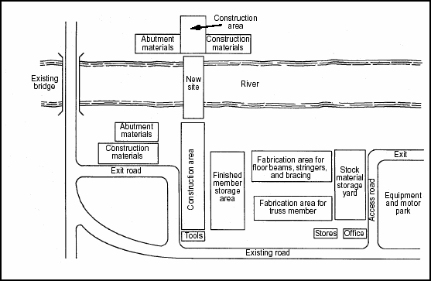

- Highlight the importance of preparing the site road suitable for the movement of heavy construction equipment.
The importance of a suitable site road infrastructure cannot be underestimated. When using heavy construction vehicles and equipment the use of a bitumen sealed road or soft clay ground is not appropriate as the tracks/wheels of these types of heavy equipment will damage the surface on regular basis and the cost would be astronomical as well as time consuming. Sealed roads are best used for offsite vehicle usage.
Coarse/roughly constructed access roads should be used for heavy and tracked vehicles and although they will still require maintenance from time to time, (especially after inclement weather and this is usually carried out using a grader type machine and roller that easily levels the road and compacts respectively) this will ensure that potholes which can cause damage to vehicle and plant and potential damage to ditches and haunches are avoided. This will provide a site road system robust enough for the earlier stages of construction period to allow the movement of heavy construction plant/equipment.
It is important to note that interfaces between heavy vehicles/plant and off-site vehicles should be well managed due to obvious safety reasons and the use of flagmen and suitable signage, including speed restrictions, should be used whenever practical as control measures. Some control signs are shown below,
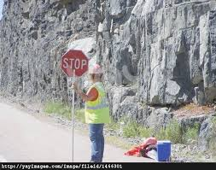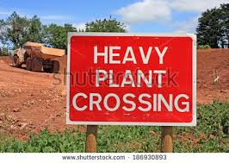
- List the precautions to be taken for the storage of cement at a construction site.
Usually purchased in 50 kg bags the primary concern for storing cement is to prevent exposure to moisture. Cement stored in damp air or moisture sets more slowly and has less strength than cement that is kept dry and therefore moisture and dampness must be alleviated. Precautions to be taken should be,
- Bagged cement stored on a job site should be stacked closely together on pallets, approx. 150mm from the floor, to reduce air circulation and to raise the cement above any moisture sources.
- Bags should also be covered with tarpaulins or other water-proof covers for further protection from moisture and draughts.
- If possible, store cement inside a well-ventilated structure to further reduce the potential for moisture exposure
- Never place the cement directly next to an exterior wall, leaving a minimum space of 450mm.
- The relative humidity within the structure should be reduced as much as possible.
- Cement has a limited shelf life so care should be taken to ensure older stock is used prior to using newly purchased stock.
- Consideration of the prevailing climate needs to be considered so that quantities of cement are not stored long term during hot and humid or rainy seasons.
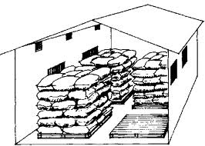 Some samples of cement bag storage 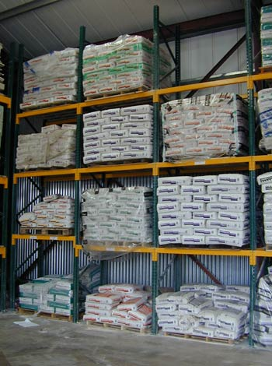

- What will you do to prevent scaling and rusting of structural and reinforcing steel?
Steel used in Construction needs to be stored in such a way that distortion and corrosion are alleviated. Chloride-induced steel corrosion is one of the major worldwide deterioration mechanisms for steel structures. Therefore preventative measures must be taken to prevent the onset of scaling and rusting.
A common and effective method of protection is to coat non painted steel with a cement wash before staking.
To ensure material usage is optimised steel shall be stored above ground and at least 150mm above grade by size, length and differing material classification that can easily be identified by adopting a coloured end marking system for each type/grade

Ideal storage conditions for re bar materials (albeit in fab shop conditions)
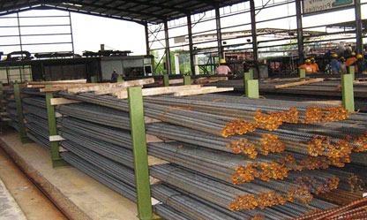

- How does exit control help in site protection?
Exit (and entry) control can go a long way in ensuring the site is protected.
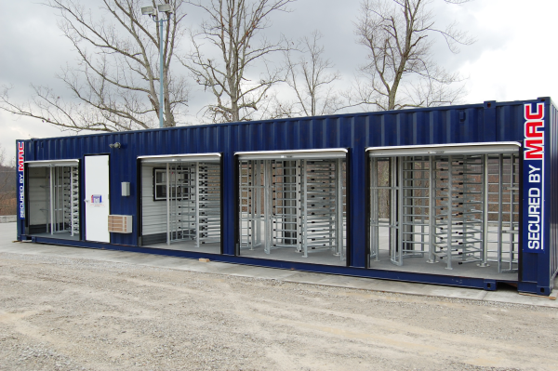
By controlling personnel and vehicle movement through the use of barriers and turnstiles, as shown on the relevant pictures, a significant benefit can be obtained as these will reduce the risk of construction site loss costs which can occur from theft, terrorist threats, sabotage attempts and vandalism. Secondary to this is also a potential saving on security, often required on construction sites, and dependent on location it may be possible to do away with security if the site has suitable barriers and is fenced off.
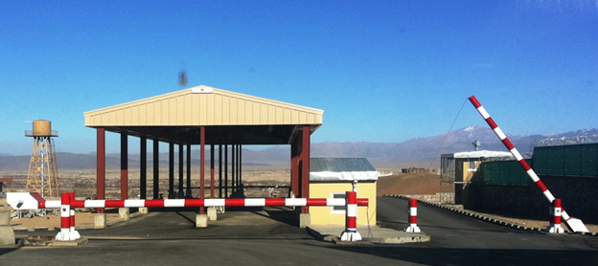

2. Discuss the advantages of providing fences for construction sites. (5)
The installation of a fence around a Construction site is quite common and satisfies two functions by acting as a deterrent to trespassers/thief’s and also determining the limits of a site which is extremely important if your site borders on someone else’s property or land.
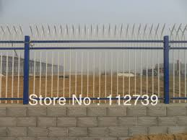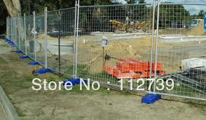
Once the requirement of a fence is determined the type of fencing should reflect the nature of the site and its surroundings and the boundary is an important aspect of managing public risk. You need to consider planning what form the perimeter will take, providing the fencing; and maintaining the fencing. Other considerations may be,
- What is the nature and type of the construction work?
- How heavily populated is the area is?
- Who will need to visit the site during the work?
- Will the site attract children?
- What are the site characteristics (e.g. existing site boundaries, location, proximity to other buildings etc.)
Typically, in populated areas, this will mean a two-metre high small mesh fence or hoarding around the site which should have access gates and be able to be secured. They are also often used to display warning signs to deter trespassers and also inform visitors of the activities that are being undertaken on the site as shown below,
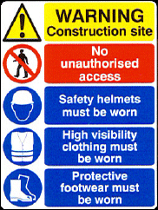

3. How is the provision of site electricity different from building electricity? (5)
Construction site electricity is an important requirement for nearly all Construction sites and the installations that supply this power requirement are normally located outdoors and may or may not be partially covered against the elements. This site electricity is used to power equipment and plant as well as being used to supply various temporary units such as site offices, rest rooms and the like.
These installations must be installed by competent and qualified electricians under the supervision of suitability qualified personnel and must conform to national codes and be checked on a regular basis to ensure the risk of electrocution is mitigated.
These power sources and continually modified or need to be moved as the construction phase develops and therefore self-powered generators are normally used. If the site is of a large nature however the supply can be obtained from the local electric supplier through feeders and transformers. A typical power generator is shown below,
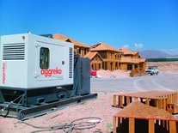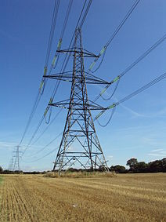

Building electricity (permanent power) however is obtained from a network of electrical components used to supply, transmit and use electric power. An example of an electric power system is the network that supplies a region's homes and industry with power - for sizable regions, this power system is known as a grid and can be broadly divided into the generators that supply the power, the transmission system that carries the power from the generating centers to the load centers and the distribution system that feeds the power to nearby homes and industries. Integral part of power supply, a pylon, is shown above.

