
Assignment Cover Sheet

Student Name: | Ray Wilson
Student Number: | 1250
Course: | Construction Management
Assignment No: | 07

Student Statement:

By submitting this assignment, I confirm that this is my own work.

Student Signature | Raymond Wilson | Date | 31 Aug 2014

For Tutor / Assessor Use Only
Total Marks
Marks Obtained
Percentage / Grade

Assessment 7 Total Marks: 30

1. Give short answers for the following questions: (25)

- Define materials management and its scope.
Materials Management can be defined as the function of business that is responsible for the coordination of planning, sourcing, purchasing, moving, storing and controlling materials in an optimum manner so as to provide service to the customer or user, at a pre-decided level of service and at a minimum cost making materials management an integral part of the construction management process.
The fundamental aims of the Materials Management function are often called the famous 5 R’s of Materials Management, are acquisition of materials and services:
- Of the right quality
- In the right quantity
- At the right time
- From the right source
- At the right price

The scope of material management is vast. Its sub functions include material planning and control, purchasing, stores and inventory besides others. Basically, under its scope are :
- emphasis on the acquisition aspect
- inventory control and stores management
- material logistics, movement control and handling aspect
- Purchasing, supply, transportation, materials handling etc.
- supply management or logistics management
- all the interrelated activities concerned with materials

- Describe the various functions and objectives of materials management.
From the management point of view , the key objectives of material management are :
- To buy at the lowest price , consistent with desired quality and service from suppliers who are prequalified and to maintain a high inventory turnover , by reducing excess storage , carrying costs and inventory losses occurring due to deteriorations , obsolescence and pilferage
- Standardization of purchasing so as to reduce the need to carry similar components in large quantities when a smaller range of items would suffice.
- To maintain continuity of supply , preventing interruption of the flow of materials and services to users
- To maintain the specified material quality level, identification and a consistency of quality which permits efficient and effective operation
- To develop reliable alternate sources of supply to promote a competitive atmosphere in performance and pricing and to minimize the overall cost of acquisition by improving the efficiency of operations and procedures
- To hire, develop, motivate and train personnel and to provide a reservoir of talent and to develop and maintain good supplier relationships in order to create a supplier attitude and desire furnish the organisation with new ideas , products, and better prices and service


- To achieve a high degree of cooperation and coordination with user departments
- To maintain good records and controls that provide an audit trail and ensure efficiency and honesty
- To participate in make or buy decisions

- Discuss the possible disadvantages of "integrated materials management approach".
The potential disadvantages revolve around functional departments in the material organization operating independently which may lead to a “conflict of interest” situation.
The purchasing department, as an example, will probably look at discounts from suppliers as a driving factor and buy large quantities to maximise the discount that can be achieved. This however could be in conflict with the capacity for storage that the warehouse has available and the additional costs associated with transporting such quantities.
If the an integrated approach is adopted however all of these factors must be taken into consideration so that a balance between all the departments can be optimised to benefit the project as a whole meaning that the materials manager would act as a mediator and coordinator from an overview prospective and thus ensure controls and balances are put in place.

- Discuss the various vendor rating techniques. Why an organization should try to rate its vendor?
There are a number of vendor rating methods and a weighted one as illustrated below is typical:
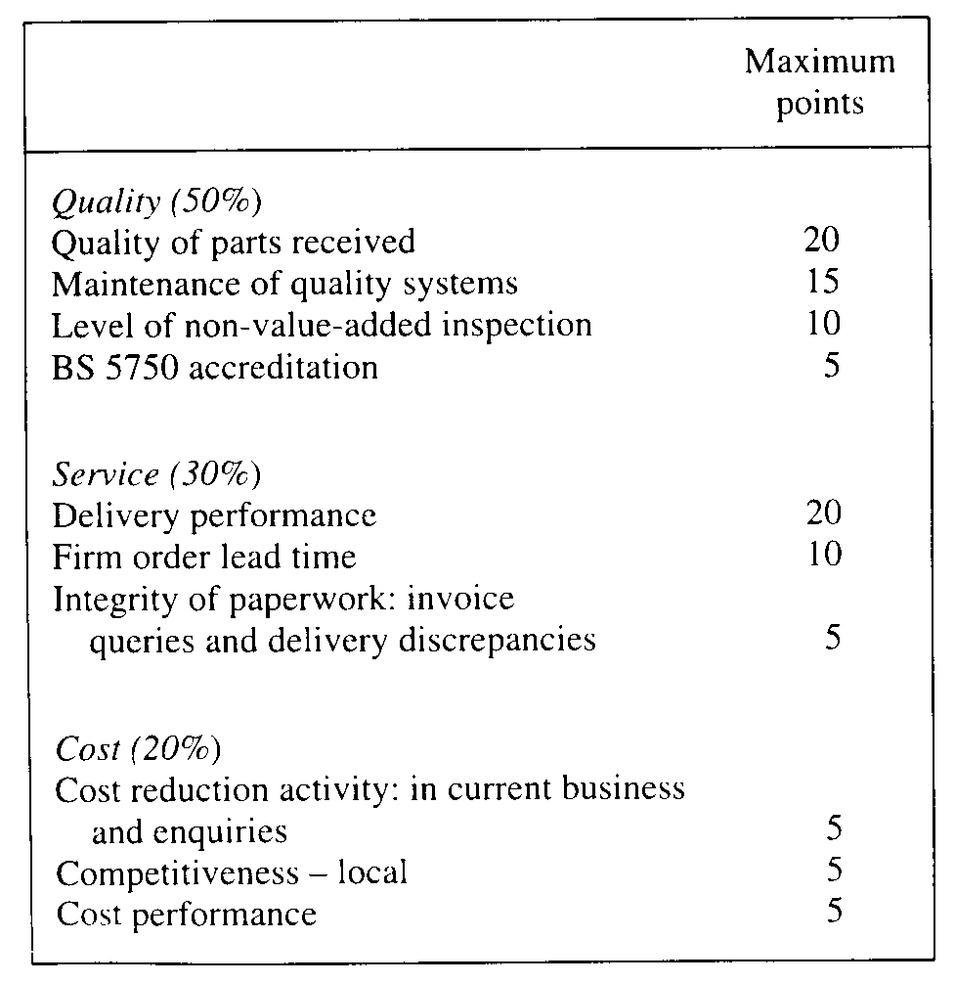

This system allows the purchasing company to evaluate each of his suppliers in a consistent manner using the parameters outlined and ultimately will provide the data so that the “preferred” suppliers can be easily identified and poorer performers can be sidelined until a better performance can be guaranteed or they can be dropped from the suppliers list altogether.

Another popular rating method (see below) is a simple check list that is utilized by various departments within the material management system. Activities such as price, quality, delivery timings etc. are then scored and evaluated to arrive at an overall rating to determine the most suitable suppliers

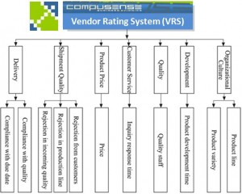

A critical incident method is also adopted by some projects. Events such as continual late deliveries of equipment/consumables and high rejection rates of delivered items due to damage or quality which can adversely affect production schedules. This system is normally adopted by management who have a large turnover of components and are therefore not set up to adopt a list or weighted score system choosing to focus on critical items only.

It is extremely important for an organization to therefore rate and continuously monitor its suppliers and vendors as poor performance can result in ongoing uncertainties on supplied items that can significantly affect the already under pressure schedule and thus making emergency purchasing an often costly alternative therefore blowing the department budget and resulting in overall project cost escalation. Some basic factors will help assess vendors such as but not limited to:

- Adherence to delivery and quantity schedules and quality specifications.
- Price competitiveness and long term and historic financial strength
- Flexibility, cooperativeness and service attitude
- Technical potential and capability
- Packaging, freight, delivery and cost effectiveness
- In-house testing facilities and reliability of product test certificates and sources.

- What advantages does a construction agency derive by treating materials management as a separate and important function?
Organisations which have embraced the integrated materials management system normally enjoy some of the following advantages:
- Advanced and efficient electronic data processing (EDP) systems can be introduced under an integrated material management system. This allows for up to date information being readily at hand so as to ensure the material information needs are centralized which will lead to better cost effective decisions on material purchases.
- Through centralization of authority and responsibility for all aspects of materials function, a clear cut accountability is established. This helps in evaluating the performance of materials management in an objective manner. Better support and coordination is also achieved when an overall materials manager is responsible for all functions as the departments who report to the materials manager create an identity which is common. Departments who require materials also find that they only have to approach one department, or even one person in smaller organizations, for discussing and solving their materials problems. This leads to an atmosphere of trust and better relations between the user departments and the materials management department.
- As all the inter-related functions are integrated organizationally, greater speed and accuracy results in better communication and therefore better overall performance. Need for materials are promptly brought to the notice by materials planning with special attention needed for long lead time items. The purchasing group are continuously advised of stock levels and order status by stores and inventory control departments. All this inter department cooperation leads to lower costs, better inventory turnover, reduced stock-outs, reduced lead times and a general reduction in paper work.
- Under a central materials manager, team spirit is a valuable asset which can be nurtured. This will result in better morale and cooperation between departments harboring the opportunities for growth and development. Individual development needs are also catered for under such a setup and they get, over a period of time, exposed to broader aspects of the materials function.

Activity (5)
Visit an organisation which has already computerised its materials management department. Study the system design for materials management, classification & coding system and find out any correction or modification required.
I visited Habtoor Leighton Group (HLG) a major civil contractor based in the Middle East and studied, discussed and reviewed their material management system.
HLG use a construction management system called Construction Industry Solutions (COINS) which is also used by companies such as Barratt Homes, Taylor Wimpey, AMEC and Balfour Beatty to name a few.


This materials management system used forms part of an overall construction management programme and is readily accessible as demonstrated in the following screen shots
During this exercise I identified some 10mm and 12mm reinforced steel bars and followed the cycle of procurement through to issue to the end user.
The programme starts with a log in prompt and following security checks my materials associate demonstrated how this material is identified, procured, tracked through a series of purchase orders/material requisition windows which results in pre populated purchase requisition and is continually tracked in the system until issued to the requestor/user.

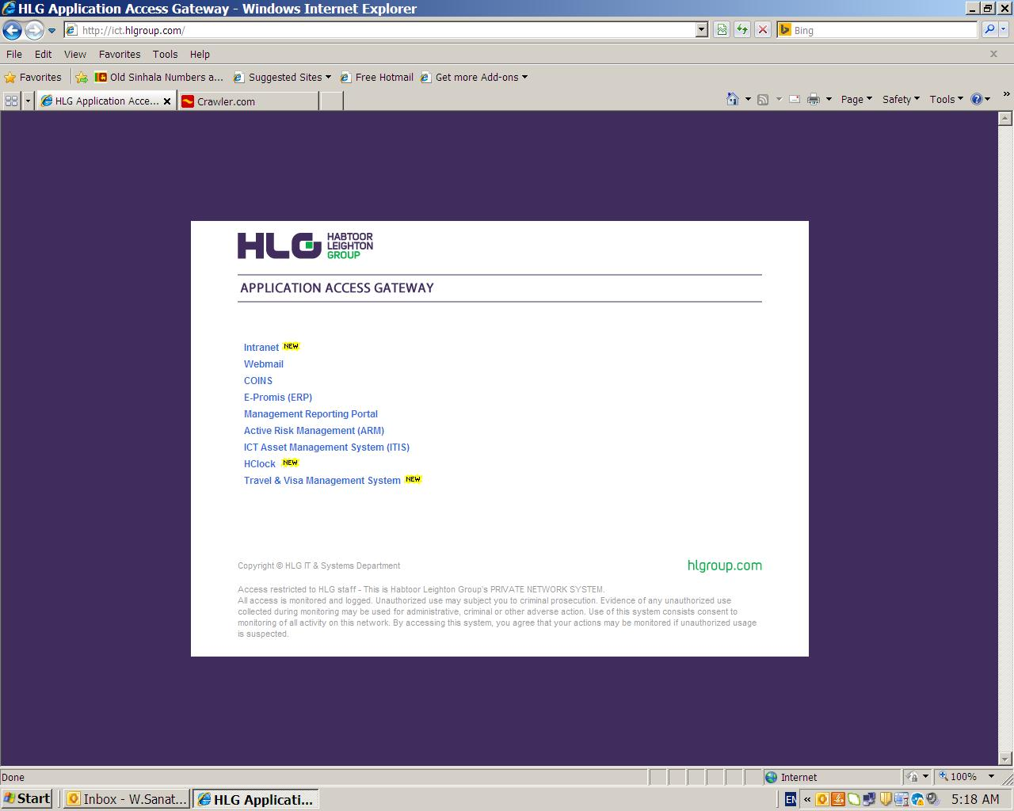
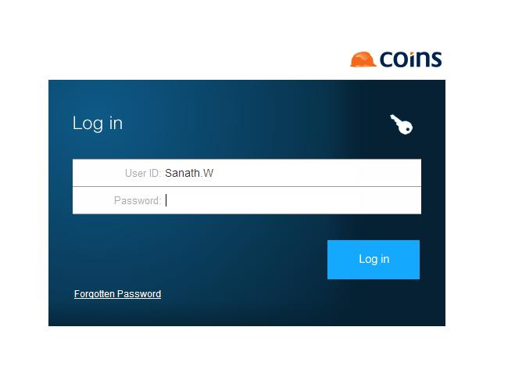
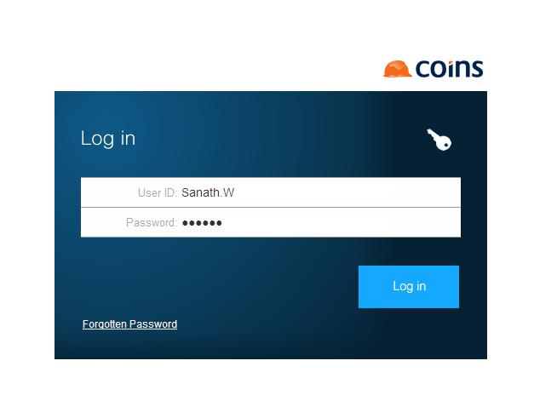
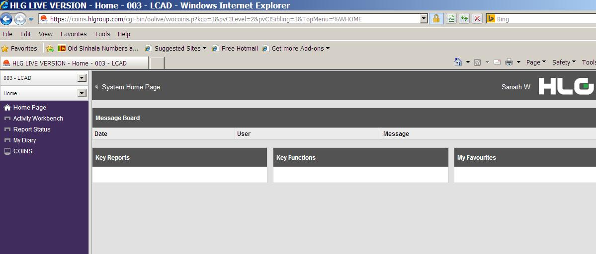
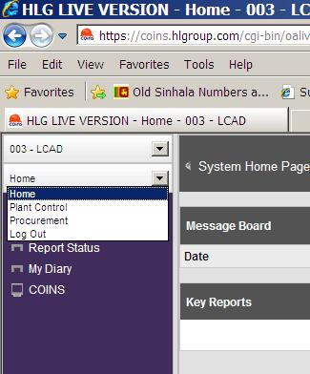

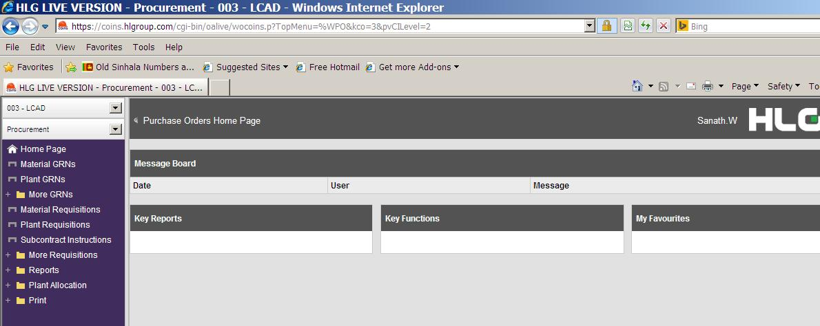
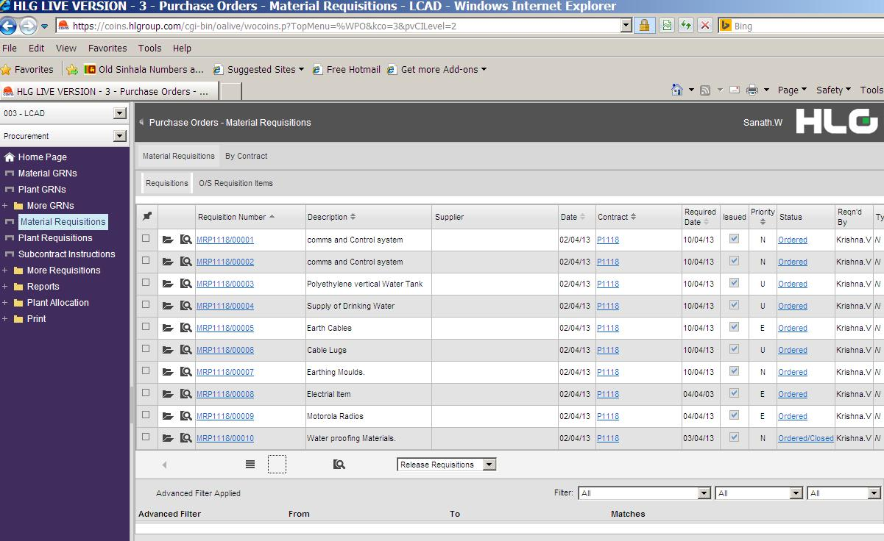
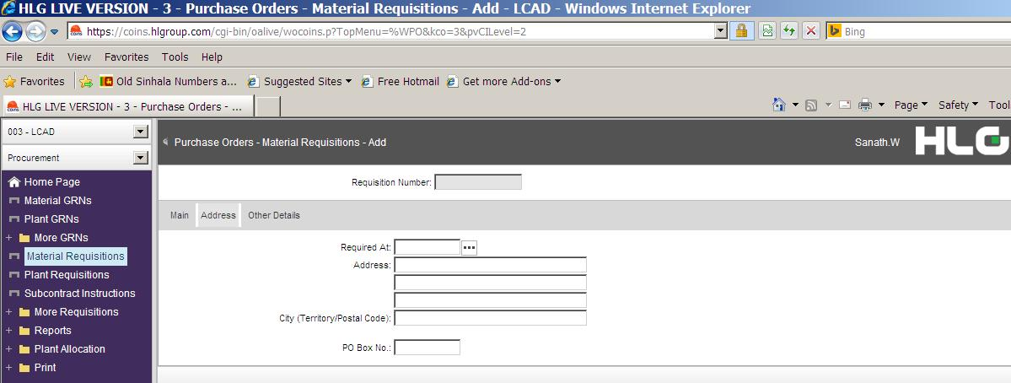

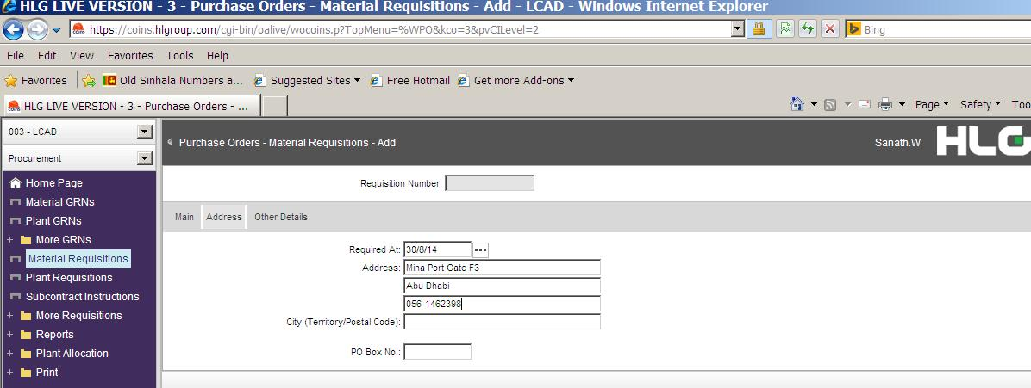
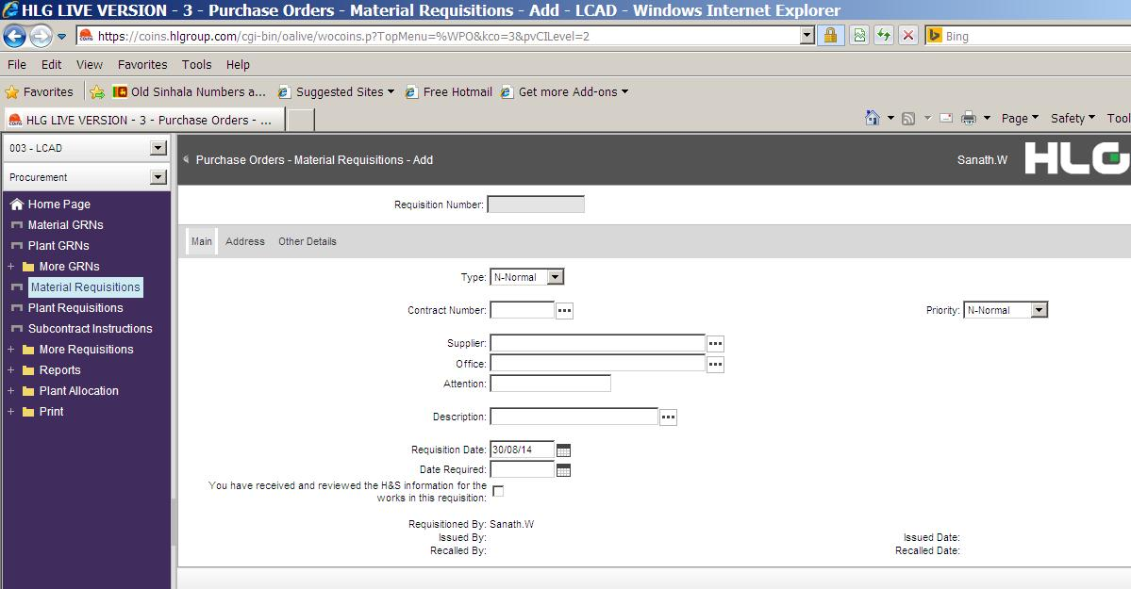

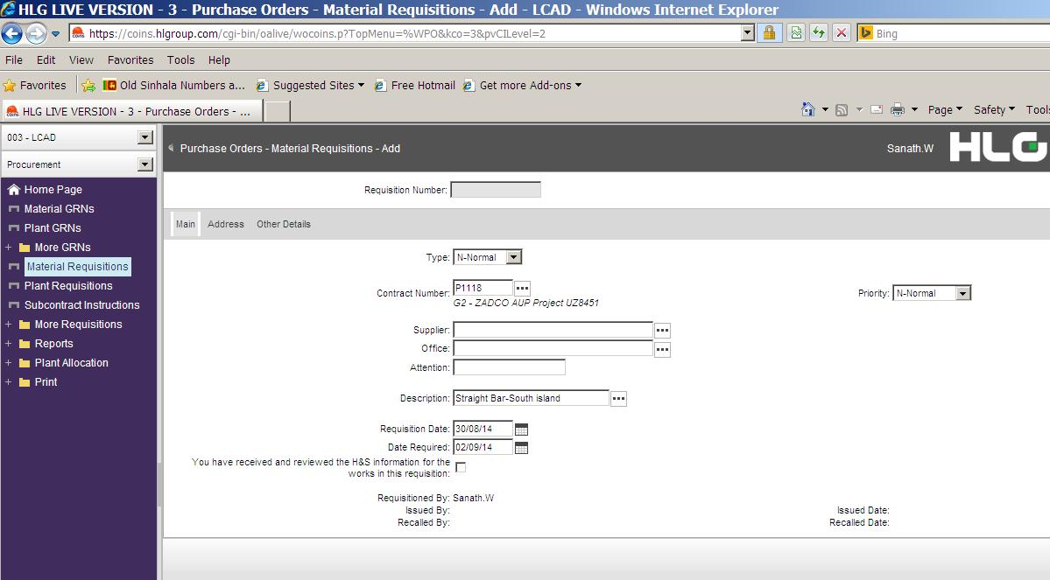

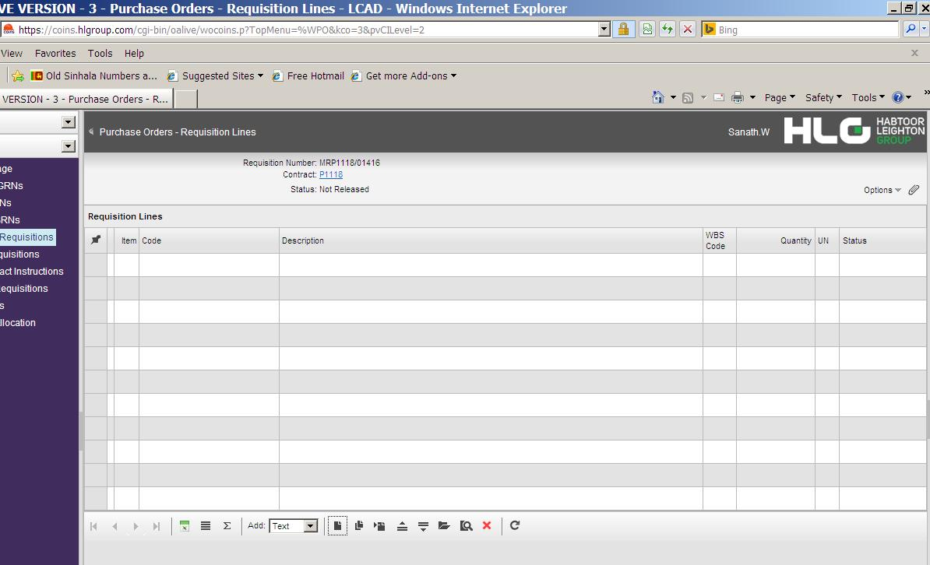
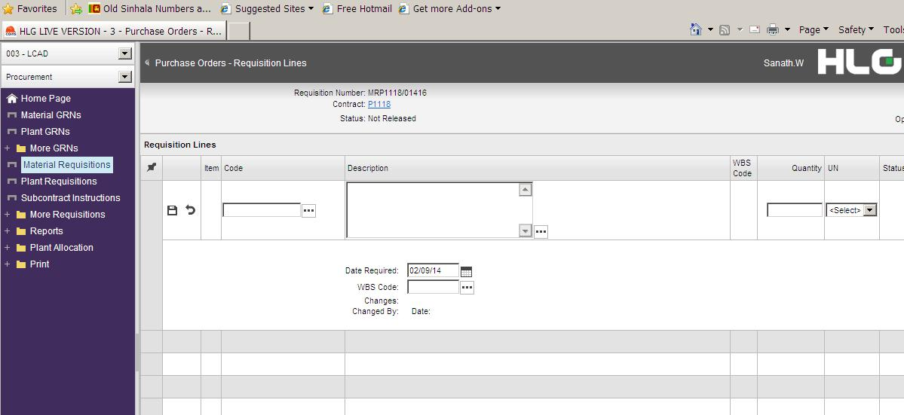
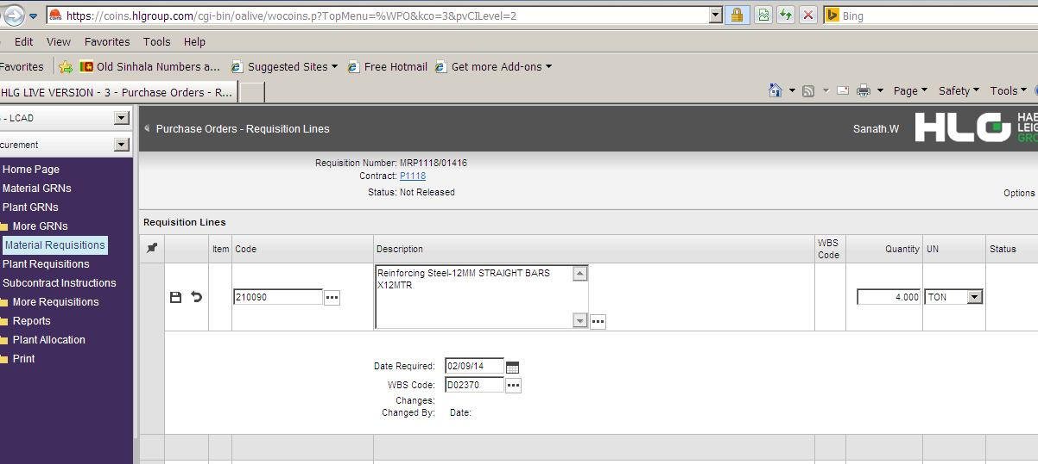
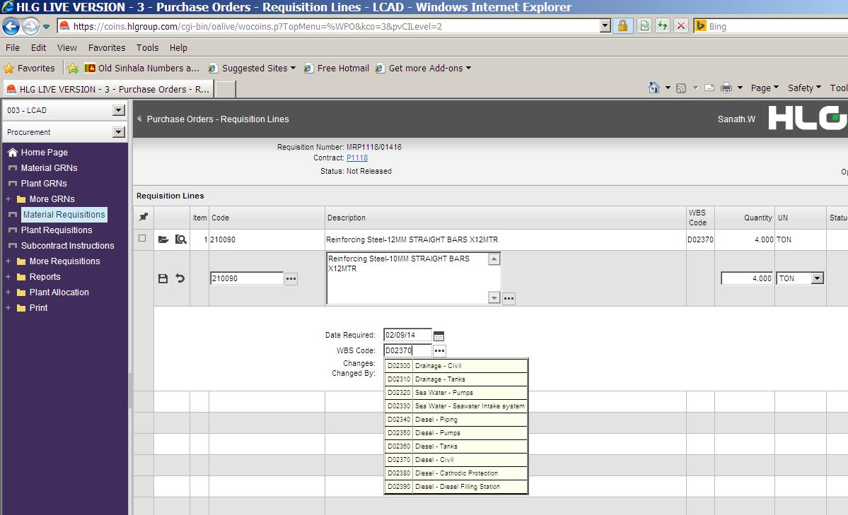
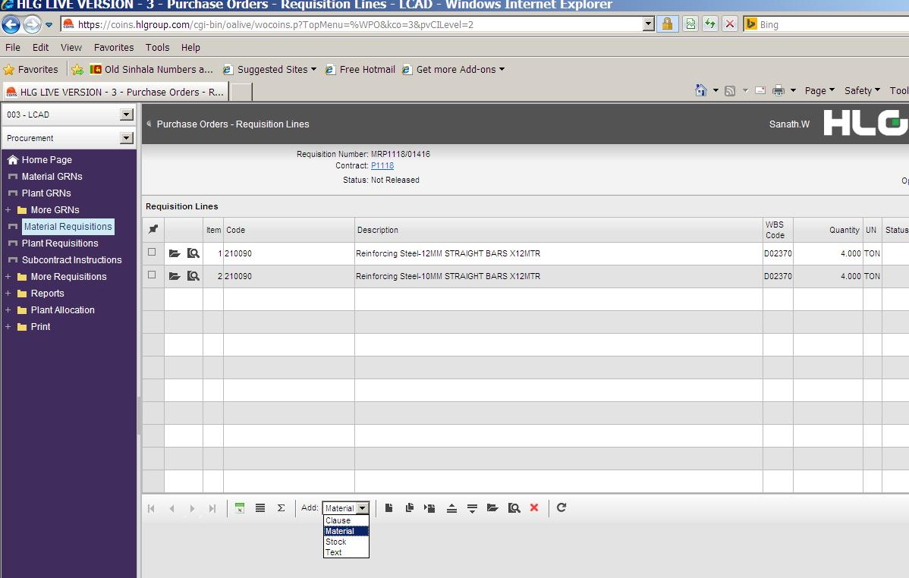

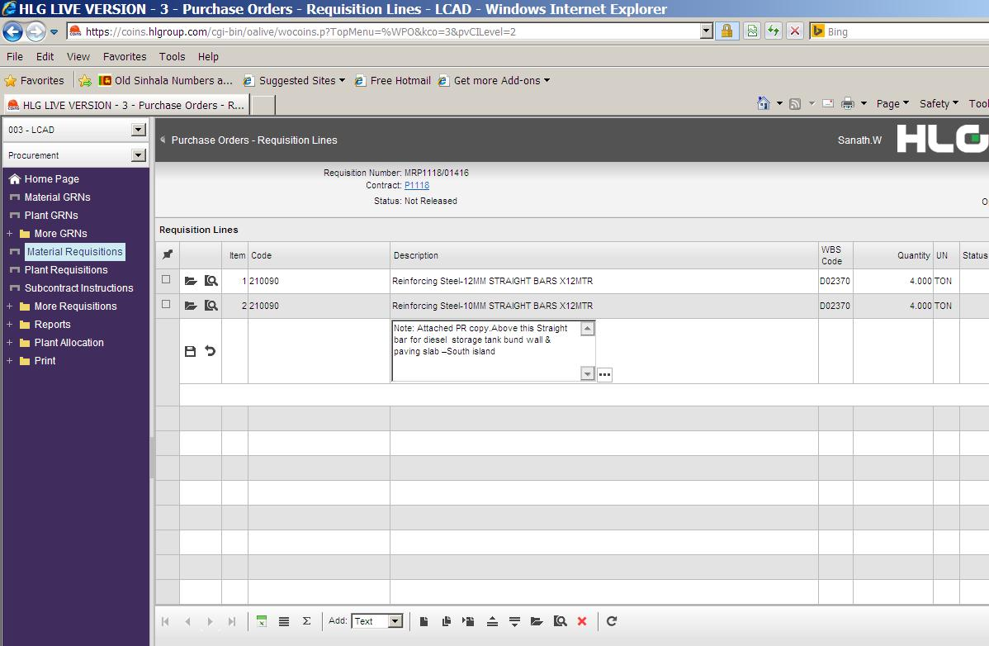
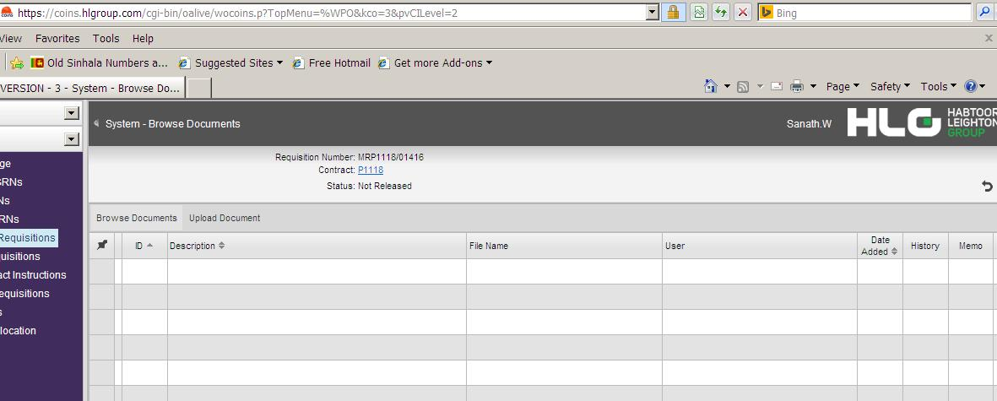
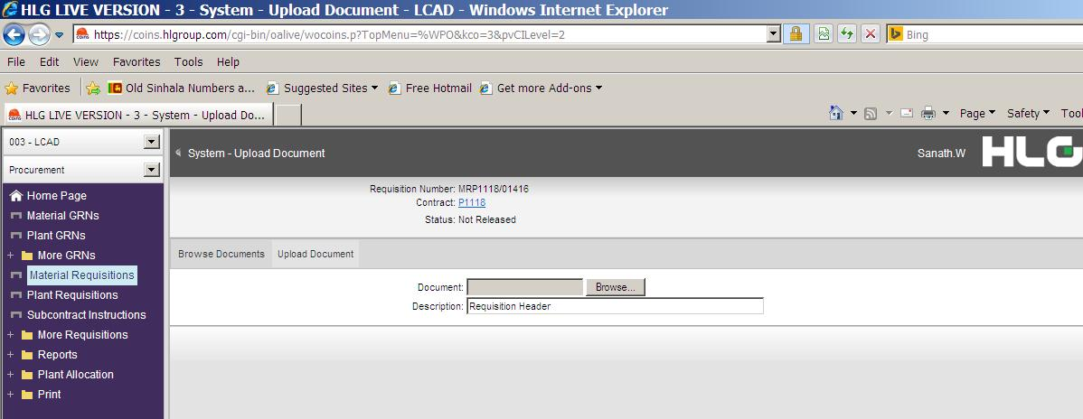
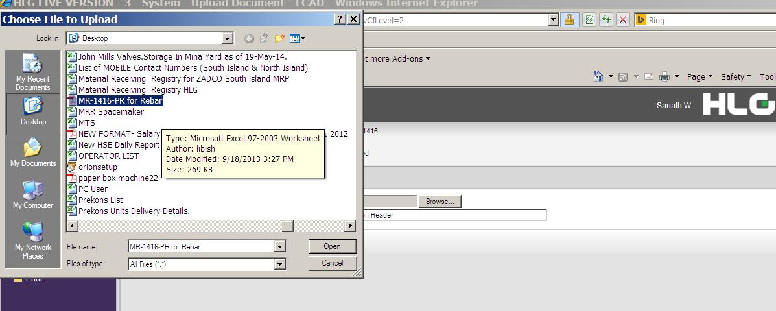
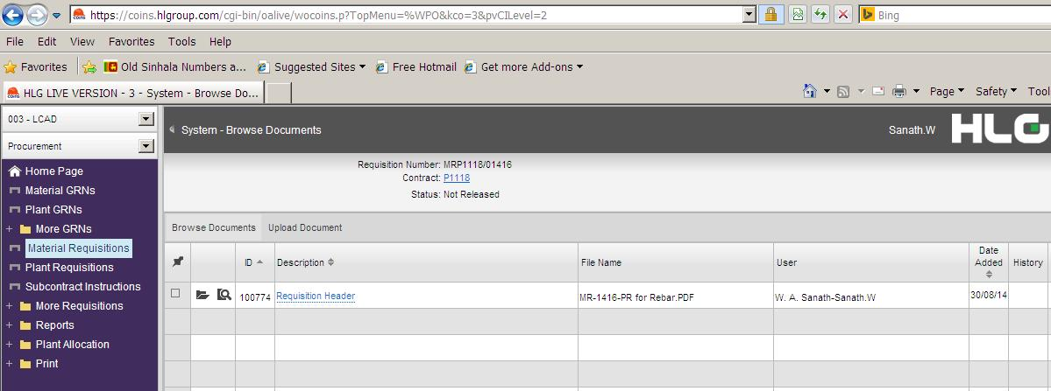

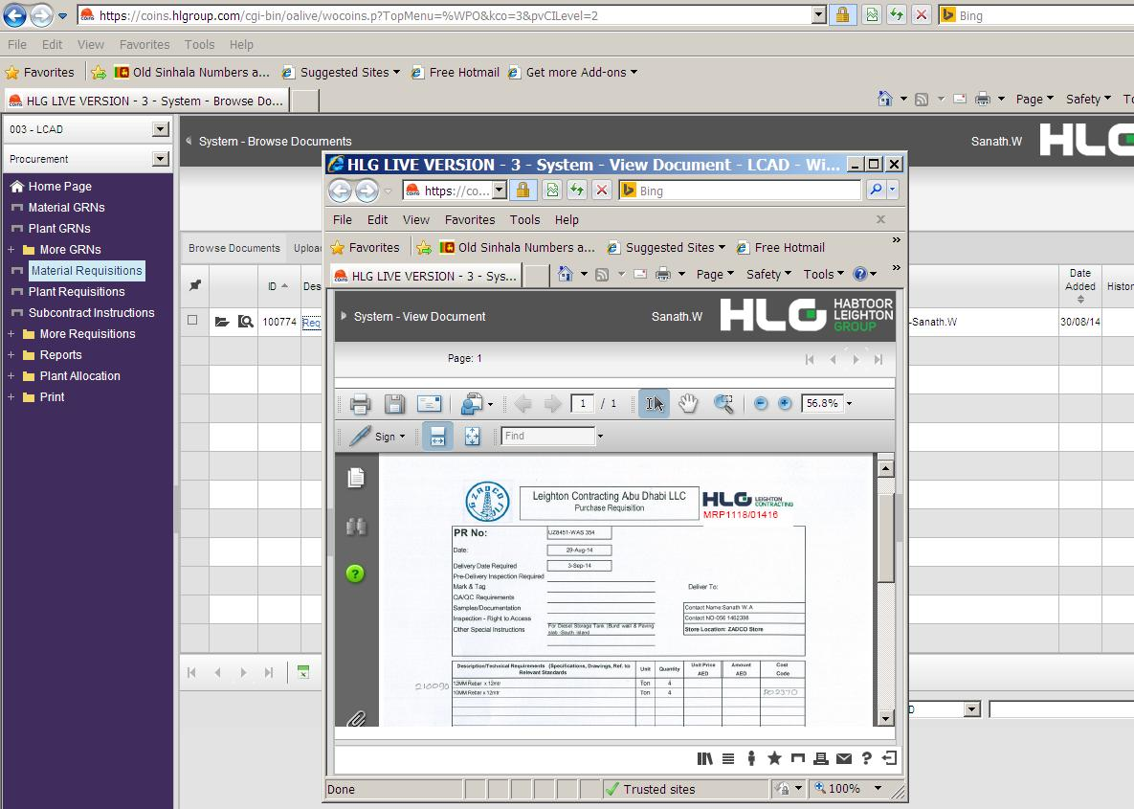
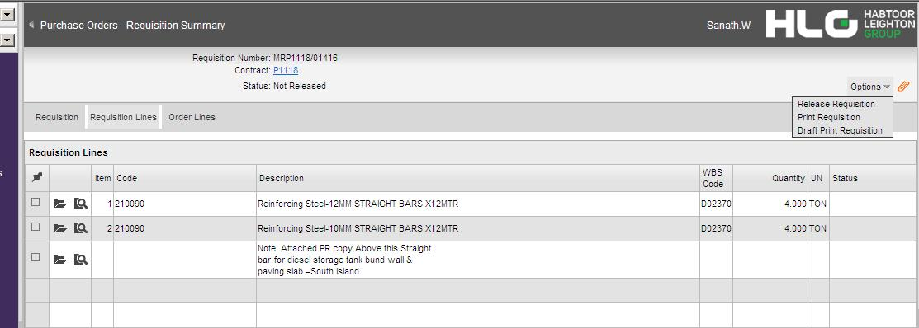

I obtained the details of this material and with the assistance of the material controller we located the material in the laydown area and confirmed the material was correct through details of the manufacturer’s test/mill certificates as well as the internal colour coding allocated for this plate.
The whole exercise was thoroughly demonstrated and persons involved professional and only a minor comment noted with regards to the laydown area used to store materials. The best management system available can only provide the front end management needed to control the purchase, procure, control and deliver but as was observed here in this instance, the limited space available on the artificial Island being constructed made laydown and material identification more difficult than would normally be encountered on projects were space availability for materials is more readily available.
Please note; these snap shots may be copy right protected and are for illustration purposes only

