
Assignment Cover Sheet

Student Name: | Omnia Rafiq
Student Number: | 1343
Course: | Diploma in interior Design
Assignment NO: | 14

Student Statement:

By submitting this assignment, I confirm that this is my own work.

Student Signature | Omnia Rafiq | Date | 4-5-2015

For Tutor / Assessor Use Only
Total Marks
Marks Obtained
Percentage / Grade

Q.1.i. How important it is for a designer to know about the function of a room before
decorating it and which questions would you ask your client as a designer to
Establish the purpose of the living room before decorating it?
- When decorating the whole house, it is necessary to look at the requirements of each space and pay special attention to individual rooms, while still maintaining common theme so that each has a sense of belonging to the larger family grouping. First, before starting to decorate a certain room, I should know what its purpose will be. Here are some common rooms and their purposes:
a. Living room: entertainment, relaxation, watching movies
b. Bedroom: sleeping, relaxation
c. Dining room: eating, entertainment
d. Home office: work, entertainment
Once the designer knows the purpose of the room, he can plan the decor around it.
Before staring working on the project , Me as a designer need to ask the client about the following questions : Would it be :
- a leisure room for quiet reading, listening to music, letter writing,
- Watching television?
- a dining room for family meals, smart diner parties, television
Supper?
- An entertaining room for family parties, video viewing, card games?
- a hobby room for dress making, arranging a sample collection and
So on?
- A work room for study, word-processing, homework, research?
- A mix of all or any of the above?
These different activities all require specialized lighting, ample storage
Facilities and suitable furniture.
- I should Investigate if any changes are expected in the family situation, such as children or teen agers going away to school or college; the arrival of a new baby; an elderly relative coming to stay; a new job requiring an amount of business entertaining or working from home part time, creating the need for study area.
- I should try to be objective: by looking at the whole area with fresh eyes, considering
size, shape orientation and architectural style of the room and the amount
Of natural light it receives. Assessing the existing furniture and storage and
Decide how efficient they are. Working out what must be replaced or
Renewed. Establishing a clear idea about the budget available. Deciding where
to put the television, or music centre because, not only this will affect the
placing of seating but it will also affect the provision of electric points and
The cable or aerial connection.
Next I will measure accurately and prepare a plan, using templates to
Fit in the furniture on paper first. Allow for opening and closing of doors
and drawers and avoid placing units and cupboards too close to other
Pieces of furniture which will make using them difficult. Once the ‘master
plan ‘is prepared I can once know exactly what I can and what I
Cannot bring in the room.
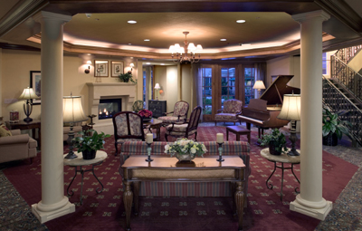

Q.1.ii. Apart from carpeting what other options do you think are available for practical
Flooring for a family living room?
Since floor is the dominant feature in the living room it should be considered first for the treatment. It gets the most wear and tear in a family living room and is likely to have to last through several changes of decorating scheme; therefore it needs to be extremely hardwearing. Besides this the floor relates to all the other surfaces.Apart from carpeting there are many other options from stripped, sanded and sealed or stained, Stencilled or painted floor boards; special wood treatments like parquet, wood strip or wood board; sealed cork tiles; linoleum sea grass or rush matting. All these floorings can be made softened with a rug in the main sitting area in front of the sofas and chairs.

Sanded floor board Stencilled Painted/stripped
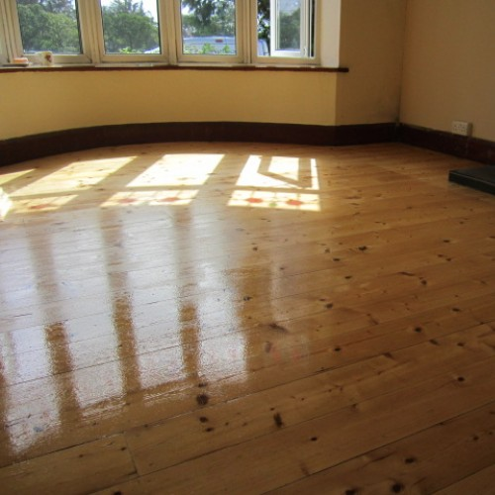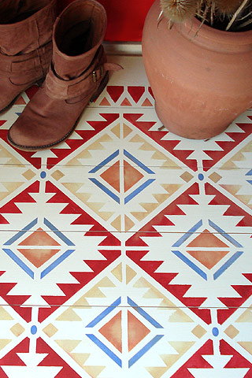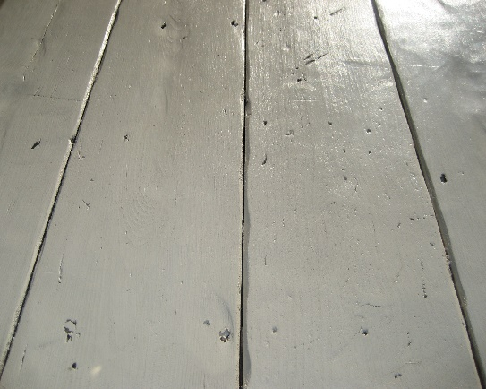
Stained floor board Stripped Sealed
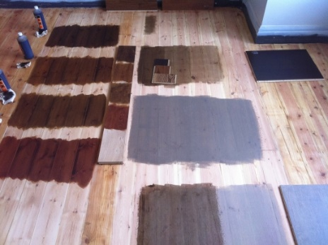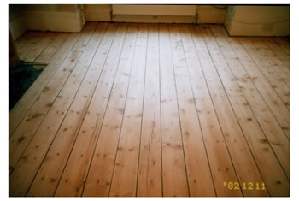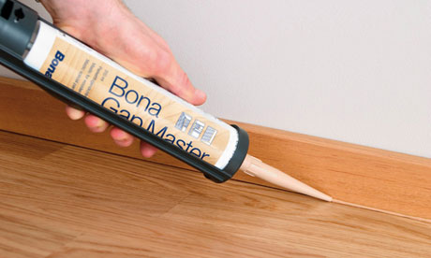
Stencilled Sealed/Sanded Stencilled
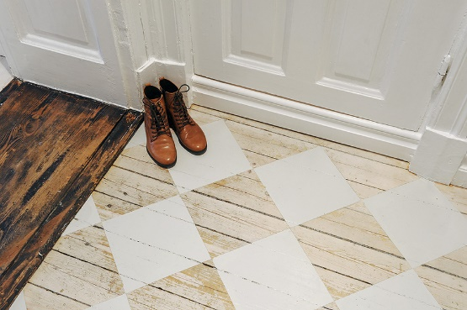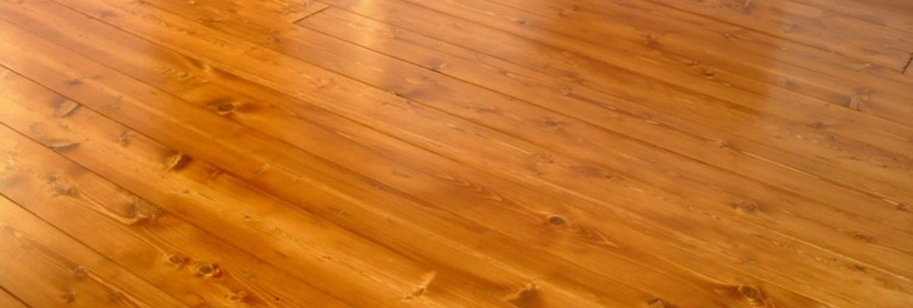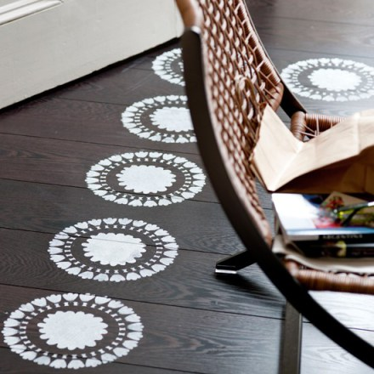

Q.1.iii. How far a well-planned lighting scheme is important for a fully functional kitchen?
One of the first things we will need to consider when planning a kitchen is the lighting, as electrics and fittings have to be installed at the start of the project, before plastering, decorating and the fitting. The key to a successful scheme lies in layering the effects, so we as designers, should try to zone the lighting according to its use - working (task), dining and mood (ambient) and creating the wow factor (feature). It's important to concentrate on all three and consider dimmable solutions for even more flexibility. Of all the rooms in the house, the kitchen demands the most care when deciding upon the lighting scheme. This is because areas used for preparing and cooking food should be well lit with spotlights or other task lighting. It is important that the light beams should direct exactly where needed and should not interrupted by shadows. Also we should ensure that the light source comes from exactly above the work surface rather than behind the person who is working. We can use ceiling fixed down lighters over the work surfaces. To create social atmosphere in the dining/ relaxing areas of the kitchen it is advisable to have at least one other circuit of lighting which can be switched on when food preparation is completed and the lighting used in the work area is extinguished. Additional soft lighting around the room could come from a combination of table lamps and wall lights.
For a good Lighting scheme:
General lighting
The term general lighting refers to the overall illumination of a room, and it plays the role of daylight – this means it’s particularly important in north-facing kitchens or small rooms with poor natural light. In a kitchen, general light should be as close to daylight as possible, so that you can tell if food is cooked properly, or if raw food is fresh. General light can include direct and indirect (reflected) light sources – for example, central pendant lights, ceiling-mounted fittings, wall lights, downlights, and up lights.
Recessed lights – such as the Double Trim with low glare AR70 Halo spot lamps – placed at intervals in the ceiling are a good option, as they light the workspace with a bright light for day and can be dimmed for mood lighting at night. A single, central pendant light – often the only source of general light in unmodernised kitchens – isn’t the best choice for general lighting as it tends to leave the corners of the room in shadow. However, pendant lights do work well hung over a dining table for mood lighting, or if they’re used to highlight a specific kitchen feature.
Task lighting
Good task lighting in the kitchen is essential to help you with food preparation and cooking. Any task lighting should be fairly bright and positioned so it doesn’t cast shadows over your working area. Task lights include directional lights, such as downlights and spotlights – under-cupboard lighting, which casts a pool of light over the work surface, is ideal. You can use a directional downlight, such as the Polestar, to great effect to bounce light off fitted cupboards, accentuating colour and creating the illusion of more space.
Mood lighting
When you’re choosing general lighting for the kitchen, if you opt for designs that you can dim you’ll have mood lighting in an instant. However, it’s also worth considering lights that pick out various kitchen features – then when you dim or turn off the general lighting, these lights will change the entire look of the kitchen. For example, if you fit Sirolo lights to the plinth of a central island they’ll throw pools of light out over the floor. And if you fit light strips to the legs of kitchen units – for example Click strip – it’ll look as if your furniture is floating.
Highlighting shelves and cupboard doors will again help turn a daytime kitchen into a place to relax over dinner in the evening. And lastly, experiment with colored lighting – for example, an illuminated splash back that turns from one shade to another. But be careful – a colorful light that’s too bright will spoil the mood.
Top Tips
- Exposed light fittings collect oily grime from cooking – always opt for recessed or semi-recessed fittings if possible
- If your kitchen has a high ceiling, fit uplighters to the top of your kitchen cabinets for general light – this will also reduce the number of downlights you need
- If you’re investing in a new kitchen, look out for items that come with built-in lighting, such as cooker hoods or cupboards with lights that are triggered when the doors are opened
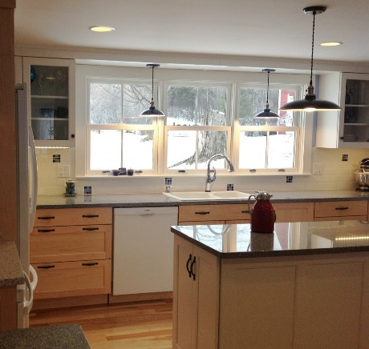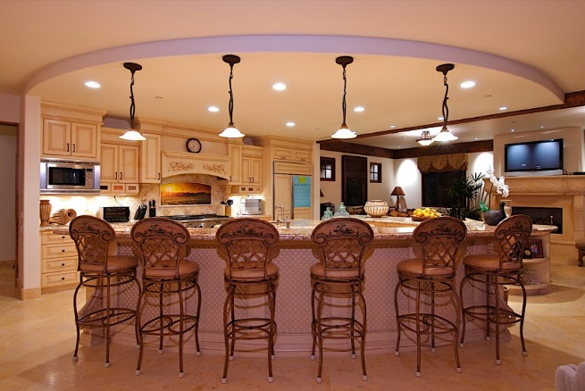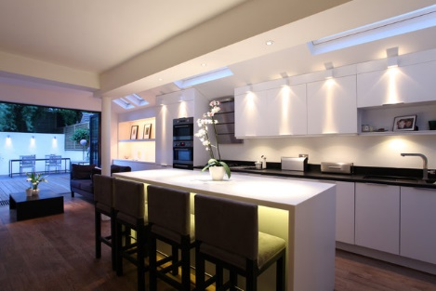

Q.1.iv. Which type of flooring is most suitable for the connecting spaces?
The highways of a home have to cope with much wear and tear. These areas suffer from the daily tramp of feet, mud, dirt and snow, therefore hard wearing surfaces should be installed in these areas. A wood floor is ideal for the hallway. This is because it has a fantastic impact on visitors when you open the front door and they see a lovely looking wood floor. However, if you choose to have a wood floor in the hall, get an outside doormat and an inside doormat, and make sure that people tread on those mats and not step over them, as if they travel dirt and grit into your wood floor, that's the same as having it sanded off and sealed.
It is worth bearing in mind that whilst a wood floor is incredibly long lasting, it is also higher maintenance and needs a lot of looking after, and refurbishment is not cheap. A wood floor will scratch, and if you don't want a floor that scratches, don't choose wood. The scratches are all part of the natural ambience, beauty, and aging process of a wood floor. A wood floor is prone to movement, but it is also unique, as it is a natural product that comes from a tree.
If a carpet is chosen it should be at least of heavy domestic quality- in a wool and nylon mixture with a hard twist or looped pile. The flooring surface should be tough and easy to clean. It is not mandatory to carpet the hall or the stairs. Also ceramic tiles can be laid - and should be further protected by installing a good quality doormat set just inside the front door. Also sealed cork tiles, studded rubber, vinyl in sheet or tile form, linoleum, which can be inlaid to create interesting patterns. Vinyl is also a popular choice for a hallway because it is very low maintenance. Vinyl is wipe clean, so all that is required to keep a vinyl floor clean is a mop. Vinyl doesn't mind water, and as the hallway is the area people come in to first with wet feet, it makes vinyl ideal. If you're worried that vinyl won't make a great first impression when someone walks through your front door then think again. Yes, you can buy cheap vinyl, but you can also buy good quality, hardwearing, robust vinyl. High quality vinyl floors are often textured, and many have an R10 rating, which means they are slip resistant. Some even come with a 15 year warranty!
But there is no right or wrong answer when it comes to the hallway – it really depends on the size and layout of your house. Wood, carpet, laminate and vinyl are all great options.
Other possible floor treatments include sisal, coir, and coconut and rush matting or sea grass matting but these tend to be too slippery when used on the stairs. The stairs themselves can be left uncovered or simply sanded and sealed, but this can be noisy underfoot and is not practical in a house with elderly occupants and young children. Otherwise lay a hard wearing carpet on the stairs up onto the landing. Stair carpets should be non-slip and must be firmly anchored to prevent accidents. One practical treatment is to use stair runner up the center of the stairway, fixed with special clips.
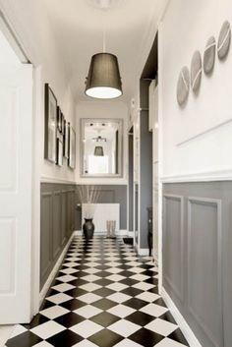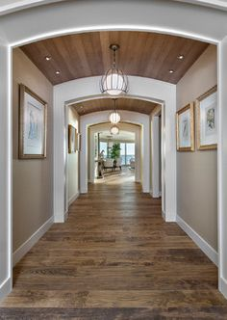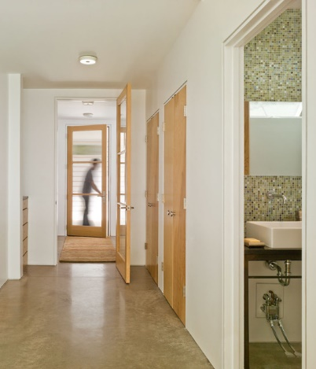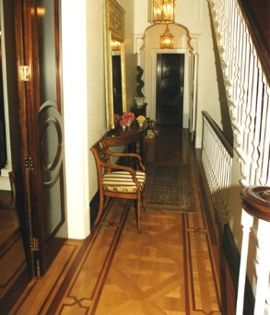

Q.1.v. How important it is to establish the visual link between the overall scheme and the
Hall ways?
We should try to link the decorating scheme so that it flows up onto the landing and then into the rooms. Also by Coordinating the colors and picking patterns which can be echoed in a different scale or used on alternative surfaces in another room. Designers must Look at companion group of fabrics, borders and wall coverings to help them mix and match schemes in an interesting way. A same colored flooring throughout further gives a sense of unity and visual link.
Here are some tips to help connect all the rooms colour design scheme :

Use a Single Color to Connect the Rooms
Using the same color in each room of your house is one way to achieve color continuity. That doesn't mean you have to paint every room with the same wall color, though you can if the color isn't too bold or intense. You just need to use that color somewhere significant in every room. The other colors in each room can vary. Consider red, for example. If you paint your entry hall red, select a red sofa for the living room next to the entry. Then, connect the dining room by laying a predominantly red oriental rug on the floor and by adding red silk shades to your chandelier. In the kitchen, mix a few red tiles into the mostly neutral backsplash and pull painted red chairs up to the breakfast table.
Use Different Values of a Single Color
Many paint chips feature a light-to-dark progression of the same color. The different versions have different values. You can use that same type of progression in your home. Painting the walls of each room with a different value is the most effective way. Though the rooms look quite different from each other, the eye recognizes the common hue and flows smoothly from space to space. You can accent the rooms with other values of that color, with completely different colors or with a mix. If you opt to paint each room with a different value of the same color, use the light-to-medium versions for bedrooms, living areas and kitchens. Reserve the darker shades for entry halls, dining rooms and other spaces where you don't spend much time. Otherwise, the darker versions may feel too intense.
Use the Same Group of Colors
The least complicated way to connect colors throughout your house is to use the same three to five colors in every room. That doesn't mean your rooms all have to look the same. You can use a different color from the group as the dominant color in each room to make them look distinct. Imagine a rust, gold and green color scheme, for example. You can paint the living room gold, which makes gold the dominant color. Choose a rust-colored sofa and accent chairs covered with a green and gold stripe. Then, add window treatments and throw pillows made from a patterned fabric containing all three colors. In the nearby dining room, paint the walls rust, cover your chair seats with gold damask and lay a rug with a green background on the floor.
Add Unifying Elements
Whichever method you use to connect the colors in your home, use some identical elements throughout to increase continuity and flow. Paint or stain all of the woodwork in the house with the same color, for example. Use the same hardwood stain or carpet color in every room except the kitchen and bathrooms. Hang all of your artwork in frames with the same finish, whether that's gilt, silver or black paint. The carving, widths and designs can vary. Repeat the glaze, stain or paint on your kitchen cabinets on the built-in bookcases in the living room.
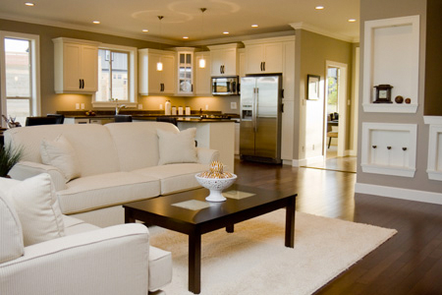

Q.1.vi.Why is it important to draw a floor plan for a room before buying furniture for it?
The layout of a room is extremely important, so we may begin choosing sizes and types of furniture after drawing a floor plan. Allowing as much space as possible for movement especially around wardrobes, counters, and we should make sure that the wardrobes, cupboards and chests can be accessed and opened easily. Second, we may List the pieces of furniture that would be required in the room. Bedside tables, chest of drawers and wardrobes are the basic choices but one need not be restricted to these conventional pieces always.
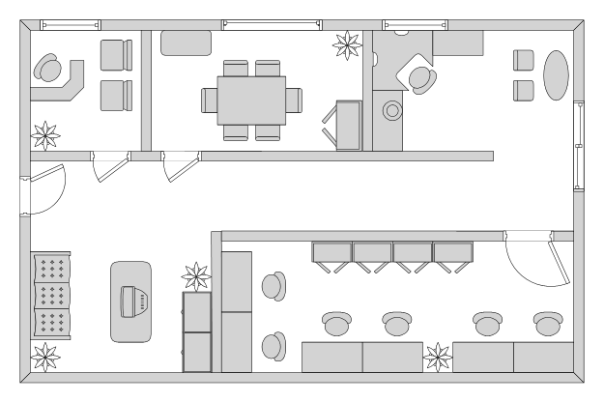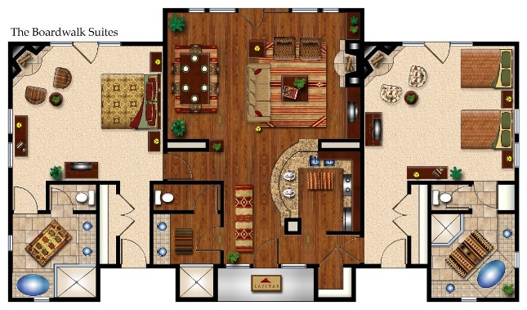

Q.1.vii.Which safety measures would you take when designing a room scheme for an
Elderly person?
Having an elderly person in a house can often benefits the whole family. The room chosen for an elderly person should always be at ground level to make the journeys easier. We should allow space for more than just sleeping. The provision of areas for relaxing, bathing, cooking and dining will allow the senior citizen to remain active and somewhat independent from the rest of the house.
- When designing a bedroom for an elderly person, a designer must choose a bed that is a comfortable height -- neither too high nor too low. If a hospital bed is necessary, a more luxurious comforter or bedspread buffers the aesthetic. Handicapped-accessible bathroom features are available through higher end vendors. Handsome, wall-to-wall carpeting provides a slip-proof covering underfoot as opposed to area rugs, which can become tripping hazards.
- Having a phone near the bed and in the bathroom is a smart idea for peace of mind. Using a retro-style phone makes the piece a designer accent as well as a functional necessity. Whole-house intercom systems are a convenient way for an elderly person to summon help. A simple, wireless doorbell can be installed in a bedroom with the button inside a nightstand drawer or to allow easy access.
- To keep noise from the kids at a minimum and let Grandma or Grandpa relax, we can install additional insulation in the walls of the bedroom, ceiling and flooring to provide both a comfortable climate and noise buffering. Drop-ceiling panels in finishes such as embossed tin allow you to insulate and decorate at the same time. Hanging a quilt on the wall introduces vintage design into a space and helps keep outside noise to a minimum.
- Installing a much-loved, familiar rocking chair and displaying treasured photos on the wall. Can make your elderly loved one feel at home. Also using Cheerful colours like a warm yellow or soft peach help give the room a warm feel.
Some of the most obvious provisions are:
- A comfortable easy to get out of chair.
- Bright lighting, walls and ceiling fixed lights plus table and floor standing lamps are suitable.
- Remember to highlight any changes in the floor level.
- Older people generally require warmer temperature than the young.
- Storage at an easy access level and with openings that is not too difficult to operate.
- The elimination of all sharp corners for safety reasons. A smoke alarm is another wise precaution.
- In the bathroom, mixer taps and controlled temperature shower system will help avoid extremes of water temperature.
- Curtains on a corded track, operated from the side, to ease opening and closing.

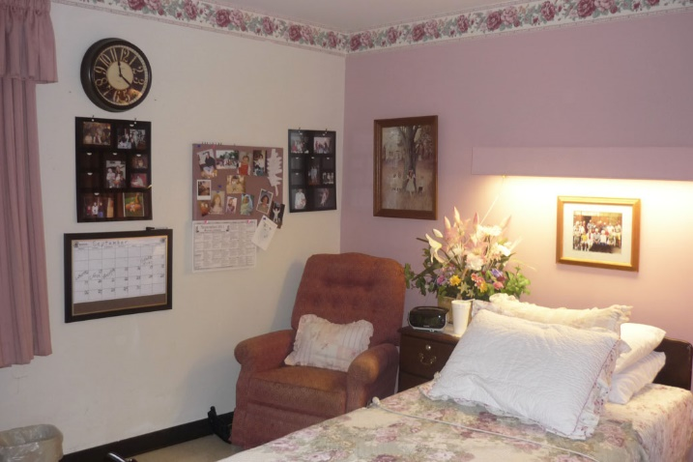

Q.1.viii.When two people have to share a room and they both have totally different tastes How will you solve the problems relating to colour, pattern etc.
This problem can usually be overcome by the skilful selection colours and patterns mid-way
between the two tastes.
- For the colours, I see that Starting with a solid white as a foundation and then adding in one basic color in both a large scale and one small scale pattern is a simple way to start mixing patterns. You can hardly go wrong. But from there, you can try getting a little more complicated by mixing in more colors and several scales of patterns. I love the look of the stripes with a large scale geometric! If you choose neutrals for their blandness, they will provide wonderful backdrop for relaxation and can be sparked up by the introduction of pretty bed linen, stylish furniture and sharp accessories.
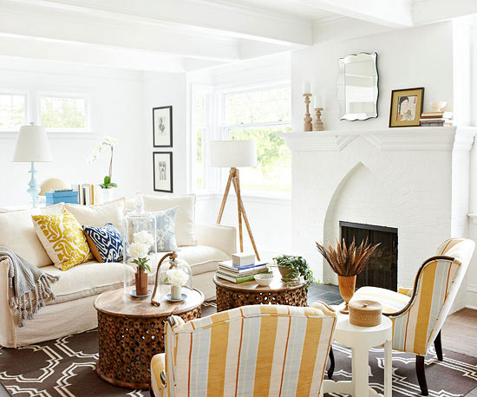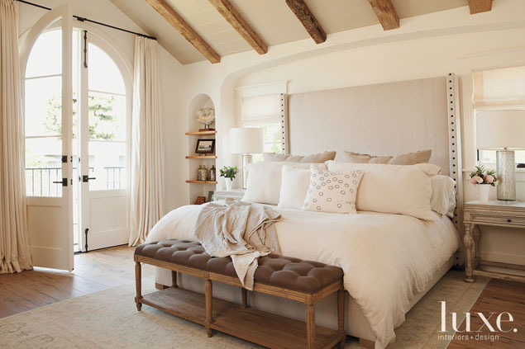
- For the patterns, The way I have to visualize patterns together is to lay everything I might want to mix together out on the floor or table before I buy. It is somewhat embarrassing to pull furniture around and grab pillows and lay out the existing fabric swatches to create my own little grouping right there on the store floor, but it really helps to visualize how things will work together. The goal for me isn’t to make it match or be perfect, just to have things look pleasant together!
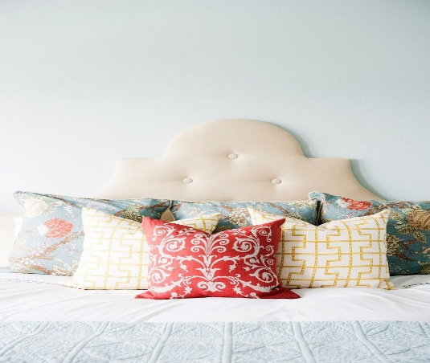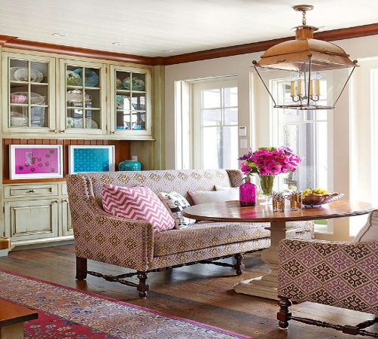

Here are some tips which could help mixing patterns to be accepted by all tastes:

1. Edit your colors. Layering patterns involves four main elements: color, scale, shape and texture. If you're like me and you fall in love with four times the amount of fabric you need at a showroom, you'll need to go through some major editing. First up is color. Lay all your possible choices out on the floor and if certain ones look a hot mess and just don't play well with others, remove them from the mix right away. It's kinda like kicking an obnoxious reality cast member off the island after an elimination challenge but with fibers and weaves versus emotions and bad behavior.
2. Add contrast. Once you have your main color selection down, add a bit of contrast. In this case, an orange geometric.

3. Vary the scale. While color and shape are easier to get a grasp on, scale is a bit more complicated. There are three different sizes of scale: small, medium and large. When mixing prints, try not to choose more than one of the same scale size; multiple patterns of the same scale often result in a one-way-ticket to Cluttersville...well, unless you're a total master like Betsy Burnham, that is. The five fabrics in this photo all fall under the small-scalecategory. Notice how your eye can't really decide which one to look at? My point exactly.

4. Note an exception when it comes to medium-size patterns. Medium-scale patterns are even more complicated since there's an exception to the rule. You can sometimes mix more than one fabric from the medium-scale category if one of them is solid and sports a shape that is more about texture than a true contrasting pattern. In this case, the blue knit fabric with the knotted braid shape works well with both the yellow/white and brown/white geometric patterns; however, those two patterns — both with similar direction and movement — do not work well together since they are pretty much the same exact size.
5. Limit yourself to one large-scale fabric design. And then there's large scale patterns. Close up, many large-scale patterns don't appear to fight; however, step back about six to eight feet and you'll notice that each is battling to take center stage. It's best to strictly stick with the "only one fabric from each scale category" when it comes to large-scale prints, unless you want each large print to look like it is eating the other...like a Tyrannosaurus Rex snacking on a Triceratops.
6. The perfect mix. We've got a small-scale pattern sporting an orange geometric, a medium-scale blue pattern which is fluid and somewhat ethnic/global and a large-scale, graphic leaf pattern. The trio is also different directionally; the geometric runs vertically, the ethnic/global runs in a zigzag like pattern and the leaf fabric runs horizontally. Now, before you spend thousands on that fancy patternedrug and super special wallpaper, whaddya say you start with throw pillows, heh? Trust me, I may or may not have had experience doing it the other way around.
- For flooring, bear in mind that whatever covering is selected,it should be kind on the feet.
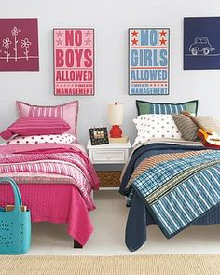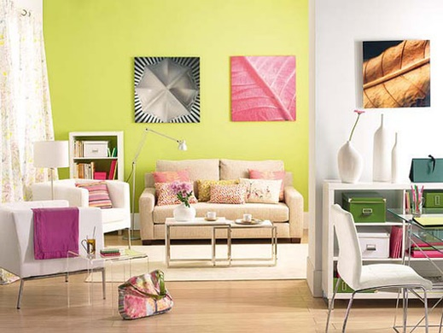

Q.1.ix. How far it is important that the ensuit bathroom scheme should relate to the
adjoining room’s scheme?
Because the ensuit bathroom is likely to be for the sole use of the occupants of the adjacent bedroom, it should be tailored for their needs without considering others. Wall paper might be considered and the bedroom carpet continued into the bathroom( with mats to protect potentially wet areas). Pictures can also be hung. Drapes around the bath might also be considered. Make sure that there is propper ventilation to avoid condensation.
If the bathroom and the bedroom are to work successfully together, their scheme need to relate, while at the same time maintaining their own individual character. An effective way of achieving this is by revising bedroom scheme in the bathroom. That is for example, by taking the
bedroom accent colour and using it as the main colour in the bathroom.
However there are some tips a designer can follow if you wish to maximise the impression of space in your ensuite:
• To make your ensuite an extension of your bedroom, choose colours that compliment your décor and tie the rooms in together.
• Darker colours are statement colours. Lighter, neutral colours are space enhancing colours. If your main aim for your ensuite bathroom design is to maximise space, choose light, bright tiles and paint colours.
• Lighting is very important too – if natural light in your ensuite isn’t possible, make sure that you have plenty of soft light sources. Multiple lights are generally more favourable than one single light, which can be ineffective and stark. Consider how you will use your ensuite – if you plan to do the majority of your grooming there, you might consider installing lights around the mirrors.
• You may like the idea of translucent walls for your ensuite – this gives privacy still but can stop the sense of being ‘boxed in’ in a small bathroom.
• Consider underfloor heating to prevent radiators taking up valuable space in your ensuite. Not only is it a space saver, it is luxurious and pleasant underfoot on 4am bathroom trips.
• Install plenty of mirrors to create an illusion of space
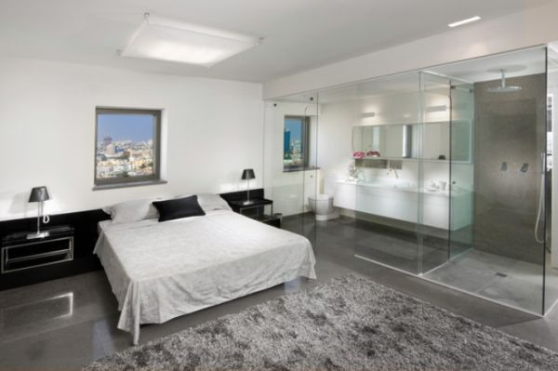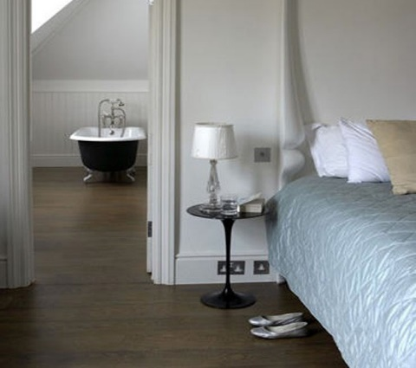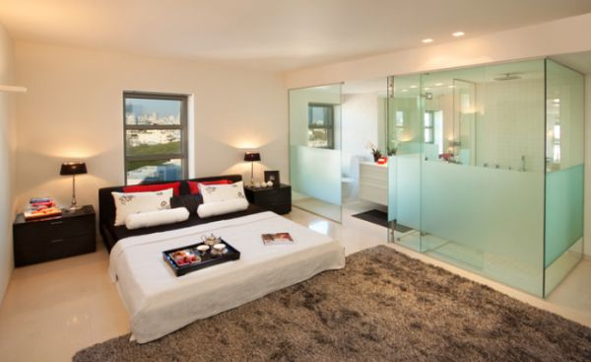

Q.1.x. Which basic equipment is usually required in a home office?
It’s important to have a designated space, preferably a room where can work in isolation, away from distractions. Having a permanent work space at home is a fairly recent development. Traditionally most of the houses did have a library which usually belonged to the male members of the family. But current trends towards freelancing and working at home have made the home office a more common element in many households.
Basic items of equipment: Definitely you’ll need a desk for your home office (large enough to hold a computer and still leave enough room for a desktop work space), ergonomically designed chair, storage equipment, such as shelves or filing cabinets, To deal with those once-yearly chores, such as income taxes, and whatever daily crises crop up, you have to have a filing system that allows you to lay your hands on exactly whatever piece of paper you need. Also telephone, fax machine, computer, reference material and desk lamps. and an office chair. Whatever other home office furniture you need will depend on how much equipment you have and what kind of business you’re running. If you have a printer and or fax machine, for instance, you’ll need stands for them. If your business involves meeting with clients in your home office, you’ll need some attractive chairs and perhaps a coffee table.

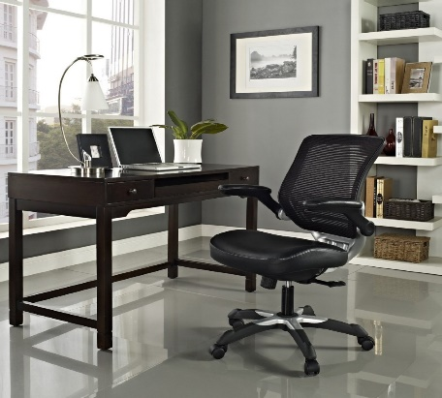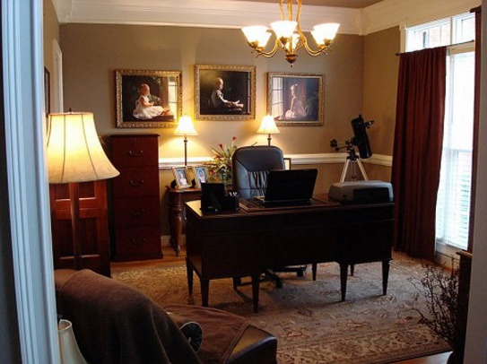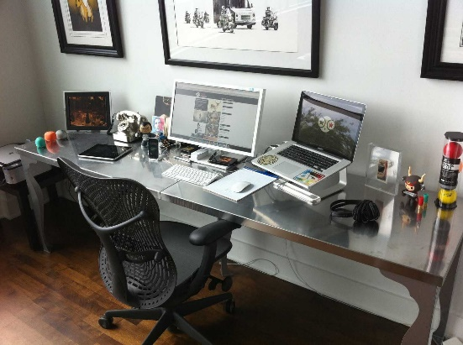

Activity

- List things that you have in your bedroom and also list things that you want to have? Measure your bedroom and convert these measurements to scale.
- Things I have:
A bed with a small cupboard below, A double seat sofa, A small dresser with a mirror, A large window with pretty curtains, A simple desk with a comfortable chair, cabinet with small drawers, One diced floor cushion in the corner with a small low end table beside.

- Things I would like to have:
- Some recessed lightings (spotlights), beside the halogen lamps in my room.
- Some soft small pillows on my sofa which will make it more eye catching
- I’d love to hang on some wall art like framed fabrics with lovely looking patterns!

- My room to scale 1:100, using metric units:
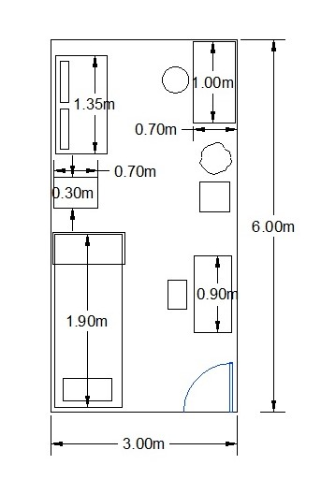

- Do you have enough storage space in your bedroom?
Due to the small area of my bedroom, I’ve been using some multi-functional furniture, which can be well used for its storage space beside its main function. For example, my loft bed, with small cupboard) closet) below.
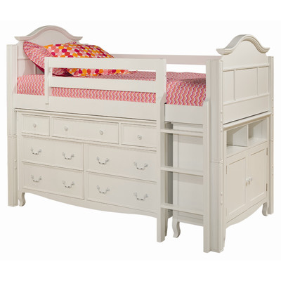
Another multifunctional thing I’ve got, with storage space is my double seat sofa.
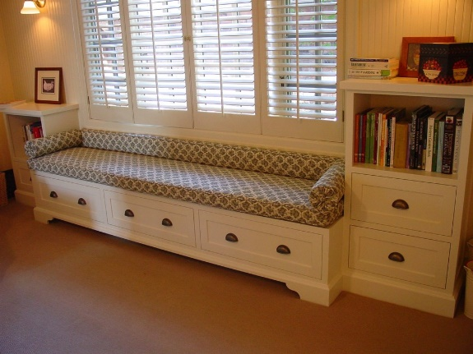
Also I have a counter with some small drawers in it. So, I think the storage is enough in my room in comparison to its size!
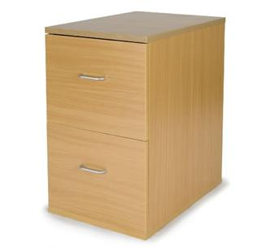

- If you are asked to create some more storage space how would you manage to do this?
If I have to create more storage space in my bedroom, First thing I would think about, is my desk, I would have changed it with another one with double sided drawer cabinet below instead of my desk whose below space wasn’t used properly !

My desk The desk I would have used!
