ELIZABETH ABIDEMI AKINLABI

1380

ASSIGNMENT 6

DIPLOMA IN FASHION DESIGN

ELIZABETH ABIDEMI AKINLABI
1380
ASSIGNMENT 6
PAGE 1

Q1. Give short answers for the following questions:

- How is formal balance achieved in dress designing? Formal balance is achieved in dress designing, when both sides from the centre point are identical, the decorations, design, sleeves and many other parts of the garment must be the same on both sides to achieve this form of balance in dress designing.

How can harmony be created in a design? The
fashion designer can create harmony in design by
ensuring the garment being designed suits the
wearer, flows where it is supposed to, moves with
the body of the wearer of the garment, is
comfortable, carries out the functions it was created
for, for example the function of a boiler suit is
different from that of a miniskirt. “Shapes and
spaces” are to be taken into consideration, from the
cut of the neckline, to the shapes and positions of the
pockets, zips etc as this aids the designer in
achieving the ‘total look’, from the embellishment or
decoration of the fabric, to the hairstyles, accessories
like sunglasses, neckerchiefs, bracelets etc, by taking
all these into consideration along with the occasion
the wearer is intending the garment for, the climate
the outfit will be worn in, the size, age, gender and
other factors, overall the personality of the wearer
and what the look is trying to communicate, rockstar,

ELIZABETH ABIDEMI AKINLABI
1380
ASSIGNMENT 6
PAGE 2

executive, artist etc the fashion designer can then
create harmony.

- What is the relationship between the principles and elements of design? The principles of design are guidelines that aid the fashion designer in implementing the elements of design. To properly create beautiful and functional garments the designer needs to understand that the elements of design, line, shape, color and texture cannot be used in their proper forms without understanding the importance of the principles of balance, emphasis, harmony, proportion and rhythm guiding them on how to combine them for optimum expression in truly artistic expressions of garments. The designer must respect the ying yang relationship of both the elements and the principles.

- Describe at least 3 ways for creating rhythm in dress designing?

Rhythm through repetition; this way of creating rhythm is by repeating a design, be it in the motifs of the same shaped edges, the use of colors to create an interesting and rhythmic pattern, trimmings,
ELIZABETH ABIDEMI AKINLABI 1380
ASSIGNMENT 6
PAGE 3

textures etc. The use of repetition can also affect the sensibilities of the wearer and the observer, for example, repetition of a design with jagged sharp lines, gives a sense of drama and excitement, while a design with flowing, wave like lines, gives a sense of calmness.

Rhythm through progression; this way of creating rhythm is when gradation is involved, this is when design elements are gradually reduced and increased, the use of small to large shapes or large to small shapes, dark to light or light to dark are utilized, it can also be created by manipulating fabric, creating textures, coarse, crimped, gathered etc. By properly placing the designs in a graded fashion, progression is achieved, creating fluidity in the garment.

Rhythm through radiation; This is rhythm that is achieved by creating movement in the garment, through the bursting outward in all directions from a center point, while utilizing folds, lines, pleats to achieve the effect.

Q2. What are the principles of design? How do they help a designer analyse the effectiveness of a design?

ELIZABETH ABIDEMI AKINLABI
1380
ASSIGNMENT 6
PAGE 4

The principles of design are: Balance, Emphasis, Harmony, Proportion and Rhythm.

As a fashion designer, comprehending the use of the principles of design is imperative, a first sketch is made and built upon, being aware and able to utilize these principles the designer can create a garment which retains it’s artistic expression, is very attractive and yet still functional. The designer can
also discuss on why and how the garment was created, these principles which are ‘specific guides’ also aids the designer in predicting the quality of the design, in the sense that what the designer is creating, whom the designer is creating it for and when this creation will be worn can be decided on and created based on these solid principles. Which in turn also saves time and resources and leads to less corrections in the production process, this is how the effectiveness of a design can be analysed using the principles of design.

ELIZABETH ABIDEMI AKINLABI
1380
ASSIGNMENT 6
PAGE 5

Activity:

Find pictures of some dresses from fashion magazines. Describe the beauty of each in terms of line, silhouette, shapes and spaces, color and texture (fabric, pattern and trims) as well as balance, proportion, rhythm and emphasis. Do all elements and principles work together harmoniously? What elements dominate? Find two garments that you feel are unsuccessful. Analyse them in the same way to discover what element or principle has not been properly used.
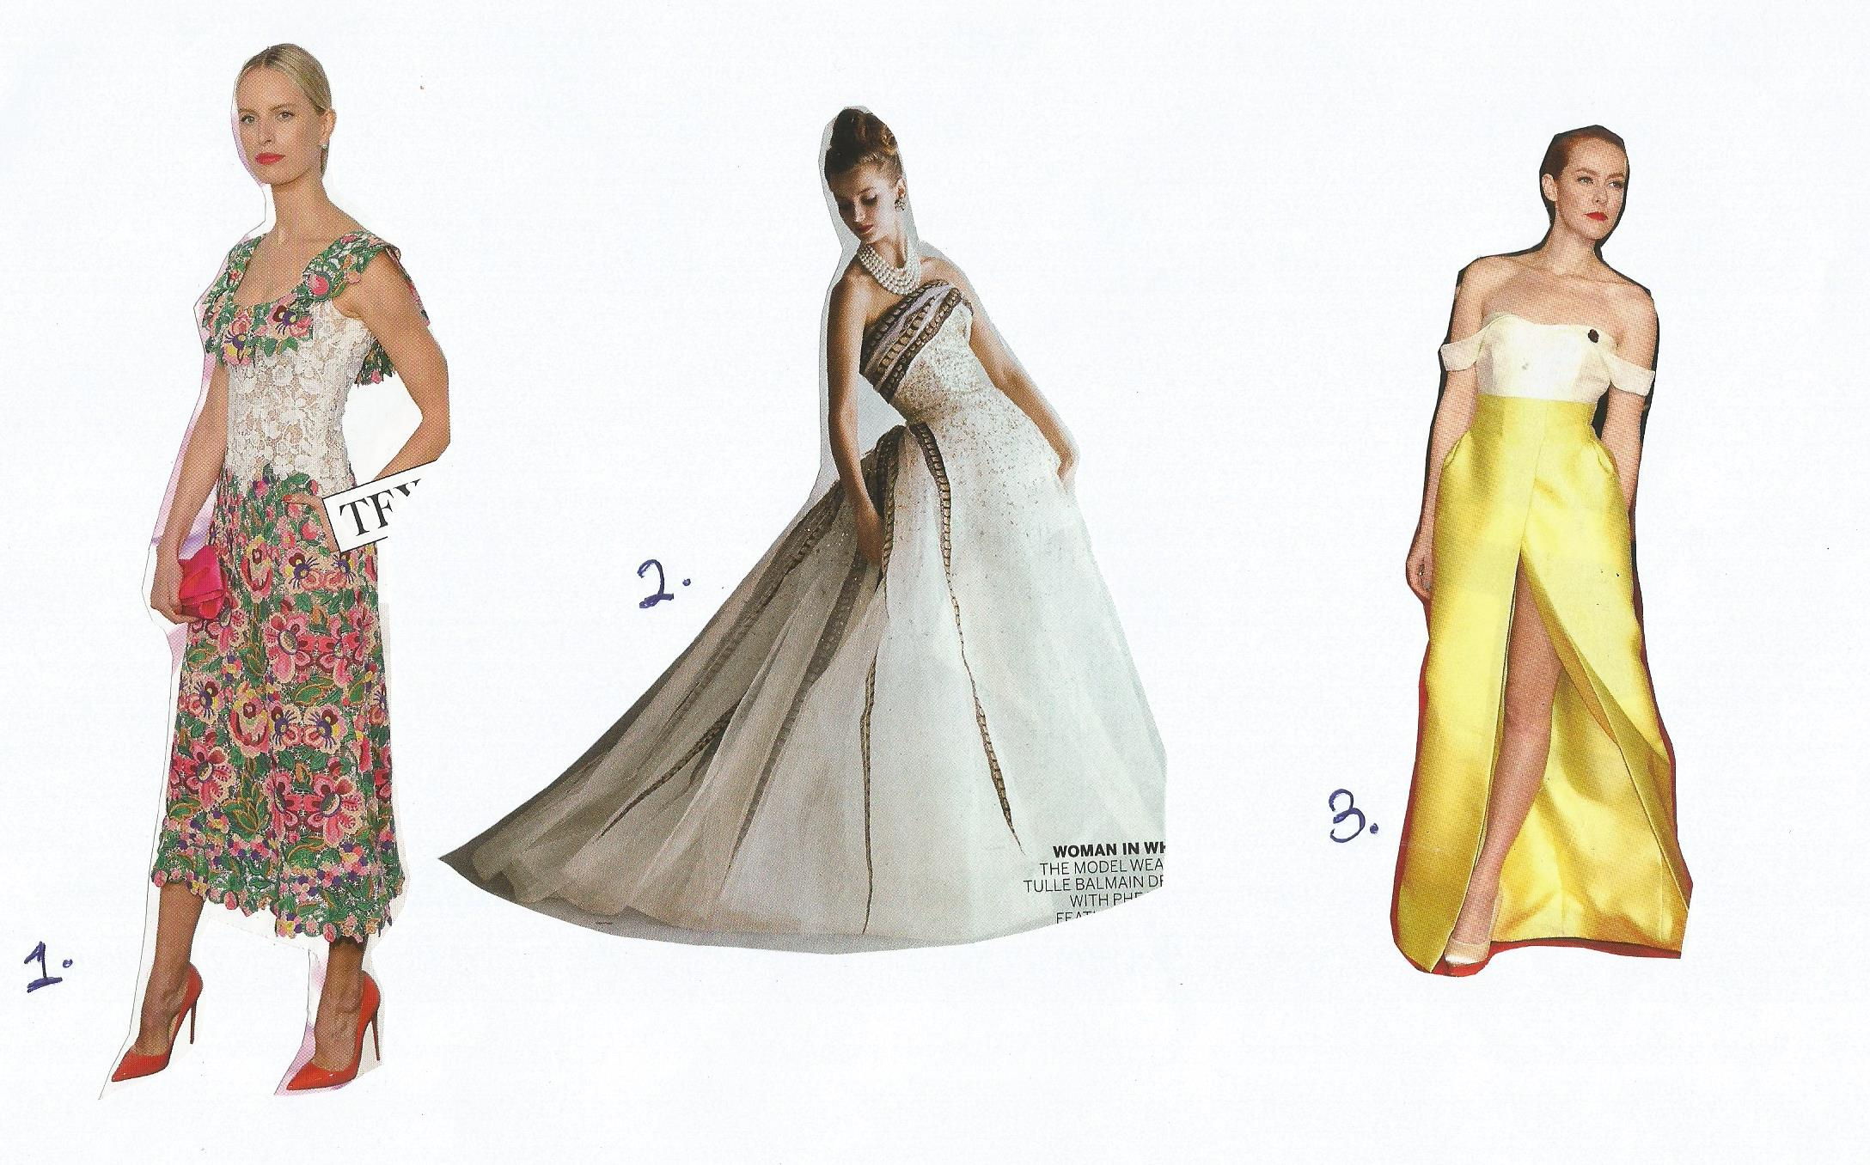

ELIZABETH ABIDEMI AKINLABI
1380
ASSIGNMENT 6
PAGE 6

Dress no 1; this dress will get you noticed with its playful colors of a naturalistic design. The refreshing green balances out the variety of colors with warm highlights, rhythm is created in the repetition of the florals. The neutral bodice joins the little drape of floral textured fabric with that of the skirt, creating balance and harmony. The texture of the embroidered flowers moves the eyes downwards, as the subtle A line of the skirt gently sweeps outwards and gives the illusion of wider hips which do very well with the wide neckline, the length of the dress is perfect and the hem is cut around the shapes of the floral motifs. I especially like the swept back hair, almost severe with the simple earrings. A styling opposite of the playful flower designs, the look is harmonious and attractive.

Dress no 2; This triangle shape off shoulder ball dress is quite beautiful as your eyes are led to the designs on the bust, the lines of trimmings in a pulled together fashion adds volumes and creates Emphasis. Rhythm is created as the surface embellishment is fuller on top and slowly becomes sparse; this guides the eyes downwards towards the skirt. The trimmings create lines and space, which gives length to the wearer, these decorative lines flare out with the fullness of the skirt, giving the garment a personality of it’s own. The piled high bun works very well with this dress, as delicate shoulder
ELIZABETH ABIDEMI AKINLABI
1380
ASSIGNMENT 6
PAGE 7

-s are displayed.

Dress no 3; emphasis is created by the line the slit makes, it’s position and length, does a great job in elongating the wearer and draws attention to an attractive part of the wearer. The off shoulder garment is well structured with clean lines creating a long silhouette, the color progression softens the lines of the dress, the cut at the waist flatters the wearers figure, the darts and texture at the hips creates the effect of fuller hips. This design achieved its purpose and is further complemented by the fact that the wearer did not accesorise, giving the garment the attention it deserves.

ELIZABETH ABIDEMI AKINLABI
1380
ASSIGNMENT 6
PAGE 8

Dress 1 Dress 2

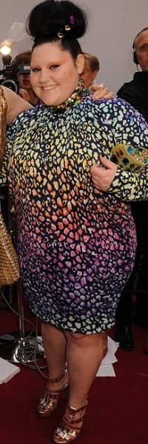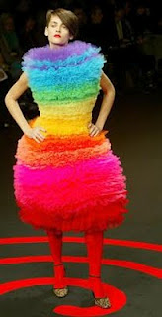

ELIZABETH ABIDEMI AKINLABI
1380
ASSIGNMENT 6
PAGE 9

Dress 1; a sense of confusion is communicated with this design, the jeweled purse and high neck collar creates disharmony. The shape of the dress makes the wearer look shorter and the length of the sleeves cuts her hands, making them look shorter, and this is emphasized because of how the pattern draws your attention towards that area. The upside down triangle shape was not achieved.The warm colors used in the design of the pattern design, yellow around the bust and orange around the waist, only works to broaden the wearers’ bust and midsection, creating imbalance and a lack of the proper use of the proportion. This look is not harmonious.

Dress 2; This dress is not easy on the eyes or the sensibilities of the wearer, the blend of various colors in different hues, cool to warm, neon and red paired with red tights does not flow, the shape is not very flattering and the fluffy texture creates an unnecessary volume that creates imbalance. Which also distorts proportion. There is a disconnection from head to toe. The functionality of the garment is questionable. I believe this design is unsuccessful.

Reference: Google, vogue.

