
Assignment Cover Sheet

Student Name: | Annur Zara Liyana Othman
Student Number: | 1227
Course: | Diploma of Fashion Design
Assignment NO: | 11

Student Statement:

By submitting this assignment, I confirm that this is my own work.

Student Signature | 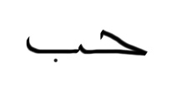 | Date | July 13th 2014

For Tutor / Assessor Use Only
Total Marks
Marks Obtained
Percentage / Grade

The Design Process
Unit 11
Assessment 11
1. Discuss in details how the designers work?
In order to create a good design, there are few step and things that designer always do.
Generating Ideas in Context
Designers use their imagination and perceptions of the relationships between garments, styles and the current situation of fashion not just to evaluate their designs but also to producing only appropriate designs. They also actively control their context; the sources of inspiration in their immediate environment in order to provide appropriate elements for these designs.
Memory and Idea Generation
Designer tends to get their design idea from what they see (visual influence). From the nature such as trees, ocean, ground or even sky to the modern thing such as building, build landscape and so on can influence and give the design idea to designer. So from this memory of this idea, they will combine, manipulate and transform the objects, features and properties they have to create a good design.

Strategies for Guiding Idea Generation
Designers have many ideas in their memory. So they use some strategies make a large number of design by the guiding it while designing.

c) Fashion Research and Range Planning
In designing for a certain design in the particular season, designer should know about what the trend on that time or the style that didn’t come yet in the past. They begin with an awareness of current fashion trends, giving an indication of proportions, styles and overall appearance. They also analyze what style that failed before and find out what they have to improve in their new design. Designer also should know their competitors in order to be competitive in the fashion industry. Designer start to work on their new design 2 years before the collection arrive to the store. Within this time designers will work closely with the fashion forecaster to get know what the future trend going to be. They also will check the magazine, certain fashion show and et the fresh idea before produce the collection. Since most of the designer go to same fashion show, read the same magazine so their source kind of look alike. When the season comes and designer’s collection arrive the store we can see many similarity in design or style between many designers.
Over all, from the information above, we can see how designer work to make their every new collection. Of course the design team gives a big hand to help designer produce a good collection that soon will be a fashion.

2. "A fashion storyboard is a summary of your collection's inspiration and theme. It is a design tool that will help you remain focused and consistent as your line develops.” Discuss
Fashion Storyboard is an industry inspired method of displaying original designs. The best storyboards create vivid visual images that are interesting and appealing to viewers. The story board “tells the story” of the designer’s idea. The storyboard includes original illustrations and flats, as well as additional materials (such as photos from the Internet or magazines, paper, fabric swatches, patterns, etc.) that have influenced the unique design. The purpose of the Fashion Story is to create a Story board of their original design. It also create responsibilities of a fashion designer and illustrator, enhance creativity and originality, and develop visual communication skills. In other word, a fashion storyboard is a summary of your collection's inspiration and theme. It is a design tool that will help you remain focused and consistent as your line develops. After displaying the ideas from many sources, designer will know what they are designing and they will design base on that. Imagine if there is no story board. Designer will easily change their idea while designing. The result is, they will never have the same outcome from the original ideas. This is how the story board help designer remain focused and consistent as their line develop. Along with the name of the collection a brief write up indicating the mood of the collection/line is given in the board. Inspiration source could be any entity the designer feels in accordance with the forecast. Later, key words are generated to formulate the styling of garments. Continuing with one of the above example- calligraphy, key words like curvaceous, smooth, feminine elegant, bell shape, continuous etc. fit the line. Also by doing this, they will see if the design is good or not because it display nicely and neatly.
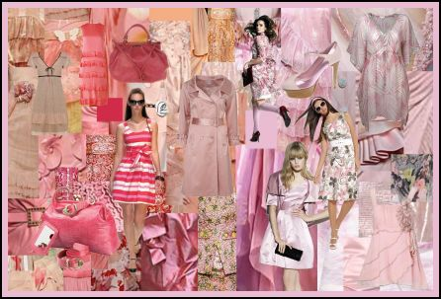
The example of a fashion story board that also show the same colour tones.

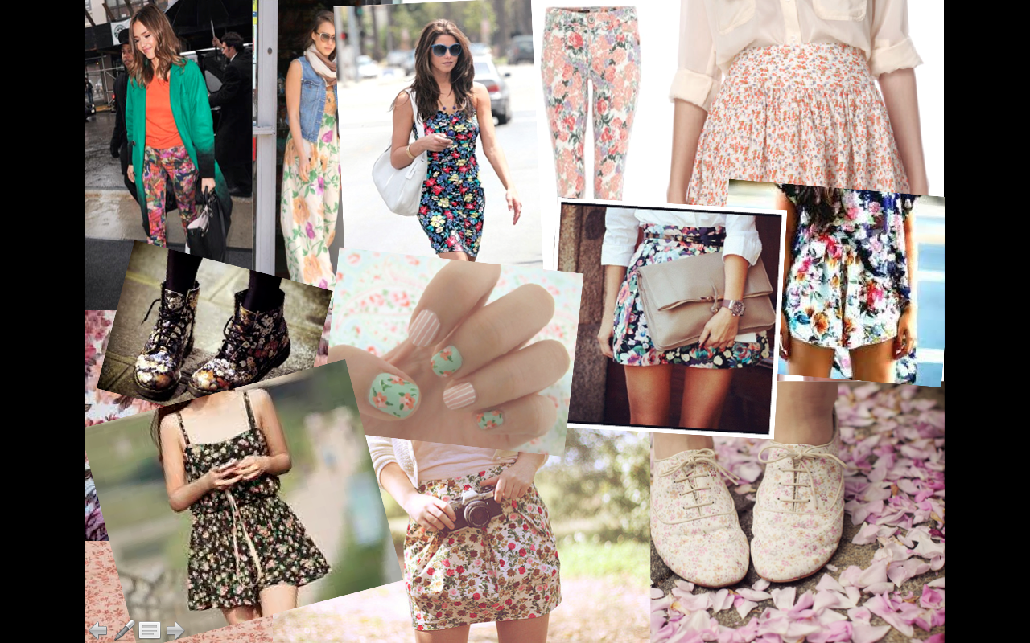
The example of fashion story board that collected a spring look.

Overall, the fashion story board is important for designer to present their idea visually and it will hold the designer with the main idea while designing a certain collection.

3. What is the difference between a story board and a colour board?
Story Board
Story board is a board that collect designer’s ideas that be display with many images. The images can be sketching, professional photograph, or the magazine images. Also, the resource of that certain styles.

Colour Board
Colour board is a board that collect the colour of the design. The colour displayed in colour board are in many tones and scheme.
The Different
The different between story board and colour board are the story board focus on displaying the origin idea and the idea resources for a certain design. For example, if the designer is making a spring collection. So she/he need all the idea in their mind be display out so they can see it visually. They collect images magazine or certain photograph about spring and their sketches. They also collect the previous collection by other designer that can be found inside the magazine. By doing this, they can see clearly the idea being organized and displayed. From that origin idea, and after seeing that in the story board they will get more idea for designing the garment. It also help to guide designer while designing the collection.
Meanwhile, the colour board allow designer to see the choices of all tones of colour. It created after the story board. Normally in colour board, they will make the based on the story board for that collection. By doing this, designer can see the matching between the design that displayed on the story board with the colour displayed in colour board. This help designer a lot.
Overall, story board and colour board are not the same thing. It contain different thing and different purpose. However, it working together. By having this two, designer can find out the real idea and soon he/she will start sketch it in a fashion figure.

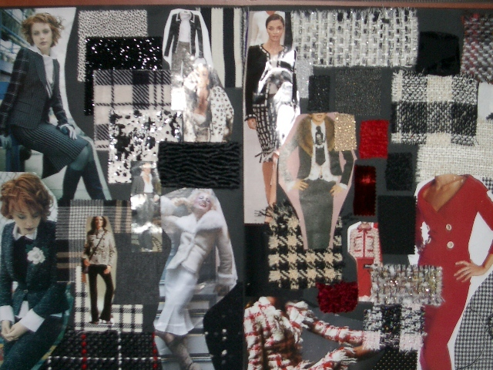
The example of a story board that displayed some images from the magazine ad also tell the mood of the style.
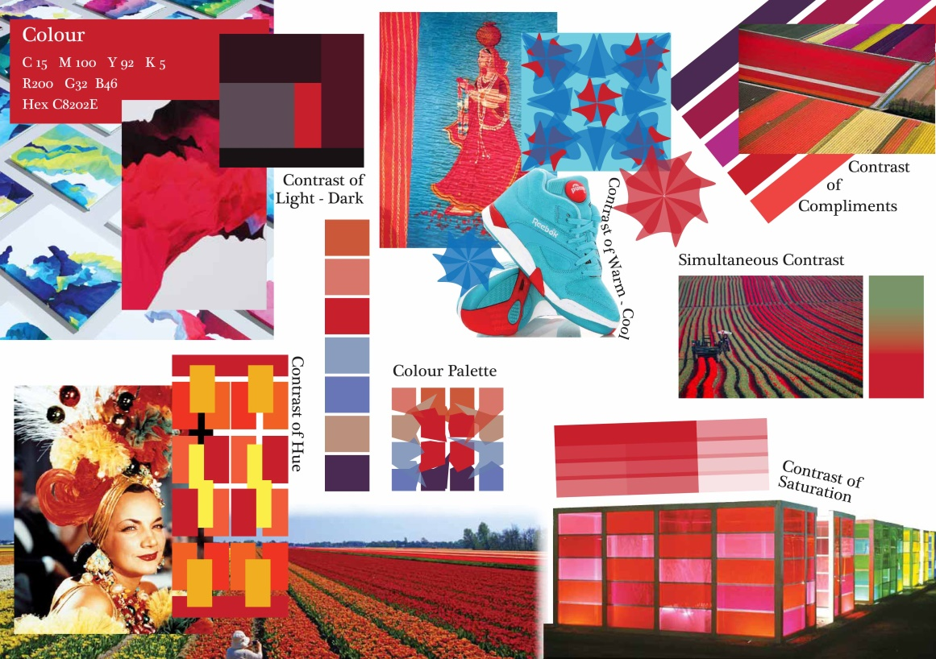
The example of a colour board that show tons of colour’s tone, contrast and the usage of it.

Reference
Information: BOLC unit 11 Note, Fashion Lecturer of Hongik University, Fashion website, Fashion blog
Pictures: Google images, Fashion magazine online and offline

