
Assignment Cover Sheet

Student Name: | Omnia Rafiq
Student Number: | 1343
Course: | Diploma in interior Design
Assignment NO: | 5

Student Statement:

By submitting this assignment, I confirm that this is my own work.

Student Signature | Omnia Rafiq | Date | 14-12-2014

For Tutor / Assessor Use Only
Total Marks
Marks Obtained
Percentage / Grade

Q.1.I. When planning a space in interior design scheme why it is important to establish the purpose for which it will be used?

There is no logical way to design a space until you determine what the primary function of that space will be. This means that it’s absolutely essential to plan for people and purpose before you ever begin to think about color schemes or trim. While all of those details are extremely fun to participate in and even more exciting to put together, without understanding what a room will be used for, there’s no way to add the right accent pieces.
Ask yourself if a room will be used for large and frequent social gatherings or filled floor-to-ceiling with children on a daily basis. These two uses require extremely different necessities when it comes to layout and furniture, and only once you’ve established the floor plan can you begin to add the smaller features like pictures, toys or end tables.
Planning with a purpose first will naturally lend itself to the smaller details that need to be attended to later on. Allowing the form to follow the rooms function results in a perfect room design.
Consider all the activities that take place in a room. A bedroom, for example, may be more than just a place to sleep. It may also be a place where someone can exercise, write letters or read. Similarly a kitchen may be much more than a place to cook. It is as likely to be a room where the family eats or they offer suppers to some informal friends.
Changing the use of a room is often beneficial. When designers plan a project, they follow a specific sequence.

1. They examine and change the structure, if necessary.
2. They plan the arrangement of the furniture.
3. They plan the lighting.
4. They select the scheme.
The order of the stages is quite specific; each operation logically follows the completion of the previous one. For example it is not possible to positioning of light fittings before you have planned where the furniture is going to be sited.

Every element has a function in this room.
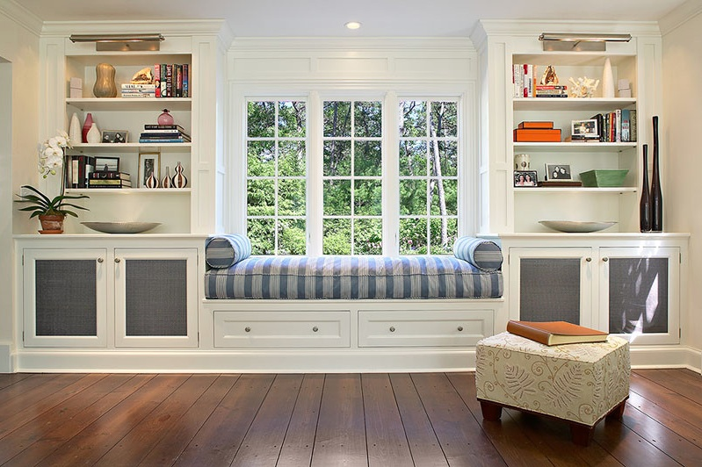

Q.1.ii. If all the rooms in a house are painted in same color scheme it will give a perception of a larger space. Why?

Since Visually connected rooms gives the feeling of a larger space. Painting the areas of the house in a common color scheme, will tie the rooms together, giving a perception of larger space.
We can define individual spaces using area rugs, furniture, art work or perhaps an accent wall colour if the architecture provides a distinct wall space to accommodate it.

Some visual tricks we can apply using colors:
- Use Monochromatic color scheme to unify and to make small rooms look bigger.
- Consider curtains to be same color as walls to help avoid contrast to the space.
- Contrast is what makes a room look smaller.
- Consider the same colors for both furniture and walls
- Use same wall and ceiling color to make room look taller. Hang art high...
- Also by using Reflected ceiling, Low profile furniture, floor to ceiling drapery, vertical lines
- White Walls. Of course, in a majority of situations, white walls are going to make everything feel proportionately larger. Scale up your room visually by utilizing light neutrals on the walls and keeping furniture light, bright and airy to maximize the feeling of additional space.

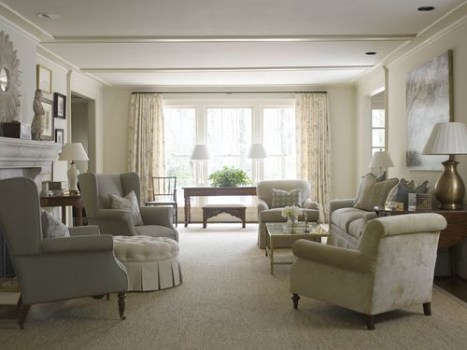

Q.1.iii. If one flooring style is used for all adjoining rooms on the same floor. What difference in your opinion it will create in the space?

Using one flooring style for all adjoining rooms on the same floor, Will create a sense of continuity and connectedness. Especially, if the floor plan is small.
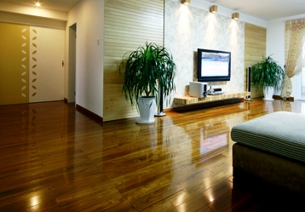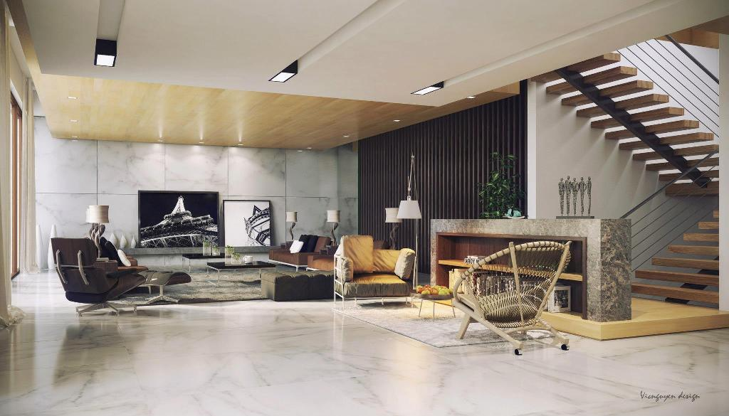

Q.1.iv. An attractive window treatment that sits well within the window frame could be a perfect solution for a small space. why?

An attractive window treatment, having a light natural colour that sits well within the window frame could be a perfect solution for a small space. As it doesn’t acquire space. In contrary with the long curtains, which needs a large room space. The greater the difference between the colour of the wall and the curtains, the more the curtains will visually intrude upon the space.
Many people begin with blinds, and then add curtains later for colour and insulation. Instead of blinds, one could begin with light-filtering fabric shades, woven grass or bamboo shades.
These fold up on themselves to leave the view open, and look attractive when raised. They should be lined to protect the fabric or wood materials from the drying effects of the sun. A heavy lining could also be used, to darken the room for sleeping or to provide effective insulation from extreme heat and cold. Used alone, they provide a more modern look, especially in a small room where long curtains might crowd the floor area.
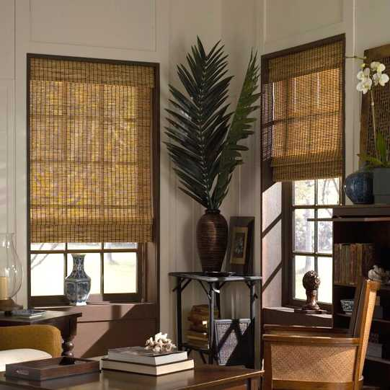
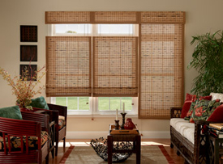

Q.1.v. How do introducing different textures in a room affect the visual perception? Does it work better in small spaces or large spaces?

Texture is an element which can sometimes be overlooked when planning a scheme. It has the ability to add a powerful, and subtle dimension to any room. It refers to how the surface of an object feels; therefore, you are no longer confined to visual elements such as line and colour, now you can actually determine the way the space will feel too by using texture.
A strategic mix of tactile qualities can create a visual interest- drawing you into space. Texture depth can be accomplished through a careful choice of flooring, upholstery, draperies, furniture and even accessories.
The careful use of groupings, scale, colour, and texture is considered to work better in large spaces, as it can turn a very large space into a welcoming, accommodating and fictional area, perfect for relaxation and entertainment.
When thinking about choosing textures we must think in terms of:
•Light reflection
For example: A carpet will reflect less light than a wooden floor
•Visual & Tactile texture
By adding a glass top to a roughly hewn coffee table you will change the tactile texture whilst retaining the visual texture
•Scale
A sofa upholstered in a chunky cord is going to look very different to the same sofa upholstered in linen
•Suitability
It may be great to have a sleek marble floor in a contemporary bathroom, but is it a practical choice?
Knowing that texture adds interest to a scheme – especially monochromatic schemes – they change the way a room ‘feels’
Rough/Course textures
•Reflect less light & therefore feel ‘warmer’
•Give an object more ‘weight’
•Feel more ‘rustic’
Smooth/Shiny textures
•Reflect more light and so feel cooler
•Make an object feel lighter
•Feel more modern

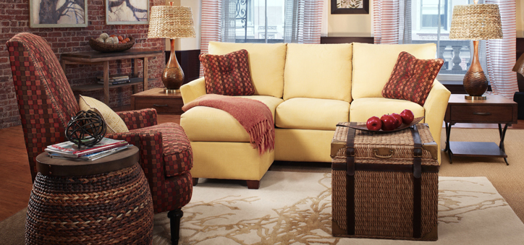

Q.1.vi. When a room is small there are things which we can do to work it better. State three tricks to make a small room appear larger.
Working with limited space can be a challenge, taking advantage of some small space tips can make a big difference in how a room is perceived. It is possible to give style even to a very small space. With some thought and imagination you can do some exciting, functional things with small spaces. While developing an interior design plan the following points must be considered to maximize the perception of a space.
1. Expand the View
Reduce unnecessary walls to create more open, flowing space. Consider creating partial walls or pass through areas as a way to create more Interior Design.
The space can be planned in a way that on entering into a house, you can see through the immediate space and partially into the next one. The sense of intrigue draws your eye toward the far room and invites you to explore the larger, attached space.
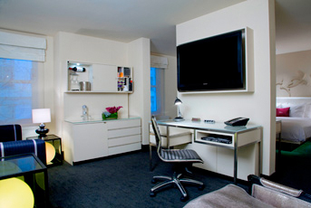
2. Co-ordinate the color scheme
Visually connected rooms feel larger. Paint the areas of the house in a common color scheme, which will tie the rooms together, giving a perception of larger space.
Define individual spaces using area rugs, furniture, art work or perhaps an accent wall color if the architecture provides a distinct wall space to accommodate it.
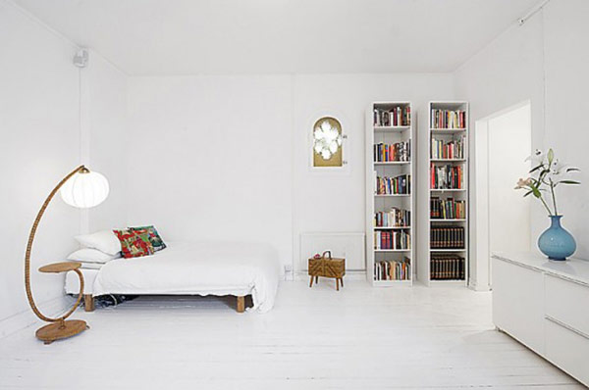

3.Use Mirrors and Glass
Mirrors and transparent items help to create a sense of space. A mirror’s reflection tricks the eye into believing that there is a window to additional, adjoining space. It is a very strong tool used for maximizing the small spaces. Transparent items create a sense of openness. Consider glass topped tables and glass fronted cabinetry and minimize the use of heavy, dark wooden objects in small spaces.
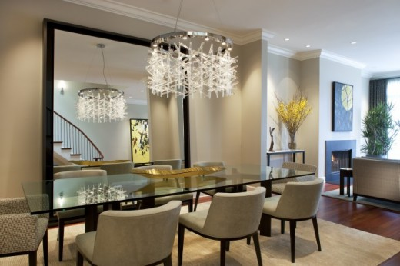

Other Tricks to be mentioned:

4. Install Recessed Lighting
Recessed lighting creates a greater sense of height in areas with lower than usual ceiling. Though, these fixtures don’t intrude on the space physically. But the pool of light created ads warmth and sophistication to the scheme.
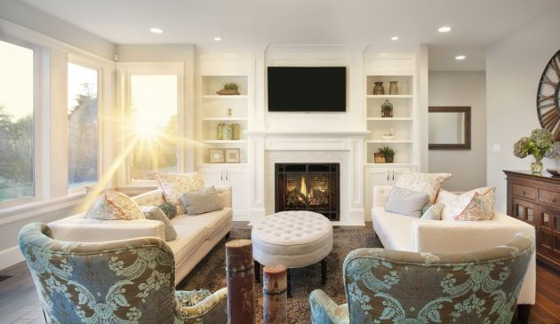
5. Maximize Scale
When purchasing furniture for a small room consider two sweater sofas instead of three sweater (even on the three sweater sofas, hardly three people sit together). Large overstuffed furniture can overwhelm a small space. Minimize doesn’t mean doll house furniture, though. It is important to get the scale right for the specific room you are working with.

6. Utilize Multifunctional Furniture
Versatile furniture pieces can be used as extra seating and much needed extra space at the same time. A storage ottoman is a great example of this particular small space tip. It can perform three different functions at the same time as a coffee table, storage, and extra seating. Also consider a small pull out sofa that can be converted to a guest bed when needed. Interior Design
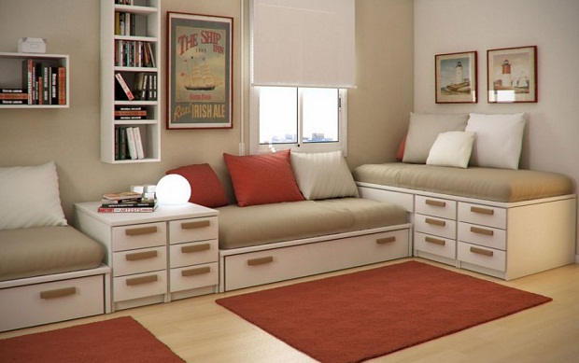
7. Get Creative
Look for unique or oddly shaped areas which can be good locations for built in cabinets and display areas. Recessed wall areas such as light niches, for example, provide decorative and storage space without intruding into the main living area.

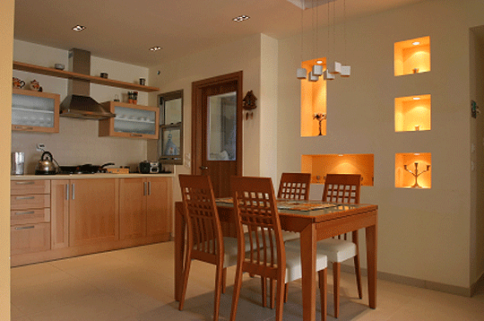

8. Reconsider the curtains
If windows have attractive moldings show them off by avoiding curtains and opting for some natural bamboo blinds or sort Roman shades for privacy and texture instead? The absence of curtains will result in less intuition into the space. Or an attractive window treatment that sits well within the window frame could be a perfect solution for a small space. The greater the difference between the color of the wall and the curtains, the more the curtains will visually intrude upon the space.

10. Unifying the Floor
Use one flooring style for all adjoining rooms on the same floor. It will create a sense of continuity and connectedness, especially, if the floor plan is small.

Q.2. How can social islands be created in a large living room? Why?
It is often easier to divide large spaces into two or more separate areas. For example you can either create areas for different activities or you can arrange two groups of seating. Alternatively, the areas can be defined by different decorative treatments, perhaps by painting walls in one area and using wall paper in the other.
Multiple seating areas are more practical a choice for a very large room, than having to shout across. Create several conversation groupings within the space. Area rugs should be used to further anchor these social areas and enhance the perception of smaller, more intimate spaces within the larger design.

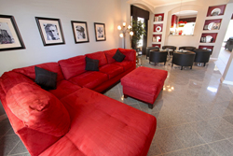

Case Study

Lucy wants to redecorate her house. It is a four bedrooms spacious house with a large living room. The living room is L-shaped at the same time it is too large with a high ceilings. One corner of the room is very dark as there is only one large window in the room which is not enough to light the whole room properly. What do you think how she should solve the problems for the followings:

- ceilings
- A perception of a lower ceiling can be created by painting the ceiling in a darker tone than the walls, or even by using a false (Suspended) ceiling also painted in warm colours with recessed spotlights.
- Place tall potted plants.
- Add ceiling panels.Choose from wood, metal, to customized mural painted panels. The options are limitless.
- Opt for taller furniture whenever possible.
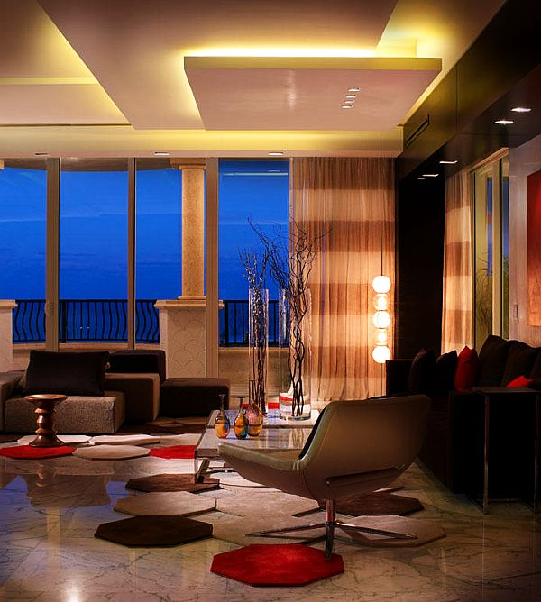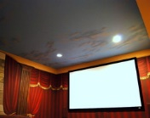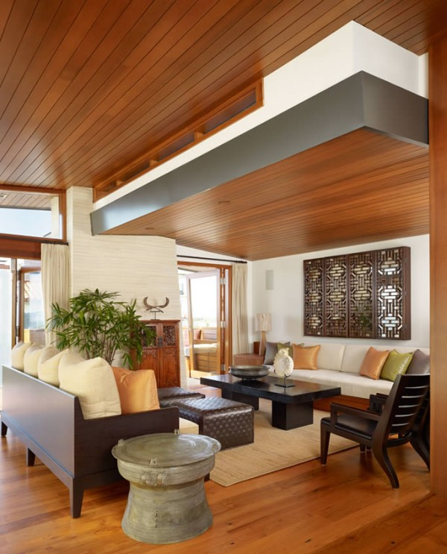

- walls
- By warming the walls, since hues on the warmer side of the colour wheel seem to move forward and visually envelope a space to create a greater sense of intimacy. Take advantage of this by painting the walls in warm colors.
- Make the most of height with wall art: Many think that you can only use human height proportions to display artwork on a wall. This isn’t true. Take advantage of wall height and hang wall art collections or one or two large pieces of artwork to add visual interest to the space. If your wall has a geometric interest, like it lies adjacent to a sloping ceiling, play up the architecture. Arrange wall art to mimic the slope of the ceiling down the adjacent wall!
- Ceiling height can be visually lowered by applying a melding on the wall below the ceiling. A rule of thumb is to place the melding at about the nine-foot level. The wall above this detail is then painted the colour of the ceiling, thus lowering its perceived height. This can even be done on the gable end of a vaulted room.
- Art work and accessories in a big room should be bigger and bolder. If you have framed prints or photos for your wall, go with a larger size than the standard 8 x 10 or 5 x 7 frames. Go group larger pieces together to make an even more bold punch in a room rather than several smaller pieces spread throughout the room.
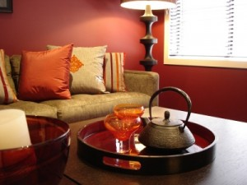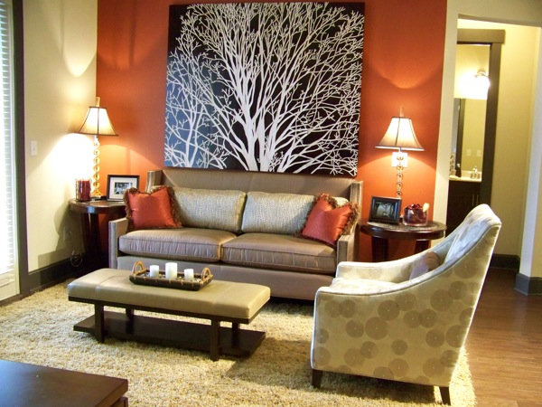

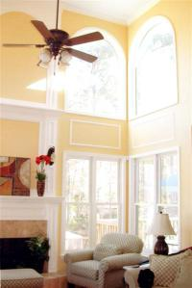

3. dark corner
  - First we must avoid blocking light by putting tall items in front of the window.
  - Never place square or rectangular pieces of furniture at an angle in a corner as it creates dead space.
  - Place furniture to make maximum use of natural light.
  - We can use lightings near that corner such as standing light lamps, wall lamps, or even recessed spot lighting.
  - Use accessories to emit and reflect light like mirrors and glasses.
  - When adding a rug, make sure it’s a light colored one.
  - Use potted colorful tall plants in that corner to make it look more refreshingly alive.
  - Add windows if possible, to bring in light.

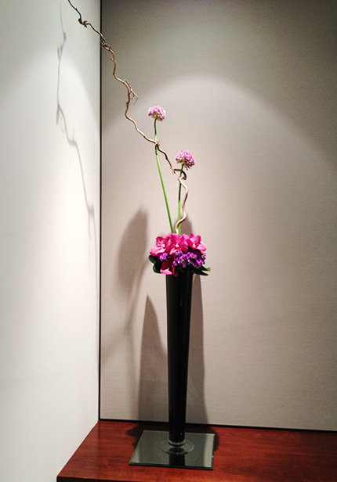

- Also suggest the suitable flooring and window treatment.

For the Flooring, I suggest to:

- Try to use as much of one material as possible in open areas. Where there are cased openings, it is okay to switch materials, but if the openings are big, like 8' across, the space will still read as one big open room. It's best not to transition if you can help it at all.
- Rugs are a great way to make the room feel cosier. We can use more than one rug to create separate areas.
- Open floor plans can create the illusion that your furniture is "floating." A carefully placed rug will anchor your space and define the area. Choose a rug that complements your décor in a size that works for your furniture, and the room's traffic pattern.
- Create a cohesive look between rooms with rugs that complement (rather than match exactly) the furnishings in a space. 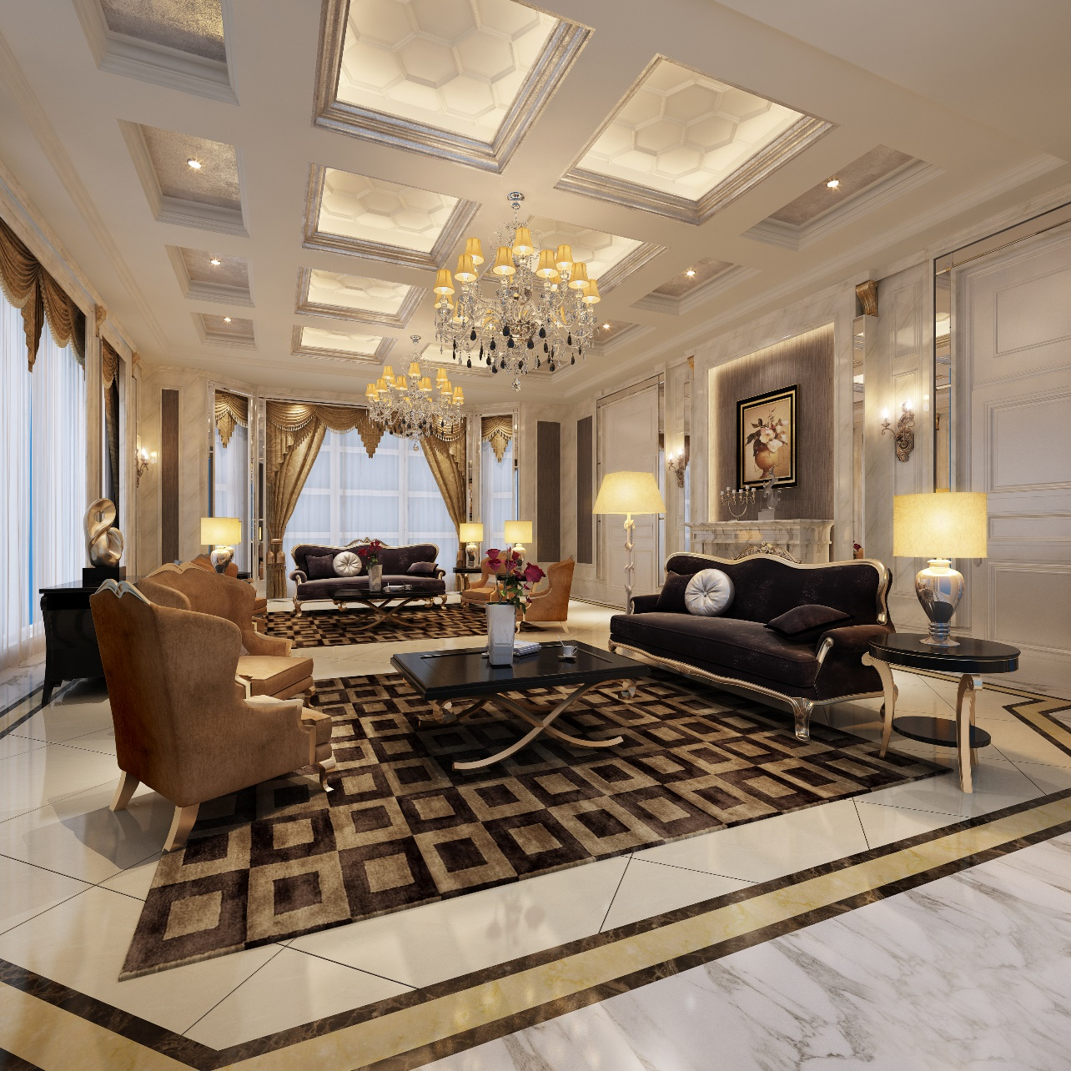

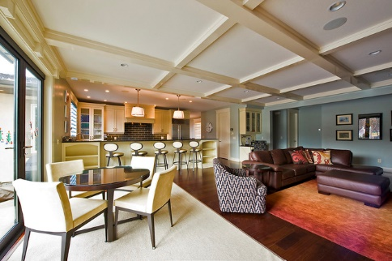

bad transition - high contrast and the strip
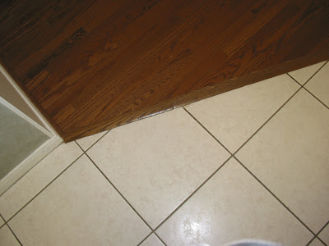

For the window treatment:
- If you have killer views and no one can see in, you may prefer to leave windows bare. If you need the option of privacy than use window treatments that fits your room scale and preferred decorative style.
- When it comes to tall windows the most recommended choice is drapery. Adding valances and tie backs gives you endless options to style your drapery.
- We can also use roman shades. Since you can raise and lower a Roman Shade to control the light flow into your room. If you want to add another layer of depth and interest to your windows, you can add drapery in addition to your Roman Shades. This is where a beautiful pattern can come into play. A solid Roman Shade will break up a patterned drapery and give your windows a complex, chic look.
