
Assignment Cover Sheet

Student Name: | Asabi Beckles
Student Number: | 1217
Course: | Diploma in Event Management
Assignment NO: | 8

Assessment 8 Total Marks: 30

Q.1. Short Questions: (10)
i. Identify the key steps involved in human resource management for an event?
There are many key steps involved when organising an event, especially in terms of human resources managements:
- Identify the tasks/jobs needed to successfully complete the event
- Determine the skills and number of staff (both paid permanent/temporary and voluntary) needed to support the event project group
- Identify and acquire staff from reliable and credible sources – internally or via recruitment processes
- Determine, invest and implement training programme(s) for volunteers to ensure tasks are performed to standard, with rewards in place for acknowledgement

ii. As an event planner you require some volunteers for your event, how would you contact them or arrange for them?
There are various ways to contact/arrange for volunteers when planning an event:
- Specialist contractors, councils or employment agencies – have a bank of experienced volunteer staff that come recommended and are available with short notice
- Recruitment advertising via multimedia outlets – newspapers, online notices, social media are a valuable means of attracting those looking to gain non-paid work experiences
- Recommendations by other event managers or networking at other events - observing potential candidates and staffing suppliers
- Clubs, community groups, colleges, schools or university – members and students are a reliable source of volunteers as they consistently require opportunities to contribute

iii. Which sort of information does a human resource plan contain?
A human resource plan contains a list of the following information:
- Staffing
- Number of staff needed
- Information on resources estimates and their costings
- Staffing time frames
- Office resources and stationery
- Training
- Specialist skills sets, competency levels and importance of these skills
- Motivation techniques
- Team building
- Rewards/recognition schemes
- Stakeholder influence

iv. Mention some ways of rewarding the volunteers at the end of event, and why it is important to do so?
Rewarding staff can motivate individuals and teams as well as encourage dependability, which is as important for volunteers as it is for paid staff. There are various means/strategies for rewarding staff when targets have been achieved, performing consistently improved or outstanding work completed:
- Vouchers
- Certificates of participation
- Thank you letters/cards/gifts
- End of event parties/celebrations
- Complementary movie/concert/event tickets
- Additional training courses
- Complementary lunches/dinner

v. Describe the management structure for one of the following events:
a) A sports event
b) A community festival
The following is a foundation diagram of the management structure that could be used for sports events such as the Virgin Money London Marathon or Men’s Health London. In terms of project management, events like this are complex and need intense planning, thus the management structure can be extended to include boards of trustees/committees:

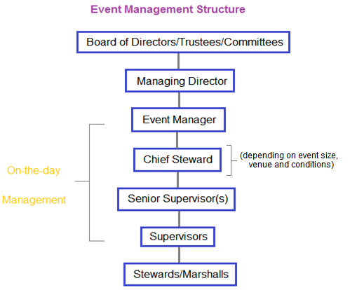

Q.2. Outline the roles and responsibilities of those managing the event. (6)
The scope of event management can be quite extensive but the following are the primary individuals associated with the daily operation of a sporting event:

- Event Manager/Planner - responsible for successfully progressing the event from inception to completion by sourcing/liaising with contractors, venues, catering, licensing authorities and other stakeholders, including organizing staffing. Reports to Board of Trustees/Committee, Managing Director or department manager.
- Chief Steward – responsible overall for monitoring contractors ensuring health and safety standards are upheld. Reports directly to the Event Manager.
- Senior Supervisors - responsible for specific tasks/areas within the event, ensuring these elements are maintained and function within set requirements. Reports directly to Chief Steward/Event Manager as appropriate.
- Supervisors – responsible for a floor staff. They ensure these stewards are briefed pre and post event advising of expectations and emergency procedure. Reports directly to Senior Supervisor.

Q.3. “The event manager must ensure that he has the right people with the right mix of skills at the right time, place and cost to meet the objectives of the event”. Discuss. (6)
As an Event Manager, it is important to ensure the right people with the right skills and experiences are sourced at the right stage and at competitive costs. This is the essence of Human Resources Management (HRM). Thus to ensure a successful event the following would need to be executed:

- Right people - Getting this correct depends on the number of tasks to be completed, the type of event and budgets restrictions (in terms of paid and unpaid staffing needs), etc
- Right mix of skills – this depends heavily on the knowledge, experience and competency of those hired, in addition to their ability to learn quickly when given new training.
- Right time – within the planning stage this can be when marketing and recruitment strategies have been finalized and adverts are commissioned in preparation for the event. Staffing sources can impact significantly as contact must be established in advance of the event date to ensure the best staff are acquired.
- Right place - Using highly recommended and reliable recruitment agencies and individuals ensures the customer service experience is premium. This includes having the appropriate individual in the most suitable position for their skills, talents and abilities.
- Right cost – though watching costs are essential, it is equally important to be prepared to invest in staff especially if industry specialists are required. Training and Development of existing or previously used staff must also be factored in; this includes the number of trainer, their time, group size, and possibly the provision of refreshments.

When all factors are achieved in unison, client satisfaction and event success are more likely to be positive.

Activity (8)
You are to organise a community festival. Preparations are to be started 8 months in advance; the first step is to recruit volunteers which you have already done as a manager. Now you have to divide the tasks and organise the teams.

Community festival: The celebration of Plumstead’s community – past and present
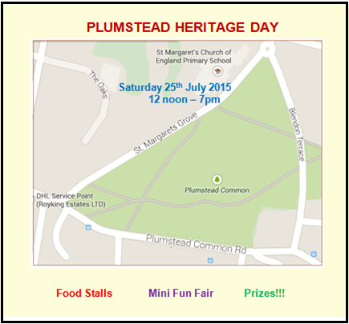

Festival Information:
- Location – Plumstead Common
- Date – 25th July 2015
- Time: 12 noon – 7pm

List of tasks:
- Information booth – festival maps & leaflets, walking group membership forms, seminar timetables, area facts
- Tickets – Entry Sales & Admissions
- Lost and Found – property & lost children
- Refreshments Bar – Food & Drinks stalls
- Activities/Entertainment – mini football, tree planting, community gardening, Community harvest, fair rides (bouncing castle, ferris wheel, etc) community bake sale, various stalls
- Health and Safety - crowd control, general security, equipment set up & pack down, first aid post
- Waste Management – litter pick up & sorting, toilet monitoring & reporting

Staffing Total: 40
Nos. of Volunteers: 20
Nos. of paid Temporary staff: 10
Nos. of paid Permanent staff: 10

Team Structure:
Staff Distribution
Area/Work stations | Volunteers | Paid Temporary | Paid Permanent
Information booth | 1 | 1 | 1
Tickets | 0 | 1 | 2
Lost and Found | 1 | 0 | 1
Refreshments Bar | 6 | 2 | 2
Activities/Entertainment | 4 | 2 | 1
Health and Safety | 3 | 1 | 3
Waste Management | 3 | 1 | 1
Relief cover | 2 | 2 | 0
Total | 20 | 10 | 10

Student Statement:

By submitting this assignment, I confirm that this is my own work.

Student Signature | Asabi Beckles | Date | 19/11/2014

For Tutor / Assessor Use Only
Total Marks
Marks Obtained
Percentage / Grade

