ELIZABETH ABIDEMI AKINLABI

1380

ASSIGNMENT 5

DIPLOMA IN FASHION DESIGN

ELIZABETH ABIDEMI AKINLABI
1380
ASSIGNMENT 5
PAGE 1

Q1. Give short answers for the following questions:

- What is meant by ‘weight and hand’ in the textile industry? Hand in the textile industry refers to the feel of the fabric when it is touched; the quality of the ‘hand’ is described as crispness, dryness, silkiness, fineness, length etc. A good ‘hand’ is also pleasing to the touch. Weight is when the weight of a fabric is increased by infusing starch, mineral salts, etc, into the fabric.

- Name the warm colors. How best these can be used in dress designing? The warm colors are red, orange and yellow, these colors are vibrant, warm uninhibited, understanding what they connote helps the designer design accordingly, it can be used to express a mood, a dangerously ‘red’ dress or a warm orange cotton skirt for a tropical holiday, maybe designing for a children’s line? All these factors and more aid in the use of warm colors for dress designing.

- Why is it important for a designer to consider the scale of a pattern, when using patterned fabric in dress designing? It is important for the designer to always ensure the scale of a pattern complements the design, and he/she understands the type of figure they will be designing for, as

ELIZABETH ABIDEMI AKINLABI
1380
ASSIGNMENT 5
PAGE 2

bold patterns can increase the size of the wearer. By utilizing the pattern as the main feature of the garment and keeping the overall design simple, free of seam lines, with little to no embellishment, the designer can achieve a garment that is pleasing to the eyes and is well balanced and proportioned to the wearer.

- What is the difference between conventional design and geometric design? Conventional design is adopted from nature, but is no longer naturalistic after the final decorative motif has been derived. While geometric design is not derived from nature but is inspired by shapes like the triangle, rectangle etc and also by lines, parallel lines etc.

2. Define the term color dimension. Explain the following terms. Hue, Value, intensity.

Color dimension is defined by Hue, value and intensity.

- Hue; this is how we are able to tell one color from the other.
- Value; this property of color helps us understand how light or dark a color is. How ‘dark’ it is means it’s closer to black and how ‘light’ it is means it’s closer to white.
ELIZABETH ABIDEMI AKINLABI
1380
ASSIGNMENT 5
PAGE 3

- Intensity; this property of color is based on how strong or how weak a color is, it also describes how pale or how weak a color is. For example, mint green is paler in comparison to dark green.

3. Write short notes on the following; basic shapes in dress designing.

- Rectangle, this straight line is long and clothes made in this style are slenderizing, making it a good choice for a ‘well proportioned heavier woman’, outfits like off shoulder dresses with full skirts, narrow sheath dresses, work with this shape type.
- Triangle; with the triangle shape, an A line dress, or a low neckline top with a fitted bodice with a full skirt works well with this shape.
- Inverted triangle; as the upper part is wider in this triangular shape, the skirt will be narrower, for example a raglan sleeve draped décolleté top on a pencil skirt will be suitable for this shape type.
- Oval; This dress shape design is suitable for the ideal figure, it can be very feminine and flattering with drapery, softly molding and shaping, creating a silhouette mostly worn for evening and afternoon wear.
- Square; This style is suitable for the thin figure, by adding a sense of fullness with a

ELIZABETH ABIDEMI AKINLABI
1380
ASSIGNMENT 5
PAGE 4

boxy jacket, capes etc, this style can aid in balancing figure irregularities.

- Round; for the very thin figure and mostly worn by young ladies, this style utilizes puffy sleeves, wide lined and full skirts, petal shapes etc. The round shape makes good formal wear and afternoon frocks.

- Hourglass; to properly style a tall thin figure the hourglass shape with its wide shoulders and very small almost waspy waist that gently accentuates the hips and widens into a full skirt is most suitable.

- Combination; All these basic shapes can be used when designing for an irregular figure type to create the most flattering design to suit the wearer, without compromising the ‘current fashion design style’

ELIZABETH ABIDEMI AKINLABI
1380
ASSIGNMENT 5
PAGE 5

PROJECT

Look through the costume books for pictures of an historic dress. Using these inspirations, design a garment using the line shapes, colors and details from the historic garment in a new combination for our lifestyle.

ELIZABETH ABIDEMI AKINLABI
1380
ASSIGNMENT 5
PAGE 6
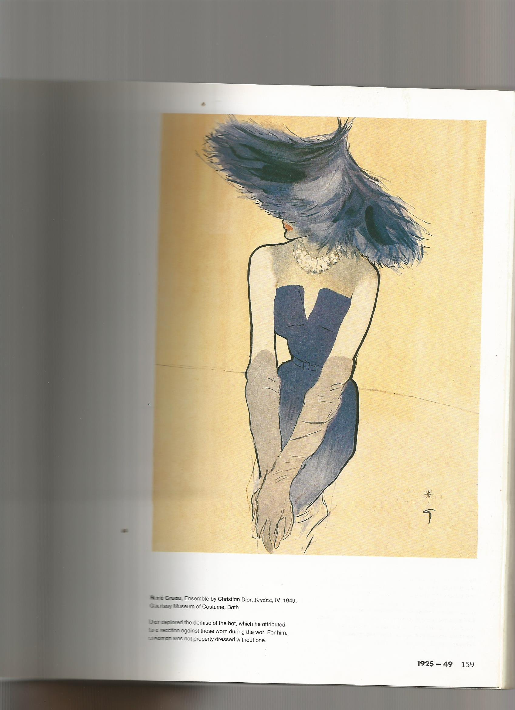

ELIZABETH ABIDEMI AKINLABI
1380
ASSIGNMENT 5
PAGE 7
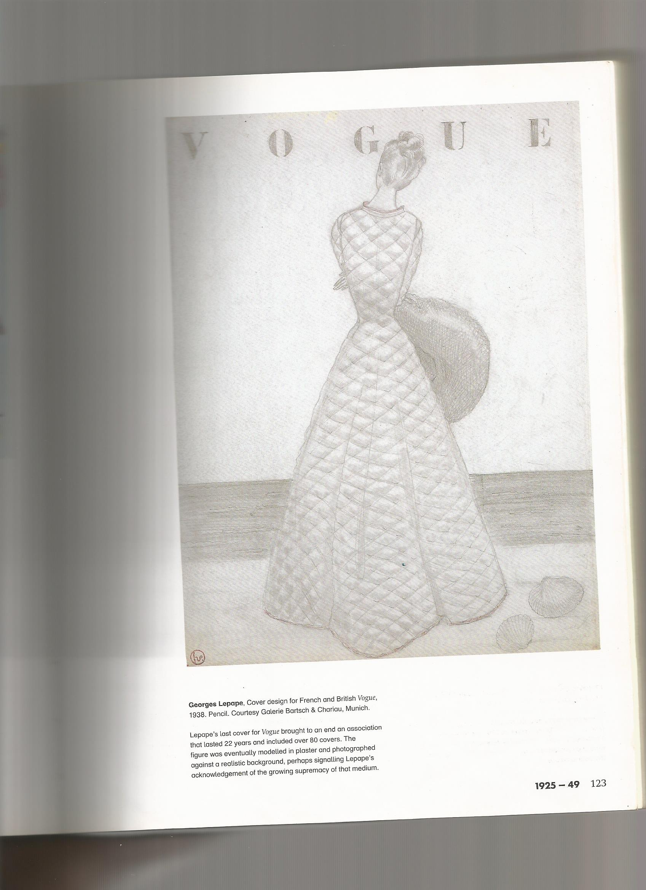

ELIZABETH ABIDEMI AKINLABI
1380
ASSIGNMENT 5
PAGE 8
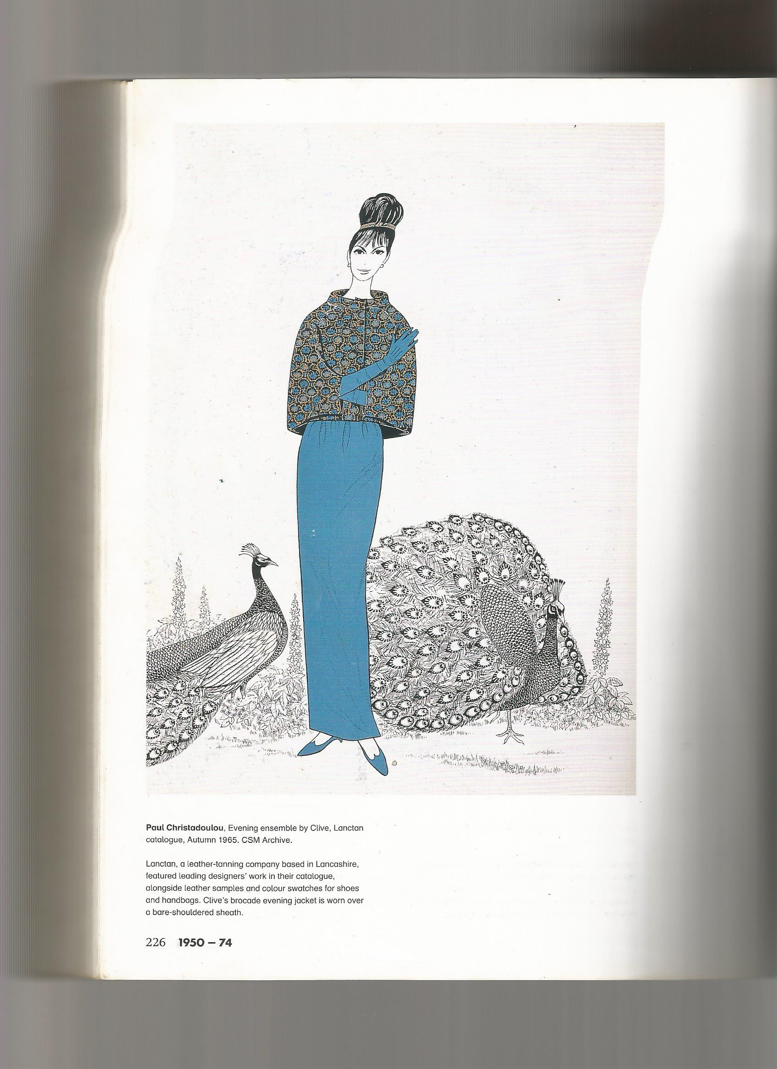

ELIZABETH ABIDEMI AKINLABI
1380
ASSIGNMENT 5
PAGE 9
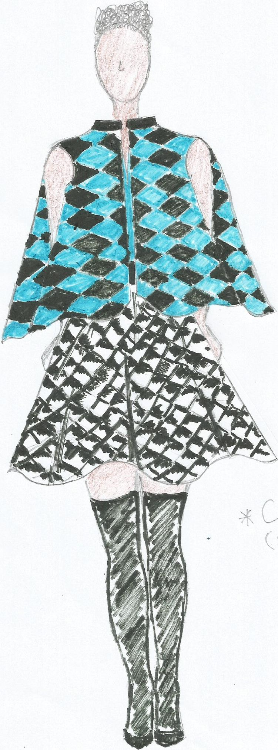

ELIZABETH ABIDEMI AKINLABI
1380
ASSIGNMENT 5
PAGE 10
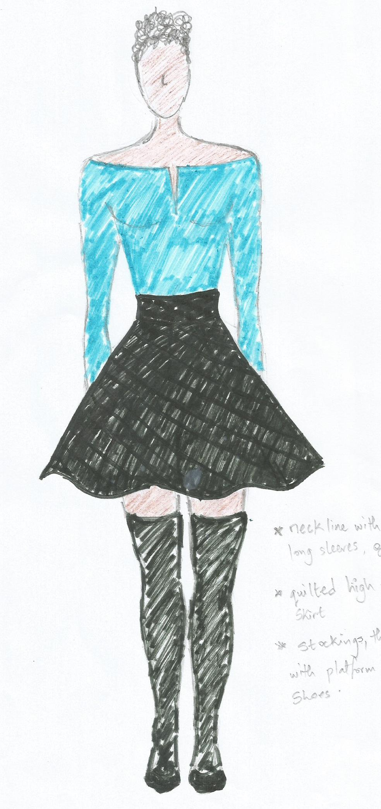

ELIZABETH ABIDEMI AKINLABI
1380
ASSIGNMENT 5
PAGE 11

The skirt was inspired by Georges Lepapes cover design for French and British Vogue in 1938, I really like the quilted texture of the overcoat/dress so I translated it into a shorter flare skirt while still trying to stay true to the shape, the cape like jacket was designed as a print in geometric patterns, inspired by Clive designs, autumn 1965.I also derived the color from that sketch also, but translated it in a different hue, the neckline of the top was inspired by the neckline of the Christian Dior dress, the image was quite dramatic with the hat and I felt the neckline would suit our urban life style while aligning vertically with the jacket like cape.

References; www.colourcube.com, scandedesigner.wordpress.com, www.textilelink.com, 100 years of fashion illustration by Cally Blackman.

NB; please find cover sheet attached.

